Conformance Pack Routing — Solution Options

Context
In the original Resource Policy Fix design document, the goal was to have a CloudFormation Custom Resource (i.e. aws_account_partitioner) output an Account –> Partition mapping that could be fed downstream to ConformancePack.yaml to lookup the lambda partition to use for each account based on the AWS::AccountId parameter. However, CloudFormation doesn’t support passing Mappings as a template parameter (only defined in the template), and there don’t seem to be any suitable alternatives to derive an account’s partition within ConformancePack.yaml solely using input parameter values.
Therefore, we are left with the question: how does ConformancePack.yaml route each account’s Config rules to the correct partition’s Lambda clone?

Option A: Separate Conformance Packs per Partition with ExcludedAccounts

Overview
Deploy one Conformance Pack per partition in main.yaml. Each pack contains the same 37 Config rules but points at a different Lambda suffix. The ExcludedAccounts property on each OrganizationConformancePack ensures each account only receives rules from its assigned partition.

How It Works
- aws_account_partitioner (Custom Resource Lambda) runs early in main.yaml. It lists all org accounts, assigns them to partitions (≤70 each), and returns partition membership lists as outputs.
- main.yaml creates 1–3 AWS::Config::OrganizationConformancePack resources, each receiving:
  - A PartitionSuffix parameter ("", "_p2", or "_p3")
  - An ExcludedAccounts list (all accounts not in that partition)
- ConformancePack.yaml remains a single, static template in S3. It uses PartitionSuffix in each rule’s SourceIdentifier:
# ConformancePack.yaml (static — no regeneration)
Parameters:
PartitionSuffix:
Type: String
Default: ""
AuditAccountID:
Type: String
OrganizationName:
Type: String
# ... other existing parameters
Resources:
GC01CheckRootAccountMFAEnabled:
Type: AWS::Config::ConfigRule
Properties:
ConfigRuleName: !Sub "${OrganizationName}-GC01-CheckRootMFA"
Source:
Owner: CUSTOM_LAMBDA
SourceIdentifier: !Sub "arn:aws:lambda:ca-central-1:${AuditAccountID}:function:${OrganizationName}gc01_check_root_mfa${PartitionSuffix}"
SourceDetails:
- EventSource: aws.config
MessageType: ScheduledNotification
MaximumExecutionFrequency: TwentyFour_Hours
- main.yaml Conformance Pack resources:
# main.yaml (simplified)
ConformancePackP1:
Type: AWS::Config::OrganizationConformancePack
Properties:
OrganizationConformancePackName: !Sub "${OrganizationName}-GC-CP-Guardrails"
ExcludedAccounts: !GetAtt AccountPartitioner.ExcludedFromP1
ConformancePackInputParameters:
- ParameterName: PartitionSuffix
ParameterValue: ""
# ... other params
TemplateS3Uri: !Sub s3://${PipelineBucket}/${DeployVersion}/ConformancePack.yaml
ConformancePackP2:
Type: AWS::Config::OrganizationConformancePack
Condition: HasPartition2
Properties:
OrganizationConformancePackName: !Sub "${OrganizationName}-GC-CP-Guardrails-P2"
ExcludedAccounts: !GetAtt AccountPartitioner.ExcludedFromP2
ConformancePackInputParameters:
- ParameterName: PartitionSuffix
ParameterValue: "_p2"
# ... other params
TemplateS3Uri: !Sub s3://${PipelineBucket}/${DeployVersion}/ConformancePack.yaml
ConformancePackP3:
Type: AWS::Config::OrganizationConformancePack
Condition: HasPartition3
Properties:
OrganizationConformancePackName: !Sub "${OrganizationName}-GC-CP-Guardrails-P3"
ExcludedAccounts: !GetAtt AccountPartitioner.ExcludedFromP3
ConformancePackInputParameters:
- ParameterName: PartitionSuffix
ParameterValue: "_p3"
# ... other params
TemplateS3Uri: !Sub s3://${PipelineBucket}/${DeployVersion}/ConformancePack.yaml

Flow Diagram
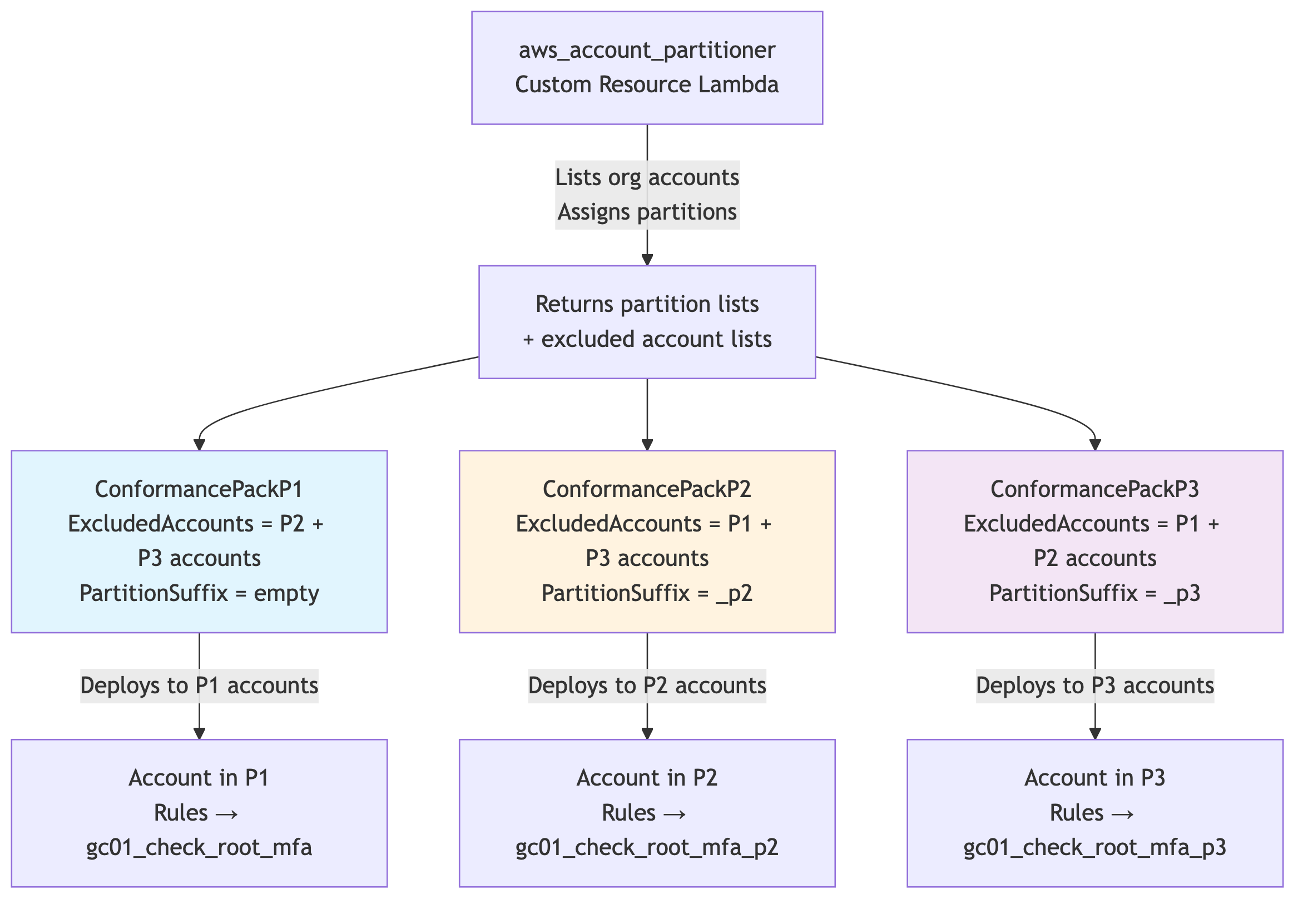
Diagram

Pros
- ✅ ConformancePack.yaml is fully static — git version loaded once to S3, never regenerated
- ✅ Each account sees exactly 37 rules — clean Config console and Audit Manager reports
- ✅ Simple template change — just add ${PartitionSuffix} to existing SourceIdentifier lines
- ✅ Same template reused for all partitions via S3 URI
- ✅ Backward compatible — orgs with ≤70 accounts just have one pack with empty suffix (no change)

Cons
- ⚠️ ExcludedAccounts behaviour needs testing — must confirm that:
  - It truly suppresses rule deployment (not just evaluation)
  - It accepts a list from aws_account_partitioner successfully
- ⚠️ Multiple Conformance Pack resources in main.yaml — up to 3 instead of 1
- ⚠️ Audit Manager impact — the custom framework in audit_manager_custom_framework.py maps controls to Config rules via keywordValue (e.g., Custom_gc01_check_root_mfa-conformance-pack). Different conformance pack names produce different rule names per partition, so each Audit Manager control would need multiple controlMappingSources entries (one per partition). The aws_compile_audit_report Lambda, which pulls evidence from Audit Manager to generate CSV reports in S3, would have gaps for P2/P3 accounts unless the framework is updated. (Note: Audit Manager is entering maintenance mode, so a future rewrite to pull directly from Config Aggregator would eliminate this coupling entirely.)

Option B: Single Conformance Pack with Regenerated Template (FindInMap)

Overview
A single OrganizationConformancePack with a dynamically generated ConformancePack.yaml. The aws_account_partitioner Lambda generates the template with a Mappings block that maps every account ID to its partition suffix. Each Config rule uses Fn::FindInMap to resolve the correct Lambda at deploy time.

How It Works
- aws_account_partitioner (Custom Resource Lambda) runs early in main.yaml. It:
  - Lists all org accounts and assigns partitions
  - Reads the base ConformancePack.yaml from S3
  - Injects a Mappings block with account-to-suffix mappings
  - Uploads the generated template to S3 (e.g., s3://<bucket>/<version>/ConformancePack-generated.yaml)
- main.yaml references the generated template in the single OrganizationConformancePack resource.
- ConformancePack-generated.yaml contains:
Mappings:
AccountPartition:
"111111111111":
Suffix: ""
"222222222222":
Suffix: ""
"333333333333":
Suffix: "_p2"
"444444444444":
Suffix: "_p3"
Resources:
GC01CheckRootAccountMFAEnabled:
Type: AWS::Config::ConfigRule
Properties:
ConfigRuleName: !Sub "${OrganizationName}-GC01-CheckRootMFA"
Source:
Owner: CUSTOM_LAMBDA
SourceIdentifier: !Join
- ""
- - !Sub "arn:aws:lambda:ca-central-1:${AuditAccountID}:function:${OrganizationName}gc01_check_root_mfa"
- !FindInMap [AccountPartition, !Ref "AWS::AccountId", Suffix]
SourceDetails:
- EventSource: aws.config
MessageType: ScheduledNotification
MaximumExecutionFrequency: TwentyFour_Hours
- main.yaml Conformance Pack resource:
ConformancePack:
DependsOn:
- AccountPartitioner
# ... existing dependencies
Type: AWS::Config::OrganizationConformancePack
Properties:
OrganizationConformancePackName: !Sub "${OrganizationName}-GC-CP-Guardrails"
ConformancePackInputParameters:
# ... existing params (no PartitionSuffix needed)
TemplateS3Uri: !Sub s3://${PipelineBucket}/${DeployVersion}/ConformancePack-generated.yaml

Flow Diagram
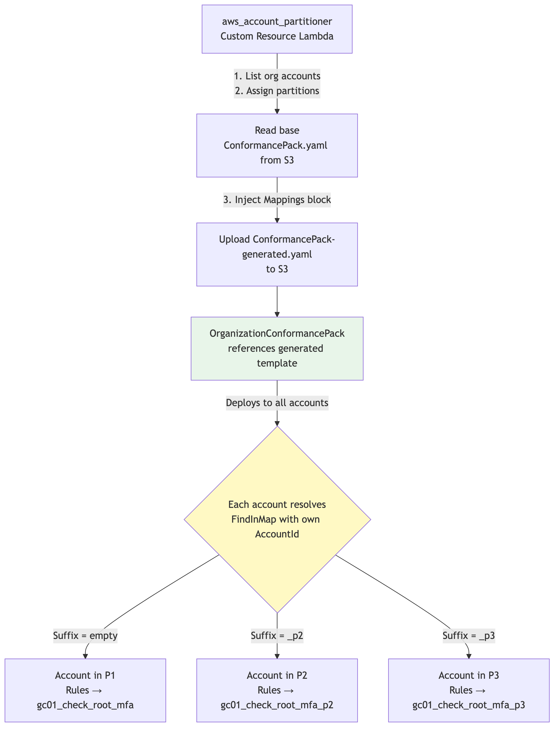
Diagram

Pros
- ✅ Proven to work — Fn::FindInMap + Ref: AWS::AccountId confirmed working in Conformance Packs
- ✅ Single Conformance Pack — one resource in main.yaml, one pack name, clean Audit Manager integration
- ✅ Single Config rule name per guardrail — consistent across all accounts, simplifies Audit Manager framework references
- ✅ No Audit Manager changes required — the existing keywordValue mappings in audit_manager_custom_framework.py and the aws_compile_audit_report evidence pipeline work as-is since all accounts see the same rule names

Cons
- ⚠️ Template is regenerated every deployment — the aws_account_partitioner must generate and upload the template before the Conformance Pack deploys
- ⚠️ Base template must be maintained separately — either as a file that the Lambda reads from S3 and modifies, or generated entirely by the Lambda

