Resource Policy Size Limit Fix — Design Document

Problem Statement
AWS Lambda resource-based policies have a 20KB size limit. The current aws_lambda_permissions_setup Lambda adds one lambda:AddPermission statement per AWS account in the organization to every guardrail Lambda function (gc*). Each statement allows config.amazonaws.com to invoke the Lambda on behalf of that account.
At approximately 70 accounts, the accumulated policy statements exceed 20KB, causing PolicyLengthExceededException errors. SSC customers operate environments with up to 200 accounts, making this a blocking deployment issue.

Current Behaviour
- AuditAccountPreRequisitesPart1–8 each deploy a set of guardrail Lambdas (e.g., gc01_check_root_mfa).
- AuditAccountPreRequisitesPartN deploys aws_lambda_permissions_setup, which iterates every org account and calls lambda:AddPermission on each gc* Lambda — one statement per account.
- ConformancePack.yaml defines Config Custom Rules pointing each account’s evaluation at the single gc* Lambda by ARN.
- An EventBridge cron re-runs aws_lambda_permissions_setup every 6 hours to pick up new accounts.
Failure mode: When the organization grows past ~70 accounts, the per-Lambda resource policy exceeds 20KB and AddPermission calls fail.

Proposed Solution — Partitioned Lambda Cloning
Companion document: CONFORMANCE_PACK_IMPLEMENTATION.md covers the conformance-pack and Audit Manager portions of this design (Sections 4 and 5 below) in greater depth — including the full ExcludedAccounts YAML, per-partition condition combinations, the CloudFormation 4 KB response-cap analysis, and Audit Manager evidence routing diagrams. This document is the high-level design overview.

Core Idea
Partition the organization’s accounts into groups of ≤70 and create one clone of each guardrail Lambda per partition. Each clone’s resource policy only contains the accounts in its partition, staying well within 20KB.
Accounts | Partitions | Lambda copies per guardrail
1–70 | 1 | 1 (no change)
71–140 | 2 | 2
141–210 | 3 | 3

Naming Convention
<org_name>gc01_check_root_mfa ← partition 1 (or sole partition)
<org_name>gc01_check_root_mfa_p2 ← partition 2
<org_name>gc01_check_root_mfa_p3 ← partition 3

New Components

1. DynamoDB Partition State Table
A single DynamoDB table stores the account-to-partition mapping. The schema is intentionally minimal — consuming processes reconstruct partition lists, counts, etc. at runtime.
Table Name: gc-guardrails-partition-state
Attribute | Type | Description
AccountId (PK) | String | 12-digit AWS Account ID
PartitionId | Number | Partition number (1, 2, or 3)
Example items:
{ "AccountId": "111111111111", "PartitionId": 1 }
{ "AccountId": "222222222222", "PartitionId": 1 }
{ "AccountId": "333333333333", "PartitionId": 2 }
Consumers can: - Get partition for an account: GetItem(AccountId). - Get all accounts in a partition: Scan with FilterExpression: PartitionId = :p (≤210 items total, scan is fine). - Count accounts per partition: Aggregate at runtime. - Get total partition count: max(PartitionId) from a full scan.
The table is created in main.yaml alongside the partitioner Lambda.

Data durability and disruption safeguards
The table resource sets DeletionPolicy: Retain and UpdateReplacePolicy: Retain so a cloudformation delete-stack on the root cannot destroy live partition state, DeletionProtectionEnabled: true to block accidental console/CLI deletes, and PointInTimeRecoverySpecification.PointInTimeRecoveryEnabled: true for 35-day continuous backup - allowing for a point-in-time restore within minutes.

2. Account Partition Lambda (aws_account_partitioner)
A new Lambda function responsible for managing partition state. It runs in two contexts:
- At deployment time: As a CloudFormation Custom Resource in main.yaml (initial setup).
- Post-deployment: As Step 1 of the Step Function orchestration (triggered by cron).
Behaviour:
- Queries organizations:ListAccounts for all active accounts.
- Reads current partition state from DynamoDB.
- Identifies new accounts not yet assigned and removed/suspended accounts.
- Greedily assigns new (sorted) accounts to the lowest-numbered partition with room (< MAX_ACCOUNTS_PER_PARTITION), opening a new partition as needed up to MAX_PARTITIONS.
- Removes entries for inactive/deleted accounts.
- Stable assignment: existing rows in DynamoDB are never re-balanced — only new accounts are placed.
- If a trailing partition becomes empty (e.g. every P3 account leaves), partitionCount is reduced to the highest occupied partition. Non-trailing partitions are not collapsed (an empty P2 with P3 still occupied leaves partitionCount=3).
- Writes updated state back to DynamoDB.
Return shape (identical in both CFN Custom Resource and Step Function contexts):
Field | Type | Description
partitionCount | int | Current number of partitions in use (1..MAX_PARTITIONS).
partitionsChanged | bool | True if partitionCount differs from the previous run. Returned for observability only — surfaced in CloudWatch logs, the Custom Resource response, and the Step Function execution history so operators can tell at a glance whether a sync run opened/collapsed a partition vs. merely added an account to an existing one. The Step Function does not branch on this flag (see accountsChanged below).
accountsChanged | bool | True if at least one account was added to, or removed from, the partition state on this run. Critical: the Step Function gates the root-stack UpdateStack cascade on this flag alone. It covers both the count-changing cases (opening or collapsing a partition is always accompanied by a membership change) and the count-stable case — a new account joining an existing partition with room leaves partitionCount unchanged, but the other partitions’ ExcludedAccounts lists must still be re-rendered so the new account doesn’t receive multiple Organization Conformance Packs simultaneously. Testing partitionsChanged in the choice would be strictly redundant.
AccountsInP1 | string | Comma-separated 12-digit account IDs in partition 1. Empty string if unused.
AccountsInP2 | string | As above for partition 2.
AccountsInP3 | string | As above for partition 3.
The per-partition account lists are consumed downstream by ConformancePackPartitions.yaml (see Section 4) to build each Organization Conformance Pack’s ExcludedAccounts.
CloudFormation 4 KB response-body cap. Custom Resource response bodies are capped at 4096 bytes. With MAX_ACCOUNTS_PER_PARTITION × MAX_PARTITIONS = 70 × 3 = 210 account IDs at ~14 bytes each (12-digit + comma), the combined AccountsInPx payload at 210 accounts is ~3.4 KB plus envelope — fits comfortably. Raising either limit further would require revisiting this.

3. Modified AuditAccountPreRequisitesPart1–8.yaml
Each template receives PartitionCount as a parameter. Using CloudFormation Conditions, it conditionally creates cloned Lambda functions:
Conditions:
CreatePartition2: !Not [!Equals [!Ref PartitionCount, "1"]]
CreatePartition3: !Equals [!Ref PartitionCount, "3"]
Resources:
GC01CheckRootMFALambda: # always created (partition 1)
...
GC01CheckRootMFALambdaP2: # created if PartitionCount >= 2
Condition: CreatePartition2
...
GC01CheckRootMFALambdaP3: # created if PartitionCount == 3
Condition: CreatePartition3
...
All clones share the same code package and IAM execution role — only the FunctionName differs.

4. Modified ConformancePack.yaml + new ConformancePackPartitions.yaml — One Pack Per Partition
The original design considered deploying one Organization Conformance Pack containing three copies of each Config rule (conditionally created per partition), with all copies deployed to every account and the un-permitted ones failing closed. This was abandoned because:
- CloudFormation Conditions are evaluated at template-processing time and cannot reference !GetAtt from a Custom Resource, so the per-partition account assignments produced by aws_account_partitioner cannot drive Conditions inside main.yaml.
- Fail-closed evaluations would muddy Config and Audit Manager evidence.
The adopted approach instead deploys up to three separate AWS::Config::OrganizationConformancePack resources — one per non-empty partition — each running the same 37-rule template (ConformancePack.yaml) but parameterised with a different Lambda-clone target. Per-pack ExcludedAccounts ensures every org account receives exactly one pack.

4a. ConformancePack.yaml — single PartitionSuffix parameter
Rather than duplicating every rule three times, a single new input parameter is added:
PartitionSuffix:
Type: String
Default: ""
AllowedValues: ["", "_p2", "_p3"]
…and appended to every ConfigRuleName and to the Lambda function name in every SourceIdentifier (37 rules × 2 substitutions). Example:
# Before
ConfigRuleName: gc01_check_root_mfa
SourceIdentifier:
Fn::Join: ["", ["arn:aws:lambda:ca-central-1:", !Ref AuditAccountID,
!Sub ":function:${OrganizationName}gc01_check_root_mfa"]]
# After
ConfigRuleName: !Sub "gc01_check_root_mfa${PartitionSuffix}"
SourceIdentifier:
Fn::Join: ["", ["arn:aws:lambda:ca-central-1:", !Ref AuditAccountID,
!Sub ":function:${OrganizationName}gc01_check_root_mfa${PartitionSuffix}"]]
When the P2 pack passes PartitionSuffix: "_p2", the deployed rule becomes gc01_check_root_mfa_p2 and targets the <org>gc01_check_root_mfa_p2 Lambda clone.

4b. ConformancePackPartitions.yaml — new nested stack
A new nested template replaces the single inline AWS::Config::OrganizationConformancePack in main.yaml. The logical name ConformancePack is preserved so the existing AuditAccountAuditManager DependsOn: ConformancePack reference still resolves.
Why a nested stack: the per-partition account lists arrive from the partitioner as !GetAtt values, which cannot be used in parent-stack Conditions. Passing them into a nested stack as regular parameters lets the nested stack’s Conditions gate each pack on partition emptiness.
Resource | Condition | PartitionSuffix | ExcludedAccounts
ConformancePackP1 (${OrganizationName}-GC-CP-Guardrails) | HasAccountsInP1 | "" | union of P2 ∪ P3 (whichever are non-empty), or AWS::NoValue
ConformancePackP2 (${OrganizationName}-GC-CP-Guardrails-P2) | HasAccountsInP2 | "_p2" | union of P1 ∪ P3 (whichever are non-empty), or AWS::NoValue
ConformancePackP3 (${OrganizationName}-GC-CP-Guardrails-P3) | HasAccountsInP3 | "_p3" | union of P1 ∪ P2 (whichever are non-empty), or AWS::NoValue
Each pack’s ExcludedAccounts is built with a nested !If ladder so empty AccountsInP* strings are never !Split into the list (which would produce trailing empty elements that fail Config’s ^\d{12}$ validation).
Result: every org account is targeted by exactly one pack — the one matching its DynamoDB-assigned partition. For organisations with ≤ 70 accounts the result is indistinguishable from the pre-fix deployment: one pack, no exclusions, base <org>gc* Lambdas only — the upgrade path requires no manual configuration.
See CONFORMANCE_PACK_IMPLEMENTATION.md for the complete ExcludedAccounts !If-ladder YAML, all condition combinations, and the full parameter forwarding list.

5. Audit Manager custom framework — three controlMappingSources per control
Because Audit Manager controls reference Config rules by name (not ARN), each control’s controlMappingSources list is expanded from one entry to three — one per partition variant (…, …_p2, …_p3) — so evidence is collected regardless of which partition’s Config rule produced an evaluation.
"controlMappingSources": [
{"sourceName": "RootMFA-check", ..., "keywordValue": "Custom_gc01_check_root_mfa-conformance-pack"},
{"sourceName": "RootMFA-check-p2", ..., "keywordValue": "Custom_gc01_check_root_mfa_p2-conformance-pack"},
{"sourceName": "RootMFA-check-p3", ..., "keywordValue": "Custom_gc01_check_root_mfa_p3-conformance-pack"},
],
Key properties:
- Audit Manager’s CreateControl / UpdateControl does not validate that the referenced Config rules exist — keywordValue is a soft string reference. At ≤ 70 accounts the _p2 / _p3 sources simply return zero evidence and contribute nothing to the merged control.
- Applies to 37 of 38 controls; gc01_check_attestation_letter is documentation-only and stays at one mapping.
- Audit Manager’s per-control limit of 5 controlMappingSources is well above the 3 used.
- Forward-compatible with growth: when an org later crosses 70 (or 140) accounts and ConformancePackP2 (or P3) is deployed, the previously-empty sources start returning real evaluations on the next collection cycle — no framework redeploy, no control rename.
Control names themselves are unchanged, so aws_compile_audit_report (which groups evidence by control name) continues to produce the same 38 CSV rows regardless of partition count.

6. Modified aws_lambda_permissions_setup — Single Responsibility: Sync Permissions
The existing Lambda is simplified to a single concern: ensure each Lambda clone’s resource-based policy matches the accounts in its DynamoDB partition.
Behaviour:
- Read all items from gc-guardrails-partition-state DynamoDB table.
- Reconstruct partition → account list mapping at runtime.
- For each base guardrail Lambda and each partition:
  - Determine clone name (gc* for partition 1, gc*_p2 for partition 2, etc.).
  - Call GetPolicy to read current resource-based policy statements.
  - Add lambda:AddPermission for accounts in the partition that are missing from the policy.
  - Remove lambda:RemovePermission for accounts in the policy that are no longer in the partition.
- Return success/failure.
No state management, no account detection, no Lambda cloning. Just permission synchronization.

7. Step Function Orchestration — Post-Deployment Account Growth
A Step Function provides observability and orchestration for the ongoing sync process.
Trigger: EventBridge cron rule (every 6 hours).
State Machine:
┌─────────────────────────────────────────────────────────────┐
│ Step Function: gc-guardrails-partition-sync │
│ │
│ ┌─────────────────────────┐ │
│ │ Step 1: Invoke │ │
│ │ aws_account_partitioner │ │
│ │ │ │
│ │ Output: │ │
│ │ accountsChanged: T/F │ (gates Step 2) │
│ │ partitionCount: N │ │
│ │ partitionsChanged: T/F │ (observability only) │
│ │ AccountsInP1/P2/P3 │ │
│ └────────────┬────────────┘ │
│ │ │
│ ▼ │
│ ┌─────────────────────────┐ │
│ │ Step 2: Choice │ │
│ │ │ │
│ │ MembershipChanged? │ │
│ │ (accountsChanged) │ │
│ └──┬──────────────────┬───┘ │
│ │ true │ false │
│ ▼ │ │
│ ┌──────────────────┐ │ │
│ │ Step 3: Update │ │ │
│ │ root stack │ │ │
│ │ (UsePrevious- │ │ │
│ │ Template=true) │ │ │
│ │ │ │ │
│ │ - Custom │ │ │
│ │ Resource re- │ │ │
│ │ runs │ │ │
│ │ - Part1-8 │ │ │
│ │ StackSets see │ │ │
│ │ new │ │ │
│ │ PartitionCount │ │ │
│ │ - Conformance- │ │ │
│ │ Pack nested │ │ │
│ │ stack re- │ │ │
│ │ renders with │ │ │
│ │ fresh │ │ │
│ │ ExcludedAccts │ │ │
│ └────────┬─────────┘ │ │
│ │ │ │
│ ▼ ▼ │
│ ┌─────────────────────────────┐ │
│ │ Step 4: Invoke │ │
│ │ aws_lambda_permissions_setup│ │
│ │ │ │
│ │ Syncs resource policies │ │
│ │ for all Lambda clones │ │
│ └─────────────────────────────┘ │
└─────────────────────────────────────────────────────────────┘
Why Step Functions: - The .sync integration pattern natively waits for CloudFormation StackSet operations to complete — no Lambda timeout concerns, no polling logic. - Full execution history for auditability and debugging. - Built-in retry and error handling per step. - Visual workflow in the AWS Console.
Step 3 detail: Uses the Step Functions AWS SDK integration to call cloudformation:UpdateStackSet with the .sync suffix. This updates AuditAccountPreRequisitesPart1–8 with the new PartitionCount parameter (which conditionally creates/removes Lambda clones) and triggers re-evaluation of the ConformancePackPartitions nested stack, which adds or removes whole conformance packs based on which partitions are now non-empty.

Proposed Solution Diagrams
The system has two distinct flows: a one-shot deployment-time flow driven by CloudFormation, and a recurring post-deployment runtime flow driven by an EventBridge cron and a Step Function. They are shown separately below.

Diagram 1 — Deployment-time (CloudFormation orchestration)
Runs once per aws cloudformation deploy of root.yaml. The partitioner runs as a CloudFormation Custom Resource, populates the gc-guardrails-partition-state DynamoDB table, and returns PartitionCount + AccountsInP1/P2/P3 as Custom Resource attributes that the rest of the template !GetAtts into the StackSets and the nested ConformancePack stack. The Step Function and its EventBridge rule are created here but do not fire until 6 hours after deployment.
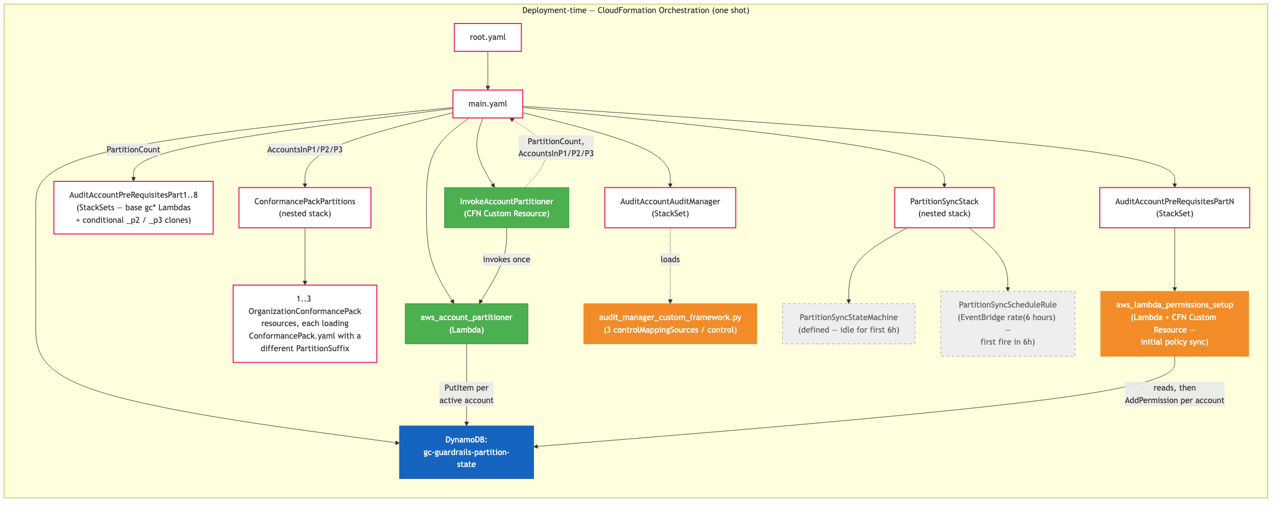
Diagram

Diagram 2 — Post-deployment runtime (Step Function on 6-hour cron)
After deployment, the EventBridge rule fires every 6 hours and starts the PartitionSyncStateMachine. The state machine refreshes the partition state in DynamoDB and — whenever partition membership changed (any account added to or removed from the table) — calls cloudformation:UpdateStack on the root with a bumped InvokeUpdate parameter. That re-runs the InvokeAccountPartitioner Custom Resource (which has InvokeUpdate: !Ref InvokeUpdate as a property), cascading fresh AccountsInP1/P2/P3 into the nested ConformancePack stack and fresh PartitionCount into the Part1-8 StackSets. The state machine polls the root stack until UPDATE_COMPLETE, then invokes the permissions Lambda to bring each clone’s resource-based policy in line with the new DynamoDB state.
Why the choice gates on accountsChanged alone. Every partition- count change is necessarily accompanied by a membership change (the account that opened the new partition, or the removal that collapsed a trailing one), so accountsChanged is sufficient on its own — testing partitionsChanged in the choice would be strictly redundant. accountsChanged also covers the count-stable membership-change case: a new account joining an existing partition with room leaves partitionCount unchanged, but the other partitions’ ExcludedAccounts lists must still be re-rendered so the new account doesn’t simultaneously receive both the P1 pack (because it’s no longer in P1’s exclusion list) and its assigned partition’s pack — that would produce INSUFFICIENT_DATA Config evaluations on the duplicated rules until the next CICD deploy. partitionsChanged is still returned by the partitioner and captured into the Step Function execution history for observability (it lets operators quickly tell a partition-opening run from a routine account-add), but the choice ignores it.
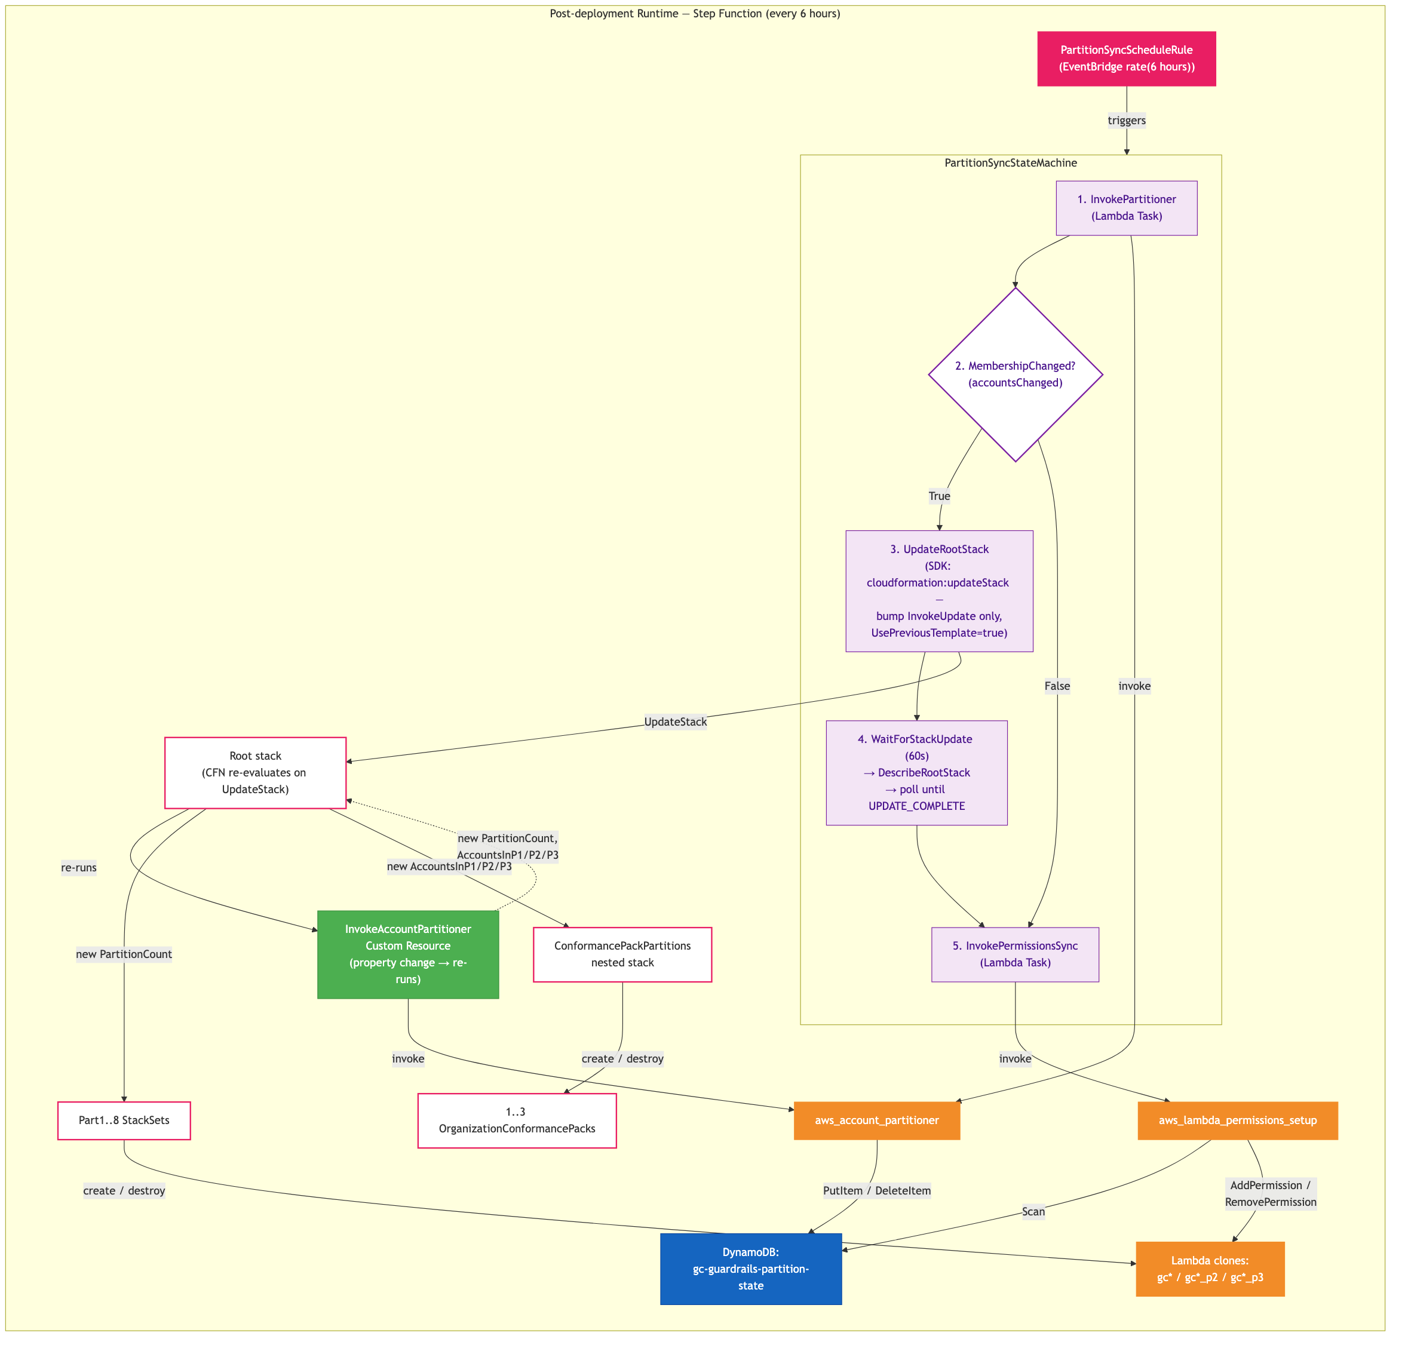
Diagram

Post-Deployment Account Growth Handling
The key requirement is that after initial deployment, when new accounts join the organization, permissions are adjusted automatically without manual redeployment.

Behaviour at Each Scale
Active accounts | Partitions | Packs deployed | Behaviour
1–70 | 1 | …-GC-CP-Guardrails only | Indistinguishable from pre-fix deployment. No ExcludedAccounts. Every account targets base <org>gc* Lambdas.
71–140 | 2 | … + …-P2 | Each pack lists the other partition’s accounts in ExcludedAccounts, so every account receives exactly one pack. P1 accounts target base Lambdas; P2 accounts target _p2 clones.
141–210 | 3 | … + …-P2 + …-P3 | Each pack excludes the union of the other two partitions’ accounts. Three sets of Lambda clones, three packs, every account in exactly one of them.
>210 | — | (failure) | Partitioner raises and the Custom Resource / Step Function step fails. Manual intervention required (raise MaxAccountsPerPartition, MaxPartitions, or both — but mind the CFN 4 KB response cap).
Existing account-to-partition assignments are stable: they are never re-balanced, only new accounts are placed.

Flow by Scenario
Scenario | Step Function Behaviour
No change (steady state) | Partitioner sees no diff vs. DynamoDB. accountsChanged=false (and partitionsChanged=false). UpdateRootStack branch skipped. Permissions Lambda still runs and is a no-op on the resource policies.
New account, partition has room | Partitioner assigns account to a partition that’s still under 70 and writes to DynamoDB. accountsChanged=true (partitionsChanged=false, since count is unchanged), so the UpdateRootStack branch fires. The root-stack update re-renders ConformancePackPartitions with fresh ExcludedAccounts lists for every pack (the new account appears in the OTHER packs’ exclusion lists so it only receives its own partition’s pack). Permissions Lambda then calls AddPermission for the new account on the relevant clone.
New account, all partitions full | Partitioner opens a new partition and writes to DynamoDB. accountsChanged=true (and partitionsChanged=true, logged for observability). UpdateRootStack branch fires; the StackSet update creates the new Lambda clones, the root re-renders ConformancePackPartitions which adds the new ConformancePackP2/P3. Permissions Lambda then adds permissions for all accounts in the new partition.
Account removed/suspended | Partitioner removes the account from DynamoDB. accountsChanged=true (and partitionsChanged=true if the removal empties a trailing partition and drops partitionCount, otherwise partitionsChanged=false). UpdateRootStack branch fires; ConformancePackPartitions re-renders with the removed account stripped from every ExcludedAccounts list. Permissions Lambda calls RemovePermission for the stale account on the relevant clone.
>210 accounts | Partitioner raises and the Custom Resource / Step Function step fails. CloudWatch alarm fires. Manual intervention required.
Step Function step fails | Built-in retry (configurable). Execution history shows exactly which step failed. Next cron in 6h retries from scratch.

Deployment-Time vs. Post-Deployment
Phase | What runs | How
Initial deploy | aws_account_partitioner as CFN Custom Resource → outputs PartitionCount + AccountsInP1/P2/P3 → StackSets and ConformancePackPartitions nested stack consume them → aws_lambda_permissions_setup runs as CFN Custom Resource in PartN | CloudFormation orchestrates everything
Post-deploy (cron) | Step Function: partitioner → (optional StackSet update) → permissions sync | EventBridge → Step Function

Required IAM Permissions

aws_account_partitioner
- Sid: AllowOrganizationsRead
Action:
- "organizations:ListAccounts"
- "organizations:DescribeOrganization"
Resource: "*"
Effect: Allow
- Sid: AllowDynamoDBAccess
Action:
- "dynamodb:PutItem"
- "dynamodb:DeleteItem"
- "dynamodb:Scan"
- "dynamodb:GetItem"
Resource:
- !GetAtt PartitionStateTable.Arn
Effect: Allow

aws_lambda_permissions_setup
- Sid: AllowLambdaPermissions
Action:
- "lambda:AddPermission"
- "lambda:RemovePermission"
- "lambda:GetPolicy"
Resource:
- !Sub "arn:aws:lambda:${AWS::Region}:${AWS::AccountId}:function:${OrganizationName}gc*"
Effect: Allow
- Sid: AllowDynamoDBRead
Action:
- "dynamodb:Scan"
- "dynamodb:GetItem"
Resource:
- !GetAtt PartitionStateTable.Arn
Effect: Allow

Step Function Execution Role
- Sid: AllowInvokeLambdas
Action:
- "lambda:InvokeFunction"
Resource:
- !GetAtt AccountPartitionerLambda.Arn
- !GetAtt LambdaPermissionsLambda.Arn
Effect: Allow
- Sid: AllowStackSetUpdates
Action:
- "cloudformation:UpdateStackSet"
- "cloudformation:DescribeStackSetOperation"
Resource:
- !Sub "arn:aws:cloudformation:${AWS::Region}:${AWS::AccountId}:stackset/*"
Effect: Allow
- Sid: AllowParentStackUpdate
# Needed to re-render the ConformancePackPartitions nested stack
# when AccountsInP1/P2/P3 change.
Action:
- "cloudformation:UpdateStack"
- "cloudformation:DescribeStacks"
- "cloudformation:DescribeStackEvents"
Resource:
- !Sub "arn:aws:cloudformation:${AWS::Region}:${AWS::AccountId}:stack/${AWS::StackName}/*"
Effect: Allow

Testing Plan

Preconditions
- Dev AWS Organization with management-account access plus permission to call organizations:CreateAccount and organizations:CloseAccount. (Closed accounts cannot be reactivated and remain SUSPENDED against the org account quota for ~90 days — size the dev-org quota to ≥ 250 before starting.)
- Starting state: organisation has only a handful (≤ 10) of active accounts, and the DynamoDB table ${OrganizationName}-gc-guardrails-partition-state does not yet exist (the first deploy creates it).

Phase 1 — Initial deployment at 1 partition

T1 — Fresh deploy with empty DynamoDB
Goal: Validate the deployment-time CloudFormation orchestration on a small organisation. Confirms the partitioner Custom Resource, the DynamoDB table creation, the conditional-Lambda-clone logic (none should be created), the single Organization Conformance Pack, the Audit Manager framework, and the initial aws_lambda_permissions_setup Custom Resource all run cleanly. This is also the baseline against which behaviour at ≤ 70 accounts must be “indistinguishable from the pre-fix deployment”.
Preconditions: Org has ~5 active accounts; no prior deployment.
Steps: 1. From the management account, run make deploy. 2. Wait for the root stack to reach CREATE_COMPLETE (~30–60 min due to StackSet propagation). 3. Record the DynamoDB scan output to the scratchpad as the T1 snapshot for later stability comparison.
Success criteria: - DynamoDB table exists with DeletionProtectionEnabled=true, PITR enabled, and one item per active account, all with PartitionId=1. - For every guardrail base Lambda <org>gc*: - Only the base version exists — no _p2 or _p3 clones. - aws lambda get-policy returns one statement per active account ID; policy size is well under 20 KB. - Exactly one AWS::Config::OrganizationConformancePack resource: <org>-GC-CP-Guardrails, with no ExcludedAccounts. - InvokeAccountPartitioner Custom-Resource Data shows: PartitionCount=1, AccountsInP1=<CSV of all active account IDs>, AccountsInP2="", AccountsInP3="". - Audit Manager custom framework deployed; each of the 37 controls has 3 controlMappingSources (gc01_check_root_mfa, …_p2, …_p3); gc01_check_attestation_letter has 1. - PartitionSyncStateMachine exists and the PartitionSyncScheduleRule EventBridge rule is Enabled.

Phase 2 — Post-deployment scale-up (monotonic account creation)
Between every account-creation batch in this phase, either wait for the next 6-hour cron firing of PartitionSyncStateMachine, or start an execution manually (aws stepfunctions start-execution …). Manual triggers are recommended throughout testing to keep wall-clock time down. Expect each scale-up Step Function run that branches into UpdateRootStack to take ~15–30 min (StackSet cascade).

T2 — Grow to 70 accounts (still 1 partition)
Goal: Confirm the partitioner adds new accounts to partition 1 greedily without opening partition 2 while there is still room.
Account op: Create accounts until total active = 70 (+65 vs. T1). Batches of ~10 in parallel are safe.
Steps: 1. Create the new accounts. 2. Manually start the Step Function and wait for Succeeded.
Success criteria: - DynamoDB has exactly 70 items, all PartitionId=1. - Partitioner Step output: partitionCount=1, partitionsChanged=False, accountsChanged=True, AccountsInP1 lists all 70 IDs. - Step Function choice took the MembershipChanged?=True branch and executed UpdateRootStack (because accountsChanged=True). - Still only base Lambdas exist (no _p2/_p3); base Lambda resource policies now list all 70 accounts. - Still one Conformance Pack, still no ExcludedAccounts.

T3 — Add 71st account (cross the 1→2 boundary)
Goal: Validate the boundary at MAX_ACCOUNTS_PER_PARTITION+1. The partitioner must open partition 2 and place the new account there; StackSet update must create the _p2 Lambda clones; nested ConformancePackPartitions must create ConformancePackP2.
Account op: Create 1 account (+1 vs. T2, total = 71).
Steps: 1. Create the 71st account. 2. Manually start the Step Function and wait for Succeeded (allow ~30 min for the cascading StackSet update). 3. Record the 71-account DDB snapshot.
Success criteria: - DynamoDB has 70 items in P1, 1 item in P2. - Partitioner output: partitionCount=2, partitionsChanged=True, accountsChanged=True. - For every guardrail: both <org>gc* and <org>gc*_p2 Lambdas exist. _p3 clones still do not exist. - <org>gc* resource policy lists 70 accounts; <org>gc*_p2 resource policy lists 1 account. - Two Conformance Packs deployed: - <org>-GC-CP-Guardrails with ExcludedAccounts = [<71st account ID>]. - <org>-GC-CP-Guardrails-P2 with ExcludedAccounts = <70 P1 IDs>. - The 71st account receives exactly one pack (P2), the others receive only P1; verify in AWS Config console under the new account’s view.

T4 — Grow to 140 accounts (still 2 partitions, fill P2)
Goal: Confirm new accounts continue filling P2 up to its capacity without opening P3.
Account op: Create 69 accounts (total = 140).
Steps: 1. Create the accounts (batches of ~10). 2. Manually start the Step Function; wait for Succeeded.
Success criteria: - DDB: 70 in P1, 70 in P2. - Partitioner: partitionCount=2, partitionsChanged=False, accountsChanged=True. - Still only base + _p2 clones (no _p3). - Base Lambda resource policy: 70 accounts; _p2 policy: 70 accounts. - Both packs’ ExcludedAccounts lists are exact mirrors of the other partition (70 IDs each).

T5 — Initial deploy at 2 partitions (tear-down + clear DDB + redeploy)
Goal: Validate the initial-deploy code path at the 2-partition scale, exercising the partitioner Custom Resource on a clean DDB with 140 active accounts. This is the only opportunity to test this path without further account churn.
Account op: None.
Steps: 1. Disable DDB deletion protection, delete the partition-state table (see “Note on clear DDB steps” above). 2. aws cloudformation delete-stack --stack-name <root-stack> and wait for DELETE_COMPLETE. (The Audit Manager framework and any AWS Config recorders are removed too — expected.) 3. make deploy from a clean checkout. 4. Wait for CREATE_COMPLETE.
Success criteria: - New DDB table created, 140 items, 70 in P1, 70 in P2. - Partitioner Custom-Resource succeeds; Data includes both AccountsInP1 and AccountsInP2, AccountsInP3="". - Base Lambdas + _p2 clones created; no _p3. - Two Conformance Packs deployed with correct ExcludedAccounts. - Audit Manager framework redeployed with 3 mapping sources per control. - No lambda:PolicyLengthExceededException in any Lambda invocation log (each clone’s policy holds at most 70 accounts).

T6 — Add 141st account (cross the 2→3 boundary)
Goal: Boundary test for opening partition 3.
Account op: Create 1 account (total = 141).
Steps: Create the account, manually start the Step Function, wait for Succeeded.
Success criteria: - DDB: 70 in P1, 70 in P2, 1 in P3. - Partitioner: partitionCount=3, partitionsChanged=True, accountsChanged=True. - Base + _p2 + _p3 clones all exist for every guardrail. - <org>gc*_p3 resource policy lists exactly 1 account. - Three Conformance Packs deployed; each one’s ExcludedAccounts is the union of the other two partitions’ members.

T7 — Grow to 200 accounts (4 KB CFN cap during update path)
Goal: Stress-test the partitioner Custom Resource at near-maximum load over the Step Function’s UpdateRootStack update path. Confirms the combined AccountsInP1/P2/P3 payload fits under the 4096-byte CloudFormation Custom-Resource response cap.
Account op: Create 59 accounts (total = 200). Recommend doing this in one large batch and triggering the Step Function once afterward, rather than after every account, to compress the ~30 min update cascade into a single execution.
Steps: 1. Create the accounts. 2. Manually start the Step Function; wait for Succeeded. 3. Open the root stack → InvokeAccountPartitioner → Data and measure the JSON response size (or check the partitioner’s CloudWatch logs for the line where it logs the response body).
Success criteria: - DDB: 70 in P1, 70 in P2, 60 in P3. - Partitioner Custom-Resource response body < 4096 bytes. (210 accounts × ~14 B + envelope ≈ 3.4 KB headroom; 200 accounts is well within this.) - All three sets of clones exist; resource-policy sizes for each clone remain well under 20 KB. - All 200 accounts are covered by exactly one of the three packs.

T8 — Account-stability spot check (no account ops)
Goal: Verify that across T1 → T7, the partitioner never re-balanced existing assignments — only placed new accounts.
Steps: 1. Take a fresh DDB scan. 2. Diff the T1 snapshot account IDs against the current DDB — every T1 account ID must still appear with PartitionId=1. 3. Diff the T3 snapshot (the original 71st account) — must still appear with PartitionId=2.
Success criteria: - 100 % of the T1 accounts have the same PartitionId=1 they were first assigned. - The T3 boundary-account is still in PartitionId=2.

Phase 3 — Redeploy validation at 3 partitions (no account changes)

T9 — Tear-down + redeploy with DynamoDB retained
Goal: Validate DeletionPolicy: Retain on the partition-state table — a delete-stack must leave the DDB items intact, and a subsequent make deploy must preserve every prior assignment.
Account op: None.
Steps: 1. Record the current DDB scan as the pre-T9 snapshot. 2. delete-stack the root; wait for DELETE_COMPLETE. Do not touch the DDB table. 3. make deploy; wait for CREATE_COMPLETE. 4. Re-scan DDB.
Success criteria: - The post-redeploy DDB scan is bit-for-bit identical to the pre-T9 snapshot (same account → partition mapping). - Partitioner Custom-Resource output reports accountsChanged=False and partitionsChanged=False (the existing assignments matched the live org list). - No Lambda resource-policy churn (the permissions Lambda finds every account already permitted on the correct clone). - All three packs come back with the same ExcludedAccounts they had before tear-down.

T10 — Tear-down + clear DDB + redeploy at 200 (initial deploy at 3 partitions)
Goal: Validate the initial-deploy code path at maximum scale — specifically the 4 KB Custom-Resource response cap during the first run of the partitioner, when the response cannot be incremental.
Account op: None.
Steps: 1. Clear the DDB table (per “Note on clear DDB steps”). 2. delete-stack the root; wait for DELETE_COMPLETE. 3. make deploy; wait for CREATE_COMPLETE. 4. Record the new DDB scan as the post-T10 snapshot.
Success criteria: - All criteria from T1 + T6 + T7 hold. - Partitioner Custom-Resource response body < 4096 bytes on this fresh deploy (the most critical instance of this test — a failure here would block deployment entirely, with no Step Function safety net yet running). - The new assignment is greedy/dense (P1=70, P2=70, P3=60) but the specific account → partition mapping may differ from the pre-T9 snapshot — that is expected after a clear-DDB.

Phase 4 — Post-deployment scale-down (monotonic account closures)
Pick the accounts to close from the post-T10 DDB snapshot so the test exercises a specific partition. Use:
aws dynamodb scan --table-name <org>-gc-guardrails-partition-state \
--filter-expression "PartitionId = :p" \
--expression-attribute-values '{":p":{"N":"1"}}' \
--projection-expression AccountId \
--output text | awk '{print $2}'
CloseAccount is irreversible and the account stays SUSPENDED against the org quota for ~90 days. Sanity-check the list before closing.

T11 — Steady-state no-op (no ops at all)
Goal: Confirm that a Step Function run with no account changes since the previous partitioner run skips the UpdateRootStack branch entirely, and that the permissions Lambda is a no-op.
Account op: None.
Steps: 1. Immediately after T10 (DDB matches the org), manually start the Step Function. 2. Inspect the execution graph.
Success criteria: - Partitioner step output: accountsChanged=False, partitionsChanged=False. - The choice state takes the False branch — UpdateRootStack, WaitForStackUpdate, DescribeRootStack, StackUpdateComplete? states are all skipped. - InvokePermissionsSync runs and logs zero AddPermission / RemovePermission calls. - Execution duration < 30 s.

T12 — Empty non-trailing partition P1 (partitionCount stays at 3)
Goal: Validate the non-trailing emptying rule — a non-trailing empty partition does not collapse partitionCount; the “hole” is preserved so existing P2/P3 accounts keep their assignments.
Account op: Close all 70 accounts in P1 (use the projection above to get the list). Total active: 200 → 130.
Steps: 1. aws organizations close-account --account-id <id> for each P1 member. Wait ~1–2 min for Status='SUSPENDED' to propagate across all of them. 2. Confirm list-accounts --query "Accounts[?Status=='ACTIVE'].Id" returns exactly 130 IDs. 3. Manually start the Step Function; wait for Succeeded.
Success criteria: - DDB: 0 items with PartitionId=1, 70 with PartitionId=2, 60 with PartitionId=3. Total items: 130. - Partitioner output: partitionCount=3 (unchanged because P3 is still occupied), partitionsChanged=False, accountsChanged=True. - All three sets of Lambda clones still exist (the StackSet is not asked to destroy any clones because PartitionCount did not change). - <org>gc* (base/P1) resource policy is now empty (or holds only the AddPermission sids that were never removed — verify the permissions Lambda issued RemovePermission for all 70). - All three Conformance Packs are still deployed. - <org>-GC-CP-Guardrails (P1) has no live targets but is not deleted — ConformancePackP1’s HasAccountsInP1 condition is based on AccountsInP1 being non-empty; with AccountsInP1="" the pack is destroyed. (Either outcome is acceptable as long as no account is multi-targeted; verify by spot-checking a P2 and a P3 account in the Config console — each should still show exactly one pack.) - The T7-recorded P2 and P3 account IDs still have their original PartitionId (stability across the scale-down).

T13 — Empty trailing partition P3 (collapse partitionCount to 2)
Goal: Validate the trailing collapse rule — when the highest-numbered partition empties, partitionCount drops to the new highest occupied partition.
Account op: Close all 60 accounts in P3. Total active: 130 → 70.
Steps: 1. Close each P3 account (close-account). 2. Wait for SUSPENDED propagation; confirm 70 active accounts. 3. Manually start the Step Function; wait for Succeeded.
Success criteria: - DDB: 0 items in P1, 70 in P2, 0 items with PartitionId=3. Total items: 70. - Partitioner output: partitionCount=2 (collapsed from 3 because P3 was trailing), partitionsChanged=True, accountsChanged=True. - StackSet update destroys every <org>gc*_p3 Lambda clone. - ConformancePackP3 is destroyed by the nested-stack update. - <org>gc*_p2 resource policy still lists its 70 P2 accounts — unchanged by the trailing collapse. - P2 account → partition mapping is unchanged (stability).

Phase 5 — Final validation (initial deploy at 1 partition, re-densing)

T14 — Tear-down + clear DDB + redeploy at 70 accounts
Goal: Re-validate the 1-partition initial-deploy path with a moderate (not tiny) account count, and confirm that a clear-DDB redeploy re-denses the previously-sparse P1/P2/P3 layout back into a dense P1.
Account op: None.
Steps: 1. Clear the DDB table. 2. delete-stack the root; wait for DELETE_COMPLETE. 3. make deploy; wait for CREATE_COMPLETE.
Success criteria: - DDB has exactly 70 items, all PartitionId=1 (re-densed — the previously-empty “P1 hole” from T12 has been backfilled by the partitioner reassigning from scratch). - Only base <org>gc* Lambdas exist; no _p2 or _p3 clones. - Only one Conformance Pack: <org>-GC-CP-Guardrails, no ExcludedAccounts. - Steady-state behaviour from this point is **indistinguishable from

