COMITE TODO:----------------------------------------------------
I guess the AT manual offers the pack i already showed you (which is fine, except for the ipod thing, because i find them really difficult to deal with. Maybe is not even an iPod but my sañña decided it was a painful device):


​It so happened that in the last course there was a chinese student (for discourses and instructions) using the wireless headphones, but the headphones themselves are not a complete solution. So i had to use my own smartphone connected to the wireless headphones dock. Right after that i asked Vaibhav to buy a smartphone only for this pourpose​ (3rd foreign language instructions), label it on the back of the phone with proper instructions, and write an "easy as an IKEA instructions leaflet" protocol and leave it hunging on both AT appartments.
​I guess it is time to write same protocol for whatever backup system we decide to stay with (if not yet existing). Maybe someone else has more to add..
The above pack is 100%autonomous since speakers and ipod have their own bateries.
If everybody is fine with the iPod, we leave and just render a protocol about it (IT comitte will do it).
And apologizes for not having realized about the lack of this solution.
----------------------------------------------------

When we put the stick into our PC it appeared.....since then I have noticed, if you put the USB into the Denon, then go to D0 in the folder, Anapana comes up, then going forward, there is no Tiki!
Going back - there it is! So this we maybe need to mention also to avoid panick attacks on D0!

​Now that you mention i remember i got a little bit caught out​

​by this phenomenon .. Maybe is related with the folder naming/structure.. i will ask Vaibh or Fred to take a look a it
SPG TODO ----------------------
Cursos disponibles (as Register)
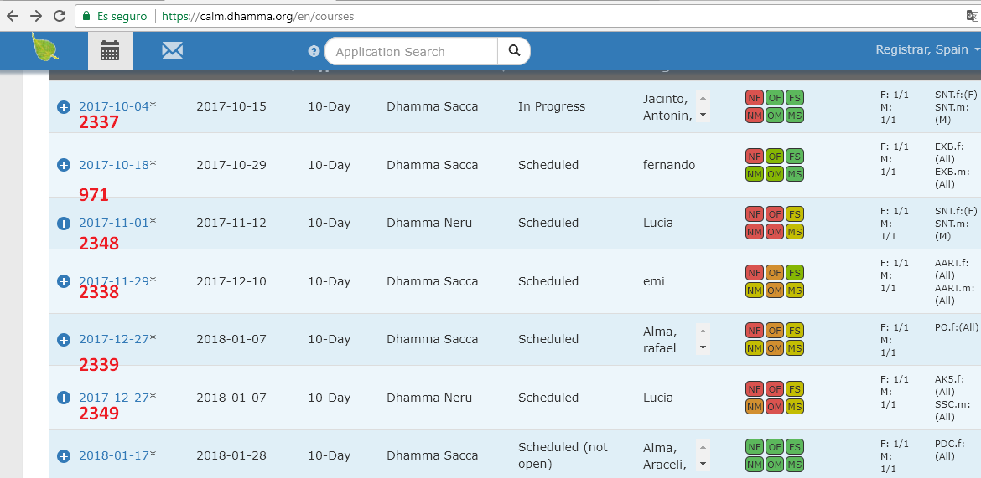
+ajustar css de Print
+algoritmo de ordenacion (primero SIT, despues SERVED, despues LONG_COURSES) ¿como saber long courses?
+poner texto "alt" en nombre y apellidos para poder seguir viendolo en caso de word-wrap:break-all

+Añadir info (dentro de la zona printable) numero de old, num new, num total, genero, nombre centro, fechas (lo que hiciste y eliminaste por que dejo de funcionar la tabla principal :)

+a la hora de SAVE, incluir en "A1".generated_hall_position el numero de columnas (para male y para female). DONE! (comprobar que funciona!)

+pedir que activen el endpoint en el servidor *produccion*
//Endpoint url is NOT this: "https://test.calm.dhamma.org/es/courses/119/course_applications/assign_generated_hall_positions"
//but this "https://test.calm.dhamma.org/es/course/119/course_applications/assign_generated_hall_positions", so lets remove the 's' from 'courses'

+Ubicación del botón:
Ahora document.getElementById("course-applications-datatable_filter").appendChild(btnSPG);
Ryan propuso: $("#seating-plan-generator-btn-placeholder").data('label')

+Solicitar el campo "hall_position" para mostrarlo en tooltip
Expllicacion de por que tenemos dos campos:
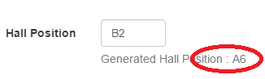

I think I have to answer that question as it was my decision. reasons are:
1: Hall Position is used on production for free text for things like "Chair", "backrest or wall" as can be seen in the database for 59 course applications:

2.3.0 :002 > CourseApplication.where.not(hall_position: [nil, ""]).pluck(:hall_position)
=> ["Chair", "chair", "Chair", "Chair", "backrest or wall", "chair", "chair", "low chair", "A10", "chair", "chair + cushions", "BR", "Chair", "chair", "BR", "backrest or wall", "back-rest", "chair", "BR, side", "chair", "side", "A1", "back-rest", "LCS", "BR", "Chair", "Chair?", "close to wall", "Requires a smaller dorm, less noisy place", "Request for a room with fewer people", "1", "back support", "Chair", "BR", "chair", "A1", "Chair", "chair?", "back support", "BR", "chair", "chair", "Chair", "BR", "LCS", "Back wall", "Chair", "chair", "back rest", "Chair", "wall", "chair next to cushion", "chair", "chair", "Pregnant", "Chair", "chair", "chair", "chair"]
so if sergio's app overwrites that then data is lost.
2: if we use the Hall Position field for the SPG, then it will be set automatically by the SPG after AT has done the hall layout. But this field is still an editable text field. A Calm4 user might think that they can edit it without consequence. e.g. they might login and change B2 to B1 thinking they have done the right thing, but now there would be 2 B1's and the SPG layout would be mixed up.

That is why I created a dedicated field for the SPG, called generated_hall_position and when that field has some data in it then it shows as Generated Hall Position A6 and it does not affect the Hall Position field.

