1. As of 2022, there are 63 national parks. The most recent national park added to the system was **New River Gorge National Park in West Virginia.**

**New Mexico's White Sands National Park hit the big leagues in December 2019**, becoming the country's 62nd national park.

Beyond just the national parks, the National Park Service manages 423 areas covering more than 85 million acres. **Each state has at least one park**, or “unit”, plus parks in Washington D.C., American Samoa, Puerto Rico, and the Virgin Islands!

In total, the National Park System (NPS) encompasses 423 national park sites in the United States.

关于国家公园的数量问题，现在有的数据是2016年以前的61个国家公园的游客数据。在2019年和2022年，**White Sands National Park和New River Gorge National Park分别成为了第62，第63个国家公园，**我们是否需要考虑这两个呢？

在数据集中的其他title不是National Park的sites是否要研究呢？

2.

NPS data portal: <https://public-nps.opendata.arcgis.com/>

Park Boundary data:

<https://irma.nps.gov/DataStore/Reference/Profile/2224545?lnv=True>

US National Parks Visitation 1904-2016: <https://data.world/datasets/national-parks>

A website of online maps of Nation Parks:

<https://nps.maps.arcgis.com/apps/webappviewer/index.html?id=43bc9db4736140e88e661c67460936e6>

3.

US county shapefile data: <https://www.census.gov/geographies/mapping-files/time-series/geo/carto-boundary-file.html>

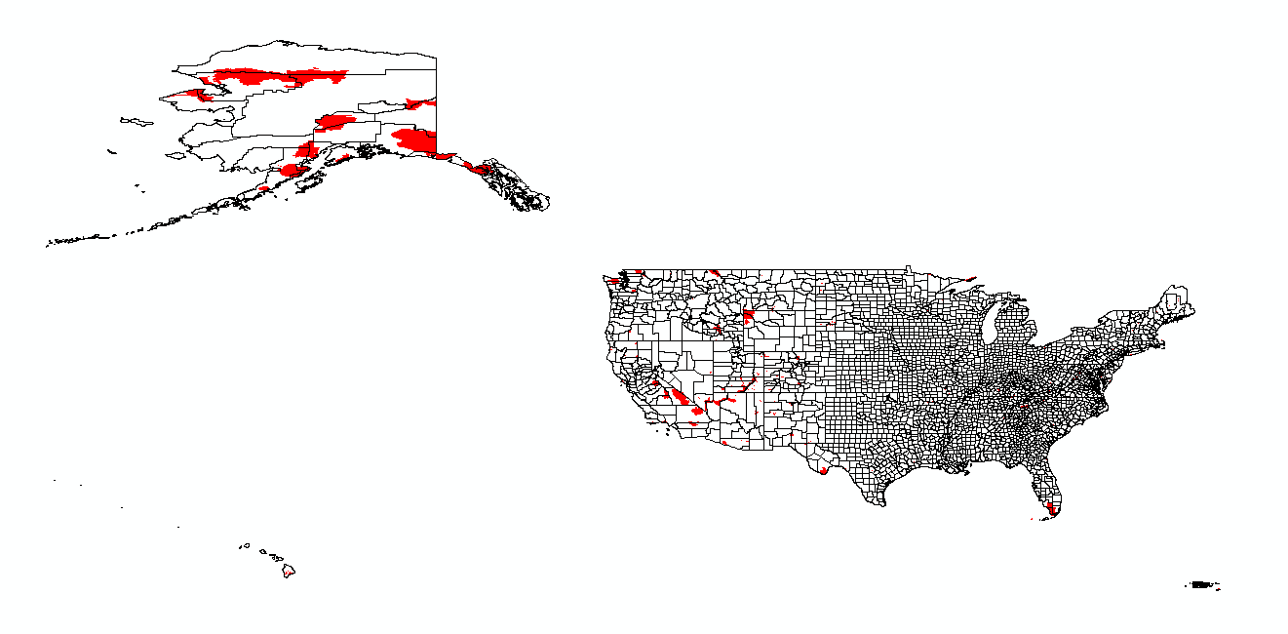

4. Twitter API data: 待补充

5. Airbnb reviews data around these National Parks 待补充，目前的数据难点

One possible site: <http://insideairbnb.com/get-the-data.html> 但是没有很多城市，只有一些大城市的数据

(<https://mp.weixin.qq.com/s/wngytBOuMr3OcGUQfunmJw>)

现在Airbnb的API情况是不对外开放的，这部分的空缺寄希望于用OSM的hotel之类的数据弥补。

6. restaurant data

OSM probably

7. census related data

easy to access