Step 1: Download Putty from <http://www.putty.org/>

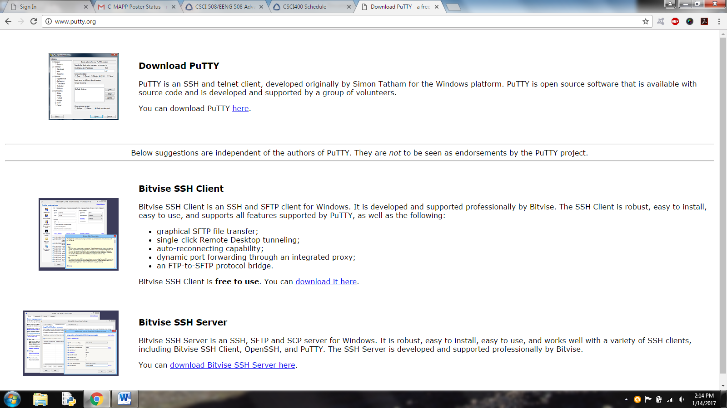

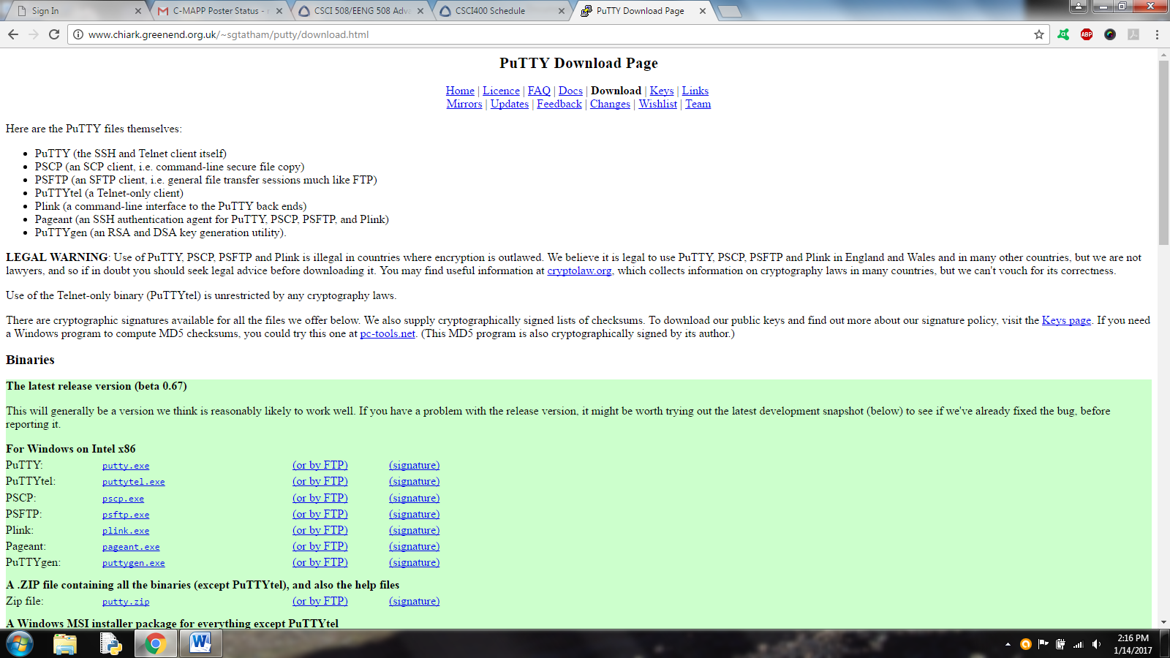

Run the putty executable that you just downloaded.

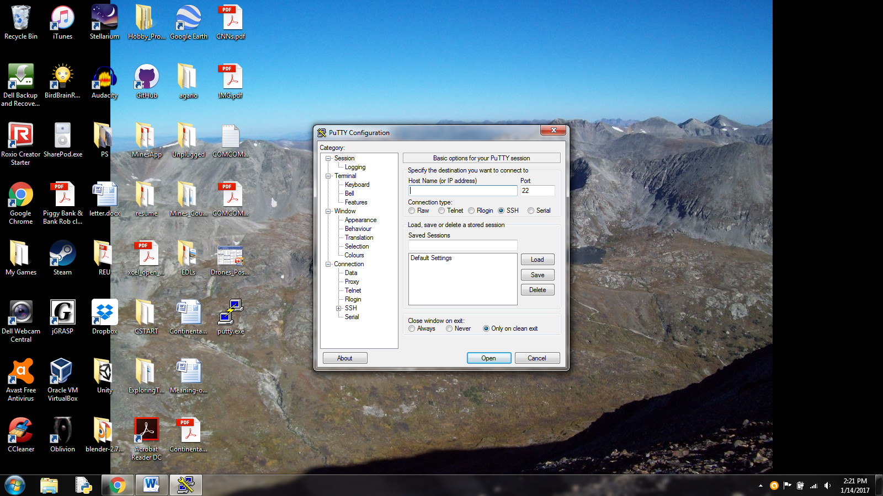

Type “imagine.mines.edu” into the Host Name box and click Open

Login with your mines multipass username and password.

Then you can use ssh to get a remote shell on a lab computer.

For the lab we hold lecture in (Green Center 297), the lab computers are named gc297-xx.mines.edu

For the Alamode Lab (Brown Building 136), the lab computers are named bb136-xx.mines.edu

where the xx is computer number of the physical machine you want to connect to. The digits you use for the xx aren't super important - **just pick one that is somewhere on the range of 01 to 20 or so**. If it's not working, pick a new number and try again (the machine you are trying to connect to may be physically turned off).

For example, if you are currently running a shell on either imagine.mines.edu or from a machine connected to the Campus network, and you need to get a shell on the Lecture Lab Machines, then you can run this command:

ssh gc297-12.mines.edu