Project 1 NanoPitch Summary - Brady Chase
Top model: vdr_focus_gru96_ft80, checkpoint epoch 127, loss 0.02686, GRU size 96, condition size 64, learning rate 1e-4. Submitted to the class leaderboard as submissions/brady_chase/weights.pth.
Overview / Strategy  - Goal: improve NanoPitch's real-time singing pitch tracker under noisy test conditions while keeping the model deployable in the browser.  - Strategy: train on realistic noisy log-mel mixtures, tighten voiced-frame learning, and fine-tune the same small GRU-96 architecture instead of making the model too large for realtime use.  Modifications  - Implemented random-SNR log-mel noise augmentation with torch.logaddexp.  - Added f0/VAD/union voicing target options, boundary weighting, positive/focal VAD weighting, and voiced balanced sampling.  - Added cosine scheduling support, gradient-norm logging, improved evaluator options, and exported the best weights for web/leaderboard use. | Rationale  - Noise mixing matched the leaderboard SNRs better than clean-only training.  - F0-aware voicing and boundary weights focused learning on the frames that most affect VDR/RPA near onsets, offsets, and noisy voiced regions.  - Longer low-LR fine-tuning improved pitch accuracy without increasing inference cost.  Impact on Performance  - Realtime macro RPA improved from 90.2% baseline to 94.0%.  - Noisy -5 dB RPA improved from 88.0% to 93.5%; clean RPA improved from 94.8% to 97.3%.  - Macro gross error dropped from 9.8% to 6.0%. Tradeoff: official VAD accuracy dropped from 87.1% to 81.1% because the run emphasized pitch/voicing accuracy.
Baseline vs. Best Model
Model | Realtime Macro RPA | Clean RPA | -5 dB RPA | Macro Gross Err | Macro VAD Acc
Class default baseline | 90.2% | 94.8% | 88.0% | 9.8% | 87.1%
Brady best run | 94.0% | 97.3% | 93.5% | 6.0% | 81.1%
Repo Link
- GitHub repo: https://github.com/Festus-Ewakaa-Kahunla/NanoPitch/tree/Brady_dev
- Leaderboard submission branch: https://github.com/illusion3333/NanoPitch/tree/brady-chase-best-run
Screenshots
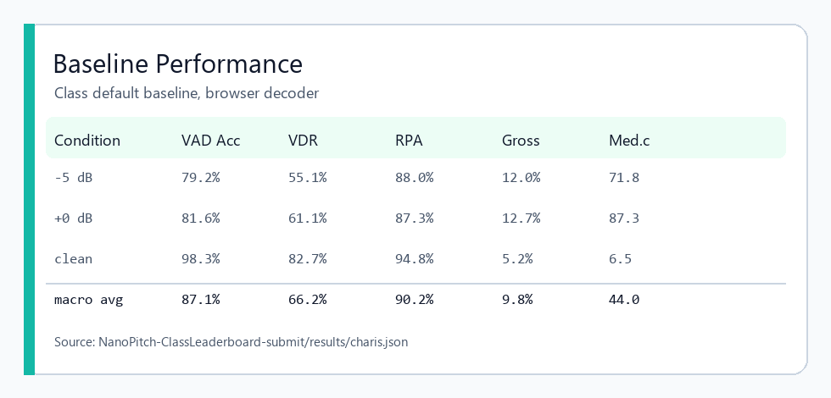  Baseline performance from class default baseline result JSON. | 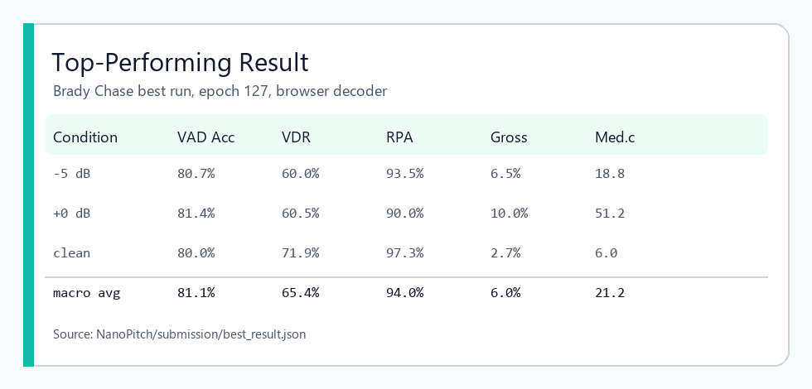  Top-performing submitted model evaluated with realtime Viterbi.

