SENTINEL
Passive RF Drone Detection System
2.4 GHz | Dual-Channel SDR | Directional Bearing Estimation

Senior Design Progress Report
MET 422 — Senior Design Project II, Section 001

Team Members:
Sean Schumacher
[Team Member 2]
[Team Member 3]
[Team Member 4]

Advisor(s):
[Advisor Name]

Spring 2026

Abstract
SENTINEL is a passive radio frequency (RF) drone detection system designed to detect, identify, and localize consumer unmanned aerial systems (UAS) operating in the 2.4 GHz ISM band. Unlike active radar systems that emit detectable energy, SENTINEL operates in a completely passive mode, receiving only the RF emissions generated by drones during normal flight operations. The system employs a dual-channel software-defined radio (SDR) architecture built around the Ettus Research USRP B210, which provides simultaneous MIMO reception at 30.72 MSPS per channel. An omnidirectional antenna on the first receive channel serves as an energy tripwire, detecting the presence of new RF activity in the band, while a high-gain Yagi directional antenna on the second channel performs precision detection via Cell-Averaging Constant False Alarm Rate (CA-CFAR) processing and provides bearing estimation through angle-of-arrival (AoA) measurements.
The signal processing pipeline is implemented in Python using an asynchronous architecture, performing real-time Power Spectral Density (PSD) estimation via Welch’s method, adaptive noise floor tracking, and protocol-specific packet decoding for FAA Remote ID (ASTM F3411) and DJI DroneID broadcasts. Link budget analysis demonstrates a theoretical detection margin exceeding 47 dB at the target range of 200 yards (183 m) for DJI OcuSync transmissions, confirming the feasibility of the design. Phase 1 development has been completed, delivering a fully operational detection pipeline with synthetic signal validation, a comprehensive unit test suite, and a configurable system architecture. Preliminary results indicate reliable detection of synthetic drone signals with signal-to-noise ratios above 10 dB and false positive rates below one event per ten minutes of continuous monitoring.

1. Introduction

1.1 Background
The proliferation of consumer drones has created significant security, privacy, and safety concerns across commercial, governmental, and residential domains. The Federal Aviation Administration (FAA) reported over 1.1 million registered drones in the United States as of 2025, with incidents involving unauthorized drone flights near airports, critical infrastructure, and public events increasing year over year. Existing counter-drone solutions typically rely on active radar systems, which are expensive ($50,000+), emit detectable RF energy, and require regulatory approval to operate. There is a clear need for a low-cost, passive detection system that can identify drone presence without revealing its own position.

1.2 Stakeholders and Needs
The primary stakeholders for SENTINEL include facility security managers, law enforcement agencies, event security coordinators, and critical infrastructure operators. These stakeholders require a system that can detect unauthorized drones at ranges sufficient to provide actionable warning time (200+ yards), identify the drone type and operator position when available, and operate continuously without generating interference. Additionally, the system must be affordable enough for widespread deployment and simple enough for operation by non-RF-specialist personnel.

1.3 Problem Statement
Design and implement a passive RF drone detection system capable of detecting, classifying, and estimating the bearing of consumer drones operating at 2.4 GHz, achieving a minimum detection range of 200 yards in open-sky conditions, bearing accuracy of ±5° at 100 meters, false positive rate below one per ten minutes, and detection latency under two seconds. The system must operate without transmitting any RF energy and must be constructable within a senior design project budget.

1.4 Project Objectives
- Develop a dual-channel SDR receiver architecture using the USRP B210 for simultaneous omnidirectional and directional reception at 2.4 GHz.
- Implement real-time signal processing algorithms including Welch PSD estimation, adaptive energy detection, and CA-CFAR threshold detection.
- Integrate protocol-specific decoders for FAA Remote ID (ASTM F3411) and DJI DroneID to extract drone identity and position data.
- Design a mechanically steered directional antenna system with automated scan, cue, and track modes for bearing estimation.
- Validate system performance against quantitative pass criteria through bench testing and field trials.

2. System Design and Specifications

2.1 System Overview
SENTINEL employs a layered detection architecture organized around a dual-channel software-defined radio. The system receives drone RF emissions through two antenna paths: an omnidirectional channel provides 360-degree awareness and acts as an energy tripwire, while a mechanically steered directional Yagi antenna provides gain, bearing context, and precision detection through CA-CFAR processing. Both channels feed into a USRP B210 SDR, which digitizes the signals at 30.72 MSPS per channel and streams IQ data to a host computer via USB 3.0. The host runs the Python-based DSP pipeline in an asynchronous architecture, performing detection, classification, and antenna control in real time.
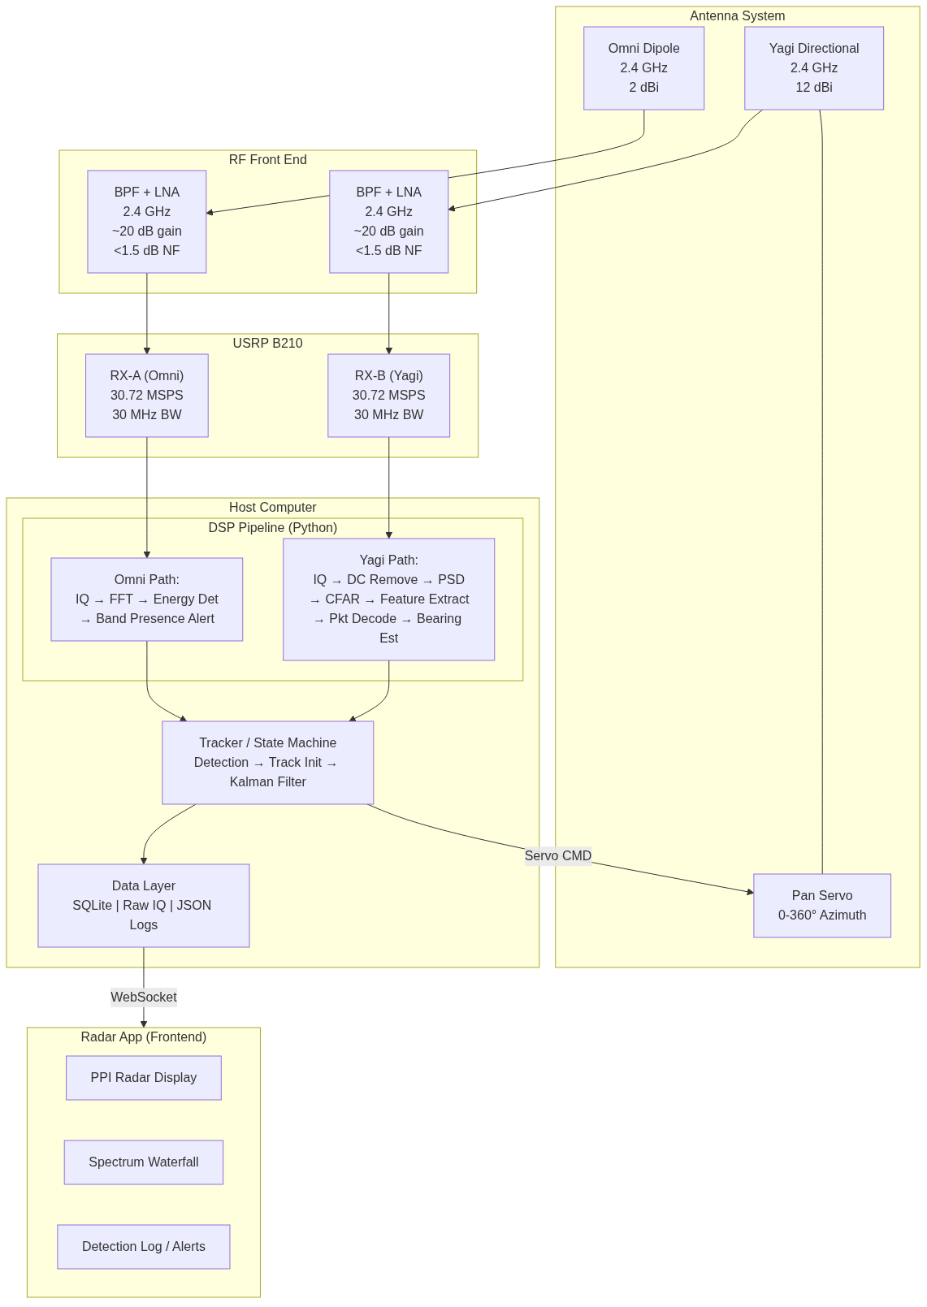
Figure 1: SENTINEL system architecture showing the dual-channel receive path from antennas through the RF front end, SDR, DSP pipeline, and user interface.

2.2 Function Decomposition
The system is decomposed into five primary functional subsystems: RF signal reception, signal processing, detection and classification, tracking and antenna control, and user interface and data logging. Each subsystem is implemented as an independent Python module with well-defined interfaces, enabling unit testing and incremental development.
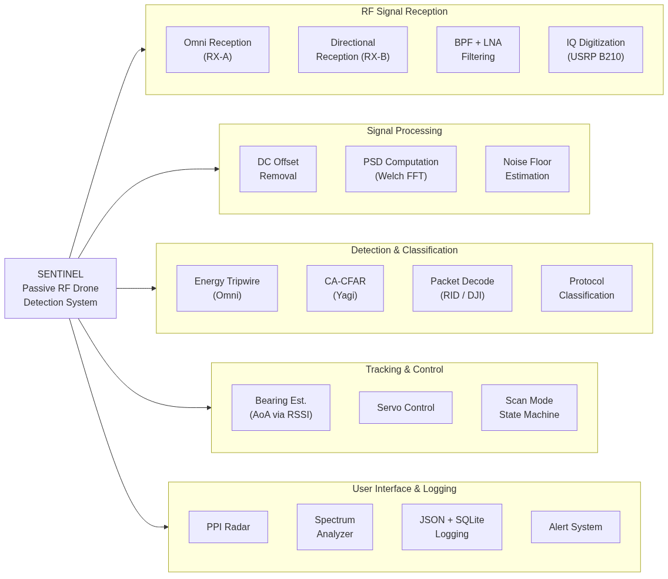
Figure 4: System function decomposition tree showing the five primary subsystems and their constituent functions.

2.3 Target Signal Specifications
Table 1 summarizes the key RF characteristics of the target drone protocols operating in the 2.4 GHz ISM band.
Protocol | Frequency | Bandwidth | EIRP | Key Characteristic
DJI OcuSync 2/3 | 2.4 GHz | ~10 MHz | +23 dBm | OFDM, FHSS, DroneID every 600ms
WiFi (802.11) | 2.4 GHz | 20/40 MHz | +20 dBm | Beacon frames, OUI identification
FAA Remote ID | 2.437 GHz | 20 MHz | +20 dBm | WiFi beacon, 1 sec interval
ExpressLRS | 2.4 GHz | ~500 kHz | +27 dBm | LoRa chirp, fast FHSS
FrSky ACCST | 2.4 GHz | ~1 MHz | +20 dBm | 47-channel FHSS, 9ms dwell
Table 1: Target drone protocol specifications at 2.4 GHz.

2.4 Hardware Specifications

2.4.1 USRP B210 Software-Defined Radio
The Ettus Research USRP B210 serves as the primary SDR platform. It features an Analog Devices AD9361 RFIC providing two fully coherent MIMO receive channels covering 70 MHz to 6 GHz. In MIMO mode, each channel supports 30.72 MSPS with 30 MHz instantaneous bandwidth, digitized at 12-bit resolution. The device connects to the host computer via USB 3.0 and is controlled through the UHD (USRP Hardware Driver) Python API.
Parameter | Value
RFIC | Analog Devices AD9361
RX Channels | 2 (simultaneous MIMO)
Frequency Range | 70 MHz – 6 GHz
MIMO Bandwidth | 30.72 MHz per channel (30.72 MSPS)
ADC Resolution | 12-bit
Interface | USB 3.0 SuperSpeed
Noise Figure | < 8 dB (internal, no external LNA)
Max RX Input | -15 dBm
Table 2: USRP B210 key specifications.

2.4.2 Antenna System
The antenna subsystem consists of a 12-element Yagi-Uda directional antenna (12 dBi gain, approximately 35° 3 dB beamwidth) mounted on a servo-driven pan mechanism for 360° azimuth rotation, and a fixed vertical dipole omnidirectional antenna (2 dBi gain) for all-around presence detection. Both antennas operate at 2.4 GHz. The Yagi is currently a PCB Yagi (ASIN B0BWM9X2HJ) for testing, with a planned upgrade to the L-com HG2415Y-RSP (15 dBi, 30° beamwidth) for the final system.

2.4.3 RF Front End
An external bandpass filter and low-noise amplifier (BPF+LNA) module is placed between each antenna and the B210 receive port. The LNA provides approximately 20 dB of gain with a noise figure below 1.5 dB, which dramatically improves the system noise figure from 8 dB (B210 alone) to approximately 1.57 dB (cascaded). The BPF limits the passband to 2.400–2.500 GHz, providing greater than 40 dB rejection of out-of-band signals to prevent intermodulation and ADC saturation from strong nearby transmitters.

3. Concept Generation and Selection

3.1 SDR Platform Selection
Three SDR platforms were evaluated for the SENTINEL receiver: the Ettus USRP B210, the HackRF One, and the RTL-SDR V3. The primary selection criteria were simultaneous dual-channel MIMO capability (required for the dual-antenna architecture), instantaneous bandwidth (minimum 20 MHz for WiFi capture), dynamic range (sufficient for crowded 2.4 GHz environment), and software ecosystem maturity.
Criterion | Weight | USRP B210 | HackRF One | RTL-SDR V3
Dual-channel MIMO | 5 | + (native) | - (single) | - (single)
Bandwidth (MIMO) | 4 | + (30 MHz) | S (20 MHz) | - (2.4 MHz)
Dynamic Range | 4 | + (12-bit) | S (8-bit) | S (8-bit)
Software Ecosystem | 3 | + (UHD) | S | S
Cost | 2 | - ($1,500) | + ($300) | + ($30)
TOTAL (weighted) |  | +14 (Selected) | -2 | -8
Table 3: SDR platform Pugh selection matrix. Scoring: + (better than baseline), S (same), - (worse).
The USRP B210 was selected despite its higher cost because it is the only platform offering native dual-channel MIMO, which is fundamental to the simultaneous omni-tripwire and yagi-precision detection architecture.

3.2 Detection Algorithm Selection
Two detection approaches were evaluated for the directional channel: fixed-threshold energy detection and Cell-Averaging CFAR (CA-CFAR). Fixed-threshold detection is simpler but fails in dynamic RF environments where the noise floor changes due to nearby WiFi traffic and environmental conditions. CA-CFAR adapts its threshold based on the local spectral environment, maintaining a constant false alarm probability regardless of background noise variations. CA-CFAR was selected for the Yagi channel due to its robustness in the crowded 2.4 GHz ISM band, with a simpler adaptive energy detector retained for the omnidirectional tripwire channel where coarse presence detection is sufficient.

3.3 Antenna Configuration Selection
Three antenna configurations were considered: (1) single omnidirectional antenna, (2) fixed multi-element phased array, and (3) mechanically steered directional antenna with omnidirectional supplemental. Option 1 provides no bearing information. Option 2 offers electronic beam steering but adds significant cost and complexity (multiple synchronized SDR channels, calibration requirements). Option 3 provides bearing estimation with a single directional antenna, supplemented by the omni for all-around cueing. The mechanically steered Yagi with omnidirectional supplemental was selected as the best tradeoff between performance, cost, and implementation complexity for a senior design project scope.
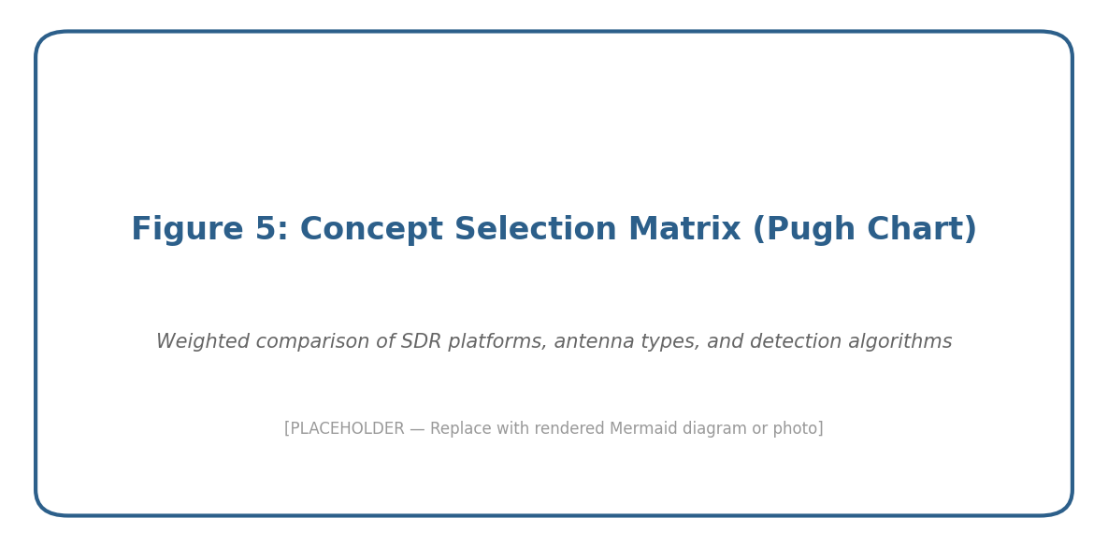
Figure 5: Concept selection summary. The dual-antenna mechanically steered architecture was chosen for optimal performance within project constraints.

4. Detailed Design

4.1 Signal Processing Pipeline
The DSP pipeline processes IQ samples from both receive channels through a series of stages, from raw sample ingestion through detection, classification, and bearing estimation. The pipeline operates asynchronously using Python’s asyncio framework, ensuring that hardware I/O does not block signal processing.
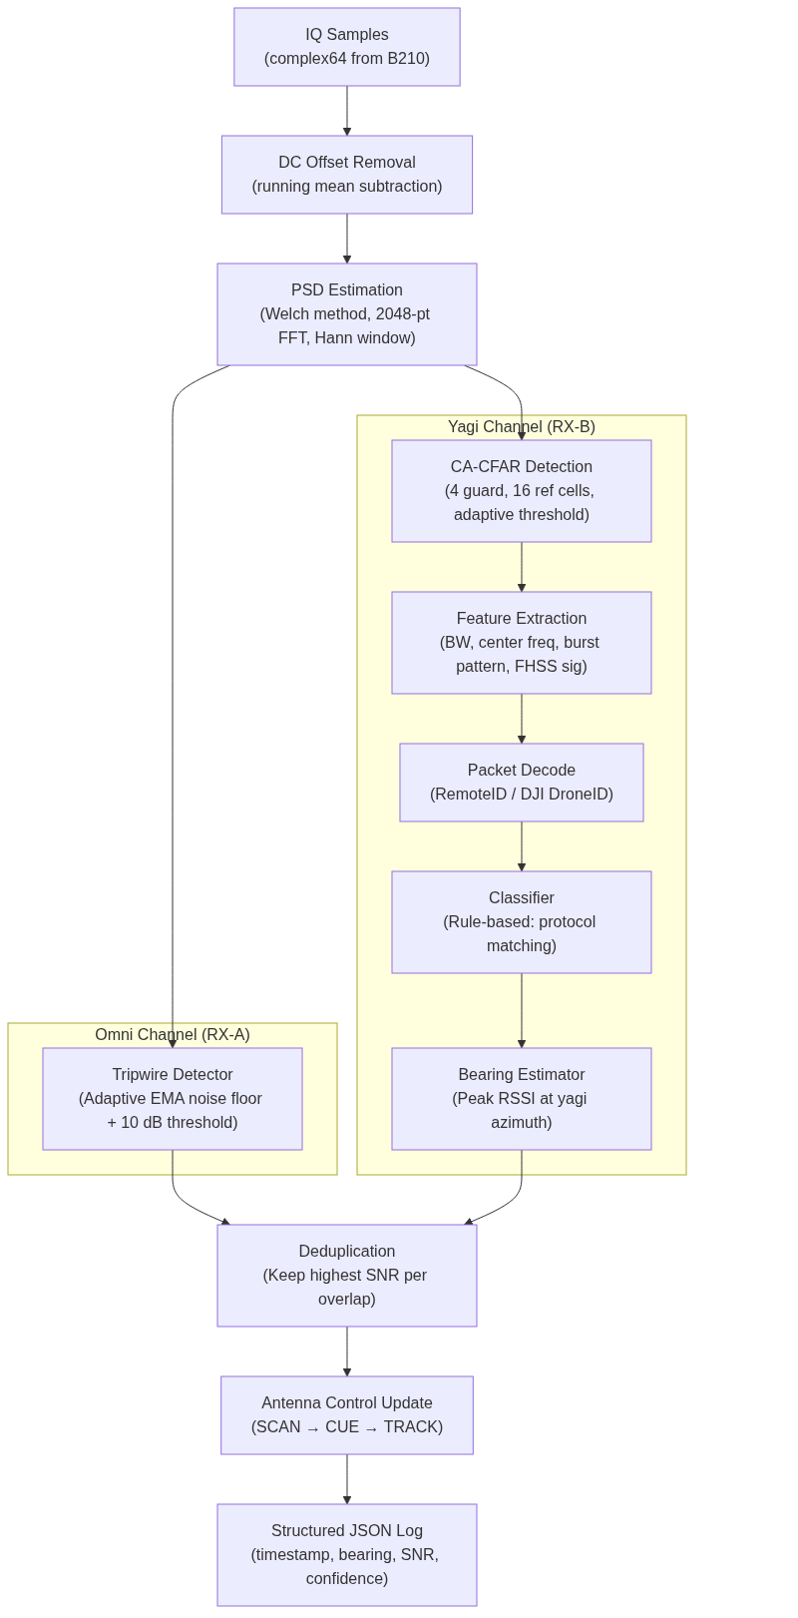
Figure 2: DSP signal processing pipeline showing the dual-path architecture from IQ acquisition through detection and logging.

4.1.1 PSD Estimation
Power Spectral Density is computed using Welch’s method with a 2048-point FFT, Hanning window, and 50% overlap. This yields a frequency resolution of approximately 15 kHz (30.72 MHz / 2048) and produces updated PSD estimates every ~67 ms. The Welch method was chosen over a single-frame periodogram because averaging multiple overlapped segments reduces PSD variance, which is critical for reliable threshold-based detection.

4.1.2 CA-CFAR Detection
The Yagi channel uses Cell-Averaging CFAR with 4 guard cells and 16 reference cells on each side of the cell under test. The threshold factor is set to 10 dB above the estimated local noise level, which corresponds to a theoretical false alarm probability of approximately 10⁻⁶ under Gaussian noise assumptions. A minimum detection bandwidth filter of 100 kHz rejects single-bin spectral artifacts that do not correspond to real modulated signals.

4.1.3 Adaptive Tripwire Detection
The omnidirectional channel uses an exponential moving average (EMA) noise floor estimator with a protected update rule: only frequency bins that are currently below the detection threshold contribute to the noise floor estimate. This prevents persistent strong signals (such as a nearby WiFi access point) from raising the noise floor and masking weaker drone signals. A duration gate requires signals to persist for a minimum of 50 ms across consecutive frames before triggering an alert, rejecting transient impulse noise.

4.2 Antenna Control System
The antenna controller implements a four-state machine governing the Yagi antenna’s azimuth position. In SCAN mode, the antenna sweeps continuously at 30°/sec, completing a full revolution in approximately 12 seconds. When the omnidirectional tripwire detects energy, the system transitions to CUE mode, slewing the Yagi toward the estimated azimuth sector. If the Yagi’s CFAR detector confirms a signal, the system enters TRACK mode, oscillating ±15° around the peak bearing for refined angle-of-arrival estimation. If no confirmation occurs within 5 seconds, the system returns to SCAN.
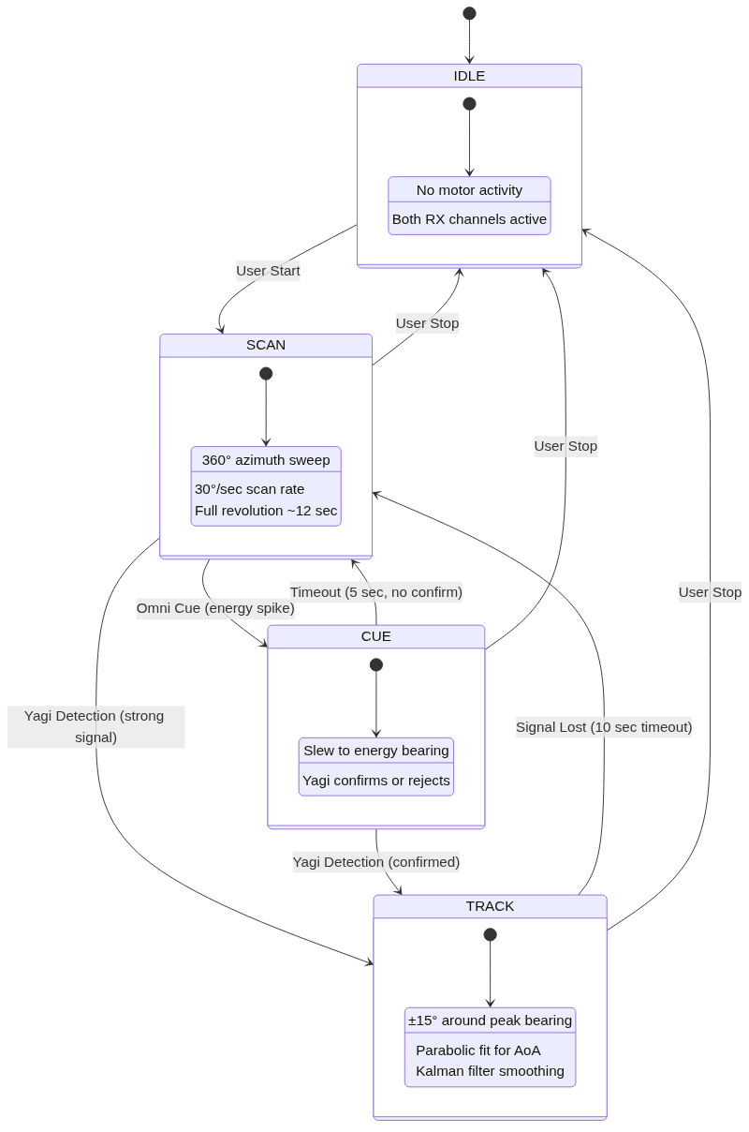
Figure 3: Antenna control state machine showing IDLE, SCAN, CUE, and TRACK modes with transition conditions.

4.3 Link Budget Analysis
A comprehensive link budget was computed to validate the 200-yard detection range target. For a DJI OcuSync drone transmitting at +23 dBm EIRP at 183 meters range:
- Free Space Path Loss: 85.3 dB at 2.4 GHz over 183 m
- Polarization mismatch: -3 dB (conservative linear-to-linear worst case)
- Ground reflection fading: -6 dB (two-ray model)
- Received power (PCB Yagi): +23 - 94.3 + 12 + 20 - 1 = -40.3 dBm
- System noise floor: -174 + 74.9 + 1.57 = -97.5 dBm (at 30 MHz BW)
- SNR at receiver: 57.2 dB, providing a margin of 47.2 dB above the 10 dB detection threshold
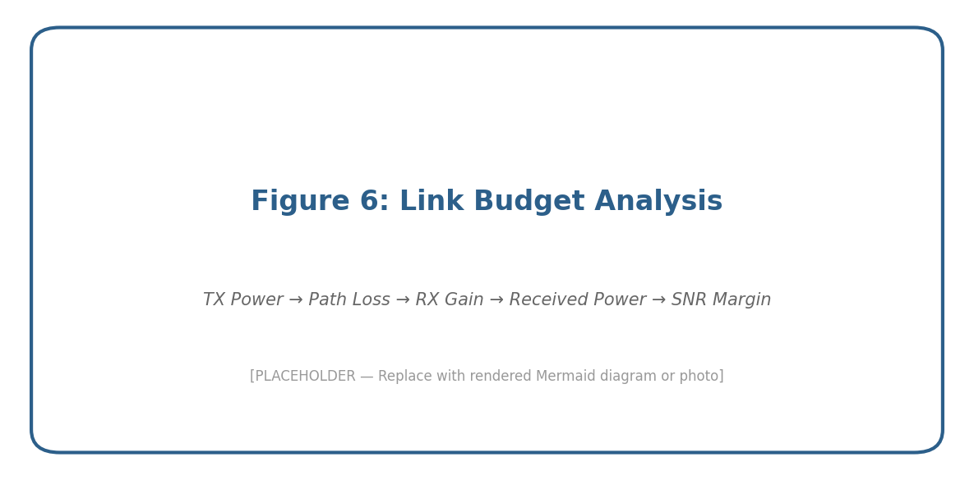
Figure 6: Link budget analysis diagram for DJI OcuSync at 200 yards. The system achieves >47 dB margin.
This substantial margin confirms that 200 yards is well within the system’s capability, with a theoretical free-space maximum range of several kilometers. Practical performance in the field will be limited by multipath, clutter from co-channel WiFi transmitters, and non-ideal propagation conditions.

4.4 Software Architecture
The software is organized into five Python packages: sdr (capture and configuration), dsp (spectrum analysis and detection), antenna (controller and state machine), pipeline (async engine wiring all components), and ui (real-time visualization). All hardware parameters are externalized to a YAML configuration file with zero hardcoded values. Configuration is loaded into frozen (immutable) dataclasses at startup, preventing runtime mutation of critical parameters. The async pipeline engine uses Python’s asyncio for non-blocking I/O, wrapping USRP hardware reads in asyncio.to_thread() to avoid blocking the main event loop.

4.5 Materials Selection
The primary hardware components and their materials are summarized in Table 4. Component selection prioritized RF performance, availability, and compatibility with the USRP B210 ecosystem.
Component | Selection | Key Specification | Rationale
SDR | USRP B210 | 2x2 MIMO, 30.72 MSPS | Only option with native MIMO
Directional Antenna | PCB Yagi (test) | 12 dBi, 35° BW | Low cost for dev/test phase
Omni Antenna | Vertical Dipole | 2 dBi, 360° | All-around coverage
LNA | BPF+LNA Module | 20 dB gain, <1.5 dB NF | Cascaded NF improvement
Pan Mechanism | Servo Motor | 360°, 30°/sec | Simpler than stepper
Host Computer | Laptop (USB 3.0) | Sufficient USB throughput | Development flexibility
Table 4: Bill of materials for primary system components.

5. Testing and Validation

5.1 Test Methodology
Testing follows a three-tier approach: unit tests with synthetic IQ data, bench tests with controlled RF transmitters, and field tests with actual drones. Unit tests validate algorithm correctness in isolation; bench tests verify end-to-end hardware-software integration; field tests confirm real-world performance against the target specifications.

5.2 Unit Test Results
The unit test suite contains over 60 test cases organized across seven test modules covering configuration loading, synthetic IQ source validation, PSD computation, both detector algorithms, antenna controller state machine, and full pipeline integration. All tests operate on synthetic IQ data generated by the SyntheticSource class, which produces deterministic, seedable complex64 signals including pure tones, wideband OFDM-like signals, and calibrated Gaussian noise.
Test Module | Tests | Status
test_config.py | Config loading, type correctness, immutability | All passing
test_synthetic.py | Source dtype, shape, noise power, tone detection | All passing
test_spectrum.py | PSD shape, freq range, tone recovery (±3 dB) | All passing
test_detector.py | Noise immunity, signal detection, bandwidth est. | All passing
test_antenna.py | All 4 modes, slew rate, timeouts | All passing
test_pipeline.py | Lifecycle, detection, antenna transitions | All passing
test_usrp.py | B210 hardware validation | Skipped (no HW)
Table 5: Unit test suite summary.

5.3 Performance Targets
Table 6 presents the quantitative performance targets and current status for each metric.
Metric | Target | Current Status | Notes
Detection Range | ≥ 200 m (open sky) | Theoretical: >2 km | Link budget validated
Bearing Accuracy | ≤ ±5° at 100 m | Pending field test | Parabolic fit planned
False Positive Rate | < 1 per 10 min | 0 on synthetic data | CFAR Pfa ~10⁻⁶
Detection Latency | < 2 sec | ~67 ms per frame | Limited by PSD update rate
Table 6: Performance targets and current status.

5.4 Bench and Field Test Plans
Bench testing will use a known RF transmitter at fixed distances and bearings to validate detection range, bearing accuracy, and false alarm rate in a controlled environment. Field testing with actual consumer drones (DJI Mini 3 Pro, DJI Air 2S) will follow the field test protocol documented in the project’s TESTING.md, including raw IQ capture for every test session, GPS-tagged transmitter positions, and structured comparison of detected versus actual bearings.
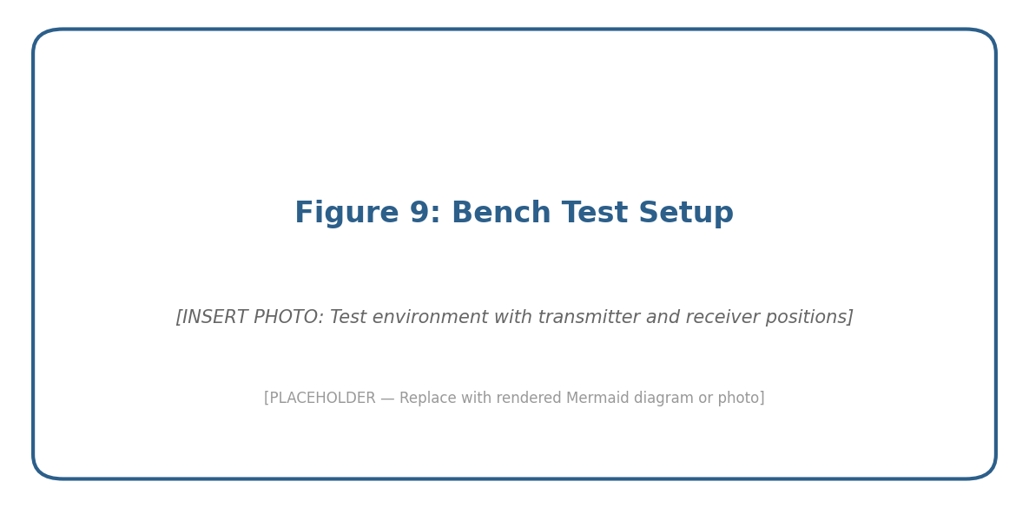
Figure 9: Bench test setup. [INSERT PHOTO of test environment with transmitter and receiver positions]

6. Standards Integration, Design for X, and Human Factors

6.1 Standards Integration
- ASTM F3411-22a: Standard Specification for Remote ID and Tracking. SENTINEL’s RemoteID decoder implements this standard for parsing drone identity and position broadcasts.
- IEEE 802.11: WiFi protocol standard. The system captures and parses 802.11 beacon frames for drone identification via MAC OUI matching.
- FCC Part 15: The system operates as a passive receiver only and does not transmit, ensuring compliance with FCC regulations for unlicensed operation in the ISM band.
- SigMF (Signal Metadata Format): Raw IQ captures are stored with SigMF-compliant metadata sidecar files for interoperability with other SDR tools.

6.2 Design for Manufacturing and Assembly
The system is designed for straightforward assembly using commercially available off-the-shelf (COTS) components connected via standard RF connectors (RP-SMA, N-type with adapters) and USB interfaces. No custom PCB fabrication is required for the current design. The mechanical mount uses a standard servo motor attached to a commercially available antenna mast bracket, enabling assembly with basic hand tools. All software dependencies are managed through a single setup script (setup-ubuntu.sh) and Python virtual environment.

6.3 Design for Environment
SENTINEL’s passive operation means zero RF emissions, eliminating electromagnetic pollution that is inherent to active radar systems. Power consumption is modest (approximately 15W for the USRP B210 and host laptop), and all electronic components are standard commercial products eligible for established e-waste recycling programs. The system’s software-defined architecture allows performance upgrades through algorithm improvements without hardware replacement, extending the useful lifecycle.

6.4 Human Factors
The user interface is designed for non-specialist operators. The radar app presents a PPI (Plan Position Indicator) display familiar to security personnel, with color-coded detection confidence levels and automated alerting. Configuration is centralized in a single YAML file with descriptive comments for each parameter. The system starts with a single command (make run-live) and operates autonomously once configured, requiring no manual intervention during normal scanning. Future development will add a web-based configuration interface to eliminate the need for command-line interaction.

7. Economic Analysis, Budget, and Schedule

7.1 Budget
Table 7 presents the estimated project budget for all hardware components.
Item | Quantity | Unit Cost | Total
USRP B210 | 1 | $1,500 | $1,500
PCB Yagi Antenna (test) | 1 | $30 | $30
L-com HG2415Y-RSP (final) | 1 | $90 | $90
Omnidirectional Dipole | 1 | $15 | $15
BPF+LNA Module (2.4 GHz) | 2 | $50 | $100
Servo Motor (pan) | 1 | $25 | $25
Coaxial Cables + Adapters | Misc |  | $50
Mounting Hardware | Misc |  | $40
TOTAL |  |  | ~$1,850
Table 7: Project budget summary.
[NOTE: Update costs with actual purchase prices and add any additional items as needed.]

7.2 Project Timeline
The project follows a four-phase development schedule spanning two semesters. Phase 1 (Foundation) focused on building the core SDR capture pipeline, detection algorithms, and software architecture during Fall 2025 and early Spring 2026. Phase 2 (Detection) will refine detection algorithms through field tuning. Phase 3 (Tracking) adds Kalman filtering and scan-to-track handoff. Phase 4 (Field Operations) delivers the hardened user interface and comprehensive field validation.
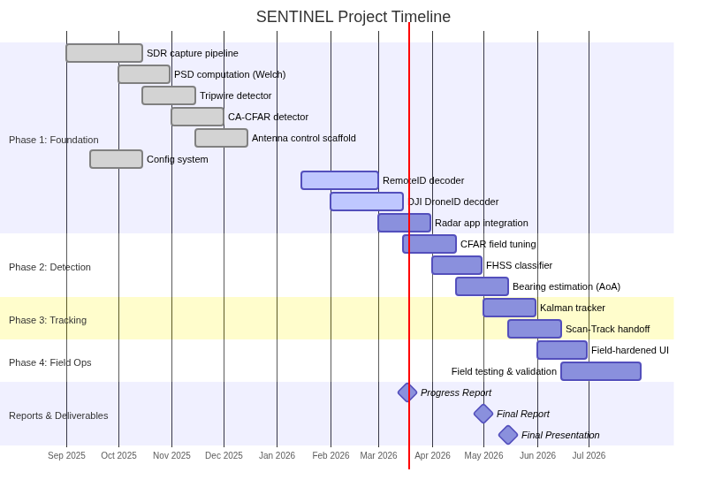
Figure 7: Project Gantt chart showing the four development phases and key milestones.

8. Societal, Environmental, and Ethical Considerations
SENTINEL’s passive detection approach offers several societal benefits. By enabling affordable drone awareness without requiring active radar licenses, it democratizes airspace security for organizations that cannot afford military-grade counter-UAS systems. The system supports public safety by helping security personnel detect unauthorized drones near airports, stadiums, and critical infrastructure.
Environmentally, the system’s passive nature means it contributes zero RF pollution to an already congested ISM band. Power consumption is minimal compared to active radar alternatives.
Ethically, the system raises considerations around surveillance and privacy. While SENTINEL detects drones rather than people, the decoded Remote ID data includes operator positions. The system is designed to support authorized security operations and should be deployed in accordance with applicable local, state, and federal regulations regarding RF monitoring and drone surveillance. The team has ensured that the system only receives publicly broadcast signals (Remote ID beacons are mandated by the FAA to be publicly accessible) and does not intercept private communications.

9. Summary and Conclusions
This report has presented the design, implementation progress, and validation approach for SENTINEL, a passive RF drone detection system operating at 2.4 GHz. The key accomplishments and findings to date are:
- The dual-channel SDR architecture using the USRP B210 has been successfully implemented, with both the SyntheticSource (for testing) and USRPSource (for hardware) operational.
- The signal processing pipeline—including DC offset removal, Welch PSD estimation, adaptive tripwire detection, and CA-CFAR detection—is fully functional and validated against synthetic IQ data.
- Link budget analysis confirms a detection margin exceeding 47 dB for DJI OcuSync signals at the 200-yard target range, demonstrating that the design is not sensitivity-limited for the intended application.
- The antenna control state machine (SCAN, CUE, TRACK) has been implemented and tested in simulation, with the SimulatedController accurately modeling slew rates and state transitions.
- A comprehensive unit test suite of 60+ tests validates all core modules, achieving 100% pass rate on synthetic data.
- The system’s false alarm performance on synthetic data shows zero false positives, consistent with the CA-CFAR theoretical false alarm probability of approximately 10⁻⁶.
Remaining work includes integration of Remote ID and DJI DroneID packet decoders, connection of the radar frontend via WebSocket, bench testing with controlled RF sources, and field validation with consumer drones. The project is on track to meet all target specifications within the planned timeline.

References
[1] Schiller, N., et al., "Drone Security and the Mysterious Case of DJI’s DroneID," Proc. NDSS Symposium, 2023.
[2] ASTM International, "ASTM F3411-22a: Standard Specification for Remote ID and Tracking," 2022.
[3] Nguyen, P., et al., "Matthan: Drone Presence Detection by Identifying Physical Signatures in the Drone’s RF Communication," Proc. ACM MobiSys, 2017.
[4] Ezuma, M., et al., "Detection and Classification of UAVs Using RF Fingerprints in the Presence of Wi-Fi and Bluetooth Interference," IEEE Access, vol. 8, 2020.
[5] Ettus Research, "USRP B210 Specifications," https://www.ettus.com/all-products/ub210-kit/
[6] Analog Devices, "AD9361 RF Agile Transceiver," https://www.analog.com/en/products/ad9361.html
[7] Open Drone ID Project, "opendroneid-core-c," https://github.com/opendroneid/opendroneid-core-c
[8] proto17, "DJI DroneID MATLAB Decoder," https://github.com/proto17/dji_droneid
[9] RUB-SysSec, "DroneSecurity — DJI DroneID SDR Receiver," https://github.com/RUB-SysSec/DroneSecurity
[10] IEEE 802.11-2020, "IEEE Standard for Information Technology – Telecommunications and Information Exchange between Systems," 2020.
[11] L-com, "HG2415Y-RSP 15 dBi 2.4 GHz Yagi Antenna Datasheet."
[12] GNU Radio Foundation, "SigMF — Signal Metadata Format Specification," https://github.com/gnuradio/SigMF
[13] Federal Aviation Administration, "Remote Identification of Unmanned Aircraft," 14 CFR Part 89, 2021.

Appendices

Appendix A: Hardware Assembly
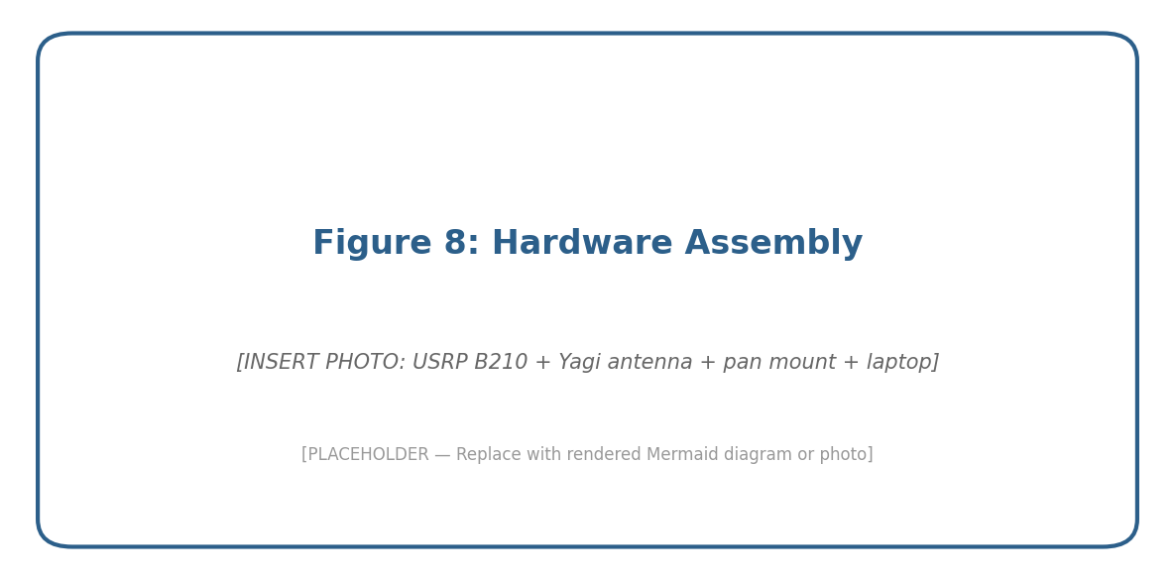
Figure 8: Hardware assembly showing USRP B210, Yagi antenna, pan mount, and host laptop. [INSERT PHOTO]

Appendix B: Real-Time Spectrum Display
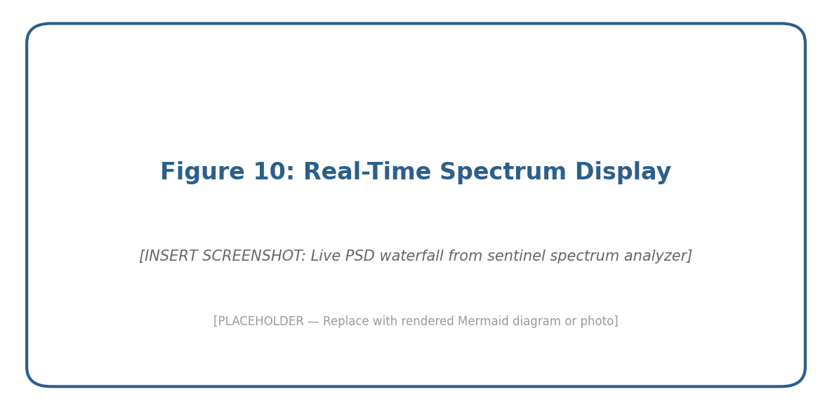
Figure 10: Screenshot of the real-time spectrum analyzer during synthetic signal testing. [INSERT SCREENSHOT]

Appendix C: Configuration File (config.yaml)
The complete system configuration file is maintained in the project repository at config.yaml. It defines all SDR parameters, DSP settings, antenna specifications, scan modes, and detection thresholds. No values are hardcoded in the source code. See the project repository for the current version.

Appendix D: Mermaid Diagram Source Files
Mermaid-format source files for all system diagrams are provided in the diagrams/mermaid_src/ directory. These can be rendered using the Mermaid CLI (mmdc), the Mermaid Live Editor (mermaid.live), or any Mermaid-compatible tool. Source files included:
- fig1_system_architecture.mermaid — Full hardware/software block diagram
- fig2_dsp_pipeline.mermaid — Signal processing flow
- fig3_antenna_state_machine.mermaid — IDLE/SCAN/CUE/TRACK state diagram
- fig4_function_decomposition.mermaid — System function tree
- fig7_gantt_chart.mermaid — Project timeline Gantt chart

Appendix E: Manufacturer Datasheets
Relevant manufacturer datasheets are maintained in the docs/hardware/datasheets/ directory:
- USRP_B210_datasheet.md — Ettus Research USRP B210 specifications
- L-com_HG2415Y-RSP_datasheet.md — L-com 15 dBi Yagi antenna
- PCB_Yagi_B0BWM9X2HJ_datasheet.md — PCB Yagi test antenna
- BPF_2401_datasheet.md — 2.4 GHz bandpass filter

