IEEE SSCI Conflicts of Interest
This document defines what constitutes a conflict of interest (COI) for the IEEE SSCI 2027 review process. It is adapted from the policies of major peer-reviewed AI conferences and is applied in accordance with IEEE peer review and publishing policies. Please read this document carefully.
Declaring conflicts
IEEE SSCI 2027 uses a double-anonymous review process. Although author identities are hidden from reviewers, declared conflicts are used by the Program Committee and the submission system to ensure that no paper is assigned to a reviewer, symposium chair, or program chair who has a conflict of interest with any of its authors.
All authors must declare their conflicts of interest at submission time through the IEEE SSCI 2027 online submission system. Two types of conflicts must be declared: institutional conflicts and personal conflicts, as defined below. It is the responsibility of the submitting author to ensure that the declared conflicts accurately cover all authors of the paper.
Reviewers, symposium chairs, and program committee members are bound by the same definitions. If, at any point during the review process, a reviewer or chair identifies a conflict with a paper assigned to them (for example, upon recognizing the work or its likely authors), they must declare the conflict, decline the assignment, and notify the responsible chairs.
Institutional conflicts
You have an institutional conflict with anyone affiliated with an institution at which you are currently employed or studying, or at which you have been employed or studying within the last three years. This includes recent internships and visiting appointments. Please declare institutional conflicts judiciously, reserving them for institutions with which you have a genuine conflict of interest; conflicts with individual collaborators at other institutions should be handled as personal conflicts.
When an institutional conflict is declared, the submission will not be assigned to reviewers, symposium chairs, or program chairs affiliated with that institution.
Personal conflicts
The following constitutes a personal conflict:
- Family or close personal relationship.
- Doctoral or postdoctoral advisee/advisor relationship, past or present.
- Current, frequent, or recent collaboration, where recent means within the past three years. This includes joint publications, joint projects, and joint grants.
- A close financial or business relationship.
In some cases, you may have a conflict that is not covered by the definitions above but that would nonetheless significantly compromise the fairness of the review process. Such conflicts may be reported confidentially to the Program Chairs, who may make appropriate arrangements without disclosing the nature of the conflict, and who may confidentially inquire into its validity if there is reason to doubt it.
Conflicts involving organizers and program committee members
Symposium chairs, program committee members, and other members of the organizing committee may submit papers to IEEE SSCI 2027, including to a symposium they help organize. Such submissions undergo the same double-anonymous review process and are handled entirely by non-conflicted chairs: papers conflicted with a symposium chair are managed by a non-conflicted co-chair of that symposium; if all chairs of a symposium are conflicted, the Program Chairs manage the review; papers conflicted with a Program Chair are managed by a non-conflicted Program Chair or delegated by the General Chairs. Conflicted individuals have no access to the reviewer identities, reviews, discussions, or decisions concerning their own submissions.
Integrity of conflict declarations
Conflict declarations are relied upon in good faith. Any attempt to influence reviewer assignment through false declaration of conflicts, whether by fabricating conflicts to avoid particular reviewers or by concealing genuine conflicts, may result in the rejection of all of the authors' submissions without review, and may be referred for further action consistent with IEEE policies.
Contact Us
If you have questions about special circumstances not discussed above, please contact the Program Chairs via the Contact Us page.

Q1: How to complete/update my conflicts?
Please navigate to ‘My Conflicts’ page and update any information using the tabs on the bottom in the figure attached. Then click the button highlighted to declare your conflicts.
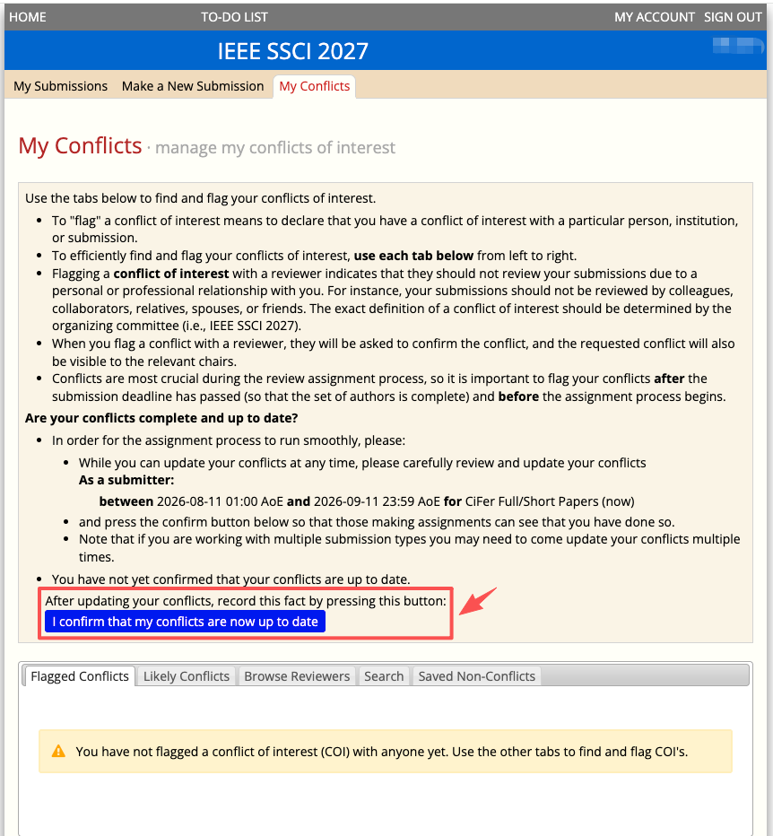

Q2: What if I do not have any conflict to declare?
Please click the button ‘I confirm that my conflicts are now up to date’ to complete the declaration process.
