1. Class Diagram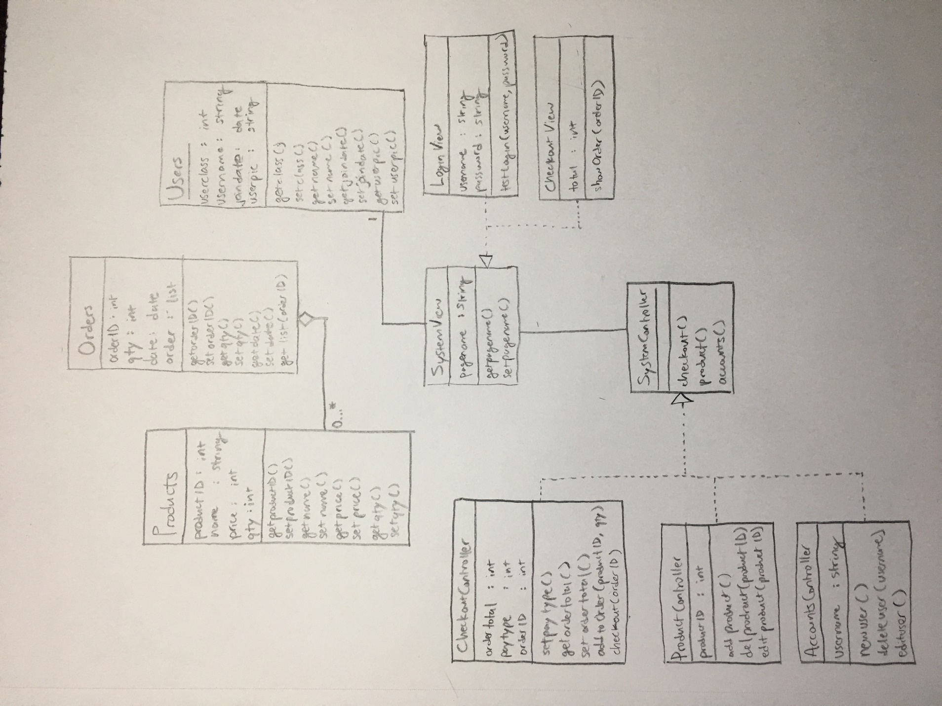

2. Entity Relationship Diagram

date

Total Tax

Total Cost

Order Id

Manages

Processes

Customer Id

Customer Name

Password

Employee Name

Employee Id

Username

Username

Employee Name

Product Id

Product Quantity

Product Name

Product Price

Password

Employee Id

Order

Cashier

Buys

Customer

Sells things to

Products

Manages

Manager

3.

CREATE DATABASE Store;

CREATE TABLE Product (

ProductID int not null primary key,

ProductName char(30) not null,

Price decimal(9,2),

Quantity int,

Expiration datetime);

CREATE TABLE Order (

OrderNo int not null primary key,

OrderTime datetime not null,

Customer char(30),

Total decimal(9,2),

Tax decimal(9,2));

CREATE TABLE Employee (

EmployeeID int not null primary key,

EmployeeName char(30) not null,

EmployeeType char(30),

Username char(30),

Password char(30));

INSERT INTO Product VALUES (111, ‘Apples’, 0.99, 200.0, DATE ‘2017-09-25’);

INSERT INTO Product VALUES (120, ‘Apricots’, 2.99, 50.0, DATE ‘2017-09-26’);

INSERT INTO Product VALUES (160, ‘Asparagus’, 3.99, 100.0, DATE ‘2017-09-24’);

INSERT INTO Product VALUES (235, ‘Broccoli’, 1.99, 100.0, DATE ‘2017-09-30’);

INSERT INTO Product VALUES (304, ‘Carrots’, 2.99, 75.0, DATE ‘2017-10-04’);

INSERT INTO Product VALUES (350, ‘Crumpets’, 6.99, 50.0, DATE ‘2017-11-14’);

INSERT INTO Product VALUES (420, ‘Donuts’, 5.99, 30.0, DATE ‘2017-09-31’);

INSERT INTO Product VALUES (570, ‘Eggs’, 2.99, 100.0, DATE ‘2017-10-14’);

INSERT INTO Product VALUES (672, ‘Froyo’, 7.99, 20.0, DATE ‘2017-09-’);

INSERT INTO Product VALUES (1802, ‘Tea’, 1.99, 75.0, DATE ‘2017-10-04’);

INSERT INTO Product VALUES (224, ‘Bread’, 2.99, 200.0, DATE ‘2017-09-25’);

INSERT INTO Product VALUES (1200, ‘Milk’, 2.99, 50.0, DATE ‘2017-09-26’);

INSERT INTO Product VALUES (189, ‘Beer’, 8.99, 100.0, DATE ‘2018-12-24’);

INSERT INTO Product VALUES (664, ‘Fritos’, 1.99, 100.0, DATE ‘2018-09-30’);

INSERT INTO Product VALUES (2204, ‘Water’, 3.99, 75.0, DATE ‘9999-12-31’);

INSERT INTO Product VALUES (780, ‘Gummy Bears, 0.99, 200.0, DATE ‘2019-03-25’);

INSERT INTO Product VALUES (1701, ‘Socks’, 2.99, 50.0, DATE ‘9999-12-31’);

INSERT INTO Product VALUES (860, ‘Icepick’, 3.99, 100.0, DATE ‘9999-12-31’);

INSERT INTO Product VALUES (1855, ‘Thermometer’, 1.99, 100.0, DATE ‘9999-12-31’);

INSERT INTO Product VALUES (1560, ‘Rope’, 2.99, 75.0, DATE ‘9999-12-31’);

INSERT INTO Product VALUES (1620, ‘Shampoo’, 0.99, 200.0, DATE ‘2018-09-25’);

INSERT INTO Product VALUES (1490, ‘Razor’, 2.99, 50.0, DATE ‘9999-12-31’);

INSERT INTO Product VALUES (2509, ‘Qtips’, 3.99, 100.0, DATE ‘9999-12-31’);

INSERT INTO Product VALUES (590, ‘Eyeshadow’, 1.99, 100.0, DATE ‘2018-09-30’);

INSERT INTO Product VALUES (1910, ‘Towel’, 2.99, 75.0, DATE ‘9999-12-31’);

INSERT INTO Order(OrderNo, OrderTime, Customer, Total, Tax) VALUES (324703, DATE ‘2017-09-21’, ‘Patricia Tannis’, 17.84, 2.34)

INSERT INTO Order(OrderNo, OrderTime, Customer, Total, Tax) VALUES (324704, DATE ‘2017-09-21’, ‘Tiny Tina’, 22.76, 2.76)

INSERT INTO Order(OrderNo, OrderTime, Customer, Total, Tax) VALUES (324705, DATE ‘2017-09-21’, ‘Torque’, 15.22, 2.02)

INSERT INTO Order(OrderNo, OrderTime, Customer, Total, Tax) VALUES (324706, DATE ‘2017-09-21’, ‘Handsome Jack’, 27.98, 4.22)

INSERT INTO Order(OrderNo, OrderTime, Customer, Total, Tax) VALUES (324707, DATE ‘2017-09-21’, ‘Felicia’, 25.32, 4.03)

INSERT INTO Employee(EmployeeId, EmployeeName, EmployeeType, Username, Password) VALUES (1, ‘Sara Locklar’, ‘Cashier’, ‘sel0027’, ‘auburn1234’)

INSERT INTO Employee(EmployeeId, EmployeeName, EmployeeType, Username, Password) VALUES (2, ‘Simon Lee’, ‘Manager’, ‘ssl0008’, ‘auburn5678’)