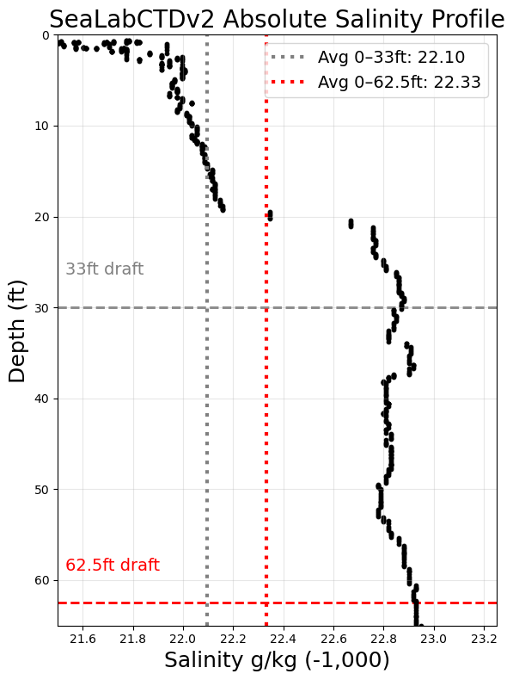

**Test Date and Time:** 29 APR 2025, 1439 – 1443 (ZD+8)

**Avg Sampling Frequency:** 4.97 Hz

**Location:** Valdez Marine Terminal Berth 4

**CTD Cast Location on Vessel:** while vessel portside to, CTD cast from the starboard side on the maindeck astern of the liferafts

**Tide:** +5.2ft

**Average salinity 0-33ft:** 1022.10

**Average salinity 0-62.5ft:** 1022.33

**Difference:** 0.23

**Surface salinity:** 1021.50

**Salinity at 62.5ft:** 1022.93

**Difference:** 1.43

**Qualitative Assessment of Weather:** Raining before the cast for a ~6 hours – light to medium rain, 0.1” an hour. Very light drizzle at time of cast.