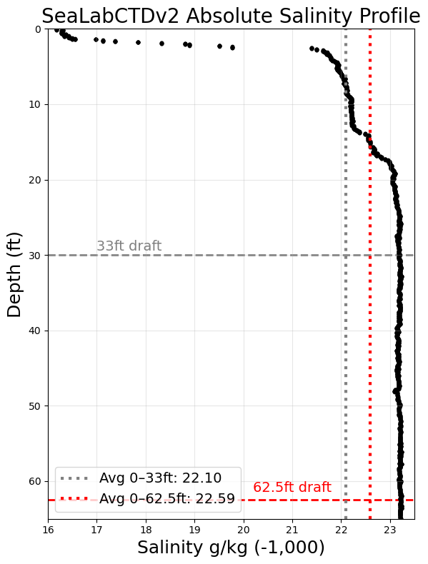

**Test Date and Time**

10 MAY 2025, 1554 – 1606 (ZD+8)

**Avg Sampling Frequency**

4.98 Hz

**Location**

Valdez Marine Terminal Berth 4

**CTD Cast Location on Vessel**

Ship starboard side to berth. CTD cast from port side on maindeck astern of the FRB

**Tide:** +6.5ft

**Average salinity 0-33ft:** 1022.10

**Average salinity 0-62.5ft:** 1022.59

**Difference:** 0.49

**Surface salinity:** 1016.1

**Salinity at 62.5ft:** 1023.1

**Difference:** 7.0

**Qualitative Assessment of Weather**

Sunny and clear

