Instructions for using the bundled Radiant Viewer

Your radiology examination is made available to you in a couple of different ways:

1. Given to you on a CD or USB dive at the clinic.
2. Downloaded as a .zip archive via the patient or physician portal.

If you obtained it via the portal download, you would have seen a single file like this after downloading:  
  
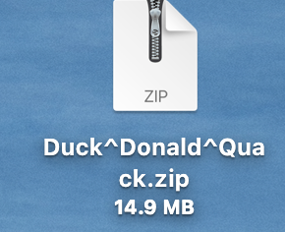

After ‘un-zipping’ that you would see a folder with a directory structure like this:

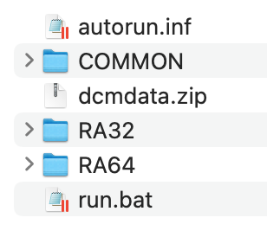

Although there may be other files included there as well, like this ‘ReadMe’ file or some other files or programs.

If you were given a CD or USB drive, you would have something very similar to the directory structure shown above. The dcmdata.zip directory contains the files for the radiology study itself.

**Using the Radiant Viewer**

The Radiant Viewer is a Windows only DICOM viewer, so you must run the application on a Windows operating system. If you were given the study on a CD or USB in the clinic, then you simply need to insert the CD or USB, and then launch the viewer by:

**Double-click or launch the run.bat file.**

If you have a CD, it may launch automatically when you insert the CD.

If you download the archive from the patient or physician portal, then you will need to either ‘burn’ your own CD, or copy the files over to a USB thumb drive before launching the program from the CD or the USB.

If you try to run the Radiant viewer from the system drive you will see a warning or notice about the requirement to run the viewer from a CD or USB. The program will still run, but the notice may obscure the viewer display somewhat.

**Other options**

If you do not have a Windows computer and have an Apple or Linux OS, there are some other options.

For Mac OS, there is a fairly advanced and free open-source viewer available from the Horos Project here:  
  
<https://horosproject.org/download/>

The Weasis viewer is a cross-platform viewer available here:  
  
https://nroduit.github.io/en/  
  
The MedDream viewer is a commercial certified package available here:

https://www.softneta.com/products/meddream-dicom-viewer/