**Colour Selection:**

**Peach, cream and charcoal:**

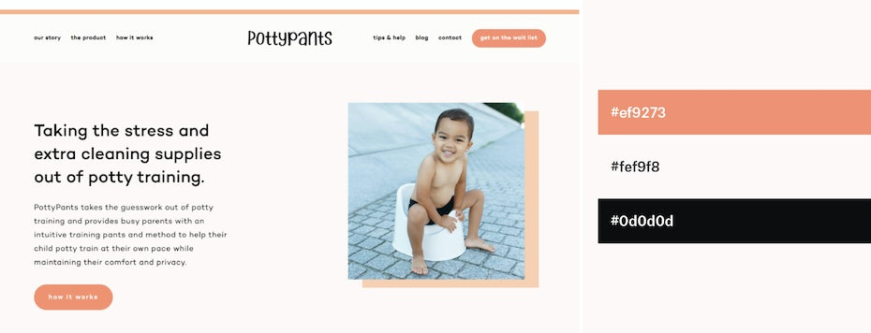Calming neutral color scheme by [Lovely Grit Studio](https://99designs.com/profiles/lovelygrit/designs/1761929): #ef9273 #fef9f8 #0d0d0d

**Teal, grey, blue, bright white, dark grey and aqua marine:**

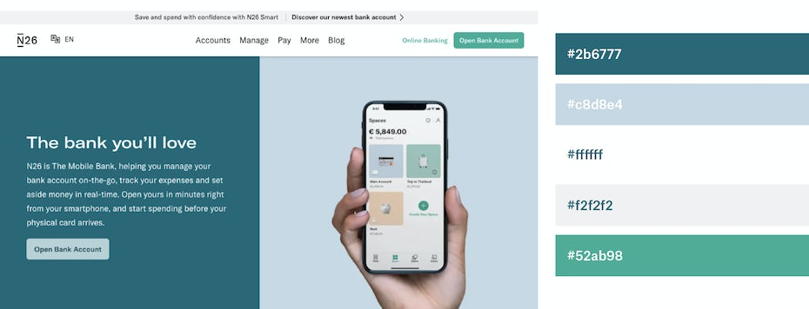Trustworthy Teal Tones via [N26](http://n26.com/):#2b6777 #c8d8e4 #ffffff #f2f2f2 #52ab98

**Colour Selection:**

1. Royal blue & peach (trending)



To start our list, we'll go for a trendy color combination, royal blue and peach. These two colors form a triadic combination, with the royal blue creating a bold sensation, balanced perfectly with peach's playfulness. This color combo is ideal for logo design or as accent colors for a web template or design.

Hex codes: Royal Blue #00539CFF, Peach #EEA47FFF

Blue codes:

$green-50: #e6e6f8;

$green-100: #b3b3eb;

$green-200: #8080dd;

$green-300: #4d4dcf;

$green-400: #3333c9;

$green-500: #0000bb;

$green-600: #0000a8;

$green-700: #000083;

$green-800: #00005e;

$green-900: #000038;

original:

$green-50: #ecfdf5;

$green-100: #d1fae5;

$green-200: #a7f3d0;

$green-300: #6ee7b7;

$green-400: #34d399;

$green-500: #10b981;

$green-600: #059669;

$green-700: #047857;

$green-800: #065f46;

$green-900: #064e3b;

// Gray colors

$gray-50: #f9fafb;

$gray-100: #f3f4f6;

$gray-200: #e5e7eb;

$gray-300: #d1d5db;

$gray-400: #9ca3af;

$gray-500: #6b7280;

$gray-600: #4b5563;

$gray-700: #374151;

$gray-800: #1f2937;

$gray-900: #111827;

New:

$green-50: #e6e6f8;

$green-100: #b3b3eb;

$green-200: #8080dd;

$green-300: #4d4dcf;

$green-400: #3333c9;

$green-500: #0000bb;

$green-600: #0000a8;

$green-700: #000083;

$green-800: #00005e;

$green-900: #000038;

// Gray colors class but peach colour codes

$gray-50: #fcede5;

$gray-100: #fae4d9;

$gray-200: #f8dbcc;

$gray-300: #f7d2bf;

$gray-400: #f5c8b2;

$gray-500: #f3bfa5;

$gray-600: #f1b699;

$gray-700: #f0ad8c;

$gray-800: #eea47f;

$gray-900: #eea47f;

2. Blue & pink (classic)



Combining blue and pink creates a nice balance. Where pink often has a softer, spring-like pastel aesthetic, blue has hints of maturity — creating duality in the color combination.

Hex codes: Blue #2F3C7E, Pink #FBEAEB

4. Red & yellow(classic)



Next on the list is the bold and vibrant color combination, red and yellow. This complementary color combo is the embodiment of cheer. Reimagine this classic ketchup and mustard color pairing with a modern, pastel take by changing the tints from red to coral.

Hex codes: Coral #F96167, Yellow #FCE77D

**The best colour goes with black:**

Try out these two neon and black schemes to give your website a contemporary twist on 1980s style.

