北京邮电大学软件学院
2020-2021学年第二学期实验报告

课程名称： 大数据原理与技术

项目名称： 实验1：安装单机Hadoop系统

项目完成人：
姓名： 马瑞遥 学号： 2018211915

指导教师： 孙鹏飞

日 期： 2021年 3 月 22 日

实验目的
- 掌握在自己本地电脑上正确安装和运行伪分布式 Hadoop系统的方法。
- 掌握运行Hadoop系统自带的WordCount可执行程序文件的方法,并产生输出结果。
- 掌握程序运行后在Hadoop Web作业状态查看界面上作业运行状态的方法。
- 掌握Hadoop的相关命令，掌握管理HDFS文件系统的方法。

实验内容
- 每人在自己本地电脑上正确安装和运行伪分布式 Hadoop系统。
- 安装完成后,自己寻找一组英文网页数据,在本机上运行Hadoop系统自带的WordCount可执行程序文件,并产生输出结果。
- 实验结果提交：要求书写一个实验报告，其中包括：
- 系统安装运行的情况
- 实验数据说明（下载的什么网页数据，多少个HTML或text文件)
- 程序运行后在Hadoop Web作业状态查看界面上的作业运行状态屏幕拷贝
- 实验输出结果开头部分的屏幕拷贝
- 实验体会

实验环境
- 一台 hp 计算机（HP Spectre x360 Convertible 13-apOxxx）
- VMware Workstation Pro 软件
- Linux 系统主机（Ubuntu 20.04.2 虚拟机）
- OpenSSH_8.2p1
- Java 1.8.0_281

实验结果

4.1 系统安装运行的情况
- 在Linux命令行中输入命令：start-all.sh，启动Hadoop。
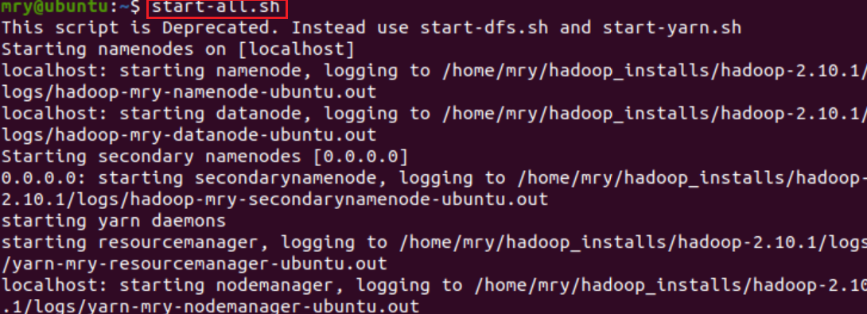
- 之后，输入命令：jps，以检查Hadoop是否成功启动。
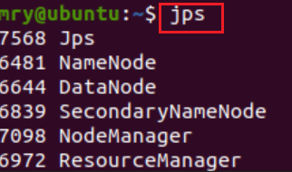
由上图可知，NameNode，DataNode，SecondaryNameNode，NodeManager，ResourceManager都已成功启动，即Hadoop已成功启动。

至此，已成功在本地电脑（Ubuntu 20.04.2 虚拟机）上正确安装和运行伪分布式Hadoop系统。

4.2 实验数据说明
- 本次实验的实验数据是三个.txt形式的英文文本文件，这三个文本文件来自于三篇英文论文的摘要。分别将这三个文本文件命名为word1，word2，word3，并使用Hadoop的put命令（如命令，hadoop fs -put /home/mry/Desktop/word1.txt /wordcount，前面为本地文件路径，后面为HDFS中的存放路径）将其存放在HDFS的wordcount目录下。
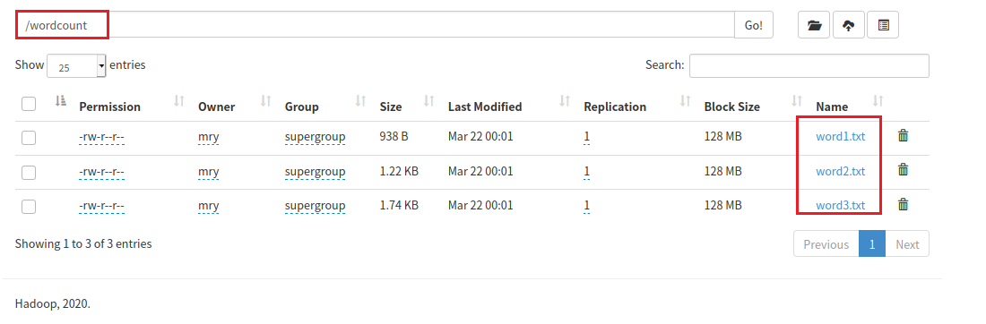
- word1中的内容是Analysis of hadoop MapReduce scheduling in heterogeneous environment这篇文章的摘要，其文件内容展示如下所示。
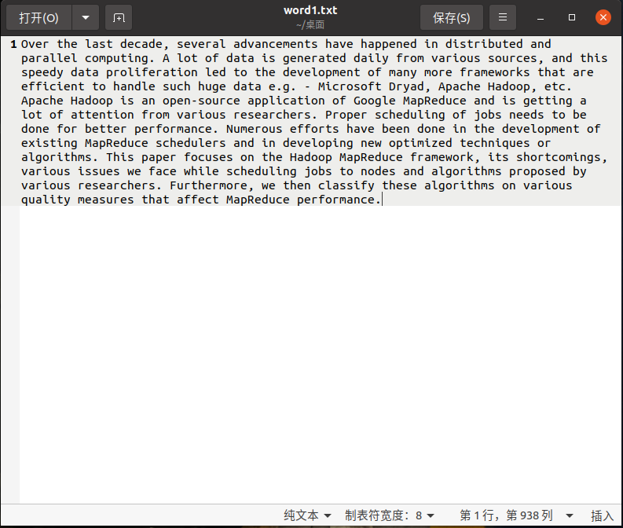
- word2中的内容是Investigating Automatic Parameter Tuning for SQL-on-Hadoop Systems这篇文章的摘要，其文件内容展示如下所示。
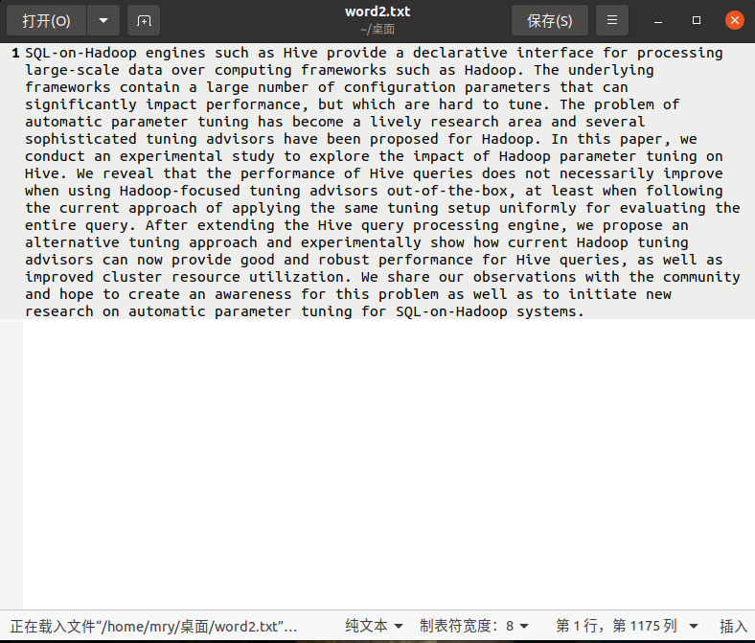
- word3中的内容是Historical data based approach for straggler avoidance in a heterogeneous Hadoop cluster这篇文章的摘要，其文件内容展示如下。
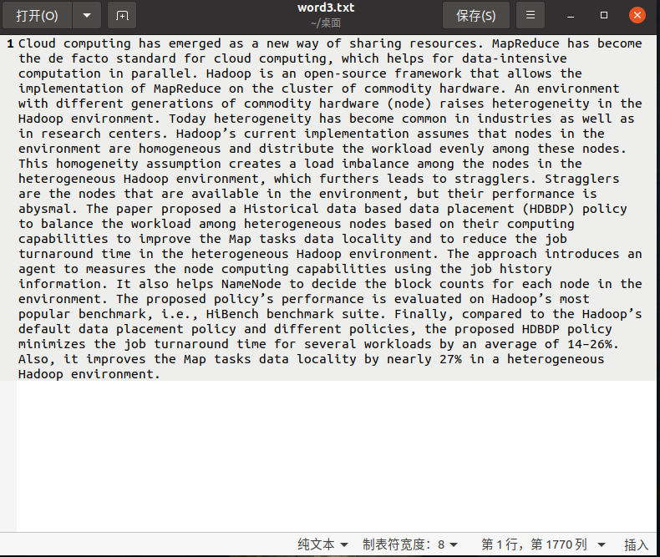

上述三个英文文本文件的相关链接及完整内容会在附录中给出。

4.3 程序运行后在Hadoop Web作业状态查看界面上的作业运行状态
运行Hadoop中自带的WordCount程序，对之前提交在HDFS中的wordcount目录进行词频计数，并将运行结果指定存放在HDFS中的outputwc目录下（如命令：hadoop jar hadoop-mapreduce-examples-2.10.1.jar wordcount /wordcount /outputwc，分别是可执行程序文件本地路径，调用方法名，HDFS中的待处理数据路径，实验输出结果路径）。运行结束后，在localhost:8088中，查看其作业运行状态，发现有一个已完成的作业，其信息如下所示。
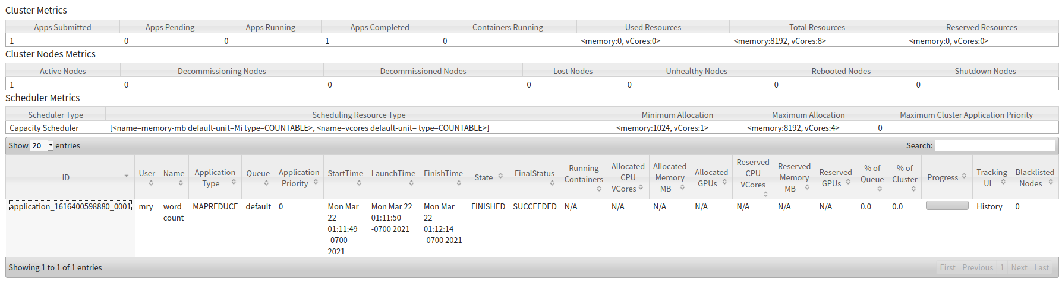

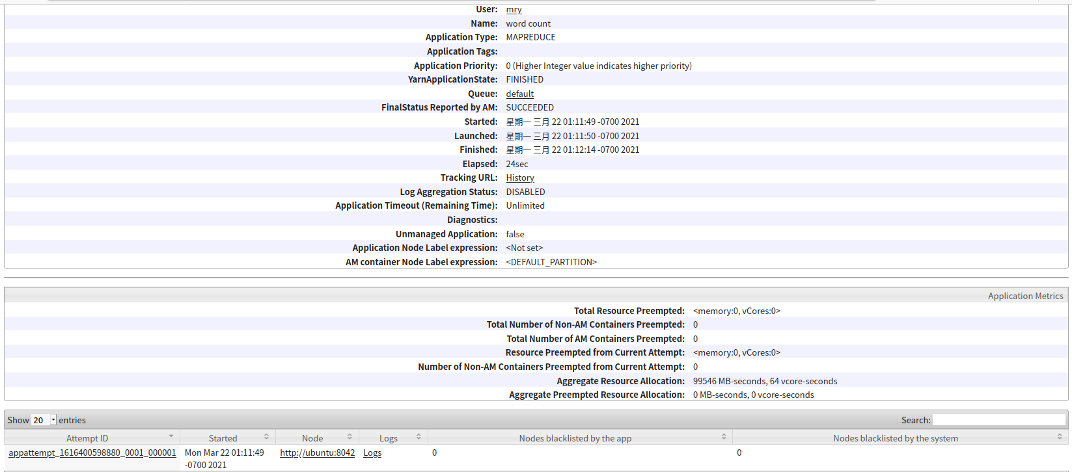

4.4 实验输出结果
- WordCount程序运行过程中，Linux命令行中的实验输出结果如下所示。
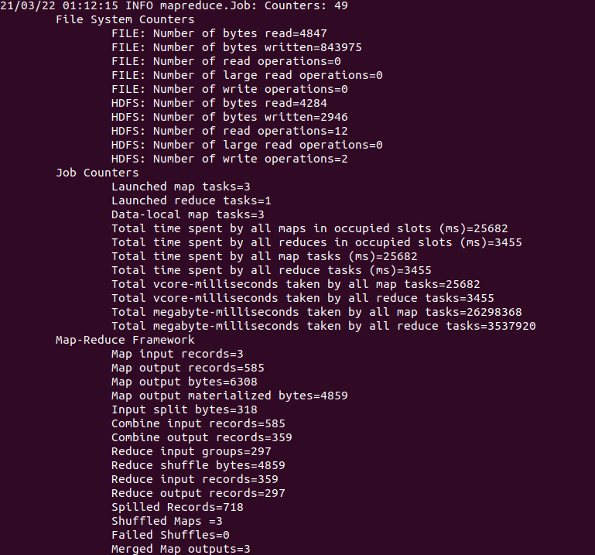
- 程序运行结束后，在localhost:50070中，查看outputwc目录下的实验输出结果，发现有_SUCCESS文件和part-r-00000文件，表目程序运行成功，其输出结果存放在part-r-00000文件中。
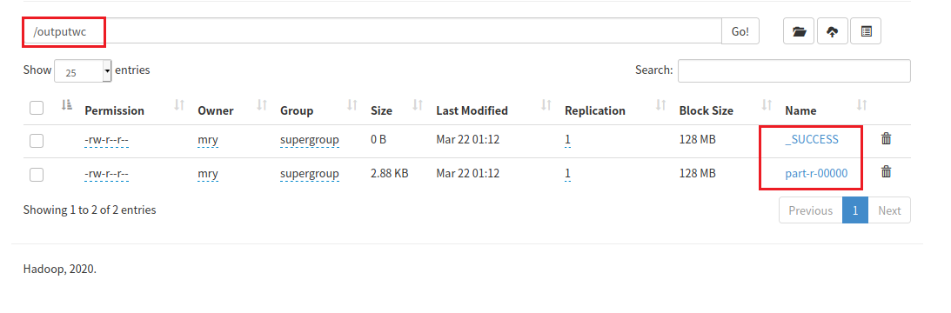
- part-r-00000文件中的输出结果如下（完整文件内容将在附录中给出）。
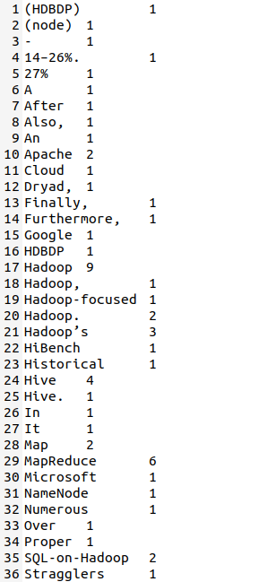

附录

5.1 实验体会
通过本次实验，我明白了如何在Linux系统上安装和运行伪分布式Hadoop系统，掌握了如何运行Hadoop系统自带的可执行程序文件（WordCount）的方法，并能够在localhost:8088中查看作业运行状态，在localhost:50070中管理HDFS的分布式文件及相应的实验输出结果。同时，我知道了Hadoop中的相关命令操作（start-all.sh，jps等），并掌握了上传文件到HDFS及运行Hadoop可执行程序文件的方法。

5.2 调试心得

5.2.1 bash_profile文件不是当前Linux的环境配置文件
在进行Hadoop环境变量的配置，并按照ppt中所说打开环境配置文件bash_profile时，发现打开了一个空文件，即bash_profile文件不存在，不是当前Linux系统的环境配置文件。
查阅相关资料后发现，本电脑中的虚拟机版本是Ubuntu 20.04.2，其环境变量的相关配置不在bash_profile文件中，而在bashrc文件中。成功找到并打开bashrc文件后（gedit ~/.bashrc），便可进行相关的环境变量配置。
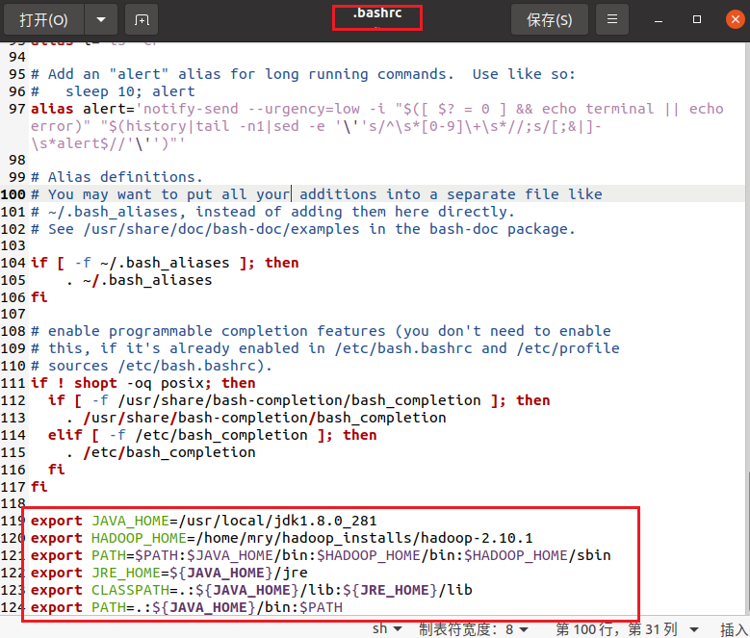

5.2.2 输入start-all.sh命令后，启动的进程与ppt上的不完全一致
在输入start-all.sh命令以启动Hadoop时，发现自己虚拟机中启动的Hadoop的进程是：NameNode，DataNode，SecondaryNameNode，NodeManager，ResourceManager；而ppt中所展示的Hadoop的启动进程是：NameNode，DataNode，SecondaryNameNode，TaskTracker，JobTracker。二者不完全一致。
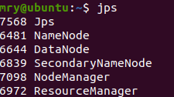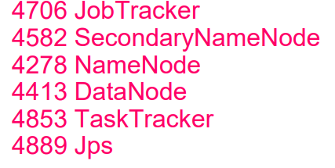
查阅资料后发现，Hadoop启动进程的差异是由版本号（Yarn的有无等）所导致的。在Hadoop一代版本中，还未引入Yarn框架，启动时会有TaskTracker和JobTracker这两个进程，即ppt中所展示的；而在Hadoop二代版本中，已从MapReduce中分离出了Yarn框架负责资源管理等，启动时便不会有TaskTracker和JobTracker这两个进程，取而代之的是NodeManager和ResourceManager这两个进程，即我自己虚拟机所跑出的结果。

5.2.3 运行WordCount程序时卡住不动，无法继续运行
在运行Hadoop自带的WordCount程序时，发现程序运行到一半时卡住不动了，无法继续执行。
上网搜集了资料后发现，原因是运行程序时，当剩余硬盘容量不足设定阈值时，会判定该节点坏了，由于是伪分布式，所以任务会被无限搁置。解决方法是在yarn-site.xml 中添加配置信息如下：
这之后，WordCount程序便可顺利运行。

5.3 实验数据

5.3.1 word1.txt
- 链接
https://doi.org/10.1016/j.asej.2020.06.009
- 完整内容
Over the last decade, several advancements have happened in distributed and parallel computing. A lot of data is generated daily from various sources, and this speedy data proliferation led to the development of many more frameworks that are efficient to handle such huge data e.g. - Microsoft Dryad, Apache Hadoop, etc. Apache Hadoop is an open-source application of Google MapReduce and is getting a lot of attention from various researchers. Proper scheduling of jobs needs to be done for better performance. Numerous efforts have been done in the development of existing MapReduce schedulers and in developing new optimized techniques or algorithms. This paper focuses on the Hadoop MapReduce framework, its shortcomings, various issues we face while scheduling jobs to nodes and algorithms proposed by various researchers. Furthermore, we then classify these algorithms on various quality measures that affect MapReduce performance.

5.3.2 word2.txt
- 链接
https://doi.org/10.1016/j.bdr.2021.100204
- 完整内容
SQL-on-Hadoop engines such as Hive provide a declarative interface for processing large-scale data over computing frameworks such as Hadoop. The underlying frameworks contain a large number of configuration parameters that can significantly impact performance, but which are hard to tune. The problem of automatic parameter tuning has become a lively research area and several sophisticated tuning advisors have been proposed for Hadoop. In this paper, we conduct an experimental study to explore the impact of Hadoop parameter tuning on Hive. We reveal that the performance of Hive queries does not necessarily improve when using Hadoop-focused tuning advisors out-of-the-box, at least when following the current approach of applying the same tuning setup uniformly for evaluating the entire query. After extending the Hive query processing engine, we propose an alternative tuning approach and experimentally show how current Hadoop tuning advisors can now provide good and robust performance for Hive queries, as well as improved cluster resource utilization. We share our observations with the community and hope to create an awareness for this problem as well as to initiate new research on automatic parameter tuning for SQL-on-Hadoop systems.

5.3.3 word3.txt
- 链接
https://doi.org/10.1007/s12652-020-02699-0
- 完整内容
Cloud computing has emerged as a new way of sharing resources. MapReduce has become the de facto standard for cloud computing, which helps for data-intensive computation in parallel. Hadoop is an open-source framework that allows the implementation of MapReduce on the cluster of commodity hardware. An environment with different generations of commodity hardware (node) raises heterogeneity in the Hadoop environment. Today heterogeneity has become common in industries as well as in research centers. Hadoop’s current implementation assumes that nodes in the environment are homogeneous and distribute the workload evenly among these nodes. This homogeneity assumption creates a load imbalance among the nodes in the heterogeneous Hadoop environment, which furthers leads to stragglers. Stragglers are the nodes that are available in the environment, but their performance is abysmal. The paper proposed a Historical data based data placement (HDBDP) policy to balance the workload among heterogeneous nodes based on their computing capabilities to improve the Map tasks data locality and to reduce the job turnaround time in the heterogeneous Hadoop environment. The approach introduces an agent to measures the node computing capabilities using the job history information. It also helps NameNode to decide the block counts for each node in the environment. The proposed policy’s performance is evaluated on Hadoop’s most popular benchmark, i.e., HiBench benchmark suite. Finally, compared to the Hadoop’s default data placement policy and different policies, the proposed HDBDP policy minimizes the job turnaround time for several workloads by an average of 14–26%. Also, it improves the Map tasks data locality by nearly 27% in a heterogeneous Hadoop environment.

5.4 实验输出结果（part-r-00000文件内容）
(HDBDP) 1
(node) 1
- 1
14–26%. 1
27% 1
A 1
After 1
Also, 1
An 1
Apache 2
Cloud 1
Dryad, 1
Finally, 1
Furthermore, 1
Google 1
HDBDP 1
Hadoop 9
Hadoop, 1
Hadoop-focused 1
Hadoop. 2
Hadoop’s 3
HiBench 1
Historical 1
Hive 4
Hive. 1
In 1
It 1
Map 2
MapReduce 6
Microsoft 1
NameNode 1
Numerous 1
Over 1
Proper 1
SQL-on-Hadoop 2
Stragglers 1
The 5
This 2
Today 1
We 2
a 8
abysmal. 1
advancements 1
advisors 3
affect 1
agent 1
algorithms 2
algorithms. 1
allows 1
also 1
alternative 1
among 3
an 7
and 12
application 1
applying 1
approach 3
are 5
area 1
as 9
assumes 1
assumption 1
at 1
attention 1
automatic 2
available 1
average 1
awareness 1
balance 1
based 2
be 1
become 3
been 2
benchmark 1
benchmark, 1
better 1
block 1
but 2
by 3
can 2
capabilities 2
centers. 1
classify 1
cloud 1
cluster 2
commodity 2
common 1
community 1
compared 1
computation 1
computing 4
computing, 1
computing. 1
conduct 1
configuration 1
contain 1
counts 1
create 1
creates 1
current 3
daily 1
data 9
data-intensive 1
de 1
decade, 1
decide 1
declarative 1
default 1
developing 1
development 2
different 2
distribute 1
distributed 1
does 1
done 2
e.g. 1
each 1
efficient 1
efforts 1
emerged 1
engine, 1
engines 1
entire 1
environment 2
environment, 2
environment. 4
etc. 1
evaluated 1
evaluating 1
evenly 1
existing 1
experimental 1
experimentally 1
explore 1
extending 1
face 1
facto 1
focuses 1
following 1
for 11
framework 1
framework, 1
frameworks 3
from 2
furthers 1
generated 1
generations 1
getting 1
good 1
handle 1
happened 1
hard 1
hardware 1
hardware. 1
has 4
have 3
helps 2
heterogeneity 2
heterogeneous 4
history 1
homogeneity 1
homogeneous 1
hope 1
how 1
huge 1
i.e., 1
imbalance 1
impact 2
implementation 2
improve 2
improved 1
improves 1
in 13
industries 1
information. 1
initiate 1
interface 1
introduces 1
is 6
issues 1
it 1
its 1
job 3
jobs 2
large 1
large-scale 1
last 1
leads 1
least 1
led 1
lively 1
load 1
locality 2
lot 2
many 1
measures 2
minimizes 1
more 1
most 1
nearly 1
necessarily 1
needs 1
new 3
node 2
nodes 5
nodes. 1
not 1
now 1
number 1
observations 1
of 16
on 7
open-source 2
optimized 1
or 1
our 1
out-of-the-box, 1
over 1
paper 2
paper, 1
parallel 1
parallel. 1
parameter 3
parameters 1
performance 4
performance, 1
performance. 2
placement 2
policies, 1
policy 3
policy’s 1
popular 1
problem 2
processing 2
proliferation 1
propose 1
proposed 5
provide 2
quality 1
queries 1
queries, 1
query 1
query. 1
raises 1
reduce 1
research 3
researchers. 2
resource 1
resources. 1
reveal 1
robust 1
same 1
schedulers 1
scheduling 2
setup 1
several 3
share 1
sharing 1
shortcomings, 1
show 1
significantly 1
sophisticated 1
sources, 1
speedy 1
standard 1
stragglers. 1
study 1
such 3
suite. 1
systems. 1
tasks 2
techniques 1
that 7
the 33
their 2
then 1
these 2
this 3
time 2
to 15
tune. 1
tuning 8
turnaround 2
underlying 1
uniformly 1
using 2
utilization. 1
various 5
way 1
we 4
well 3
when 2
which 3
while 1
with 2
workload 2
workloads 1

