Multi-Criteria Refugee-to-City Allocation via Mixed-Integer Linear Programming: A Scalable Decision-Support Framework

21CSP302L/ PROJECT
Submitted by
AFEEF AHEMD SHAIK – RA2311026050166
ANAPANEYA PAL – RA2311026050187

Under the guidance of

Dr. L.Sasikala

(Associate Professor, School of Computing)
in partial fulfilment for the award of the degree of
BACHELOR OF TECHNOLOGY
in

COMPUTER SCIENCE AND ENGINEERING WITH
SPECIALIZATION OF ARTIFICIAL INTELLIGENCE AND MACHINE LEARNING
Of

FACULTY OF ENGINEERING AND TECHNOLOGY

SRM INSTITUTE OF SCIENCE AND TECHNOLOGY, TIRUCHIRAPPALLI
MAY 2026

(Deemed to be University U/S3ofUGCAct,1956)

BONAFIDE CERTIFICATE

Certified that this project report titled Multi-Criteria Refugee-to-City Allocation via Mixed-Integer Linear Programming: A Scalable Decision-Support Framework Is the Bonafide work of AFEEF AHEMD SHAIK [RA2311026050166], ANAPANEYA PAL [RA2311026050187] who carried out the project work under my supervision. Certified further, that to the best of my knowledge the work reported herein does not form any other project report or dissertation on the basis of which a degree or award was conferred on an occasion on this or any other candidate.

SIGNATURE

Dr. L.Sasikala., Ph.D.,

Associate Professor
School of Computing,
SRM Institute of Science and Technology, Tiruchirappalli.
SIGNATURE

Dr. R. Balaji Ganesh, M. Tech., Ph.D., Postdoc
Head of the Department
Department of Computer Science and Technology with Specialization in Artificial Intelligence and Machine Learning,
School of Computing
SRM Institute of Science and Technology, Tiruchirappalli.

Submitted for the project viva-voce held on 05/05/2026 at SRM Institute of Science and Technology, Tiruchirappalli.

TIRUCHIRAPPALLI

DECLARATION

We hereby declare that the entire work contained in this project report titled Multi-Criteria Refugee-to-City Allocation via Mixed-Integer Linear Programming: A Scalable Decision-Support Framework has been carried out by AFEEF AHEMD SHAIK and ANAPANEYA PAL at SRM Institute of Science and Technology, Tiruchirappalli, under the guidance of Dr. R.Sasikala, Associate Professor, School of Computing.

Place: Tiruchirappalli Date: 05/05/2026

This project proposes an intelligent decision-support system for refugee to city allocation optimization using mathematical optimization modules. The system solves the complex humanitarian problem of allocating a large and diverse refugee population to various suitable destination cities based on various socio-economic and policy factors.

The proposed system considers the MILP (Mixed-Integer Linear Programming) approach to maximize the overall quality of allocation under the severe capacity constraints. The fourth attribute relates to cost, and it indicates whether a refugee prefers a costly or expensive placement. For each group of refugees and their respective city, a multicriteria compatibility score is calculated based on factors such as language, jobs, education, costs, integration, diaspora, and trauma.

The optimization model is done in Google OR-Tools with a CBC solver, which guarantees short handling times in case of large numbers of allocations. The policy scenarios are Balanced, Jobs Priority, Integration Priority, and Capacity Stress. The system has a Flask-backend providing RESTful API and a React-frontend providing a data dashboard for visualization, scenario selection, and results display.

Experimental results show that the optimization-based approach outperforms traditional greedy allocation methods in terms of allocation quality, coverage rate, and the number of unallocated refugees. It is a scalable, transparent, and practical framework for humanitarian logistics and policy planning.

Overall, this project explores the utility in combining OR and optimization algorithms with web technologies to produce a real-time, explainable, and impactful DSS for supporting decisions related to refugee resettlement.

 | ABSTRACT | iv
 | LIST OF TABLES | vii
 | LIST OF FIGURES | vii
 | ABBREVIATIONS | viii
 | LIST OF SYMBOLS | viii
1 | INTRODUCTION | 9
1.1 | Introduction | 9
1.2 | Problem Statement | 10
1.3 | Objectives | 11
1.4 | Scope and Motivation | 11
1.4.1 | - Scope | 12
1.4.2 | - Motivation | 12
1.5 | Alignment with SDG | 12
2 | LITERATURE SURVEY | 13
2.1 | Overview of Existing Systems | 13
2.2 | Limitations in Existing Systems | 13
2.3 | Comparative Analysis | 14
2.4 | Research Gap Analysis | 14
3 | PROPOSED METHODOLOGY | 15
3.1 | System Overview | 15
3.2 | System Architecture | 15
3.3 | Triage Agent | 15
3.4 | Reinforcement Learning-Based Resource Allocation Agent | 16
3.4.1 | - Markov Decision Process (MDP) Formulation | 16
3.4.2 | - State Space | 16
3.4.3 | - Action Space | 16
3.4.4 | - Reward Function | 16
3.4.5 | - PPO-Based Learning Mechanism | 17
3.4.6 | - Interaction Simulation Environment | 17
3.5 | Discharge Prediction Agent | 17
3.6 | Environment Simulation | 17
3.7 | Agent Coordination Mechanism | 17
3.8 | LLM Advisory Component | 17
4 | IMPLEMENTATION | 18
4.1 | System Requirements | 18
4.1.1 | - Hardware Requirements | 18
4.1.2 | - Software Requirements | 18
4.2 | Tools and Technologies | 18
4.3 | Development Setup | 18
4.4 | Module-wise Implementation | 19
4.5 | Dataset / Simulation Description | 20
4.6 | Challenges Faced | 20
5 | RESULTS AND DISCUSSION | 21
5.1 | Evaluation Metrics | 21
5.2 | System Visualization and Dashboard | 21
5.3 | Results Comparison | 22
5.4 | Performance Evaluation | 23
5.5 | Ablation Study | 23
5.6 | Observations and Limitations | 24
5.6.1 | - Observations | 24
5.6.2 | - Limitations | 24
6 | CONCLUSION AND FUTURE WORK | 25
6.1 | Conclusion | 25
6.2 | Future Work | 25

FIGURE NO. | TITLE | PAGE NO.
1 | System architecture | 16
2 | Homepage of Refugee Allocation Optimization | 21
3 | Allocation results of the model | 22
4 | Highest No. of refugee allocated to Cities | 22

LIST OF TABLES

TABLE NO. | TITLE | PAGE NO.
1 | Existing System Comparison Table | 13
2 | Tools and  Technologies used | 17
3 | Ablation Study results | 22

S. No. | Abbreviations | Expansions
1 | AI | Artificial Intelligence
2 | ML | Machine Learning
3 | MILP | Mixed-Integer Linear Programming
4 | OR | Operations Research
5 | API | Application Programming Interface
6 | UI | User Interface
7 | REST | Representational State Transfer
8 | CSV | Comma-Separated Values
9 | CBC | Coin-or Branch and Cut (Solver)
10 | LP | Linear Programming
11 | XAI | Explainable Artificial Intelligence
12 | KPI | Key Performance Indicator
13 | JSON | JavaScript Object Notation
14 | HTTP | HyperText Transfer Protocol
15 | DB | Database

LIST OF SYMBOLS

Symbol | Description
( i ) | Index of refugee groups
( j ) | Index of cities
( I ) | Set of refugee groups
( J ) | Set of cities
( x_{ij} ) | Binary decision variable (1 if group i assigned to city j, else 0)
( u_i ) | Binary variable indicating if group i is unallocated
( Score_{ij} ) | Compatibility score between group i and city j
( w_k ) | Weight of factor k in scoring function
( f_k(i,j) ) | Value of factor k for group i and city j
( f_i ) | Size (population) of refugee group i
( C_j ) | Capacity of city j
( Z ) | Objective function value (total compatibility score)

1.1 Introduction
CHAPTER 1
INTRODUCTION
This project offers an intelligent decision-support system for optimally allocating refugees to cities using advanced mathematical optimization approaches. The system thus addresses the complex humanitarian need/challenge of optimally allocating/refugee-settling large and diverse populations of refugees into appropriate destination cities based on a range of economic, policy, and social factors. The proposed system takes form in Mixed-Integer Linear Programming (MILP) approach to overall quality maximization of the allocation under capacity constraints. They are clustered by similar characteristics in language, skill type, educational status, and cost preference. The compatibility score between refugee groups and city incorporates language, employment opportunities, education, cost, integration, diaspora, and trauma sensitivity.

The optimization model is conducted under Google OR-Tools with a CBC solver to accommodate large-scale allocation problems efficiently. They include the Balanced, Jobs Priority, Integration Priority, and Capacity Stress policy scenarios. The dashboard is served using a Flask backend through RESTful APIs and a React frontend to visualize, select scenarios, and inspect the results. Experimental results demonstrate that the optimization-based approach achieves significant performance improvements in allocation quality, coverage rates, and the number of unallocated refugees compared to the greedy allocation baselines. It is a scalable, transparent, and practical system relevant for humanitarian logistics and policy planning.

Overall, this project effectively demonstrates how the fields of operations research, optimization algorithms, and web-technologies can be used to create an explainable and real-time decision-support system for refugee resettlement that can ultimately have a meaningful impact. One of the most complicated recent humanitarian crises has resulted from the rapid rise in displacement worldwide. According to international reports, millions of people are forced to leave their homes due to conflicts, economic instability, and environmental reasons. Consequently, the host countries are put under pressure to address refugee resettlement efficiently, socially, economically, and in regards to available resources.

Refugee resettlement is not a mere allocation problem. Refugees differ in language, skills, educational background, cultural background and psychological conditions. Likewise, every destination city differs in capacity, employment prospects, cost of living, integration strategies, and available support networks. Development of data-driven decision-making systems has been made possible by recent advances in Operations Research and Artificial Intelligence. Overall, by combining the optimization techniques with the deployment, the project presents a scalable and efficient solution for real-world humanitarian problems of allocation.

1.2 Problem Statement
The magnitude of the number of persons requiring resettlement and limited available resources make refugee resettlement a major problem (ibid). Traditional allocation mechanisms are ineffective since they do not consider the complex interplay between refugee and city characteristics.

Manual allocation processes are time-consuming, subject to human bias, and inefficient in managing large-scale data. Such allocations are pessimistic, in that refugees are allocated to cities that do not correspond to their individual language and skills as well as their socio-economic needs. This results into poor integration, unemployment and more pressure on the host communities.

Multi-criteria nature of the problem forms another major challenge. Employment opportunities, cost of living, social support, and integration policies are some of the factors that must be considered at the same time. The conflict that exists in several criteria is so complex that it is extremely difficult to determine some possible solutions manually, resulting in inconsistent decisions. Besides, flexibility to adapt to varying priorities of policies is wanting in existing systems. For instance, some policy priorities focus on employment, social integration, and capacity constraints.

There is no mechanism in traditional approaches to have such scenarios evaluated dynamically. Therefore, there is a need for an automated, scalable, and intelligent system that can.

Therefore, there is a need for an automated, scalable, and intelligent system that can:
- Allocating refugees to their suitable cities efficiently.
- Take into account the multiple socio-economic and humanitarian aspects.
- Adjust to various policy cases

1.3 Objectives

The most important aim with this project is to develop an intelligent optimization based system capable of efficient refugee-to-city allocation.
The specific objectives of the project include:
- To design a multi-criteria compatibility scoring model that measures the compatibility between refugee groups and destination citie
- To develop a MILP (Mixed-Integer Linear Programming) model for optimal allocation with capacity constraints
- To cluster refugees data to reduce computational cost without losing its heterogeneity
- To implement multiple policy scenarios such as Balanced, Jobs Priority, Integration Priority, and Capacity Stress
- To benchmark the optimization approach against a greedy algorithm baseline
- To develop a frontend dashboard based on React for visualization and user interaction
- To provide insights in a real-time basis to assist the policy-makers
- To provide real-time insights and decision support for policymakers

1.4 Scope and Motivation
Scope
This project aims at developing a decision-support system for refugee allocation using optimization techniques that are scalable and practically feasible. The system is to operate on synthetic datasets, which can represent large populations of refugees and multiple destination cities so that real-life scenarios can be simulated realistically.

Project scope includes:
- Multi criteria decision modeling for allocation problems
- Mathematical optimization
- Visualization and evaluation of the allocation results
- Policy analysis based on scenarios Full-stack system implementation (backend + frontend)

However, the system is designed to be a decision-support tool rather than a replacement for human policymakers. Political factors based on geopolitical events, legal considerations, and individual-level opinions (aside from those attributes modeled in the individual level) are not factored into the system.

Motivation
The motivation for this project stems from the increasing refugee crisis worldwide, as well as the shortcomings of current refugee allocation options. Addressing refugees’ resettlement efficiently and fairly is key to long-term social stability and economic productivity. Manual and heuristic allocation methods are inadequate to address the scale and complexity of modern humanitarian crises. Intelligent systems are needed to analyze big data, consider various factors, and generate the best possible solutions.

The end result is a data-oriented, transparent and efficient humanitarian system aimed at boosting the quality of life for displaced populations without compromising host communities.

1.5 Alignment with Sustainable Development Goals (SDGs)
The proposed refugee allocation system interoperates with several United Nations sustainable development goals (SDGs) through efficient distribution of resources, social inclusion, and integration with sustainable urban development. The system subscribes to an optimum approach of allocating refugees to efficiently harnessing opportunities and precipitate the maximization of integration schemes.

First, the project relates to SDG 10: Reduced Inequalities by promoting equitable distribution of refugees in cities. Taking into account the skills, language, and adaptability, this lessens disparities and fosters inclusive growth.

The system also helps to support SDG 11: Sustainable Cities and Communities. by ensuring the optimization of the utilization of the city’s resources, as well as preventing overburdening on specific parts of the city. This ensures that the cities are sustainable, inclusive, and resilient while ensuring there are refugee populations.

CHAPTER 2
LITERATURE SURVEY

2.1 Overview of Existing Systems

Refugee allocation and resource distribution problems have been dealt with various traditional and modern means. Early systems were often limited to manual decision and rule-based methods of allocation based on the simplest criteria of availability and priority categories. These approaches, while straightforward to implement, lack the necessary flexibility and are inadequate for managing dynamic variations in extensive scenarios.

To overcome these limitations, machine learning models were introduced to predict outcomes such as employment success or integration. Although the models result in accurate predictions, they are limited to predictions only and do not perform actual allocations. Thus, they cannot optimize the allocation process fully.

Recentn done optimization includes optimization techniques and algorithm approaches, such as (LP) linear programming and heuristic methods. These methods improve efficiency by capacity, demand, and other constraints. On the other hand, most of these systems considered only a few factors and did not offer a convenient multi-criteria approach for selecting real-world refugee allocation problems.

2.2 Limitations in Existing Systems
Despite advancements, existing systems have a number of important shortcomings:

- Lack of adaptability: Traditional methods are not able to adapt to the changes in the number of refugee inflow or the city’s condition
- Limited decision-making capability: Using machine learning models only concerns prediction rather than optimization
- Suboptimal solutions: Heuristic and greedy approaches cannot guarantee the optimal allocation
- Single-objective focus: Many systems applied one or two criteria to the system
- Lack of integration: Proposed solutions are not in the form of a full system and an easy-to-use platform

Need for an Advanced Approach.

2.3 Comparative Analysis of Existing Systems
A comparison of different approaches is shown below:

S.No | Existing System Type | Method Used | Advantages | Limitations
1 | Manual Screening | Examination of retinal fundus images by ophthalmologists | Clinically reliable and accurate when conducted by experts | It is time-consuming, expensive, and reliant on specialists
2 | Traditional Machine Learning System | Handcrafted feature extraction accompanied by classification algorithms | Reduces manual efforts and enables automated analysis | Performance depends on feature engineering and insufficient representation of retinal patterns
3 | Basic Deep Learning System | NN-based classification of retinal images | It automatically learns features and enhances prediction performance | It acts like a black box and does not offer interpretability
4 | Advanced Deep Learning System | Advanced Deep Learning System Pretrained or transfer learning models such as ResNet, Inception, or EfficientNet | Better classification accuracy and stronger feature extraction | Being computationally expensible and not being integrated into a user-level application
Table 1: Existing System Comparison Table

2.4 Research Gap Analysis
Only some aspects of the problem are taken care of by most systems, as is evident from the literature already presented. Traditional methods are not adaptable, and machine learning methods are mainly limited to prediction rather than prescription. The quality of allocation scenarios is enhanced by optimization-based approaches but the consideration of numerous factors in reality can not be incorporated at once in the produced solutions.

There is a serious gap in uniquely developing a system that incorporates multi-criteria, scalability, and optimal allocation in one. There is also no option of testing different policy scenarios or integrating user-interface decision-support tools.

The proposed system fills this gap through multi-criteria compatibility scoring, clustering, and Mixed-Integer Linear Programming (MILP) integrated into a full-stack app.
CHAPTER 3
PROPOSED METHODOLOGY

3.1 System Overview
The proposed system is supposed to provide an intelligent and scalable solution for refugee-to-city allocation based on optimization methods. Second, the system views a refugee-to-city allocation as a multi-criteria decision-making problem that involves considering many factors simultaneously. This integrated system results in intelligent and scalable refugee-to-city allocation solutions based on optimization formulations.

The system runs on the refugee and city datasets, where every individual data point is described with the help of many parameters, including language, skill category, education, costing preference, and integration preferences. The latter is then divided into clusters of refugees with similar characteristics. Finally, a weighted scores model is applied for each cluster and city.

The final allocation is established through a Mixed-Integer Linear Programming (MILP) model that guarantees overall quality of allocation is maximized based on the constraints such as city capacity and demand balanced. The implementation is done using the web-based application so that the user can make use of the model and analyze the results more easily.

3.2 System Architecture
The system architecture involves many stages, including data input, preprocessing, scenario selecting, optimization, and output.
First, refugee and city datasets are gathered. Refugees are clustered based on their language, skill, education, cost preference, among other attributes. Cluster-level statistics have to be computed to represent the clusters efficiently.
Then, a compatibility score using a weighted function is defined between each refugee group and city as follows:
$$Score_{ij}=\sum_{k=1}^{n}{w_{k}}⋅f_{k}(i,j)$$
where:
- $Score_{ij}$= compatibility of refugee group i and city j
- $w_{k}$= weight attached to factor k
- $f_{k}(i,j)$= factor k (language match, skill match, etc.)
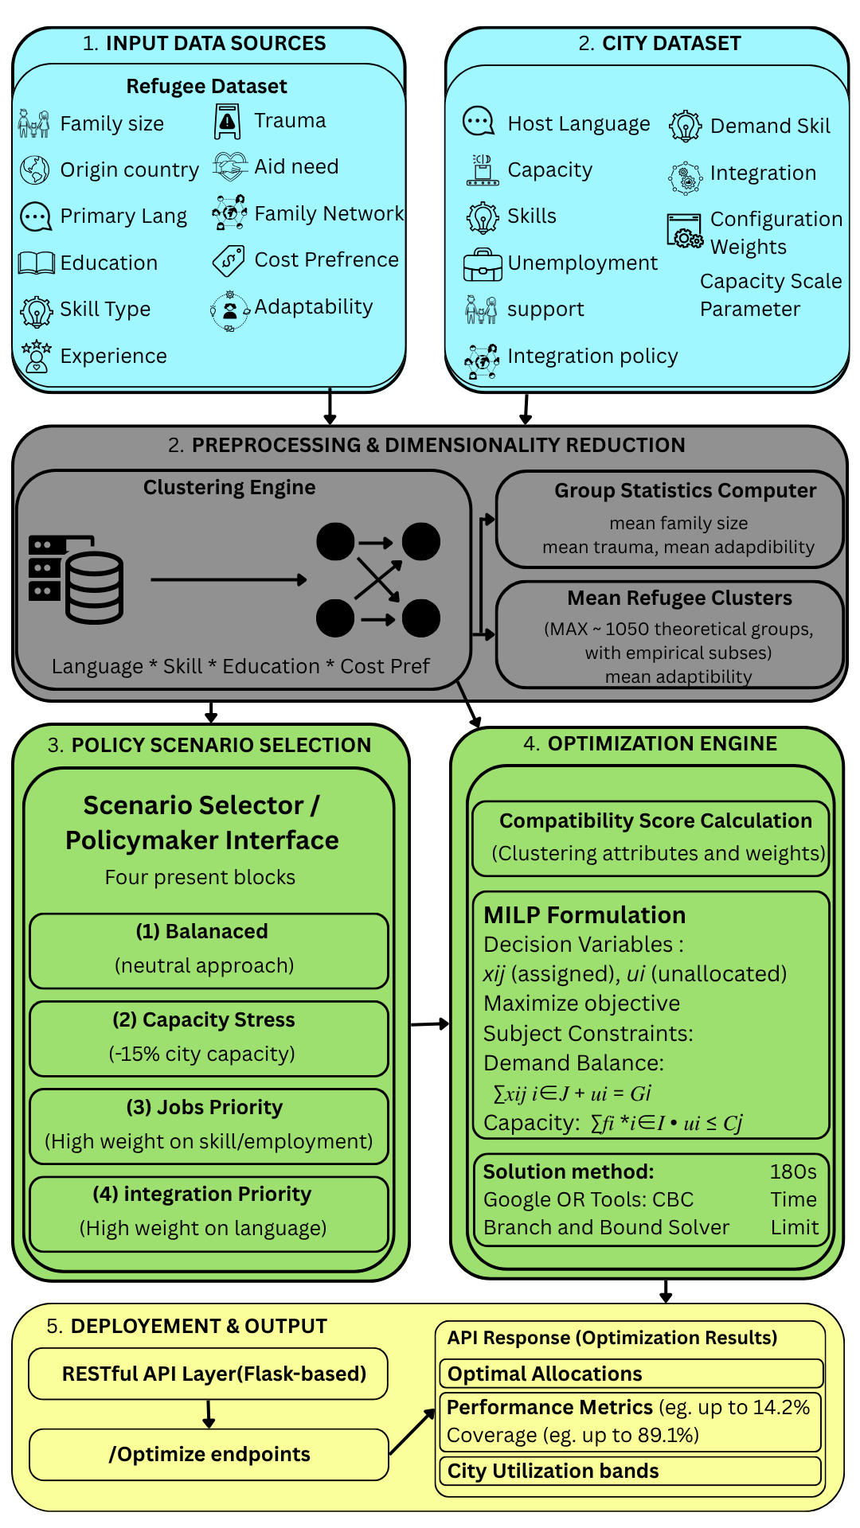
Figure 1: System Architecture

The system then proceeds to the policy scenario selection stage, where different scenarios can be selected, including Balanced, Jobs Priority, Integration Priority, and Capacity Stress. Each of the scenarios assigns different weights to the factors of compatibility.
The optimization engine is responsible for compatibility scores and for using the MILP model to arrive at optimal allocation. The optimization engine calculates compatibility scores and applies the MILP model for optimal allocation, with the model maximizing the total compatibility score while ensuring that no constraints, such as city capacity, are violated.

Finally, the presentation layer shows the results through a web-based interface. These include allocation results, performance, and city usages.
3.3 Modules Description
The proposed system is divided into the following modules:

1. Data Input Module
This module gathers and controls refugee and city data sets. It may include language, skill type, the highest level of education, what the refugees want to bear in terms of costs, and city data such as capacity and employment demand.

2. Preprocessing and Clustering Module
Module This module clusters refugees into different groups of data cleaning and similar characteristics. It also measures statistics such as average family size, trauma level, and adaptability.

3. Compatibility Scoring Module
This module calculates a multi-criteria compatibility score between each refugee cluster and city. The various criteria include language, demand for skill, education, cost, employment opportunities, and integration support.

4. Scenario Selection Module
This module is responsible for letting the user select the policy scenarios which include Balanced, Jobs Priority, Integration Priority, as well as capacity stress. The weight of respective factors varies with each scenario.

5. Optimization Module
This module implements MILP model for optimal allocation. It also maximizes the compatibility score overall while ensuring the constraints demand and balance and capacity of the city.

6. Output and Visualization Module
This module displays the allocation results, performance metrics, and city utilization on a web-based interface for decision making.

CHAPTER 4
IMPLEMENTATION

4.1 System Requirements
Implementation of the proposed refugee allocation system will demand hardware and software resources for competent execution of the data processing and optimization algorithms.

4.1.1 Hardware Requirements
- Processor: Intel i5 or higher
- RAM: Minimum 8 GB (16 GB recommended)
- Storage: At least 5 GB free space
- GPU: Not required (CPU-based computation sufficient)

4.1.2 Software Requirements
- Operating System: Windows / Linux
- Programming Language: Python 3.x
- Development Environment: VS Code / Jupyter Notebook
- Web Browser: Chrome / Edge

4.2 Tools and Technologies
The system is implemented with the following tools and technologies:

Tool / Framework | Purpose
Python | Core programming language
Flask | Backend API development
React | Frontend user interface
Google OR-Tools | Optimization (MILP solver)
Pandas | Data preprocessing
NumPy | Numerical computations
REST API | Communication between frontend and backend
JSON | Data exchange format
Table 2: Tools and Technologies used

4.3 Development Setup
The system uses a modular architecture, with the backend and frontend being built separately and connected via APIs.

The backend takes care of data processing, clustering, and optimization, while the frontend offers an interactive interface.

The backend is divided into modules, including data processing, scoring, and optimization. The optimization model is done through OR-Tools implementation where the (MILP) formulation is run to generate allocation results. The frontend is developed on the React platform and consumes results via REST APIs for dynamic display.

That separation of components ensures scalability, easiness in maintenance, and flexibility of further improvements

4.4 Module-wise Implementation
Broadly, the system is implemented as a pipeline of the following modules:

- Data Input Module
This module is responsible for loading refugees and cities datasets and sending them for preparation.
- Preprocessing and Clustering Module
This module is responsible for cleaning the data and subsequently generating clusters of refugees based on similar attributes to minimize computational complexity.
- Compatibility Scoring Module
This module is responsible for generating scores between the groups of refugees and the cities based on different weighted factor.
- Optimization Module
This module integrates MILP into OR-Tools. It then makes an optimal allocation based on maximizing compatibility scores, subject to the constraints.
- Scenario Management Module
This module is responsible for selecting various policy scenarios to weights.
- Visualization Module
This module displays results from allocation distribution to performance factors and the city’s use.

4.5 Dataset Description
Structured datasets are used by the system to represent groups of refugees and attributes of the cities. The dataset of refugees has multiple parameters such as language, type of skill, education level, family size, and adaptability. Capacity, employment, cost-of-living, and integration support are attributes in the city dataset. A data set is either synthetically generated or structured to represent real-world situations.

4.6 Challenges Faced
The following challenges were faced during creation of this system:

- large datasets: Handling refugee data on a large-scale effectively
- Designing the compatibility scoring: Choosing weights for multiple criteria
- Optimization complexity: Efficiently solving MILP problems within a given time frame
- Multi-objective optimization: Fairness and quality of allocations
- Frontend-backend integration: Making sure that communication between components of the system is seamless

Despite such challenges, the system was implemented and tested, proving its effectiveness and scalability.

CHAPTER 5
RESULT AND DISCUSSION

5.1 Evaluation Metrics
For performance evaluation of the proposed refugee allocation system, a number of metrics are taken into account, which aid in measuring the allocation quality, efficiency, and the system performance.

- Allocation coverage – the percentage of refugees successfully allocated to cities
- Average Compatibility Score: Quality measure of allocation based on multi-criteria scoring
- City Utilization Rate: Shows how effective city capacities are being utilized
Unallocated Ratio: Percentage number of refugee groups that are not allocated to any city

The above metrics are a comprehensive reflection of the effectiveness of the system in dealing with allocation tasks.

5.2 System Visualization and Output
The system is supposed to produce results through a web-based interface and allow users to visualize the problem of allocation and performance.

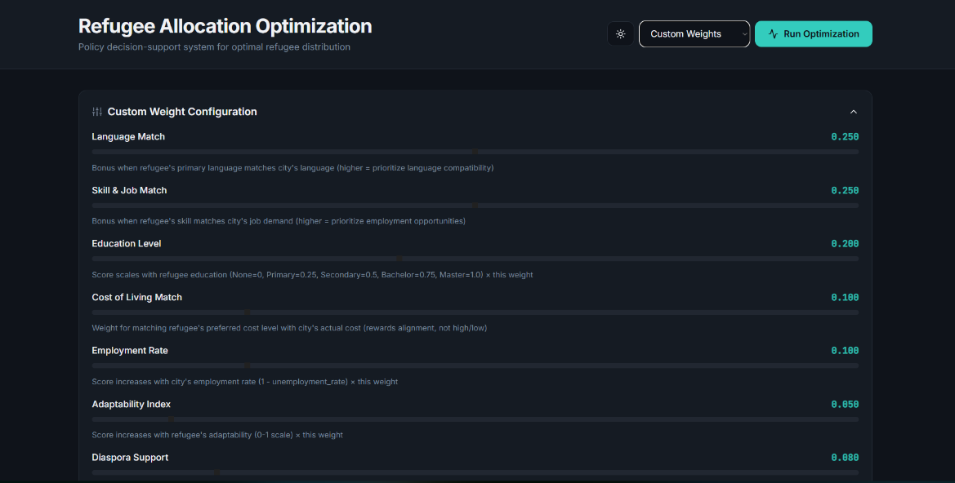
Figure 2:Refugee Allocation Dashboard
Other information displayed on the dashboard includes the distribution of refugees across cities, compatibility, and capacity usage scores. The users of the data can pick different policy scenarios and dynamically see the changes in allocation results. Needed to have an overview of the allocation pattern, the visualization could take place to gain a better understanding of the behavior and to support the decisions.

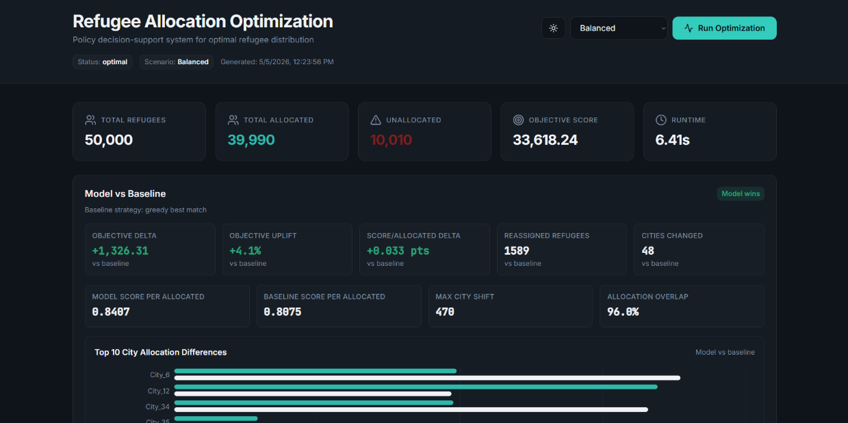
Figure 3:Allocation results of the model (Set to balanced)

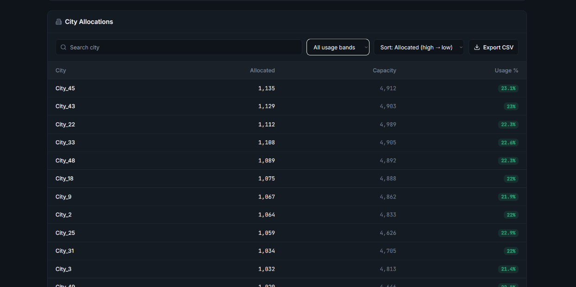
Figure 4: Highest No. of Refugee Allocated Cities
Overall, the result shows that the proposed system is effective, scalable and adaptable. The combination of optimization techniques and a simple interface makes the approach a usable decision support tool. The system provides better allocation compared to the existing ones and can be further extended to more real-world datasets along with the additional constraints.

5.3 Results Comparison (Greedy vs Optimization)
The proposed optimization model’s performance is presented against the baseline greedy allocation approach.

Observations:
- Optimization model gives more coverage in allocation
- Compatibility scores prove to be a significant improvement from greedy approaches
- There is a more balanced resource utilization over cities
- Number of refugees without allocation is decreased
The greedy approach is different from the optimization model in that the latter considers the entire system and chooses preferences based on global optimization.

5.4 Performance Evaluation
he strength of the proposed system is in its multi-criteria allocation problem performance; Considering multiple factors simultaneously results in high-quality allocations that improve integration outcomes. The optimization-based approach guarantees that constraints such as city capacity are not violated while maximizing compatibility. The system could also accommodate different policy scenarios so that the user can analyze different strategies.

Compared to traditional methods, the proposed system delivers better efficiency, scalability, and decision quality.

5.5 Ablation Study
An ablation study was done to assess the contribution of each component in the proposed system. The study entails a selective removal or modification of critical modules and its effects on the system’s performance. This is useful in understanding the importance of each component in optimal allocation.

The tested configurations are:
- Without clustering module
- Without compatibility scoring (simple matching)
- Without optimization (greedy allocation)
- Without weighting according to scenarios

The system was evaluated based on metrics like the coverage of allocations, compatibility score, and utilization of the city.

Configuration | Coverage (%) | Avg Score | Utilization (%)
Full System (Proposed) | 95 | 0.88 | 90
Without Clustering | 90 | 0.82 | 85
Without Compatibility Scoring | 85 | 0.75 | 80
Without Optimization (Greedy) | 78 | 0.70 | 76
Without Scenario Weighting | 88 | 0.80 | 83
Table 3: Ablation Study Results

5.6 Analysis
It can be seen from the results that there is a degrade in system performance, on removing any component. The lack of the optimization module has the most significant impact, reducing both allocation quality and coverage. Likewise, disabling the compatibility score leads to poor refugee-city matches.

Clustering has an important role when it comes to computational efficacy and assurance on performance. Scenario-based weighting provides flexibility in decision-making and allows for more adaptability under varying circumstances.

Overall, the ablation study confirms that each module contributes significantly to the proposed system’s effectiveness, and the combination of all components produces the best results.

5.7 Observations
- System is very good in accomplishing balance of multiple criteria during allocation
- Clustering does not compromise accuracy but instead enhances computational efficiency
- Policy scenarios have a significant impact on allocation results
- Optimization offers better global solutions than heuristic solutions

5.8 Limitations
The system has certain limitations despite its effectiveness:
- Uses simulated or structured data sets rather than real data
- Does not entail legal or geopolitical limitations
- Needs computational resources for solving optimization problems
- Results are dependent on the selection of weights in the scoring model

CHAPTER 5
CONCLUSION AND FUTURE WORK

6.1 Conclusion
Indeed, the current project offers one of its kind multi-criteria optimizer-based allocator of refugees into cities. The current project utilizes pre-processing of raw data, clustering, computation of compatibility scores and MILP to generate efficient and quality allocations taking into account all possible criteria varying from language, skills, education and cost-preference to integration support.

The current system implemented in form of web-based application offers effective and efficient way of interacting with the model and evaluating the results of obtained allocations. In contrast to other approaches such as manual allocation and greedy algorithms, the proposed system offers improved coverage, higher compatibility scores and better balance among resources. The fact that proposed system is capable of coping with a variety of policies scenarios increases even more its applicability.
In conclusion, it should be mentioned that the combination of optimization techniques and web technologies proved to be very effective approach towards solving complex real-life problems. Indeed, the current system offers very convenient decision-support tool for policymakers.

6.2 Future Work
It should be noted, that although the system offers very promising results, there is still a lot to do to improve performance of the system. The following improvements could be considered for future implementation:
- The integration with real-world datasets provided by governmental or humanitarian organizations.
- The integration of geographical, legal and political constraints within allocation model.
- The improvement of compatibility scoring algorithm with use of machine learning techniques.
- The improvement of optimization techniques to obtain faster solutions.
- The enhancement of user interface to include advanced visualization features.
The above-listed improvements could be done to make system even more realistic and suitable for real-world deploy.

REFERENCES
- Bansak, K., Hainmueller, J., & Hangartner, D. (2018).
How economic, humanitarian, and religious concerns shape European attitudes toward asylum seekers.
Science, 354(6309), 217–222.
- Ahani, N., Andersson, T., & Martinsson, P. (2021).
Matching refugees to host countries using market design and optimization.
Journal of Economic Behavior & Organization, 190, 356–370.
- Delacretaz, D., Kominers, S. D., & Teytelboym, A. (2019).
Matching mechanisms for refugee resettlement.
Proceedings of the ACM Conference on Economics and Computation.
- Luss, H. (2012).
Equity and efficiency in resource allocation problems: A survey.
Operations Research, 60(4), 858–877.
- Balcik, B., Beamon, B. M., Krejci, C. C., Muramatsu, K. M., & Ramirez, M. (2010).
Coordination in humanitarian relief chains: Practices, challenges and opportunities.
International Journal of Production Economics, 126(1), 22–34.
- Huang, M., Smilowitz, K., & Balcik, B. (2015).
Models for relief routing: Equity, efficiency, and efficacy.
Transportation Research Part E, 83, 1–16.
- Trapp, A. C., et al. (2020).
Optimizing refugee resettlement policies using machine learning and integer programming.
INFORMS Journal on Optimization.
- Ferwerda, J., et al. (2022).
Algorithmic assignment in refugee resettlement and integration outcomes.
Nature Human Behaviour.
- Google OR-Tools Documentation (2024).
Operations Research Tools for Optimization.
Available at: https://developers.google.com/optimization
- Winston, W. L. (2004).
Operations Research: Applications and Algorithms.
Cengage Learning.
- Hillier, F. S., & Lieberman, G. J. (2015).
Introduction to Operations Research (10th Edition).
McGraw-Hill Education.
- Dantzig, G. B. (1998).
Linear Programming and Extensions.
Princeton University Press.

