Table of Contents

TASK 1 - Environment Configuration

• Setting Up of User Profile
• Set up of User Terminal

TASK 2 – Working DOCKER images and NGC container

• Log in to NGC Dashboard
• Generate NGC Organization API Key
• Verify the Availability of Available Docker Images (before pulling GitHub and Friend Images)
• Pull and run the TensorFlow container
• Pull and run the PyTorch container
• Pull and run use-case-based container

TASK 3 – Install and pull packages from DOCKER hub

• Push the self project image to DOCKER HUB
• Pull and run the self project image
• Pull and run the friend docker image
• Verify the list of docker images after pulling operation

TASK 4 – Implementation and execution of kubernetes

• Nodes and pods verification after minikube installation
• YAML configuration to pull and deploy self project image
• Deployment scaling (Up-scale and down scale)
• Secret YAML creation and deployment using secret
• Secrets verification and implementation
• Scale operations on secrets based deployment(up scale and down scale)

Oracle VirtualBox Setup and Ubuntu
Oracle VM VirtualBox is a virtualization application that allows users to operate multiple operating systems on a single computer. In this setup, Ubuntu Linux was installed within VirtualBox to establish a virtual Linux environment. This environment is used to:

- Practice operating system and command-line operations
- Create a secure and isolated testing platform

Installing Oracle VirtualBox

Steps:

1: Go to https://www.virtualbox.org
2: Download the installer for Windows hosts.
3: Open the installer file and click Next to begin setup.
4: Leave the default configuration settings and proceed with installing all required components.
5: Approve the installation of the network drivers when prompted.
6: Click Finish to complete the installation process.

Download Ubuntu

Steps:

1: Visit https://ubuntu.com/download/desktop\

2: Download the Ubuntu 22.04 LTS ISO file.

Creating Ubuntu Virtual Machine

Steps:

1: Launch VirtualBox and select New.

2: Provide the following details:
- Name: Ubuntu
- Type: Linux
- Version: Ubuntu (64-bit)
3: Assign memory (RAM):
- Minimum: 2048 MB
- Recommended: 4096 MB
4: Set up a virtual hard disk:
- Disk Type: VDI (VirtualBox Disk Image)
- Storage Allocation: Dynamically allocated
- Disk Size: Between 20–25 GB

Installing Ubuntu

Steps:

1: Choose the created virtual machine and click Start.
2: Select the downloaded Ubuntu ISO file when prompted.
3: Click on Install Ubuntu.
4: Choose the Normal Installation option.
5: Select Erase disk and install Ubuntu (this will only modify the virtual disk, not your actual system).
6: Create a username and set a password.
7: Wait until the installation finishes, then restart the virtual machine.

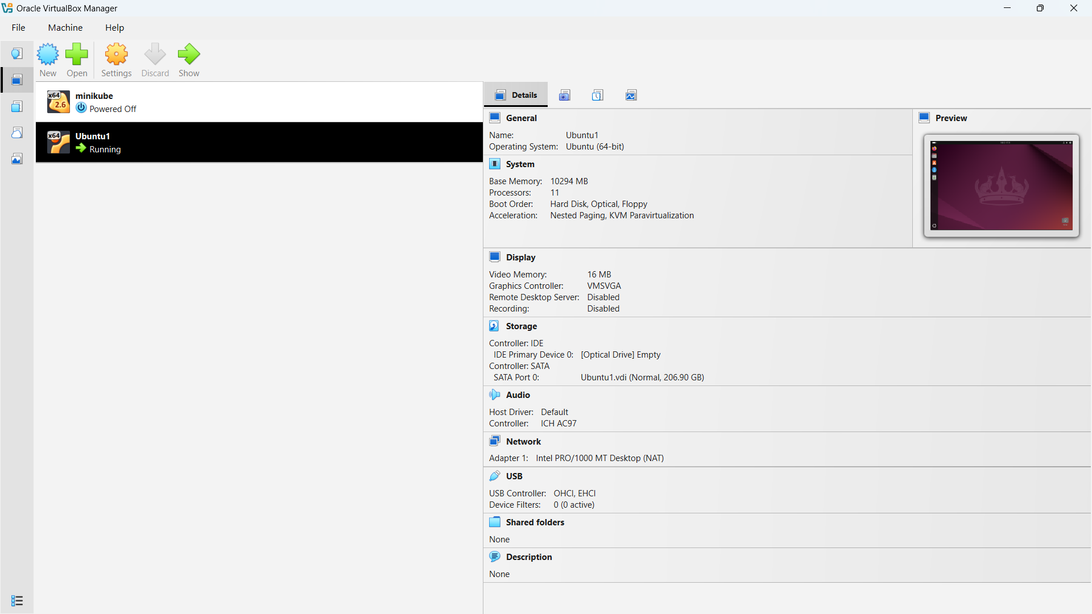

Figure 1: Ubuntu OS installed in a VM

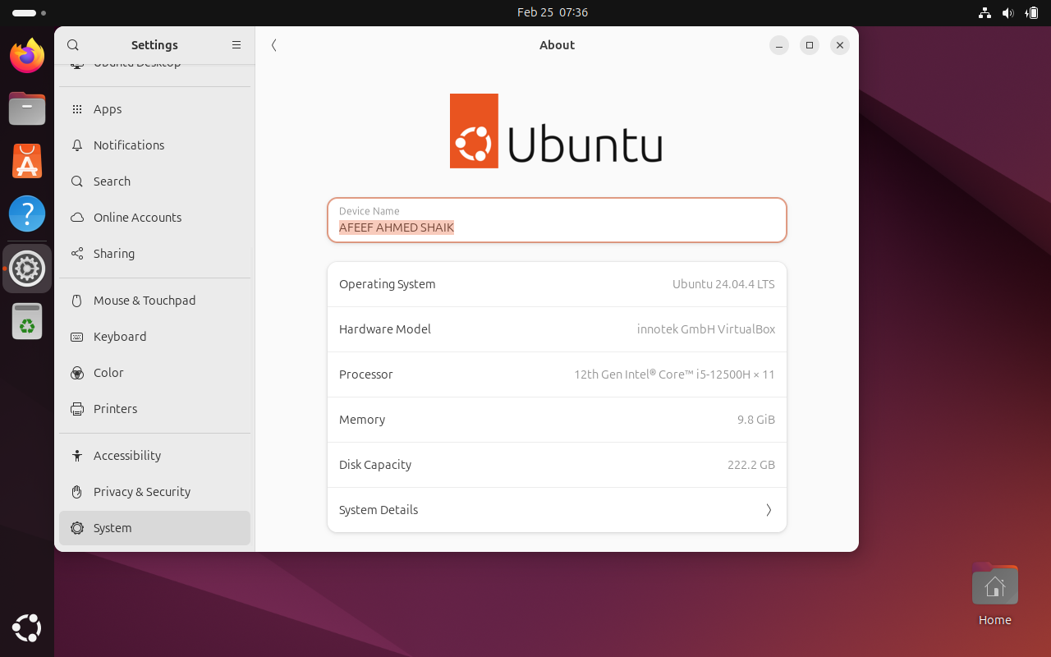

Figure 2: USER PROFILE

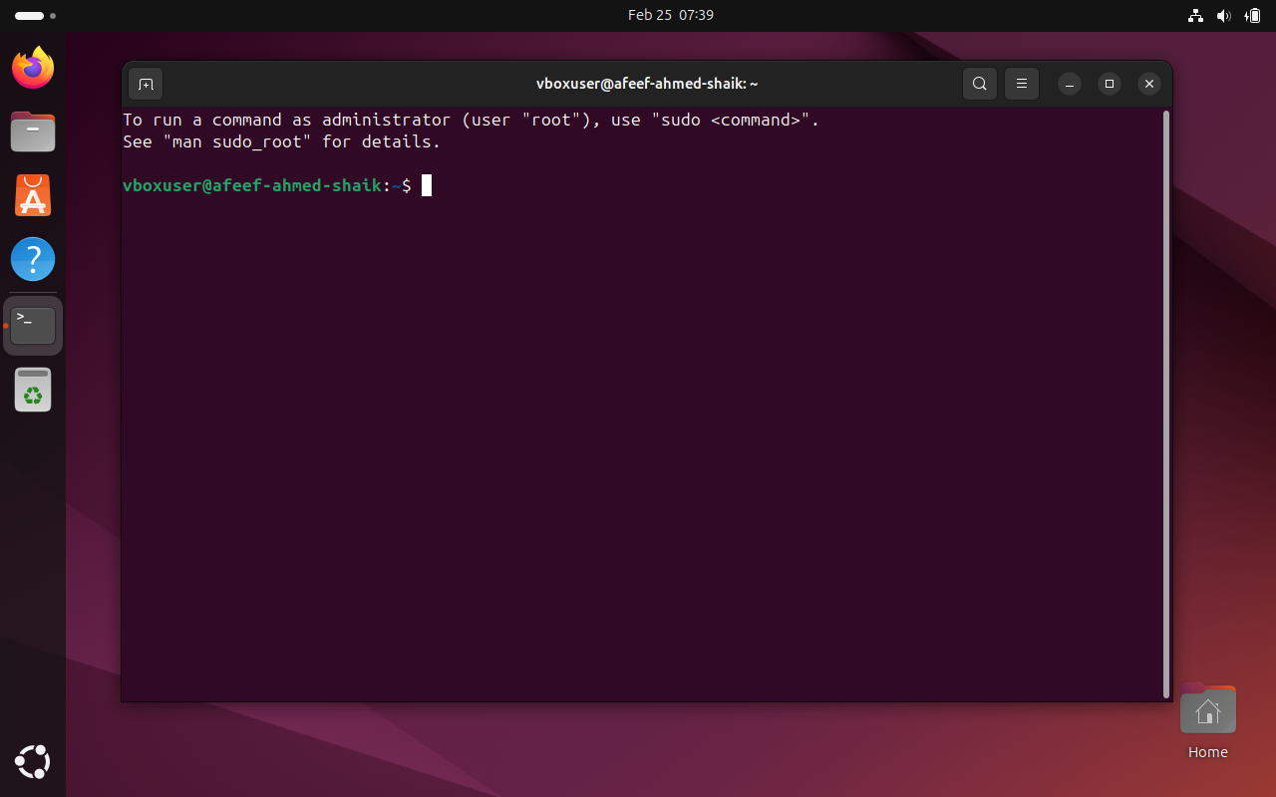

Figure 3: USER TERMINAL

Task 2 : Working Docker Images and NGC Container

NVIDIA NGC Login and API Key Generation

An NVIDIA NGC account was created to access GPU-enabled containers available in the NVIDIA Container Registry. An API key was generated and used to authenticate Docker, allowing the system to download NGC containers securely.

Step 1: Create NVIDIA NGC Account
- Open a web browser.
- Go to: https://ngc.nvidia.com
- Click on Sign In.
- Choose Create Account.
- Complete the registration form and verify your email address to activate the account.

Step 2: Generate NGC API Key
- Sign in to the NVIDIA NGC dashboard.
- Click on your User Profile icon.
- Select API Key option.
- Click on Generate API Key.
- Copy the generated key and store it securely for future use.

Step 3: Login to NGC Using Docker (Ubuntu Terminal)

In the Ubuntu terminal, run the following command: Code: docker login nvcr.io
When prompted, enter the following credentials:
- Username: $oauthtoken
- Password: Paste the generated NGC API key
If the login process is successful, the terminal will display:
Login Succeeded
This confirms that the system is successfully authenticated and can now pull containers from the NVIDIA NGC registry.

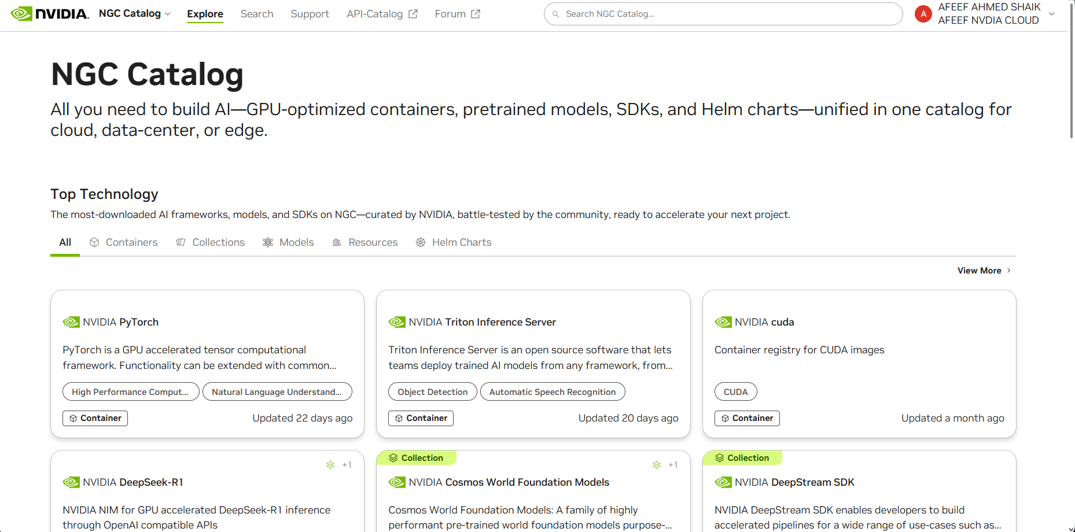

Figure 4: NVIDIA NGC USER DASHBOARD

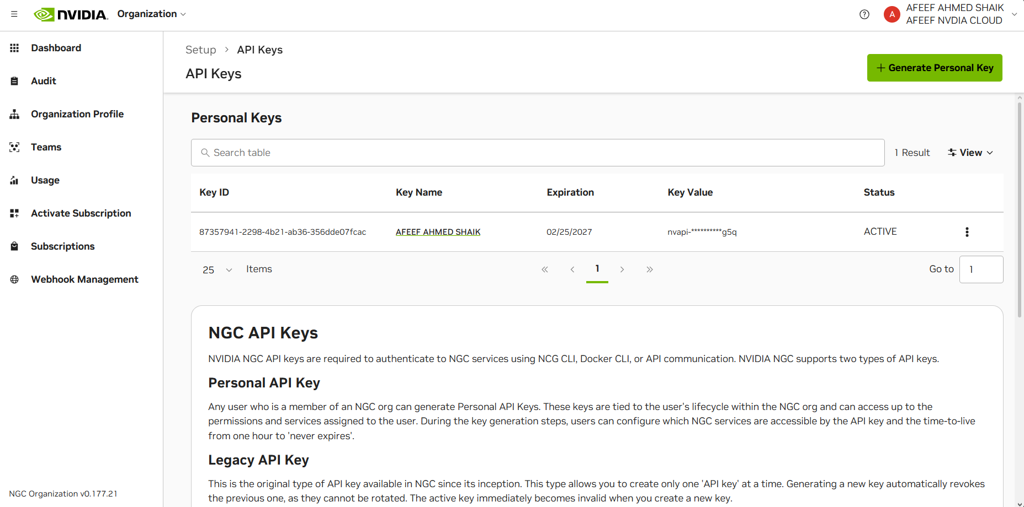

Figure 5: NVIDIA NGC API ORGANIZATION DASHBOARD

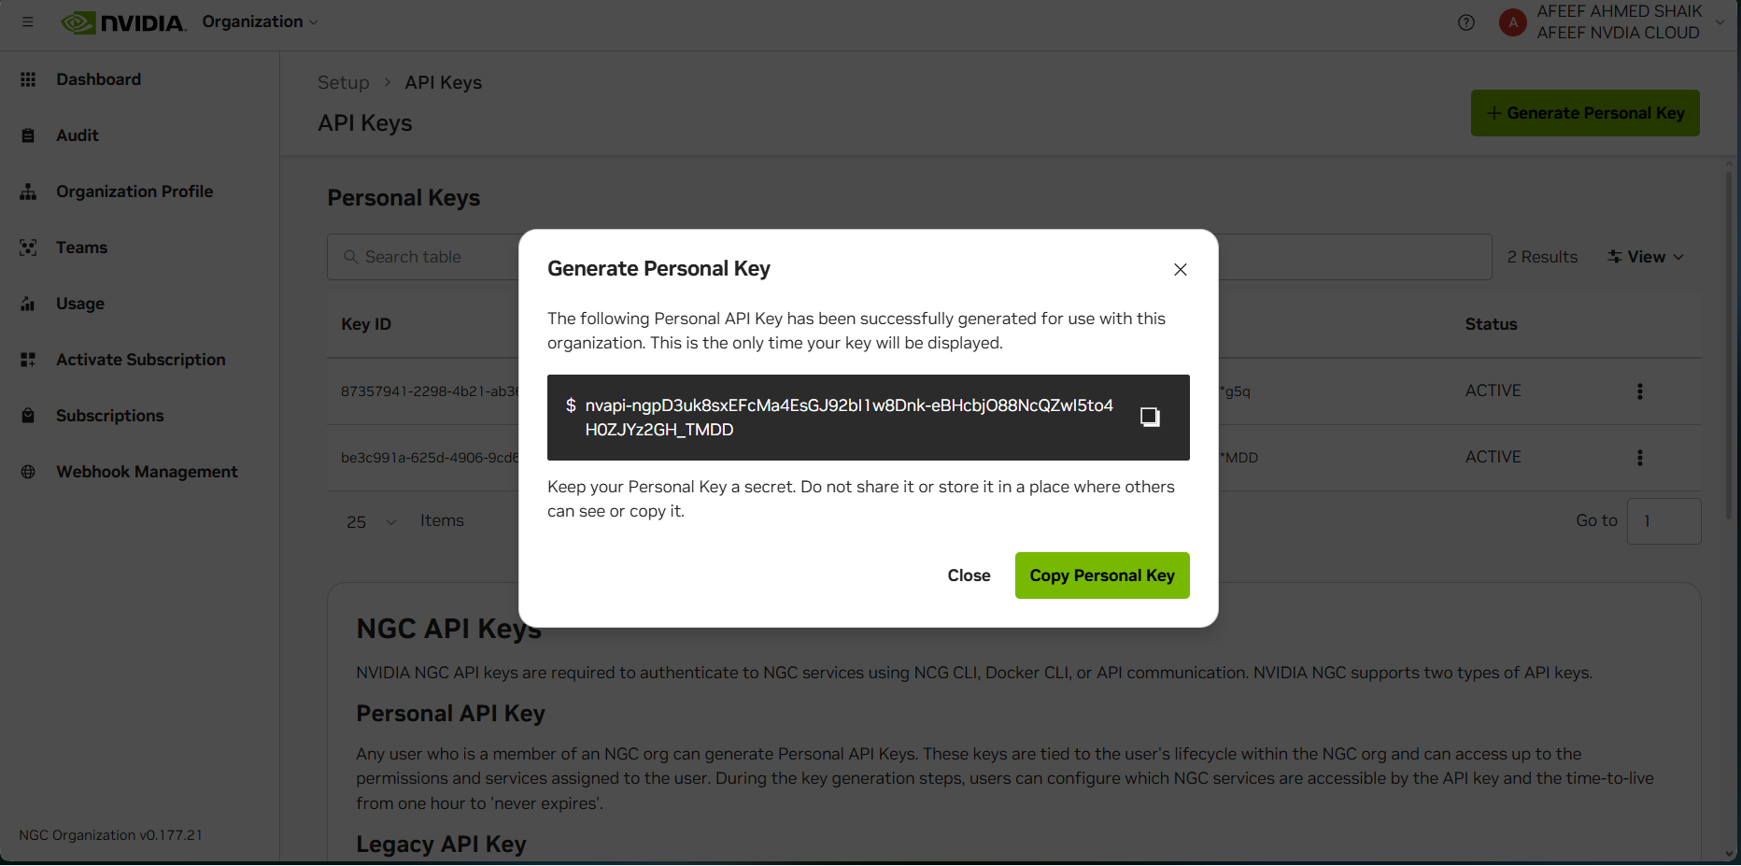

Figure 6: NVIDIA NGC API KEY GENERATION

Docker Images Before Pulling GitHub and Friend Images

Before downloading any new Docker images, the existing images were checked to understand the current status of the Docker environment.

The following command was executed:

docker images

This command lists all Docker images stored locally on the system. It provides details such as the repository name, tag, image ID, date of creation, and image size.

By running this command, it becomes easier to verify which images are already available and to identify any newly downloaded images afterward.

At this point, only previously pulled images (for example, NVIDIA container images) were present in the system. No custom images created by the user or peers had been downloaded yet.

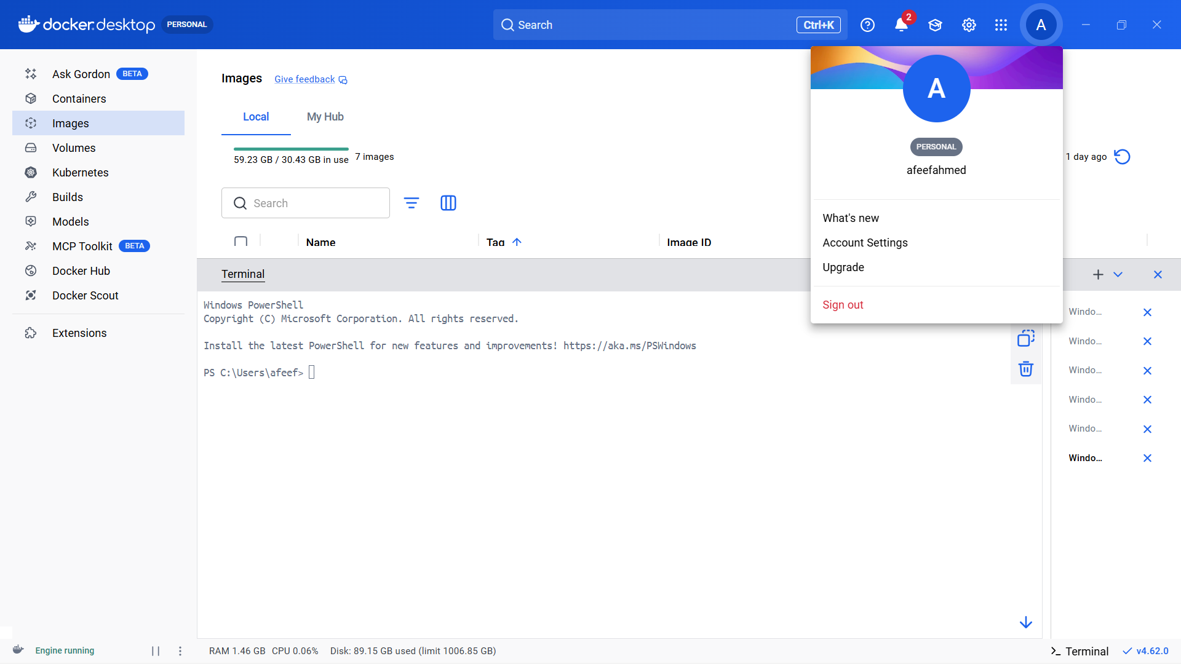

Figure 7: Docker Images Before Pulling GitHub and Friend Images

TensorFlow Container Pull & Program Execution

The TensorFlow container was obtained from the NVIDIA NGC registry to set up a pre-configured deep learning environment within Docker. This container already includes Python, TensorFlow, and all necessary libraries, removing the need for manual installation of dependencies.

docker pull nvcr.io/nvidia/tensorflow:25.10-tf2-py3

Once the download was complete, the container was launched in interactive mode using:

docker run -it nvcr.io/nvidia/tensorflow:25.10-tf2-py3

This command opened an interactive Python session inside the container.

To confirm that TensorFlow was installed properly and functioning as expected, the following Python commands were executed:

import tensorflow as tf
print("TensorFlow Version:", tf. version )
print("GPU Available:", tf.config.list_physical_devices('GPU'))

The output displayed the installed TensorFlow version and indicated that the container was running correctly. Since the system does not include an NVIDIA GPU, the GPU list was empty, which confirms that TensorFlow was operating in CPU mode.

This verified that the TensorFlow container was successfully downloaded and executed within the Docker environment.

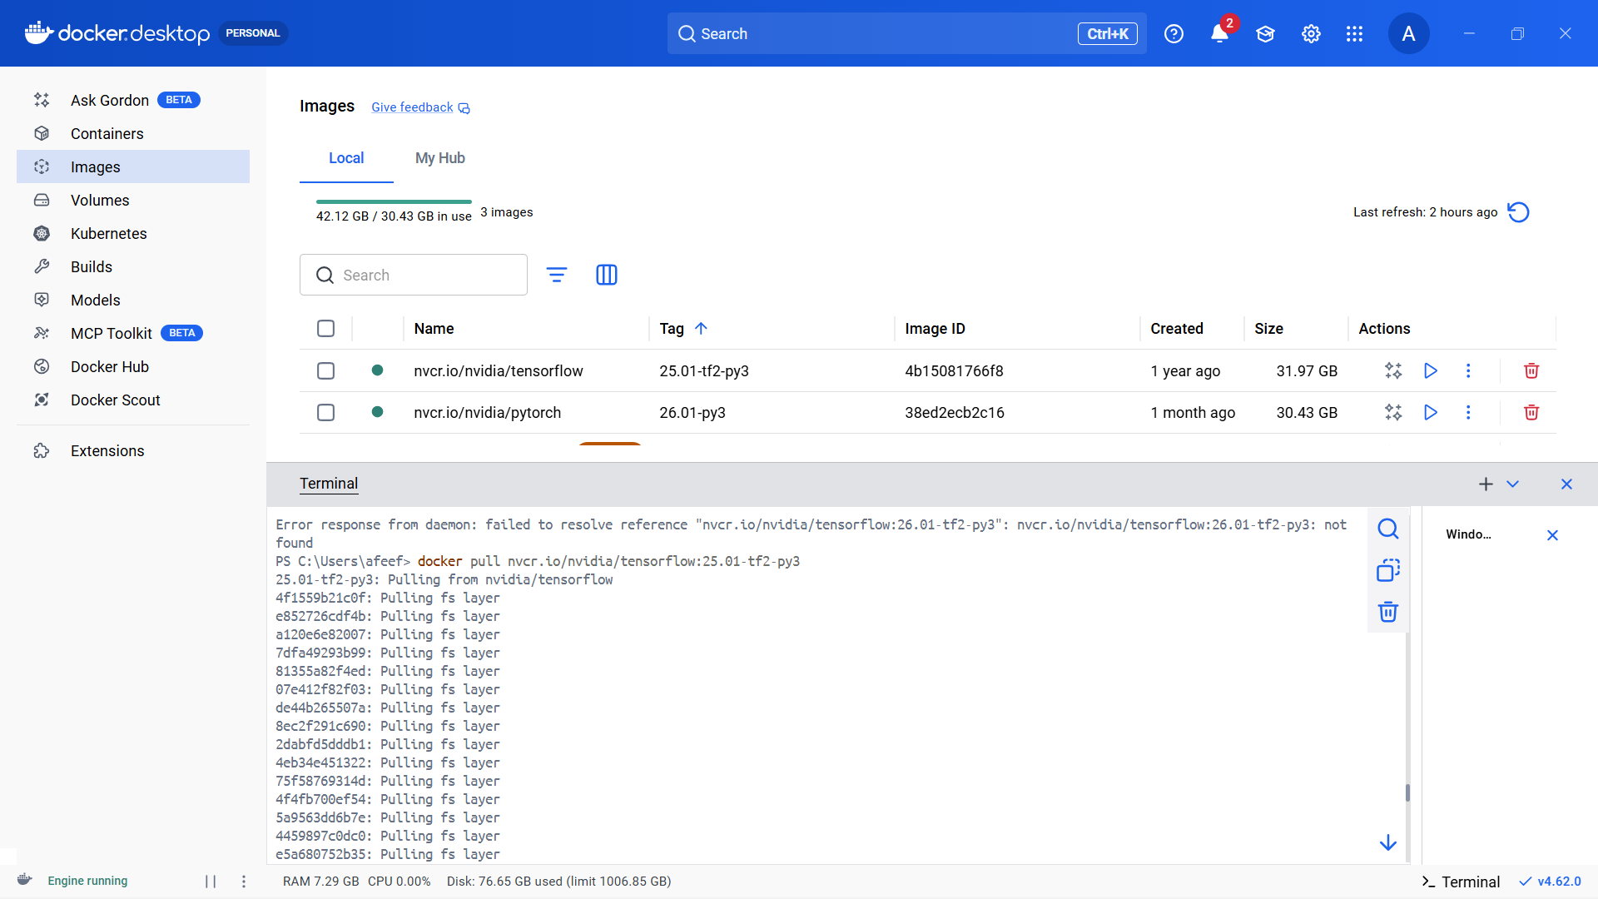

Figure 8: TensorFlow Container Pull

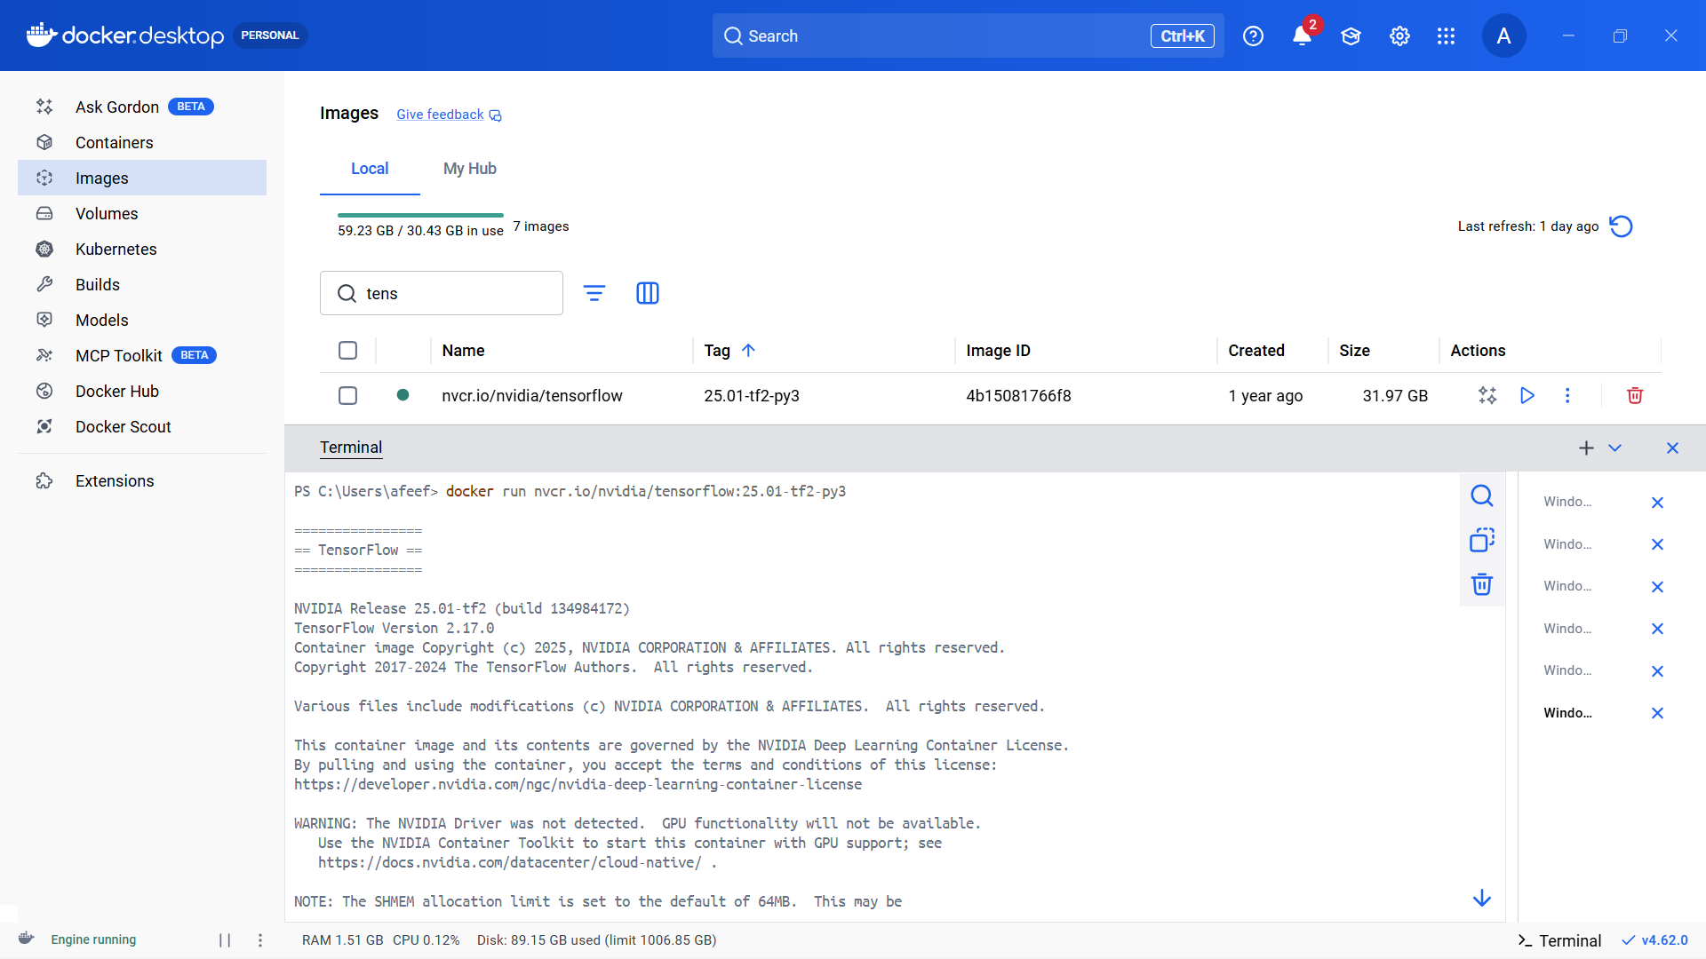

Figure 9: TensorFlow Container Run

PyTorch Container Pull & Program Execution

The PyTorch container was downloaded from the NVIDIA NGC registry to set up a ready-to-use deep learning environment within Docker. This container comes pre-installed with Python, PyTorch, CUDA libraries (if a compatible GPU is available), and all necessary dependencies, eliminating the need for manual configuration.

The image was pulled using the following command:

docker pull nvcr.io/nvidia/pytorch:26.10-py3

After the download was completed successfully, the container was launched in interactive mode with:

docker run -it nvcr.io/nvidia/pytorch:26.10-py3

This command opened a Python terminal inside the container environment.

To ensure that PyTorch was correctly installed and working properly, the following Python commands were executed:

import torch
print("PyTorch Version:", torch. version ) print("GPU Available:", torch.cuda.is_available())

The output displayed the installed PyTorch version and indicated whether GPU acceleration was available. Since the system does not have an NVIDIA GPU, the result returned False, confirming that PyTorch was running in CPU mode.

This verified that the PyTorch container was successfully downloaded and executed within the Docker environment.

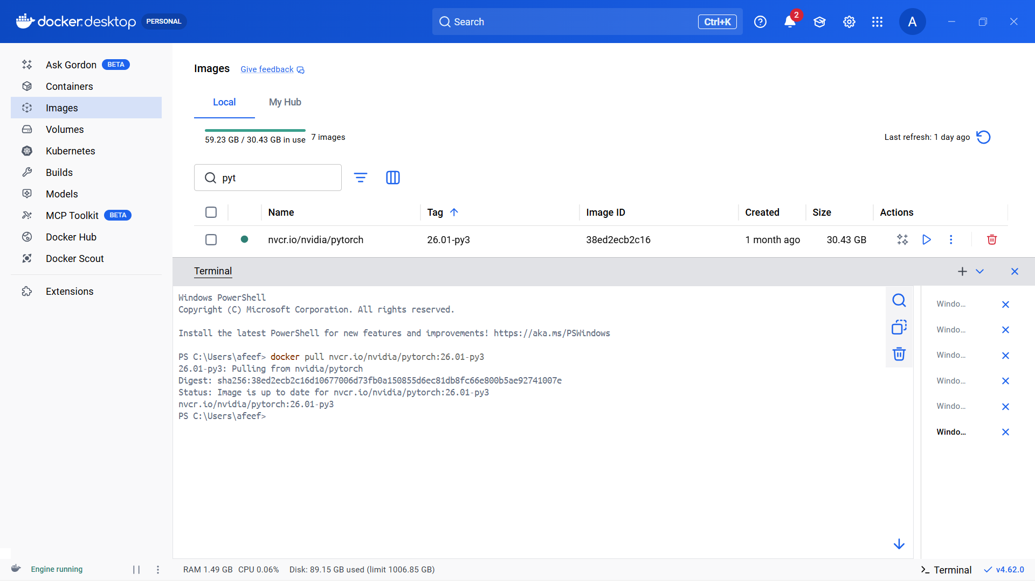

Figure 10: PyTorch Pull

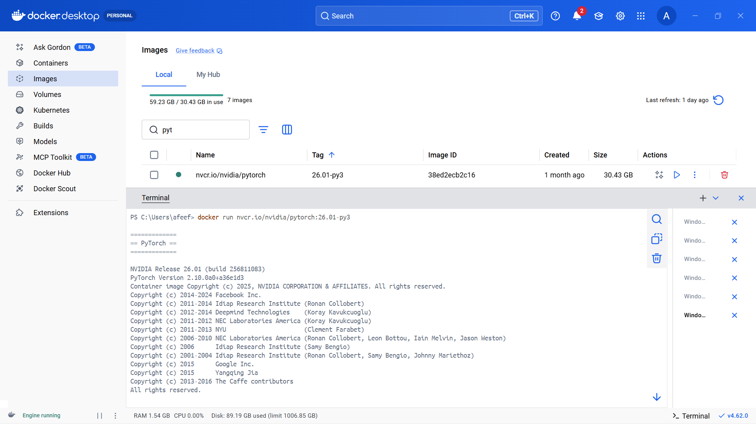

Figure 11: PyTorch Run

Use Case Container Setup Using NGC Pull and Run

The Triton Inference Server container was utilized as a practical example to demonstrate how NVIDIA NGC containers can be downloaded and executed using Docker. This container is specifically designed to deploy and serve AI models in production environments and includes optimized libraries for efficient and high-performance inference.

The container image was pulled from the NVIDIA NGC registry with the following command:

docker pull nvcr.io/nvidia/tritonserver:24.10-py3

After the image was successfully downloaded, the container was launched to confirm that it operates correctly:

docker run nvcr.io/nvidia/tritonserver:24.10-py3

Once the container started, initialization logs appeared on the terminal, indicating that the Triton Inference Server was starting successfully. These logs verified that the container was functioning properly.

Triton Inference Server is widely used to deploy and manage trained machine learning models, enabling applications to send inference requests and receive real-time predictions. This experiment demonstrated how an NGC container can be effectively used for real-world AI model serving and deployment.
correctly:

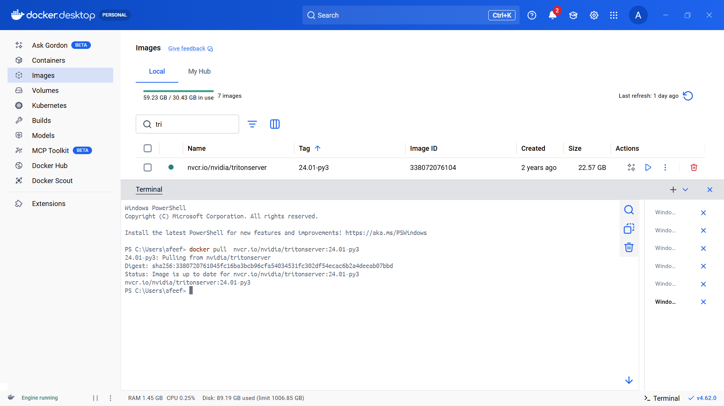

Figure 12: Use Case Container Pull

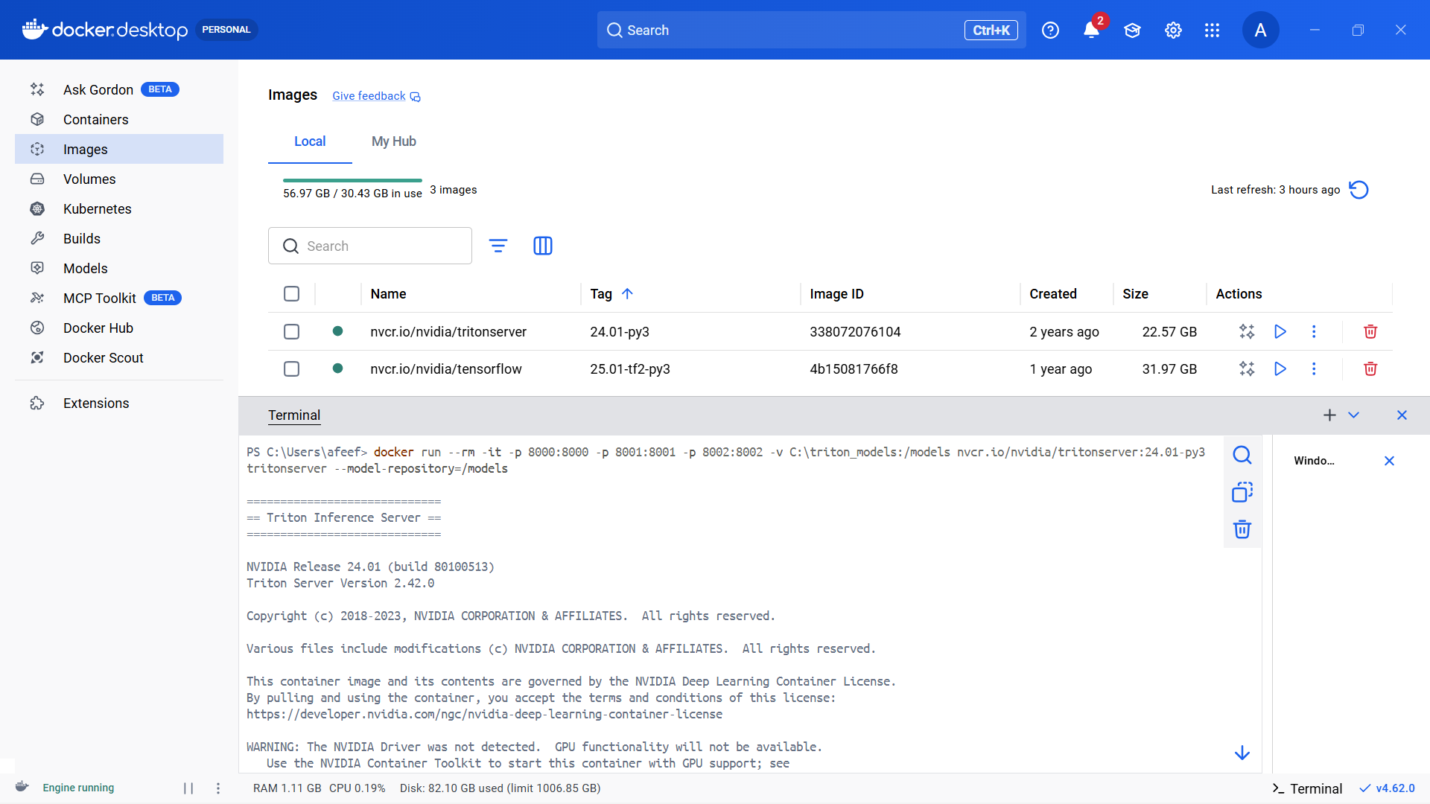

Figure 13: Use Case Container Run

Task 3 : Installition and Pulling Packages from DOCKER Hub

Self Project Pushed in Docker Hub

The personal project was containerized and uploaded to Docker Hub to allow it to be shared, deployed, and executed on any system that has Docker installed.

First, a Docker image was created from the project directory using the Dockerfile with the following command:

build -t fitnessapp .

After successfully building the image, it was tagged with the Docker Hub username and version number to prepare it for uploading:

docker tag fitnessapp afeefahmed/fitnessapp:v1

Next, Docker Hub authentication was completed by running:

docker login

Once logged in, the image was pushed to the Docker Hub repository using:

docker push afeefahmed/fitnessapp:v1

During the push operation, Docker uploaded the image layers to the Docker Hub repository. A digest message confirmed that the upload was completed successfully.

This process ensures that the containerized project can be downloaded and executed on any system, providing portability and simplifying deployment.

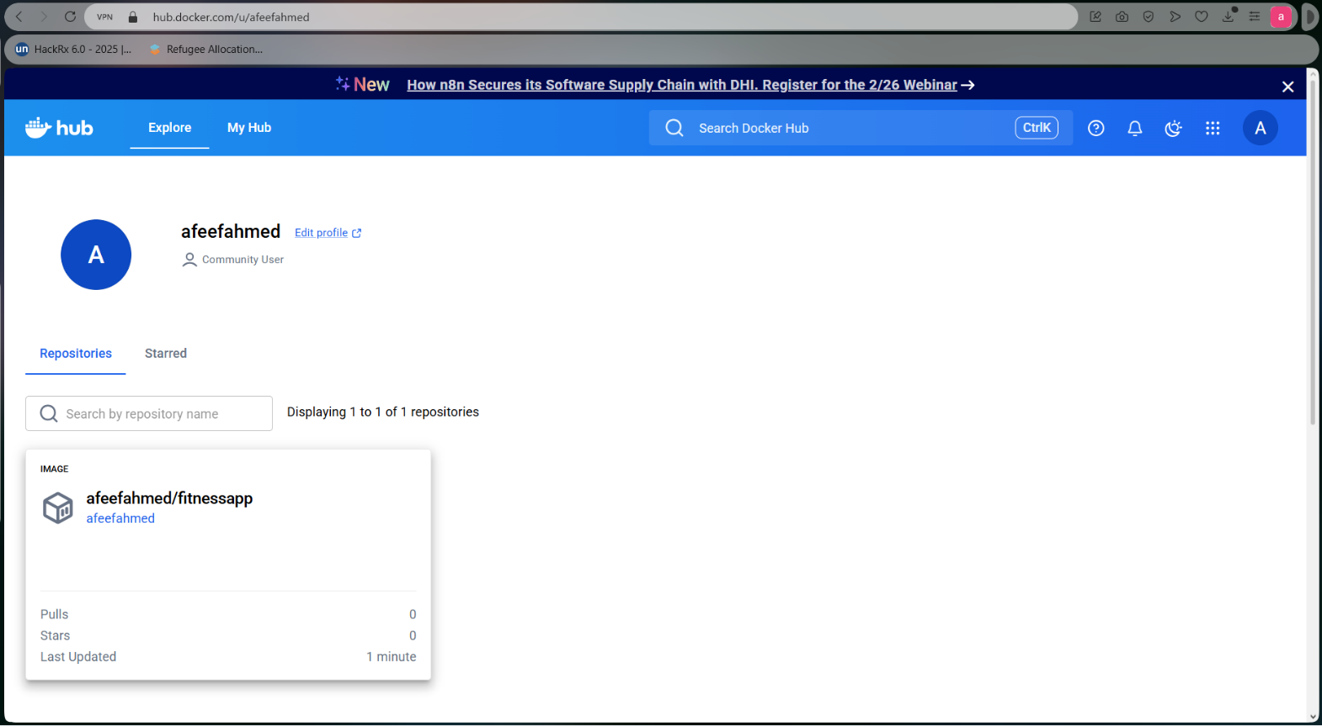
Figure 14: Self Project Pushed in Docker Hub

Pulling Self Image and Running Self Image

The project image that was previously uploaded to Docker Hub was pulled again to verify that it can be downloaded and executed on any system. Pulling the image confirms its availability in the remote repository and ensures portability across different environments.

The image was downloaded using the following command:

Docker pull afeefahmed/fitnessapp:v1

After the download was completed, Docker displayed a message indicating that the image was successfully retrieved or was already up to date.

Next, the container was launched to run the application:

docker run afeefahmed/:v1

Since the project is a web-based application, it was executed with port mapping to allow access through a web browser:

docker run -p 8600:8600 afeefahmed/fitnessapp:v1

Once the container started running, the application became accessible at:
http://localhost:8600
This confirmed that the project image was successfully pulled from Docker Hub and executed correctly, demonstrating container portability and simplified deployment across systems.

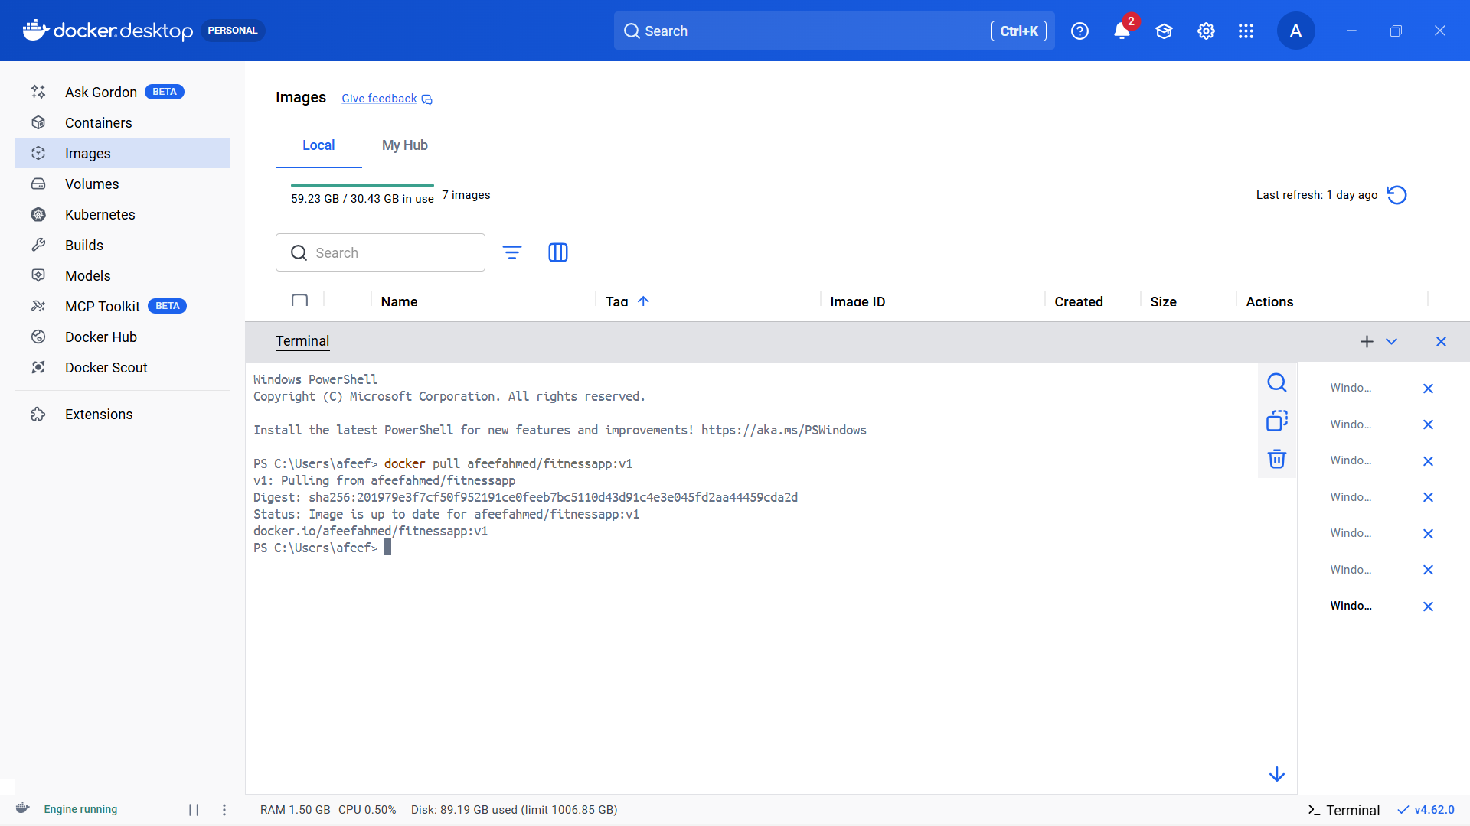

Figure 15: Pulling Self Image

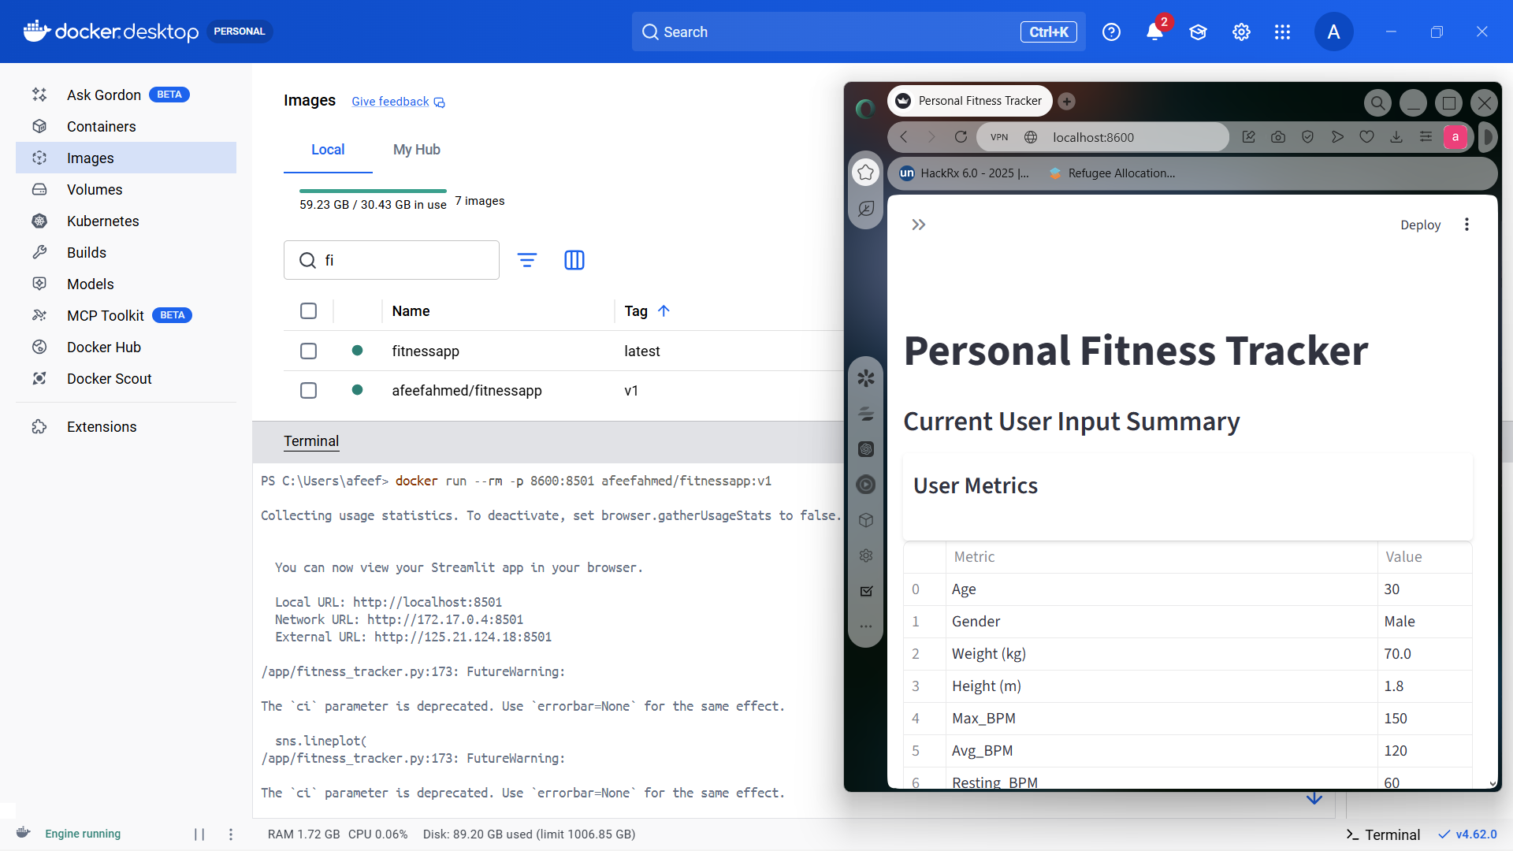
Figure 16: Running self-image

Pulling and Running Friend Image

The Docker image shared by a friend was pulled from Docker Hub to verify that containers published by other users can be successfully downloaded and executed. Pulling the image confirms that the application can be reproduced on different systems without requiring manual installation or configuration.

The image was downloaded using the following command:

docker pull afeefahmed/fitnessapp:v1

After the process completed, Docker displayed a confirmation message indicating that the image was successfully retrieved.

Next, the container was executed to launch the application:

docker run afeefahmed/fitnessapp:v1

If the application includes a web-based interface, it can be started with port mapping to allow browser access:

docker run -p 8600:8600 afeefahmed/fitnessapp:v1

Once the container began running, the application operated successfully. This demonstrated that Docker images shared by other users can be easily pulled and executed, highlighting container portability and collaboration through Docker Hub.

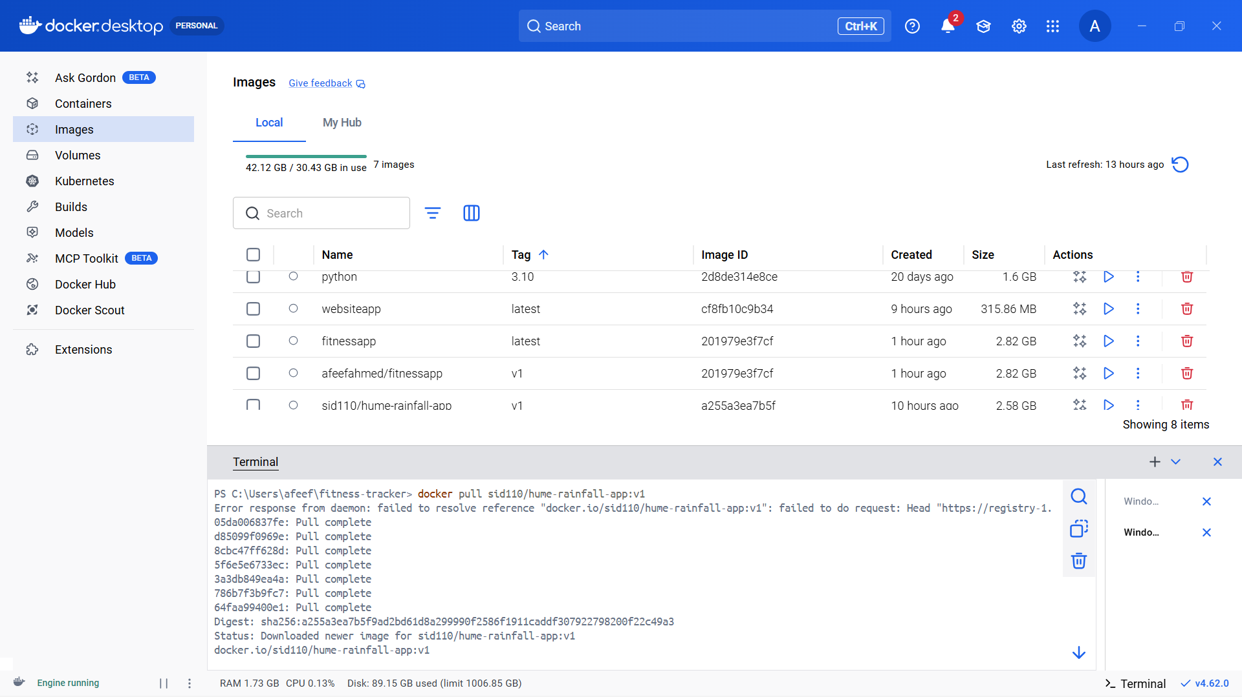

Figure 17: Pulling Friend Image

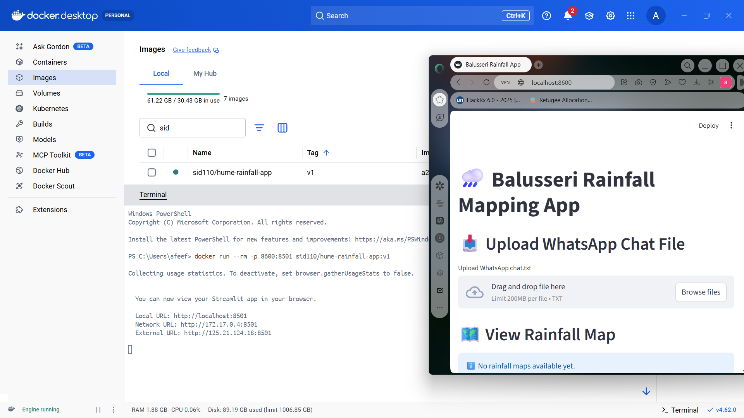

Figure 18: Running Friend Image

Docker Images After All Pulls

After downloading all the required containers, the list of Docker images was checked to ensure that every image was successfully pulled and stored locally. This step confirms that the TensorFlow, PyTorch, Triton Server, self project image, and friend’s image are available in the system.

The following command was executed:

docker images

This command displays all locally stored Docker images along with important details such as:
- Repository name
- Tag (version)
- Image ID
- Creation date
- Image size
The output included images such as:
- NVIDIA TensorFlow container
- NVIDIA PyTorch container
- Triton Inference Server container
- Self project image from Docker Hub
- Friend’s shared Docker image
This verification step ensured that:
- All required images were downloaded successfully
- The images are stored locally in the Docker environment
- The containers are ready to be executed whenever needed
This confirms the successful completion of the image pulling process and proper setup of the Docker environment.

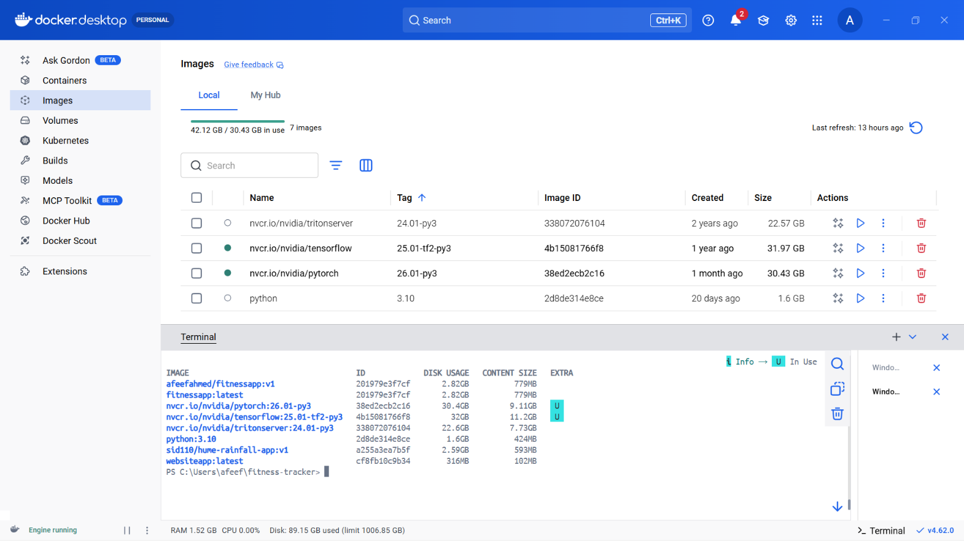

Figure 19: Docker Images After All Pulls

Task 4 : Implementing and executing Kubernetes

CHECKING NODES & PODS AFTER INSTALLING MINIKUBE

After installing Minikube, the Kubernetes cluster was started to create a local single-node environment for deploying containerized applications.
The cluster was initiated using the command:

minikube start

This command performs the following actions:
- Creates a local Kubernetes cluster
- Uses the Docker driver to set up a virtual node
- Automatically configures kubectl to communicate with the cluster
Once the startup process was completed successfully, the cluster status was verified.
To check whether the node was running properly, the following command was executed:

kubectl get nodes

The output displayed the minikube node with the status Ready, confirming that the cluster was successfully initialized.
Next, all running pods across namespaces were checked using:

kubectl get pods -A

This command listed the essential system pods required for Kubernetes operations, including:
- kube-apiserver
- kube-controller-manager
- kube-scheduler
- Other core Kubernetes services
These verification steps confirmed that:
- Minikube was started successfully
- The Kubernetes node was in a Ready state
- All system components were functioning properly
This ensured that the local Kubernetes cluster was fully operational and ready for deploying containerized applications.

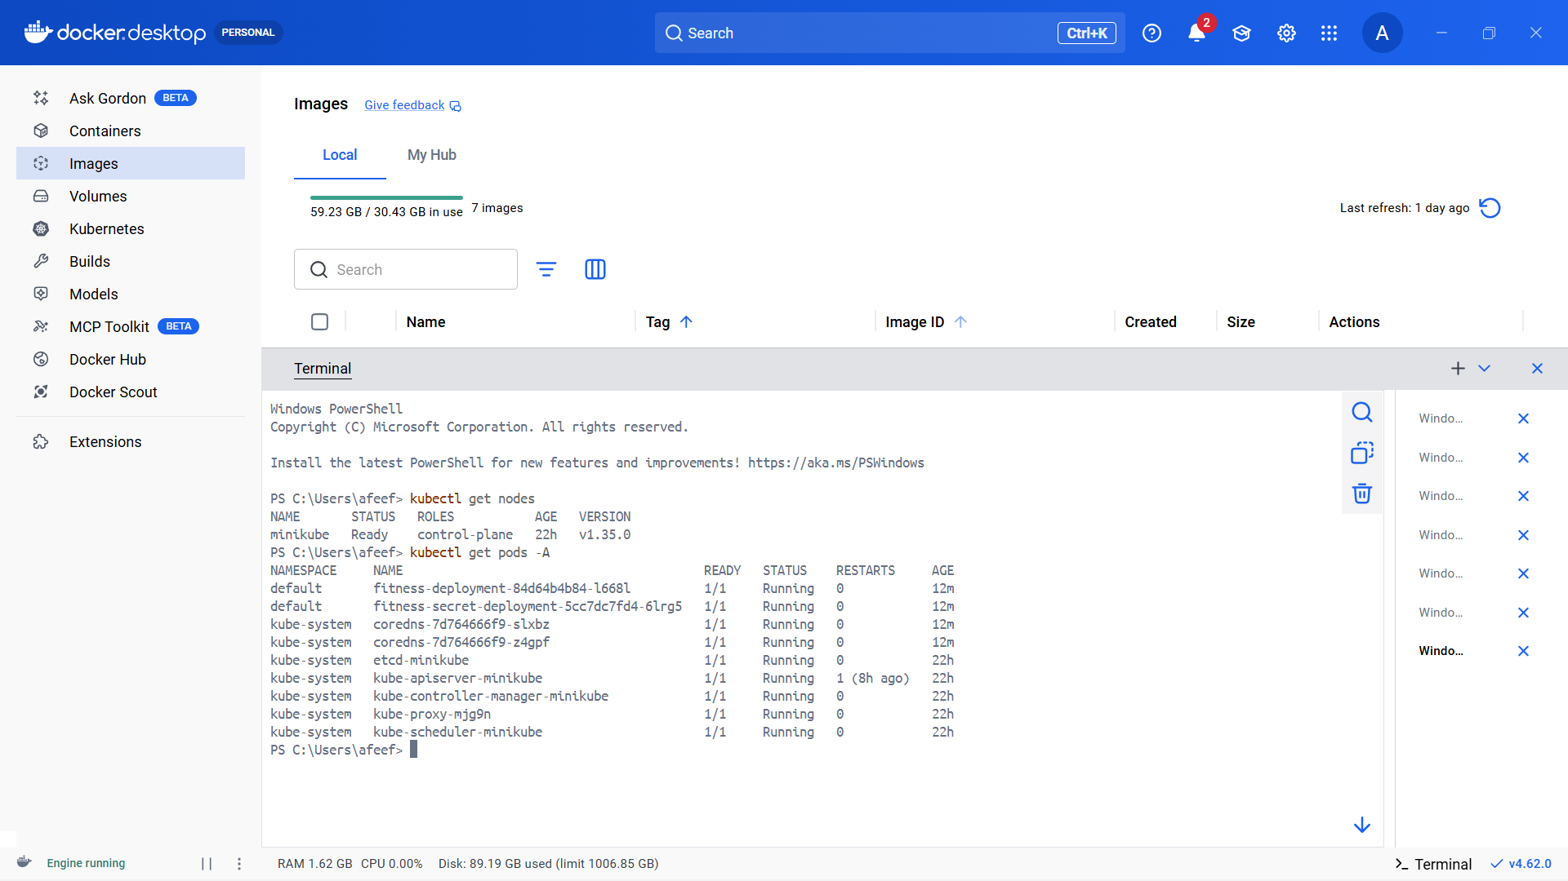

Figure 20: Checking Nodes & Pods After Installing

YAML DEFINING FOR SELF PULL

A Kubernetes deployment YAML file was created to deploy the self project image from Docker Hub into the Minikube cluster. This configuration file specifies the desired state of the application, including details such as the container image, number of replicas, and port settings.
When this YAML file is applied, Kubernetes automatically:
- Pulls the specified container image from Docker Hub
- Creates the required pods
- Maintains the defined number of replicas
- Ensures the application runs according to the configuration
The deployment configuration was saved in a file named:

apiVersion: apps/v1
kind: Deployment
metadata:
name: fitness-deployment
spec:
replicas: 1
selector:
matchLabels:
app: fitnessapp
template:
metadata:
labels:
app: fitnessapp
spec:
containers:
- name: fitness-container
image: afeefahmed/fitnessapp:v1
ports:
- containerPort: 8501

This configuration directs Kubernetes to create a single replica of the container using the self project image available on Docker Hub.
Once the deployment is applied, Kubernetes automatically downloads the specified image (if not already present) and launches it within the cluster.
This ensures that the application runs according to the defined configuration inside the Minikube environment.

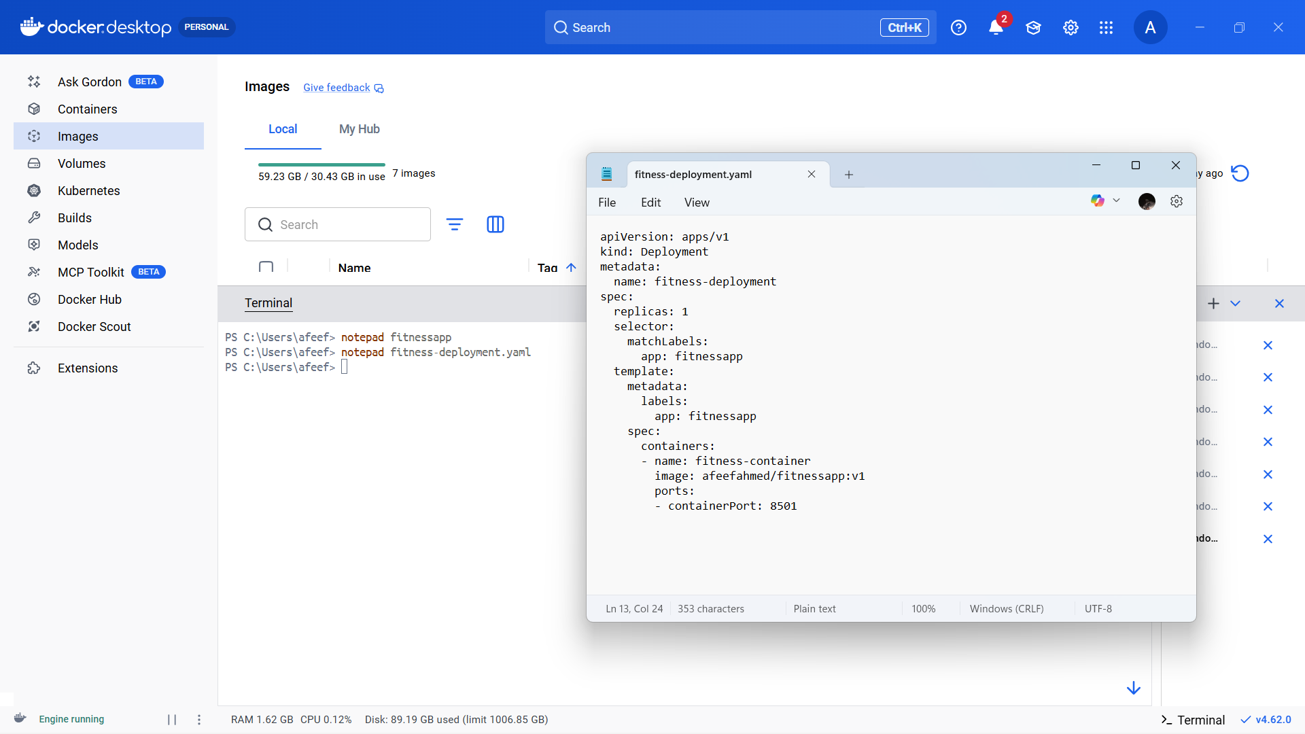

Figure 21: Yaml Defining For Self Pull

SELF PULL EXECUTION

After preparing the deployment YAML file, it was applied to the Minikube cluster to deploy the self project image. This step instructs Kubernetes to retrieve the image from Docker Hub and create the necessary pod.

The deployment was executed using the following command:

kubectl apply -f fitness-deployment.yaml

When this command was run, Kubernetes performed the following actions:

- Created the deployment resource
- Pulled the container image from Docker Hub (if not already available)
- Launched the container inside a pod

To confirm that the pod was successfully created and running, the following command was used:

kubectl get pods

The output displayed a pod associated with the deployment in the Running state.

This verified that the self project image was successfully pulled and executed within the Minikube Kubernetes cluster.

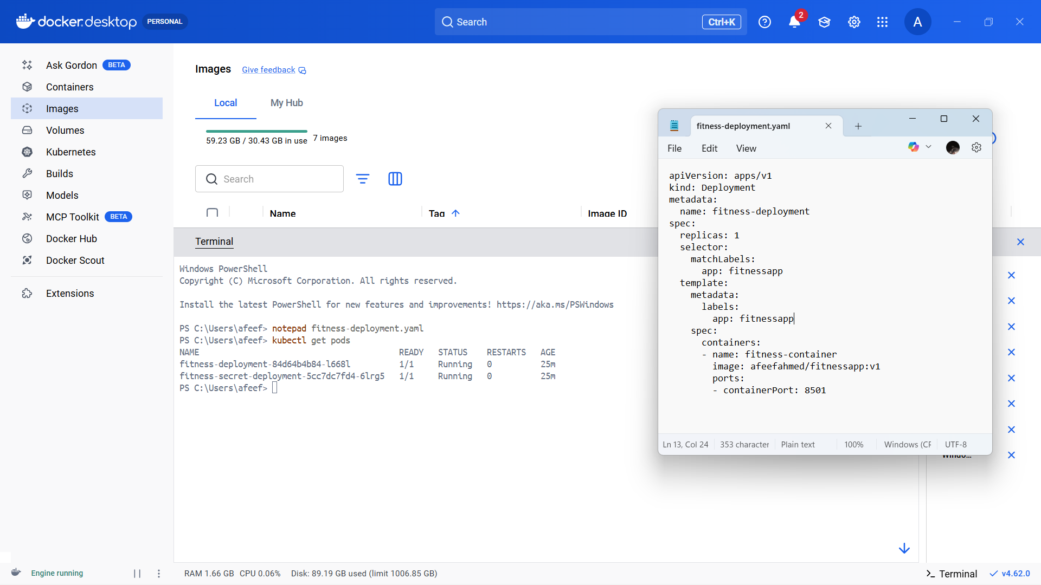

Figure 22: Self Pull Execution

UPSCALE

After the application was successfully deployed in Minikube, the deployment was scaled up to increase the number of active pods. Scaling enables Kubernetes to run multiple instances of the same application, which helps to:
- Handle increased user traffic
- Improve application availability
- Enhance reliability through redundancy

The deployment was scaled using the following command:

kubectl scale deployment fitness-deployment --replicas=3

This command directs Kubernetes to run three replicas of the container instead of just one.
To confirm that the scaling process was successful, the following command was executed:
kubectl get pods
The output showed three pods in the Running state, all associated with the deployment.
This verified that the application was successfully scaled and multiple instances were operating within the Minikube cluster.

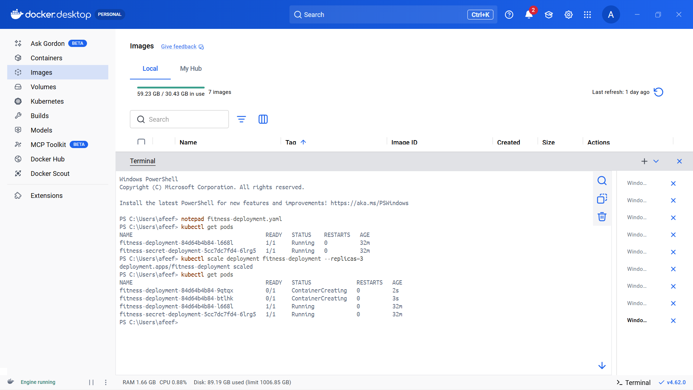

Figure 23: UPSCALE

DOWNSCALE

After increasing the number of replicas, the deployment was scaled down to demonstrate Kubernetes downscaling. Downscaling reduces the number of active pods and frees up unnecessary system resources.

The deployment was downscaled using the following command:

kubectl scale deployment fitness-deployment --replicas=1

This command instructs Kubernetes to decrease the number of running replicas to one.

To verify that the downscaling operation was completed successfully, the following command was executed:

kubectl get pods

The output displayed only a single pod in the Running state, confirming that the deployment was successfully reduced to one replica.

This demonstrated Kubernetes’ ability to dynamically manage application scaling based on requirements.

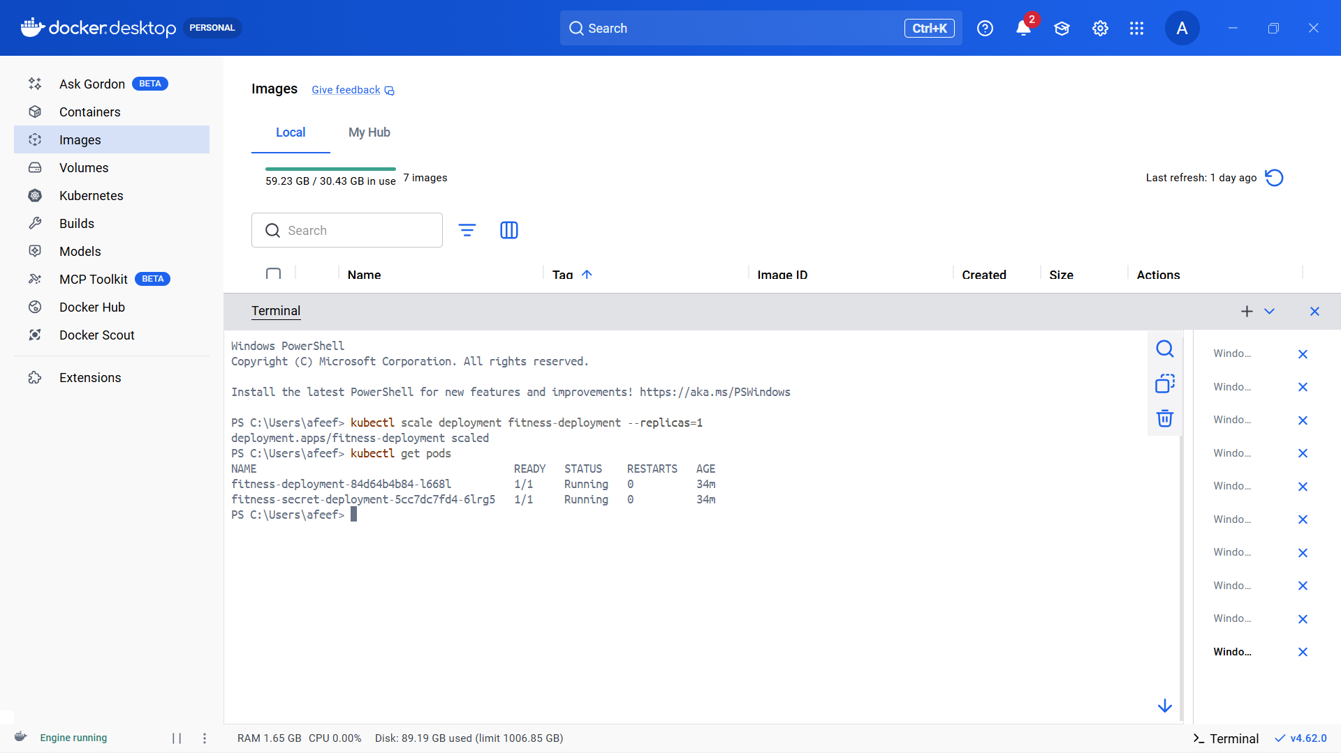

Figure 24: Downscale

SECRET YAML DEFINING

A Kubernetes Secret YAML file was created to securely store configuration data within the Minikube cluster. Secrets are used to handle sensitive information such as passwords, API keys, or environment variables without embedding them directly into the application code.

The secret configuration was saved in a file named:

apiVersion: v1
kind: Secret
metadata:
name: fitness-secret
type: Opaque
data:
username: YWRtaW4=
password: MTIzNA==

In this configuration:
- A Secret named app-secret is created
- The type Opaque indicates a generic secret
- A key-value pair is defined where APP_MODE is set to production
- The stringData field allows plain text values, which Kubernetes automatically converts into Base64 encoding internally
This secret can later be referenced in a deployment file, typically as an environment variable inside a container. This approach improves security by separating sensitive configuration from application code.

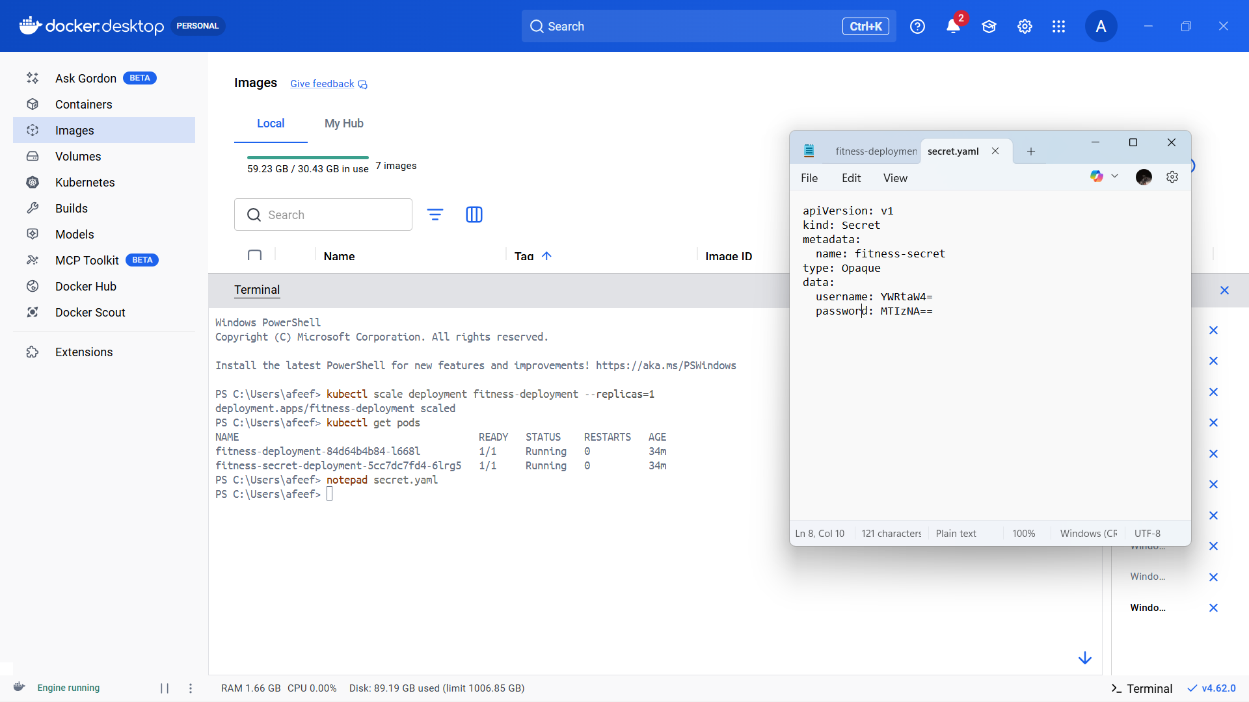

Figure 25: Secret Yaml Defining

NEW DEPLOYMENT DEFINING KIND SECRET

A new Kubernetes deployment configuration was created to demonstrate how a Secret can be integrated into an application through environment variables. This deployment references the previously created Secret and securely injects its value into the running container, instead of hardcoding sensitive information directly into the application code.

The configuration was saved in a file named:

apiVersion: apps/v1
kind: Deployment
metadata:
name: fitness-secret-deployment
spec:
replicas: 1
selector:
matchLabels:
app: fitnesssecret
template:
metadata:
labels:
app: fitnesssecret
spec:
containers:
- name: fitness-container
image: afeefahmed/fitnessapp:v1
ports:
- containerPort: 8501
env:
- name: USERNAME
valueFrom:
secretKeyRef:
name: fitness-secret
key: username
- name: PASSWORD
valueFrom:
secretKeyRef:
name: fitness-secret
key: password

Explanation of the Configuration
- A deployment named fitness-secret-deployment is created.
- It runs one replica of the container using the self project image stored on Docker Hub.
- The selector and labels ensure that Kubernetes properly identifies and manages the associated pods.
- The critical part is the env section, where:
  - The environment variable APP_MODE is defined.
  - Its value is not written directly in the file.
  - Instead, it is securely retrieved from the Kubernetes Secret named app-secret.
  - The secretKeyRef specifies both the secret name and the exact key to access.

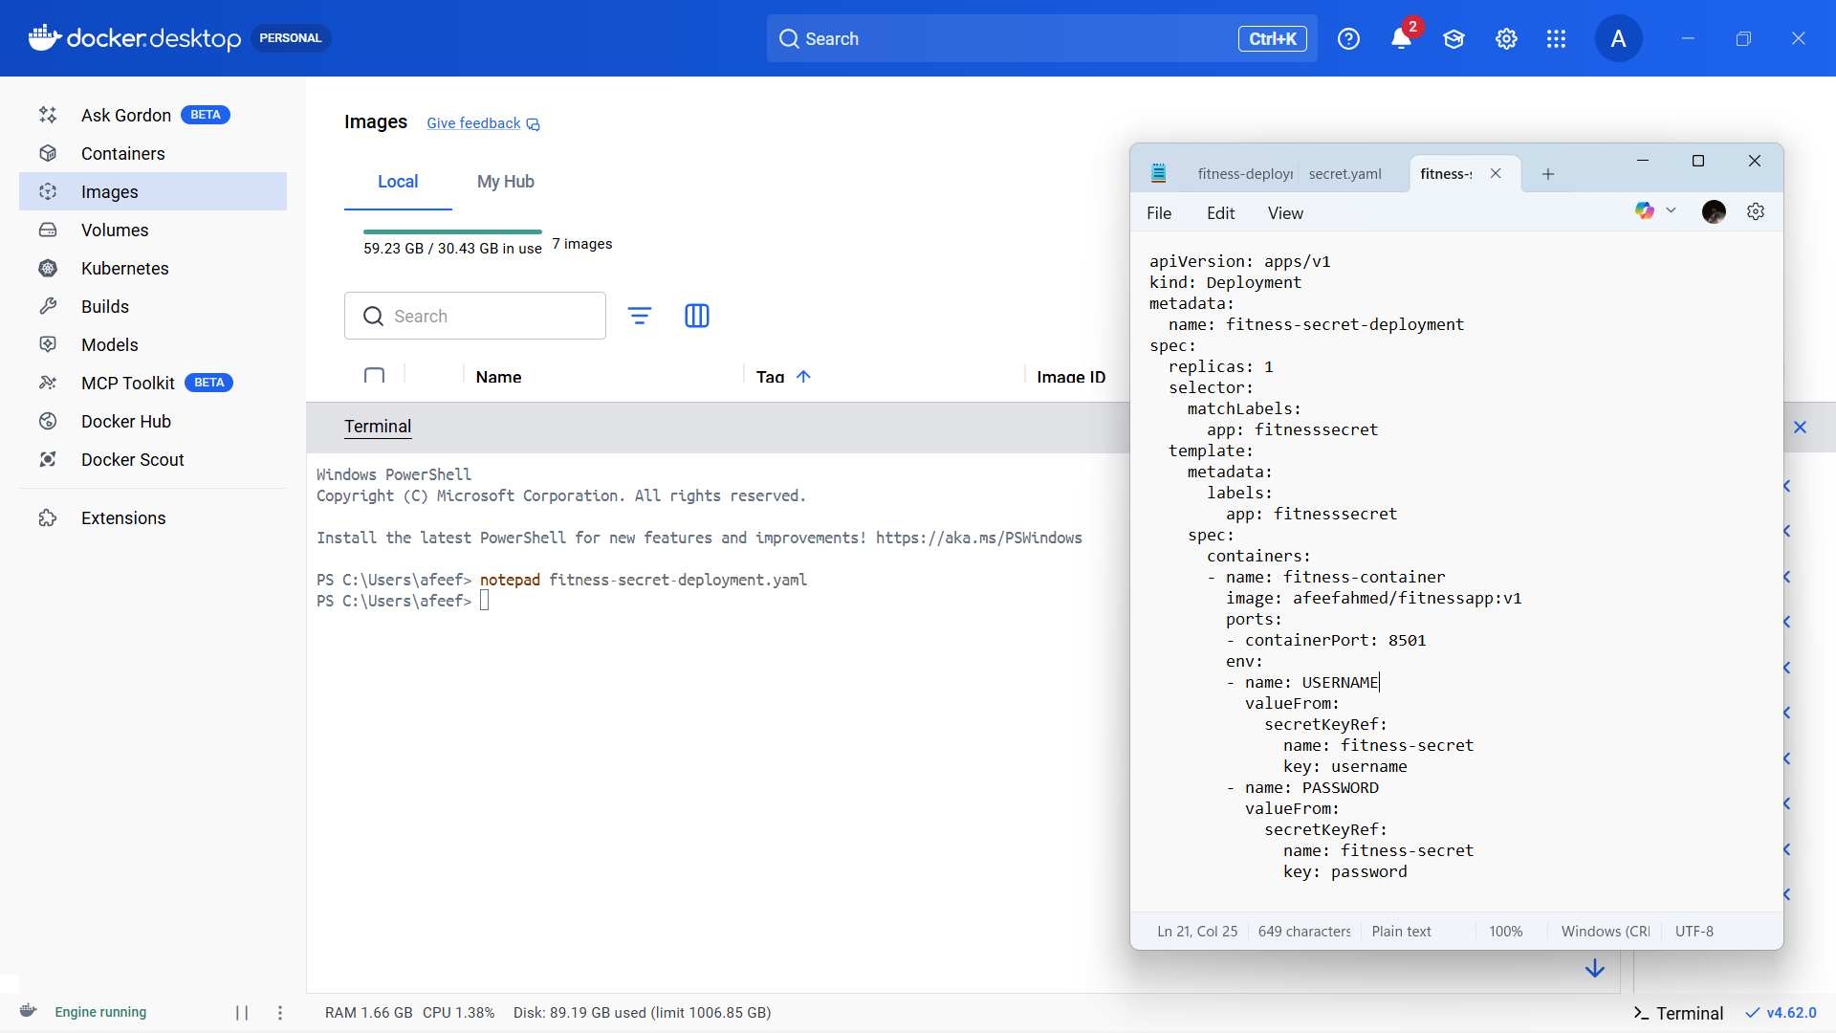

Figure 26: New Deployment Defining Kind Secret

GETTING SECRET FOR CHECK

After creating the Kubernetes Secret, it was verified to ensure that it was successfully stored in the cluster. Kubernetes provides multiple commands to check the secret’s existence, metadata, and stored values.

To list all available secrets in the cluster, the following command was executed:

kubectl get secrets

This command displayed the secret named app-secret, confirming that it was successfully created.
To view detailed information about the secret, the following command was used:
kubectl describe secret app-secret

This command provided metadata such as:
- Secret name
- Type (Opaque)
- Available keys stored within the secret
To retrieve the complete secret information in YAML format, the following command was executed:

kubectl get secret app-secret -o yaml

The stored values appear in Base64 encoded format for security purposes.
To decode and view the actual value of APP_MODE, the following command was used:

kubectl get secret app-secret -o jsonpath="{.data.APP_MODE}" | base64 -- decode

This final verification step confirmed that:
- The secret was successfully created
- It was securely stored in the cluster
- Its values can be accessed by deployments when required
This demonstrates proper secret management and secure configuration handling in Kubernetes.

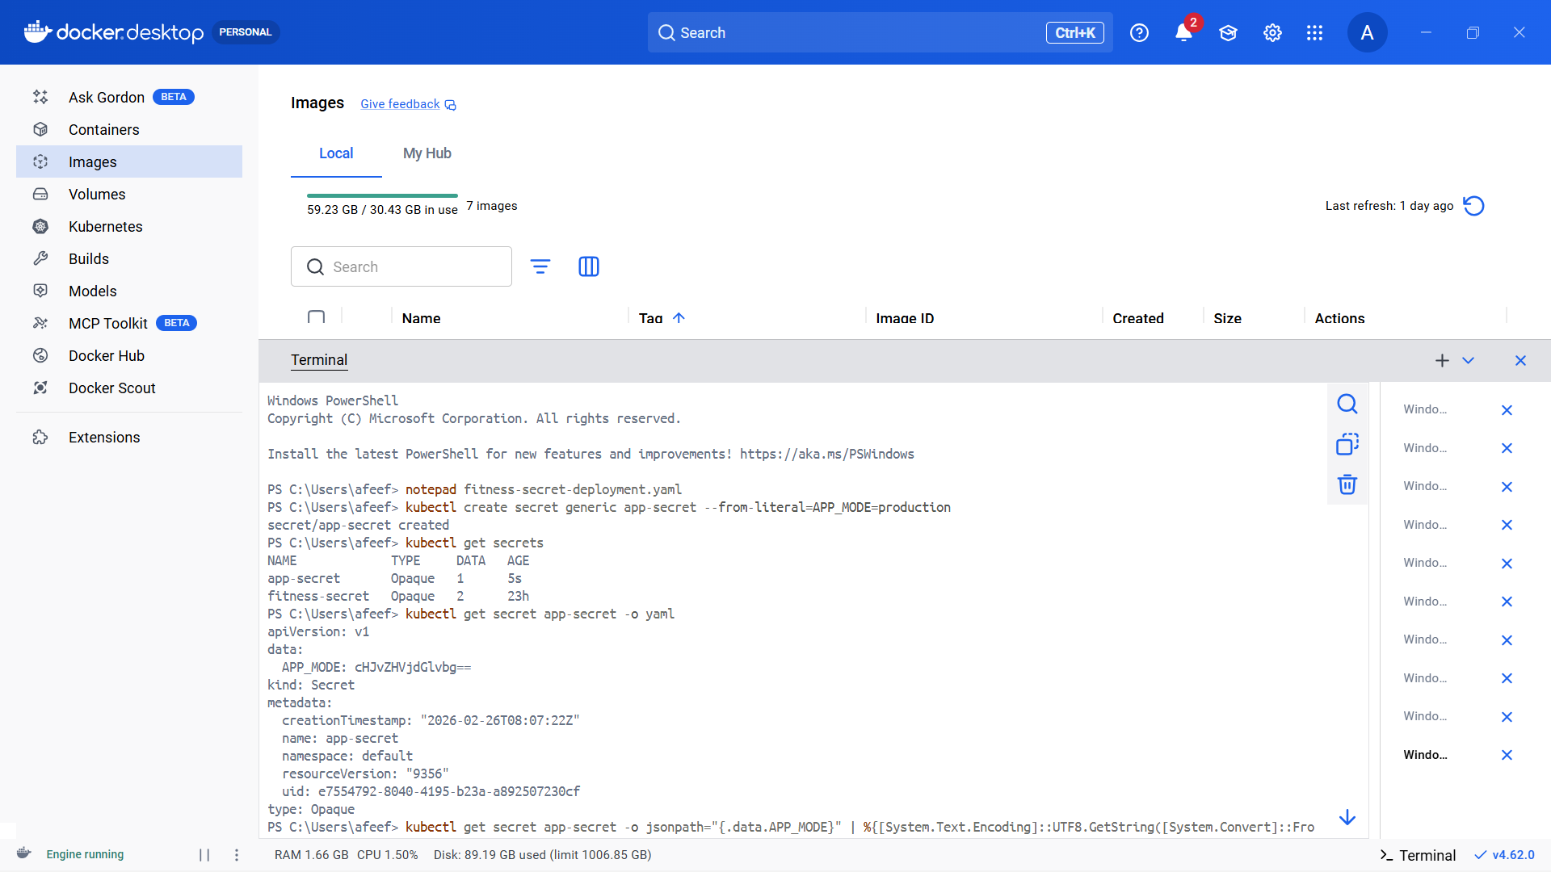

Figure 27: Getting Secret For Check

SECRET DEPLOYMENT

After creating the Kubernetes Secret, it was verified to confirm that it was properly created and stored within the cluster. Kubernetes provides several commands to inspect secret metadata and ensure its availability.

To list all existing secrets in the cluster, the following command was executed:

kubectl get secrets

The output displayed the secret named app-secret, confirming that it was successfully created.

To obtain detailed information about the secret, the following command was used:

kubectl describe secret app-secret

This command displayed important metadata, including:
- Secret name
- Secret type (Opaque)
- The keys stored within the secret
To retrieve the complete secret data in YAML format, the following command was executed:

kubectl get secret app-secret -o yaml

The stored values appear in Base64 encoded format, as Kubernetes automatically encodes secret data for secure storage.

To decode and view the actual value of the APP_MODE key, the following command was used:

kubectl get secret app-secret -o jsonpath="{.data.APP_MODE}" | base64 -- decode

This verification process confirmed that:
- The secret was successfully created
- It was securely stored within the Kubernetes cluster
- Its values can be safely accessed by deployments when required
This demonstrates proper secret management and secure handling of sensitive configuration data in Kubernetes.

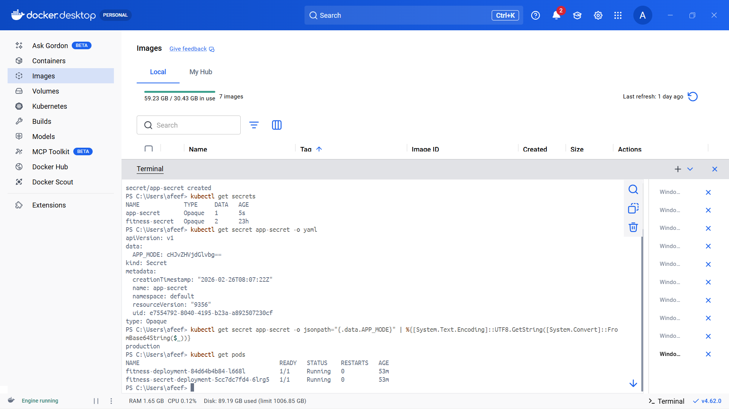

Figure 28: Secret Deployment

UPSCALE

After deploying the application with the secret configuration, the deployment was scaled up to increase the number of active pods. Upscaling improves application availability and demonstrates Kubernetes’ ability to manage increased workload by running multiple instances of the same application.

The deployment was scaled using the following command:

kubectl scale deployment fitness-secret-deployment --replicas=3

This command directs Kubernetes to create three replicas of the pod associated with the deployment.

To confirm that the scaling process was completed successfully, the following command was executed:

kubectl get pods

The output displayed three pods in the Running state, all linked to fitness-secret-deployment.

This verification confirmed that the application was successfully upscaled and that multiple instances were running within the Kubernetes cluster, ensuring improved reliability and availability.

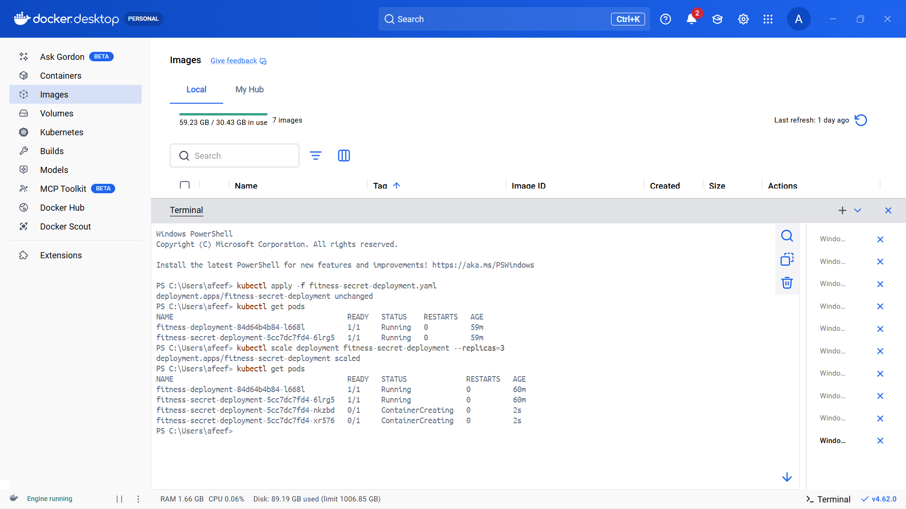

Figure 29: UPSCALE

DOWNSCALE

After demonstrating the upscaling process, the deployment was scaled down to decrease the number of active pods. Downscaling helps optimize resource usage and illustrates how Kubernetes can dynamically adjust application capacity based on requirements.

The deployment was reduced using the following command:

kubectl scale deployment fitness-secret-deployment --replicas=1

This command instructs Kubernetes to lower the number of pod replicas to one.

To confirm that the downscaling process was completed successfully, the following command was executed:

kubectl get pods

The output displayed only one pod in the Running state for fitness-secret-deployment, indicating that the additional pods were successfully terminated.

This demonstrates Kubernetes' ability to efficiently manage scaling operations while maintaining application stability.

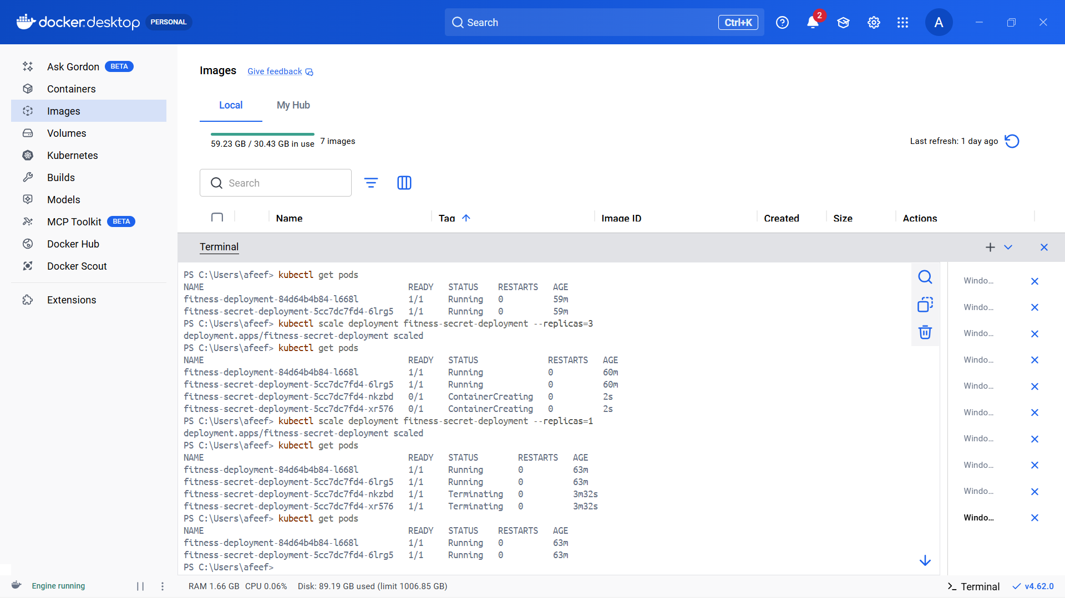

Figure 30: Downscaling

ALL FINAL DEPLOYMENT

After completing the deployment process, performing scaling operations, and integrating secrets, the final status of all deployments in the Minikube cluster was verified. This step ensures that all applications are correctly deployed and properly managed by Kubernetes.

To display all deployments in the cluster, the following command was executed:

kubectl get deployments

This command provides details such as:
- Deployment name
- Desired number of replicas
- Available replicas
- Current status
The output included deployments such as:

- fitness-deployment
- fitness-secret-deployment
- hume-rainfall-deployment

Each deployment showed the required number of replicas in the READY state, confirming that the applications were running successfully.
To obtain detailed information about a specific deployment, the following command can be used:

kubectl describe deployment fitness-secret-deployment

This command displays additional information, including:
- Pod template configuration
- Associated ReplicaSets
- Events related to scaling and updates
This final verification step confirmed that all deployments were successfully created, scaled, and managed within the Minikube Kubernetes cluster.

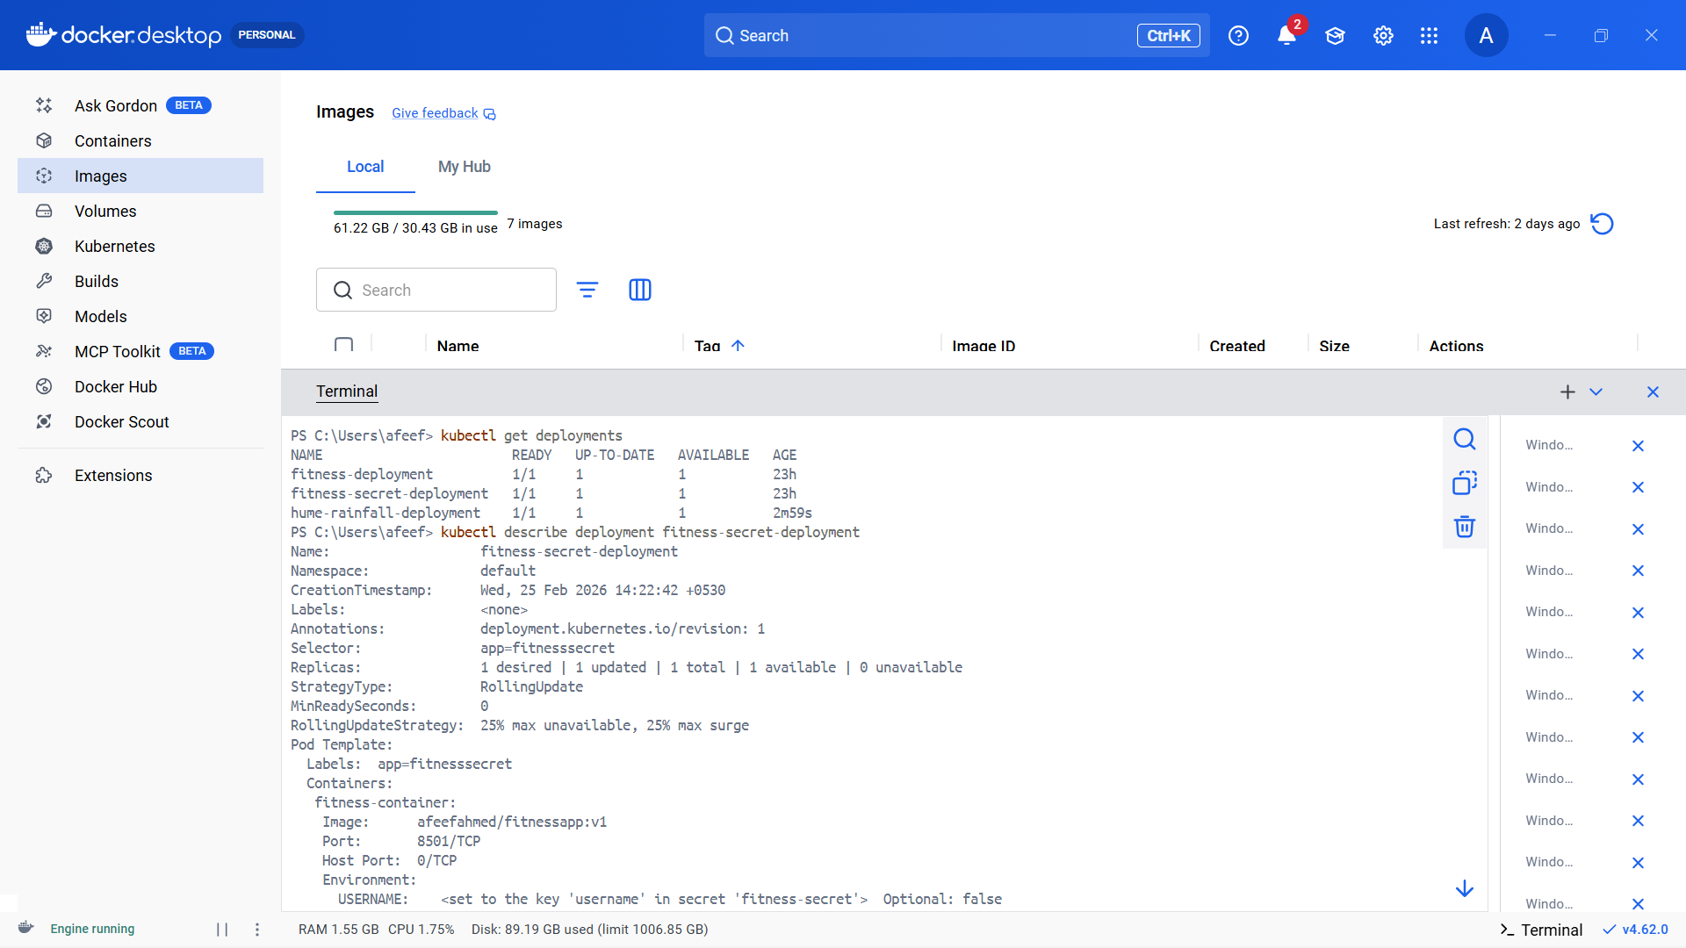

Figure 31: All Final Deployment

ALL PODS AT THE LAST

After completing all deployment, scaling, and secret configuration tasks, the final status of all active pods in the Minikube cluster was verified. This step ensures that the applications are operating correctly and that Kubernetes is managing them efficiently.

To list all running pods, the following command was executed:

kubectl get pods

This command displays details such as:
- Pod name
- Readiness status
- Current state
- Number of restarts
- Age of the pod
The output included pods associated with:

- fitness-deployment
- fitness-secret-deployment
- hume-rainfall-deployment

Each pod showed a status of Running with the required number of containers ready (for example, 1/1), confirming that the applications were functioning properly within the cluster.
This final verification confirmed that all pods were successfully deployed, scaled, and securely configured, and were being properly managed by Kubernetes.

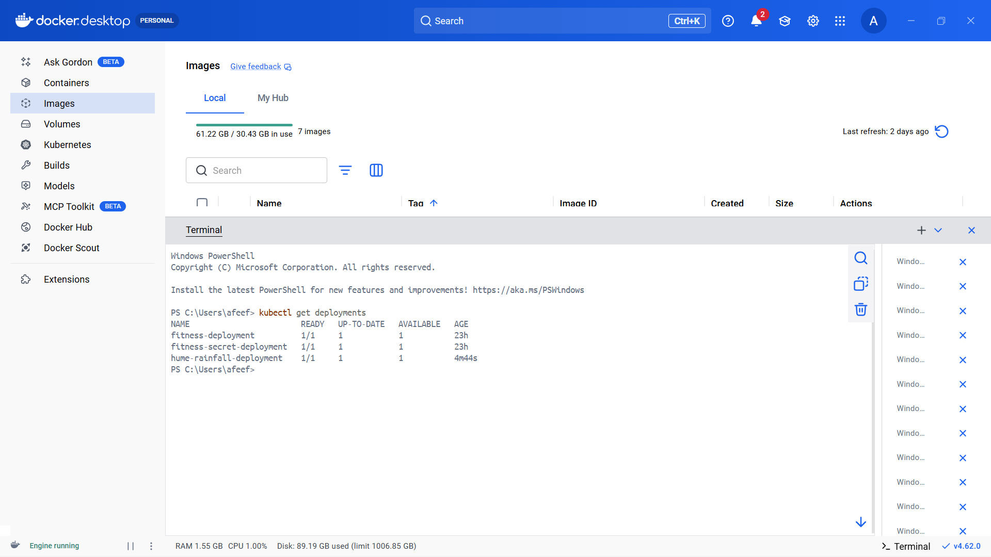

Figure 32: All Pods

