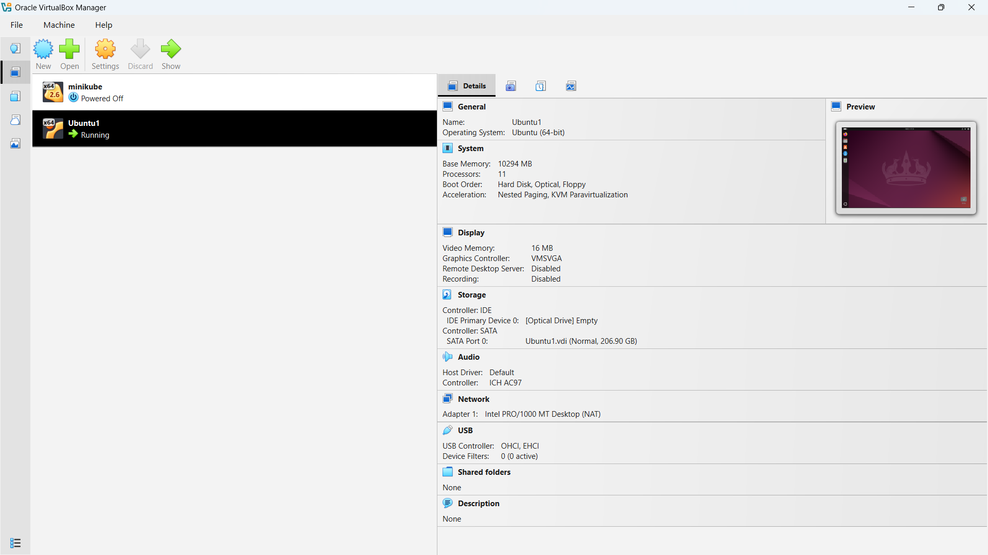
Figure 1: Ubuntu OS installed in a VM

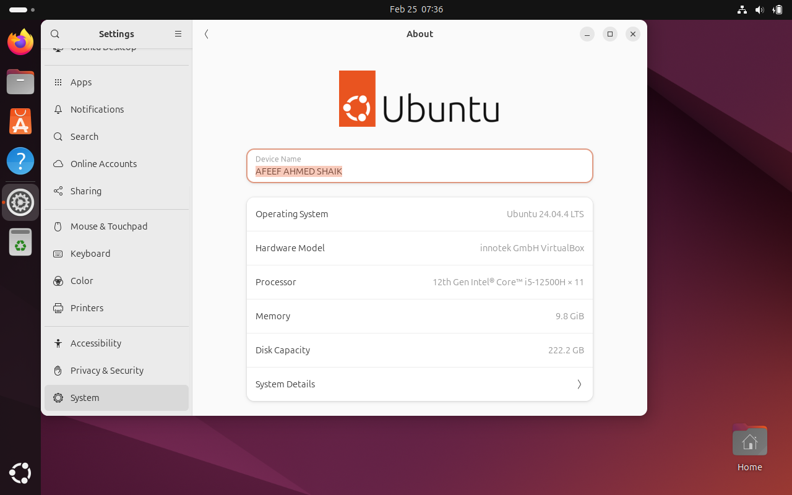
Figure 2: USER PROFILE

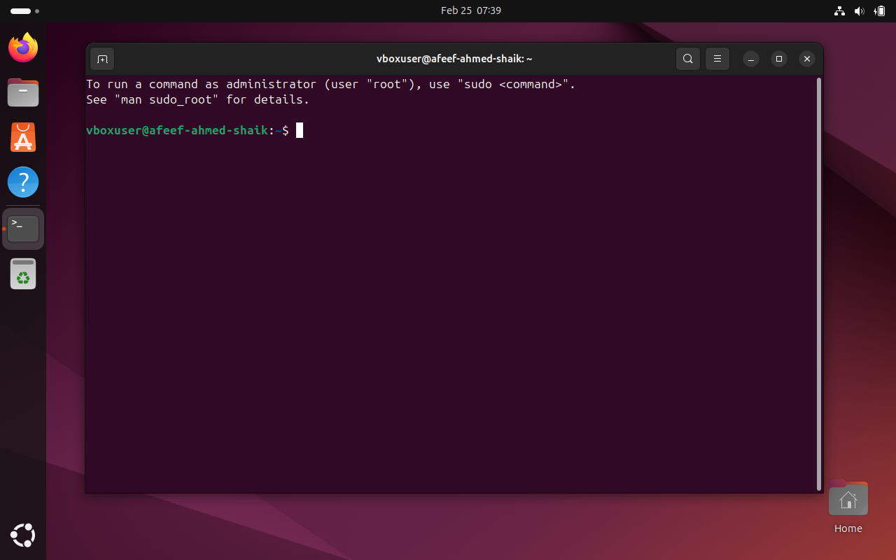
Figure 3: USER TERMINAL

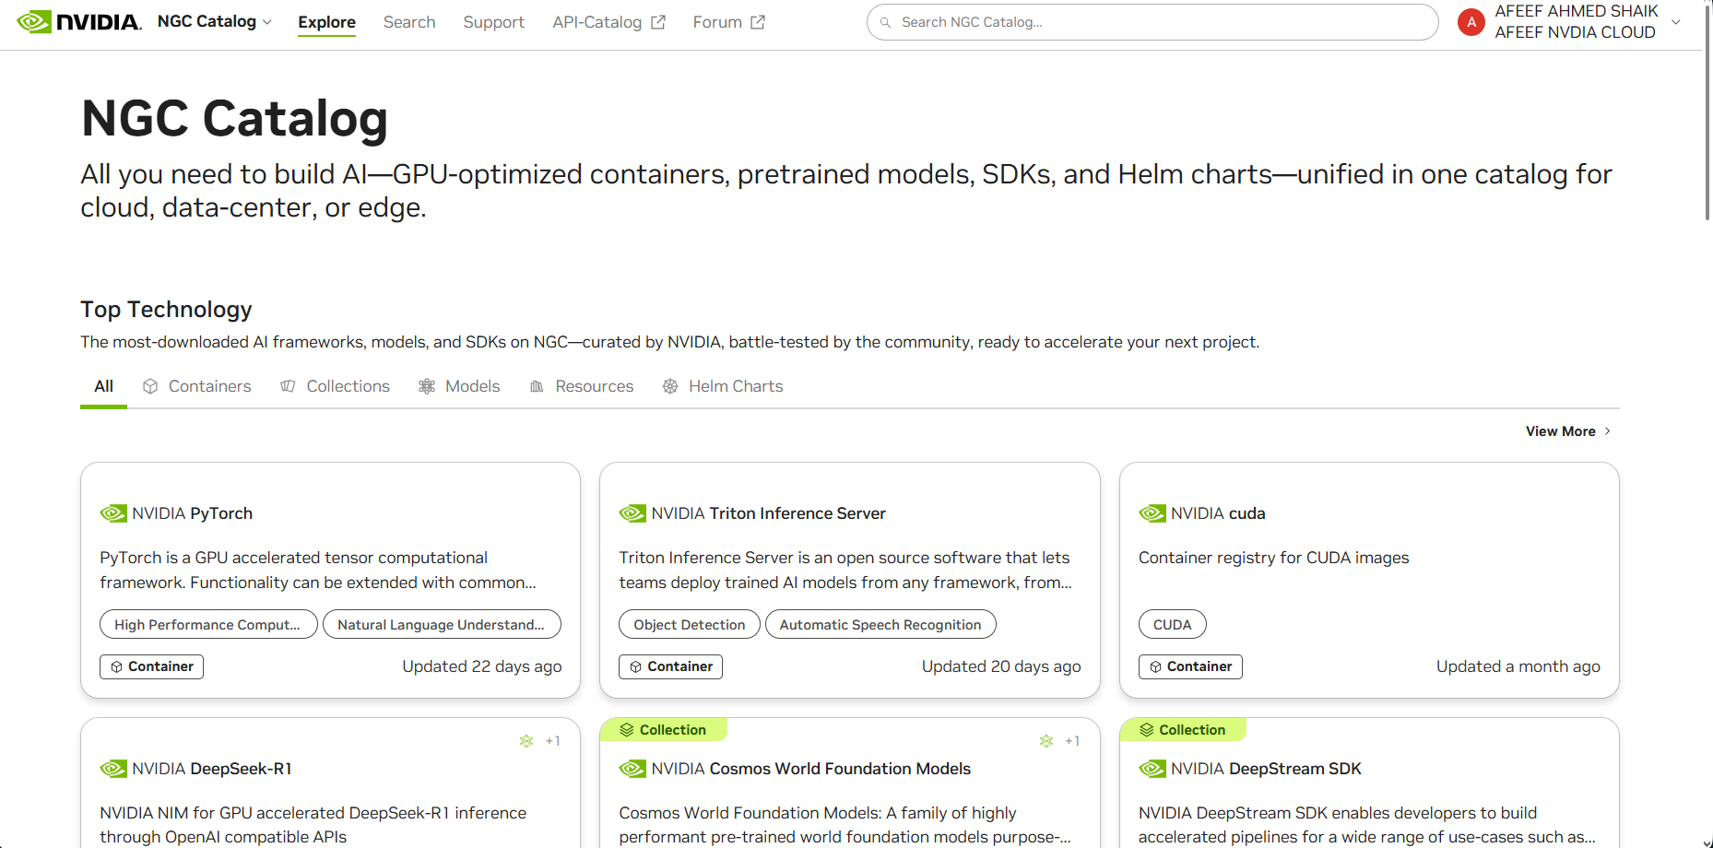
Figure 4: NVIDIA NGC USER DASHBOARD

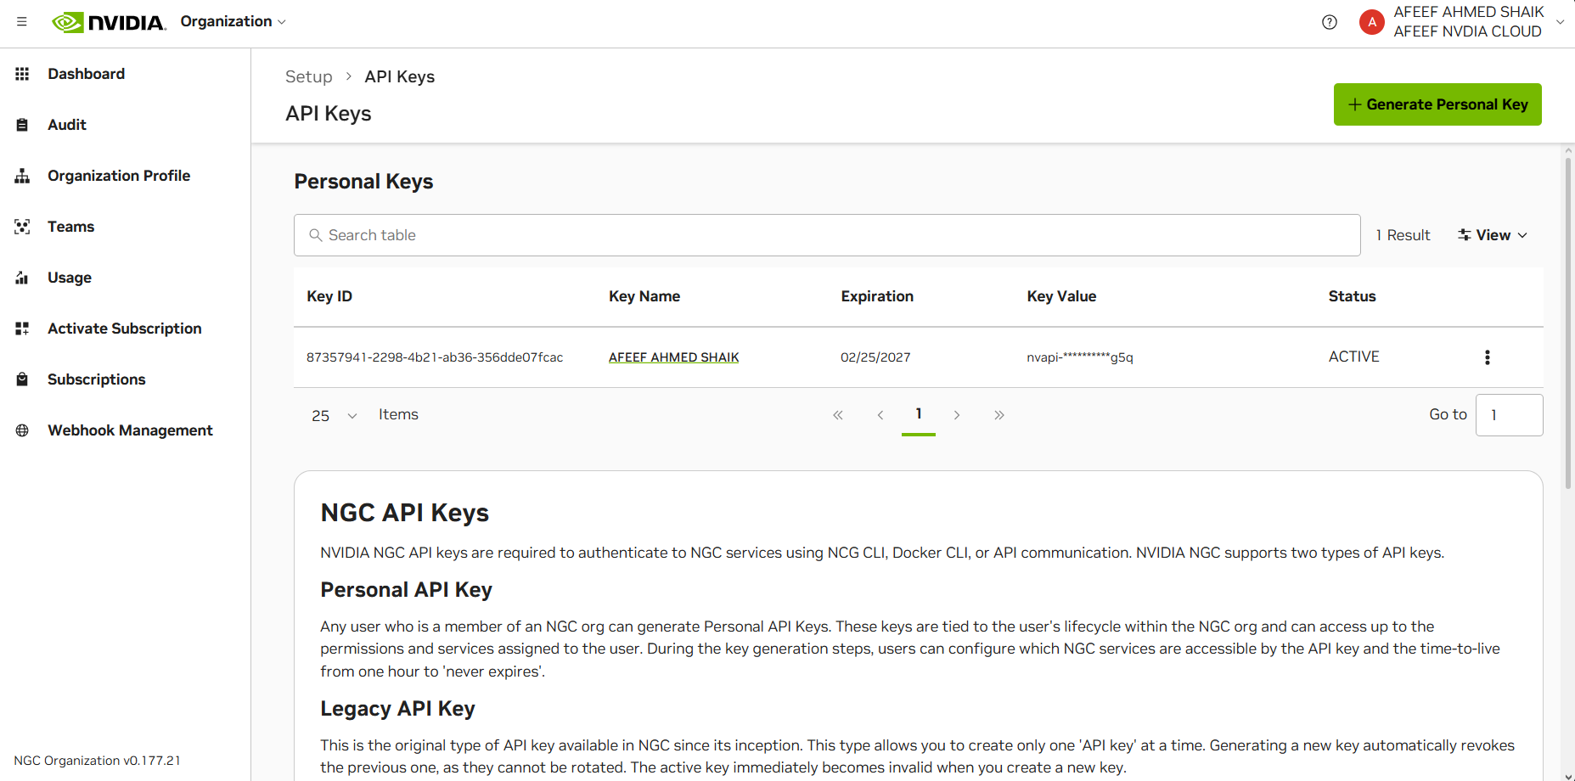
Figure 3: USER TERMINAL

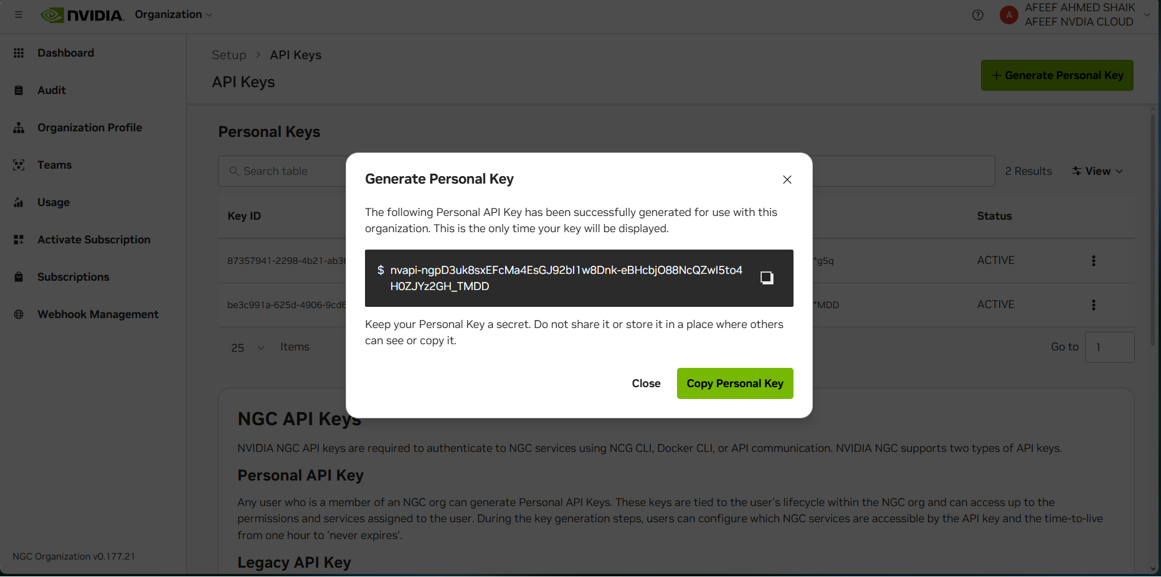
Figure 6: NVIDIA NGC API KEY GENERATION

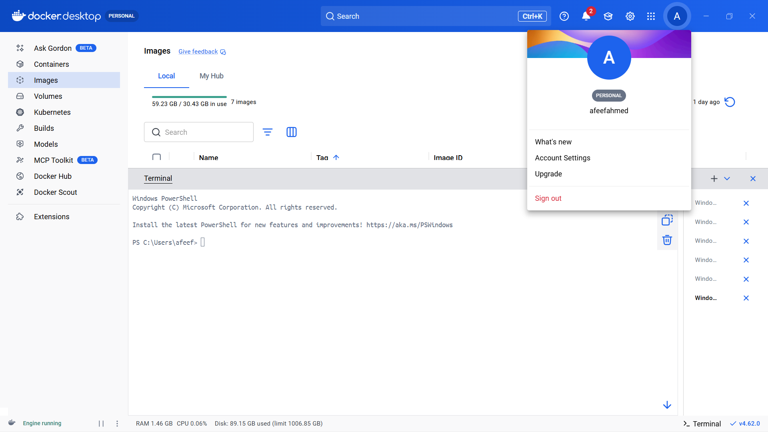
Figure 7: Docker Images Before Pulling GitHub and Friend Images

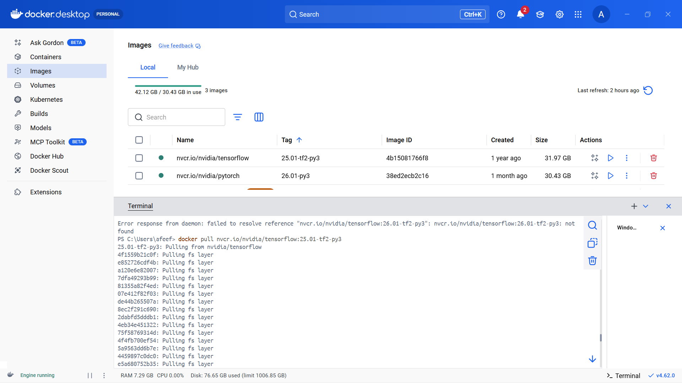
Figure 8: TensorFlow Container Pull

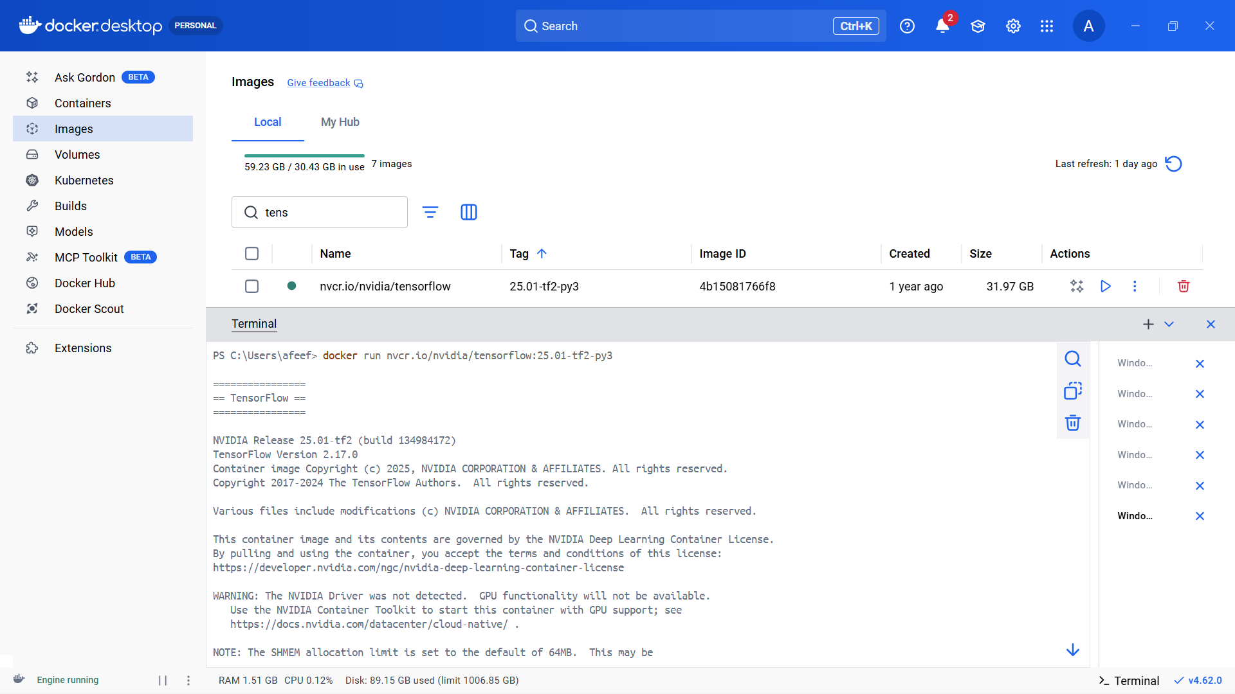
Figure 9: TensorFlow Container Run

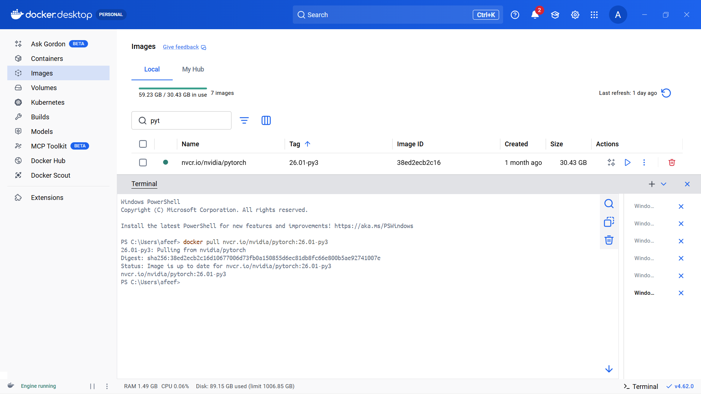
Figure 10: PyTorch Pull

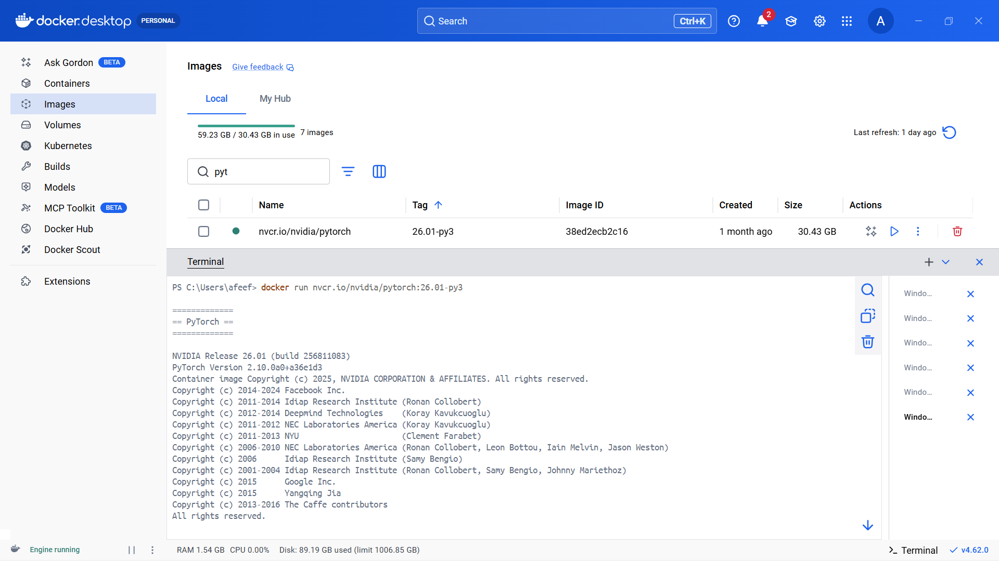
Figure 11: PyTorch Run

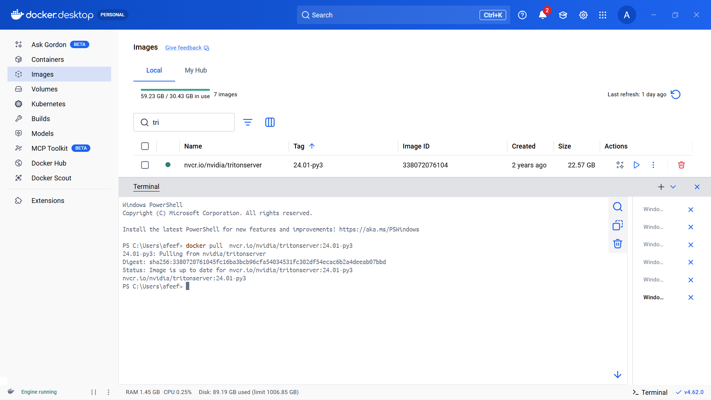
Figure 12: Use Case Container Pull

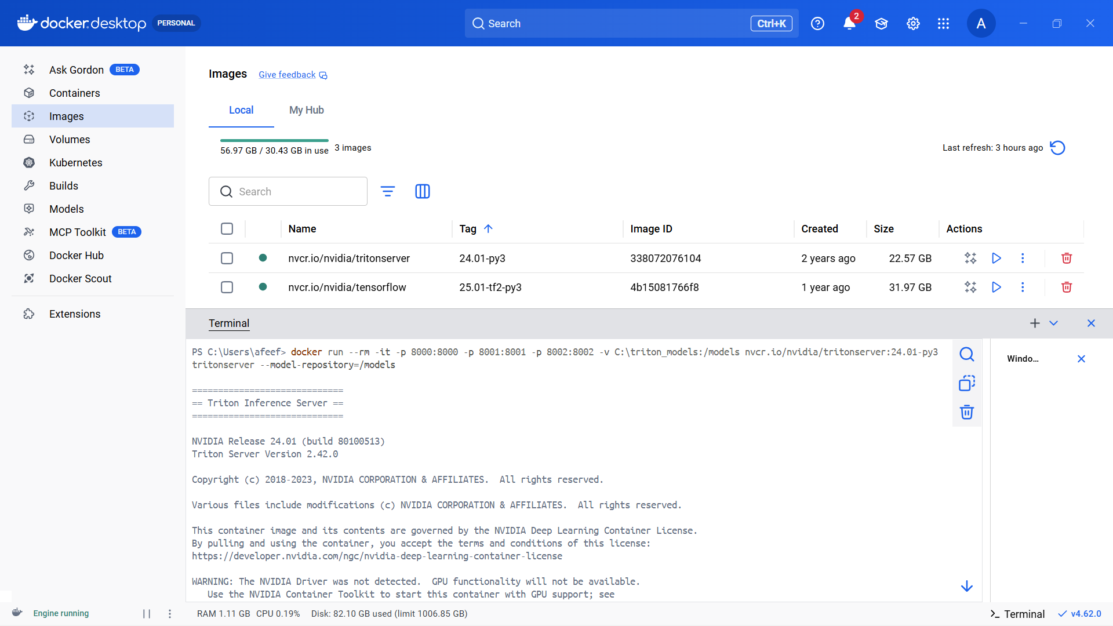
Figure 13: Use Case Container Run

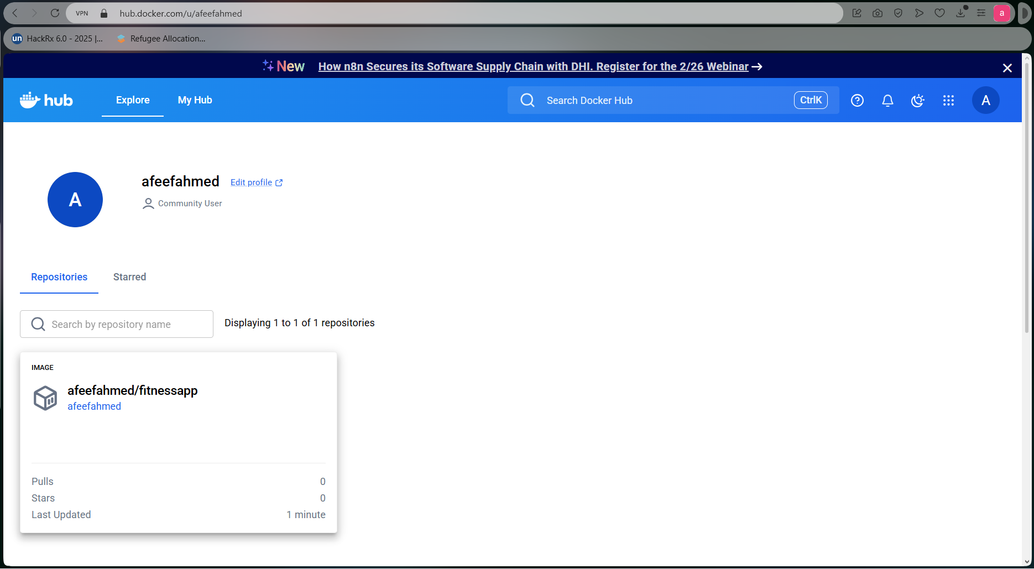
Figure 14: Self Project Pushed in Docker Hub

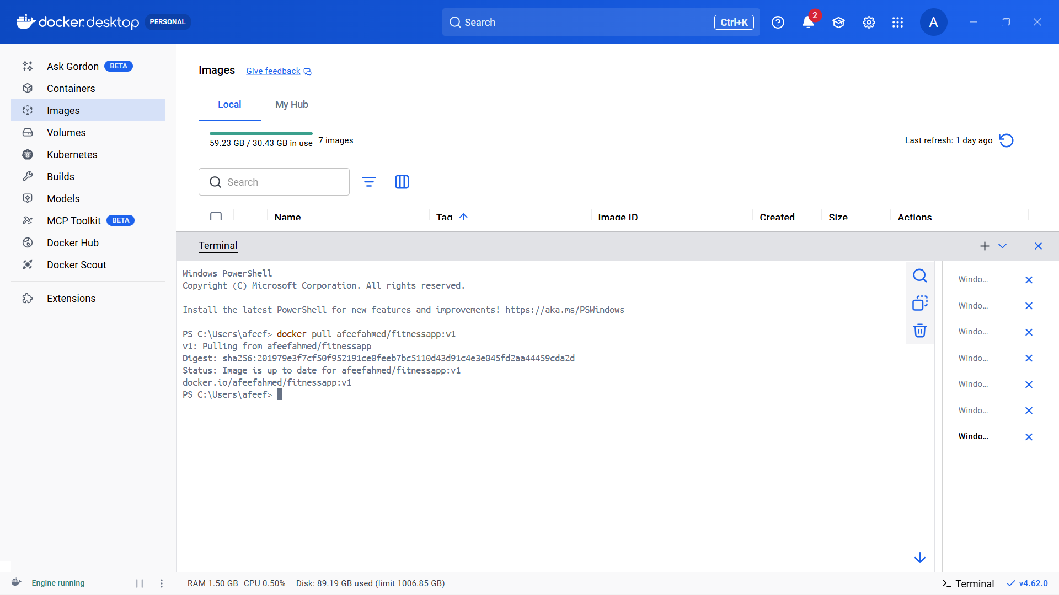
Figure 15: Pulling Self Image

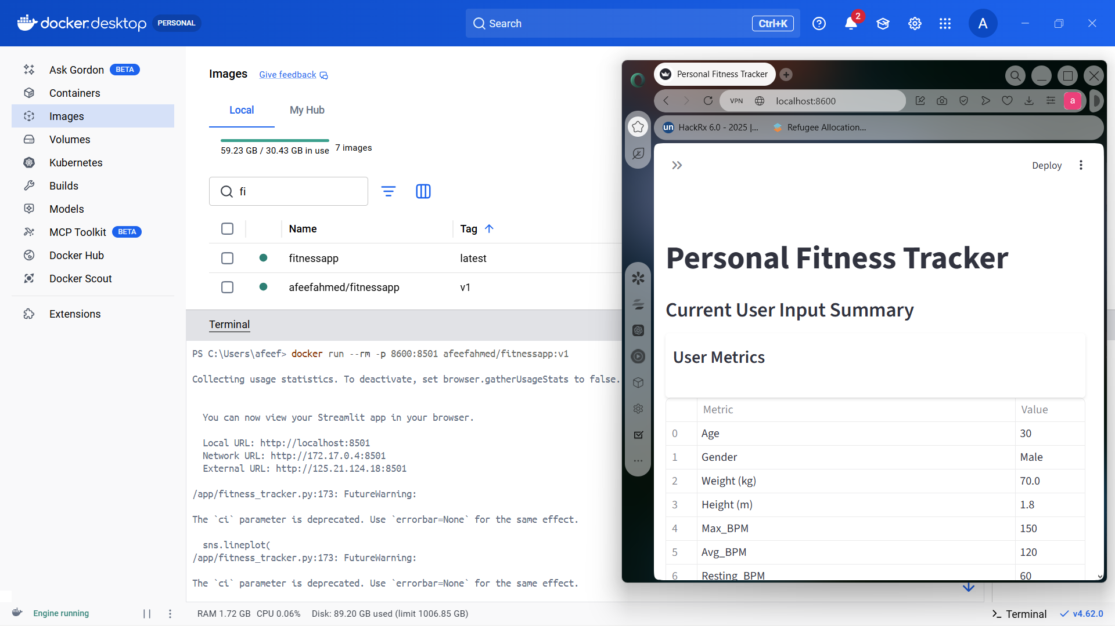
Figure 16: Running self-image

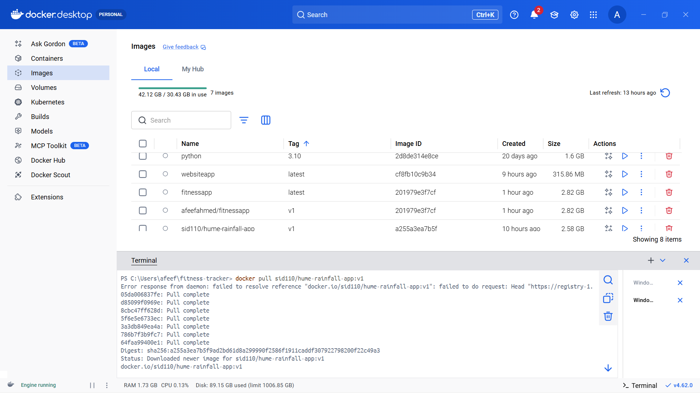
Figure 17: Pulling Friend Image

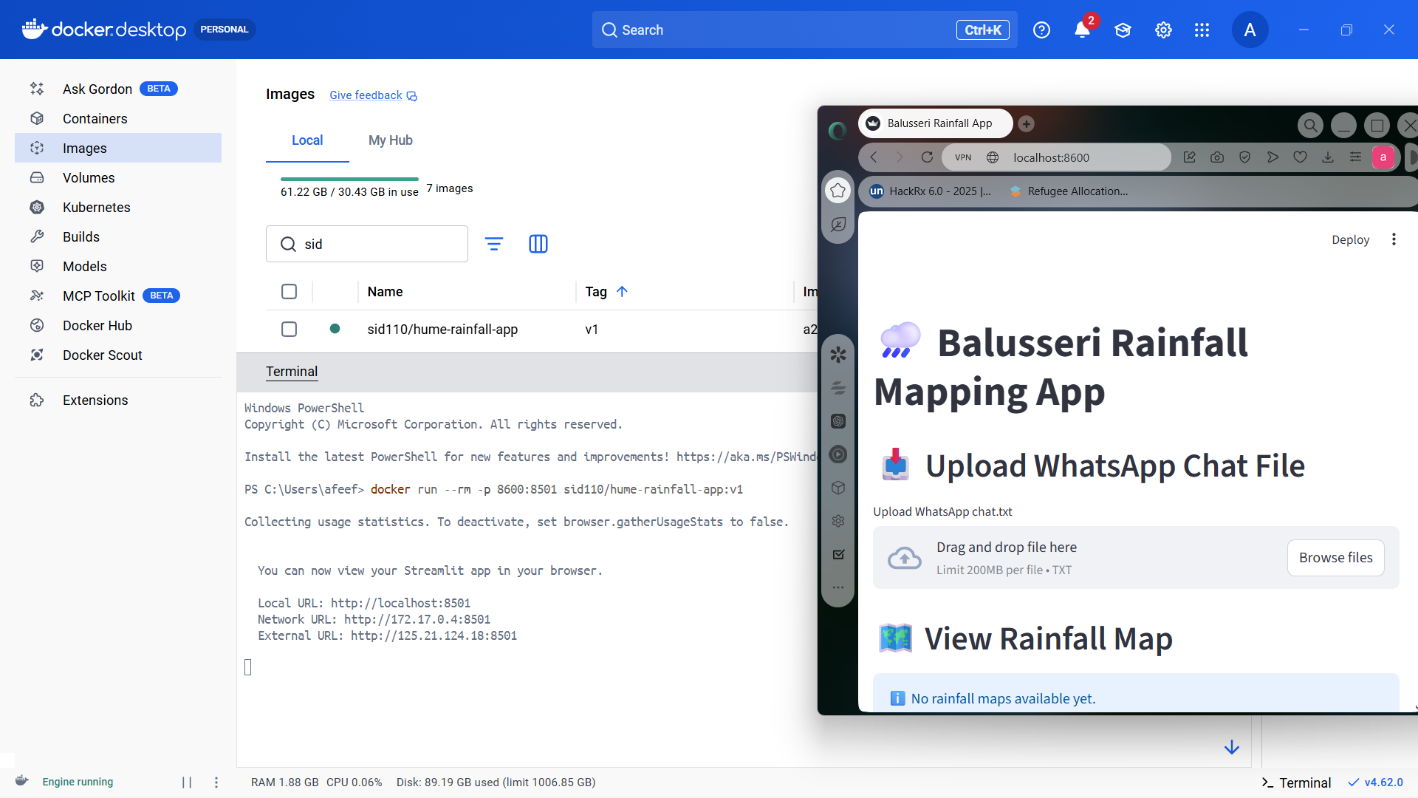
Figure 18: Running Friend Image

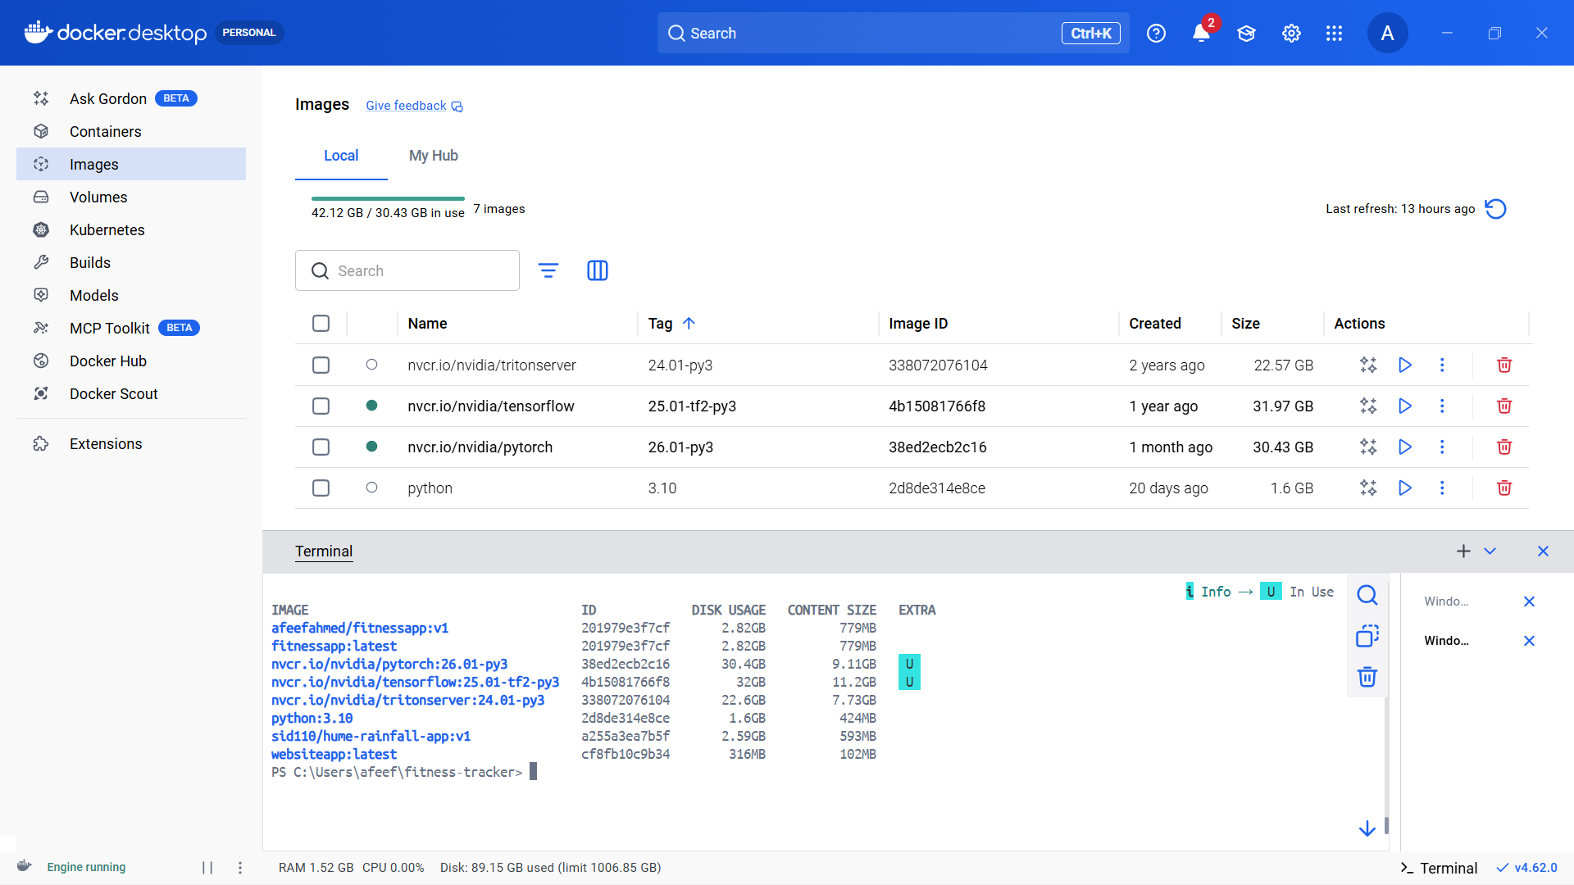
Figure 19: Docker Images After All Pulls

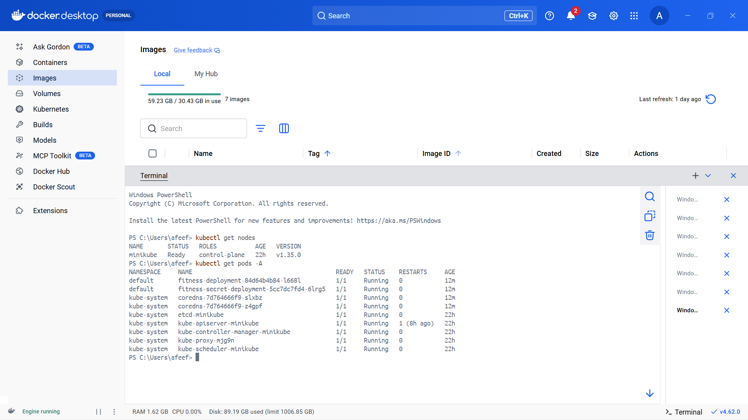
Figure 20: Checking Nodes & Pods After Installing

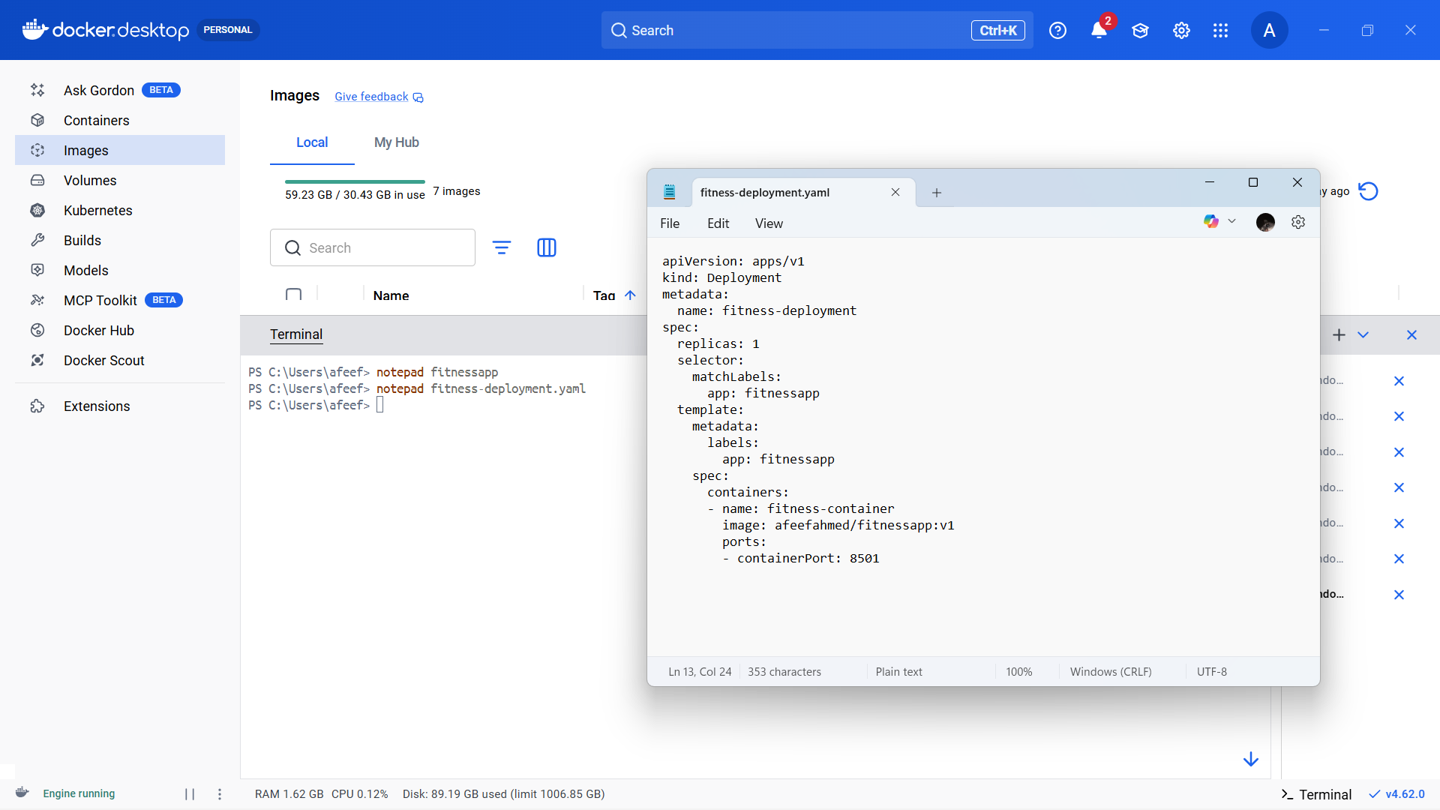
Figure 21: Yaml Defining For Self Pull

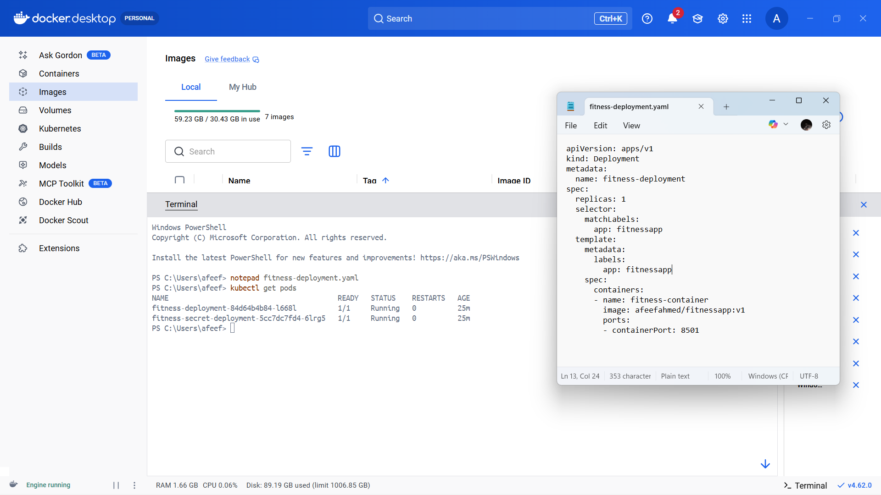
Figure 22: Self Pull Execution

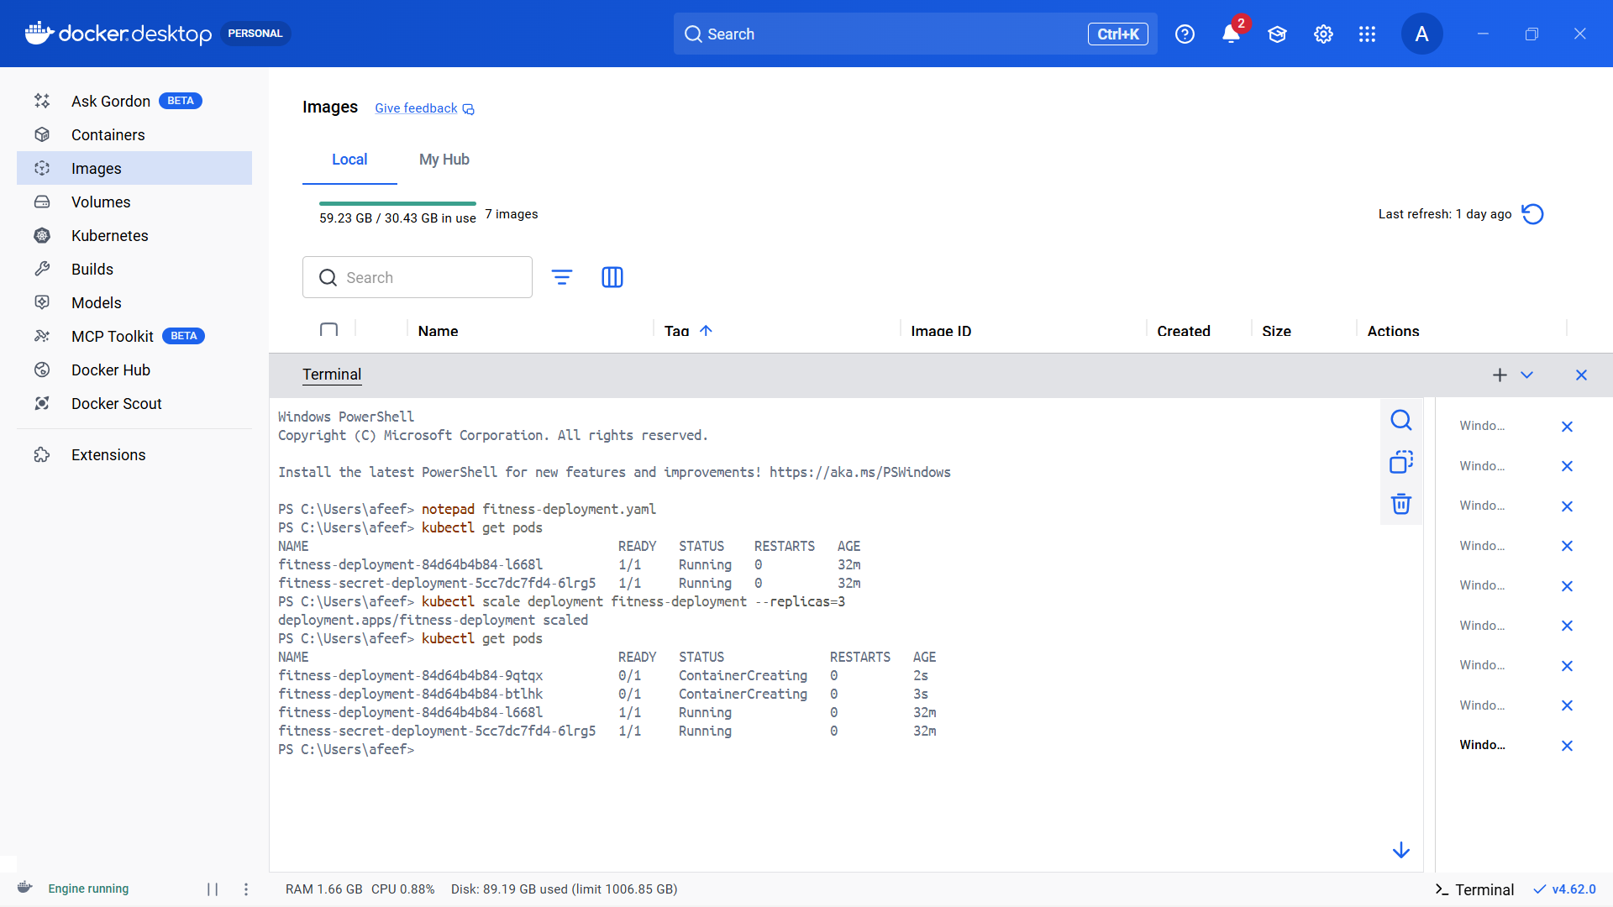
Figure 23: UPSCALE

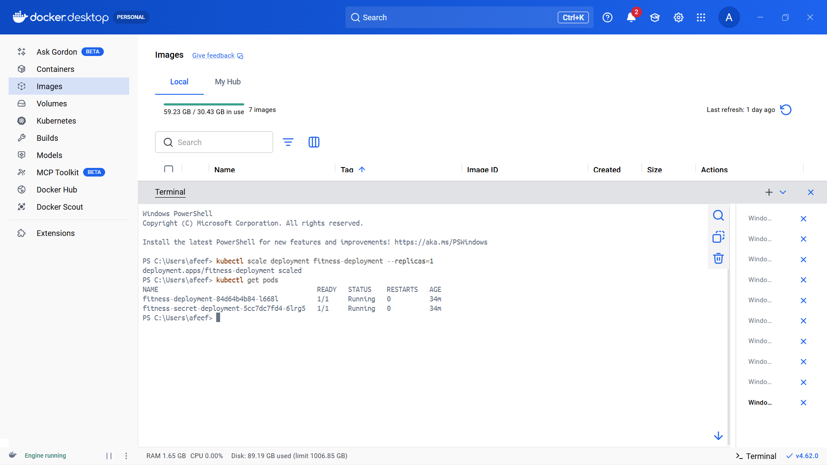
Figure 24: Downscale

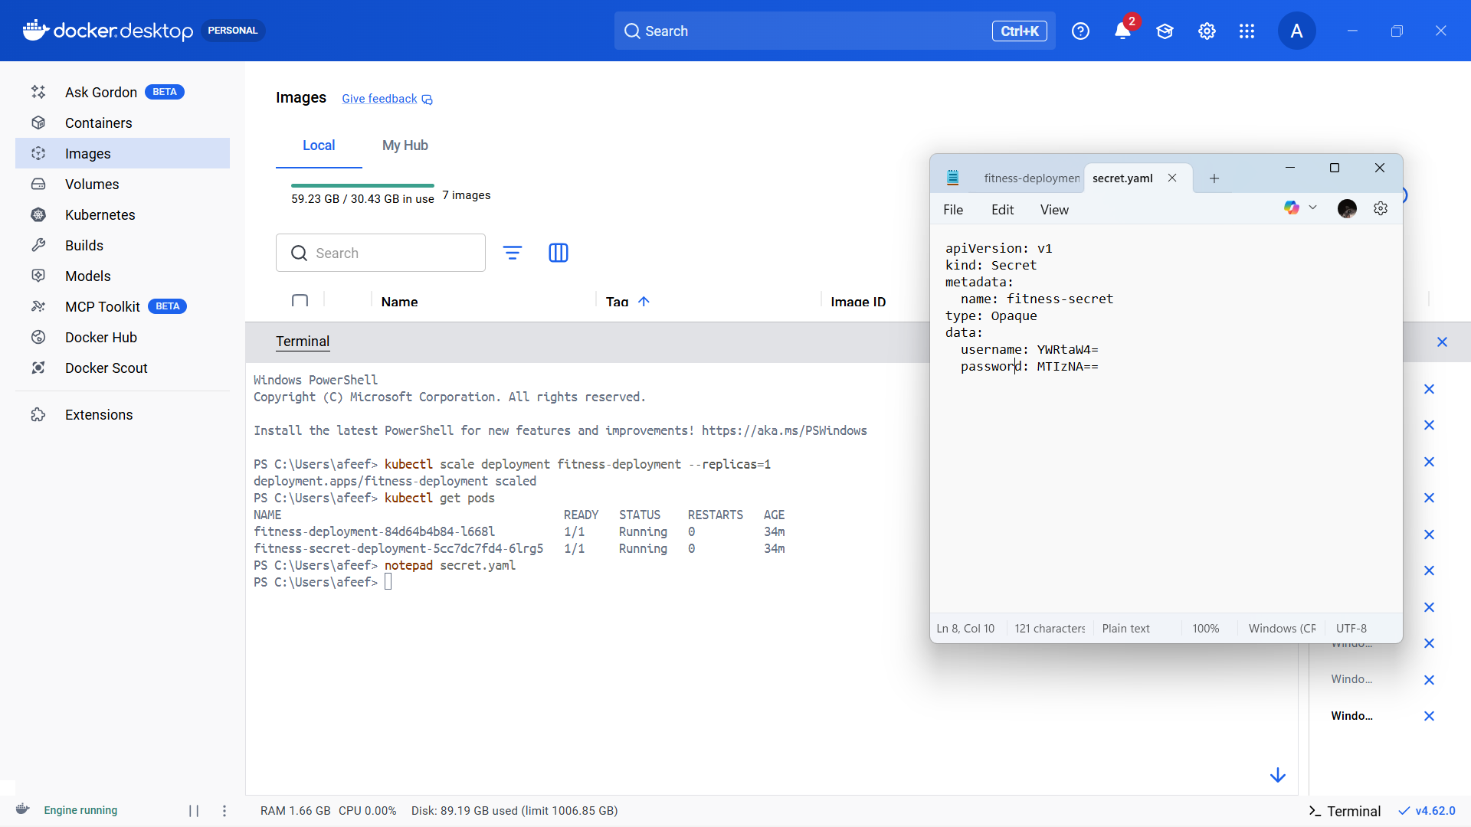
Figure 25: Secret Yaml Defining

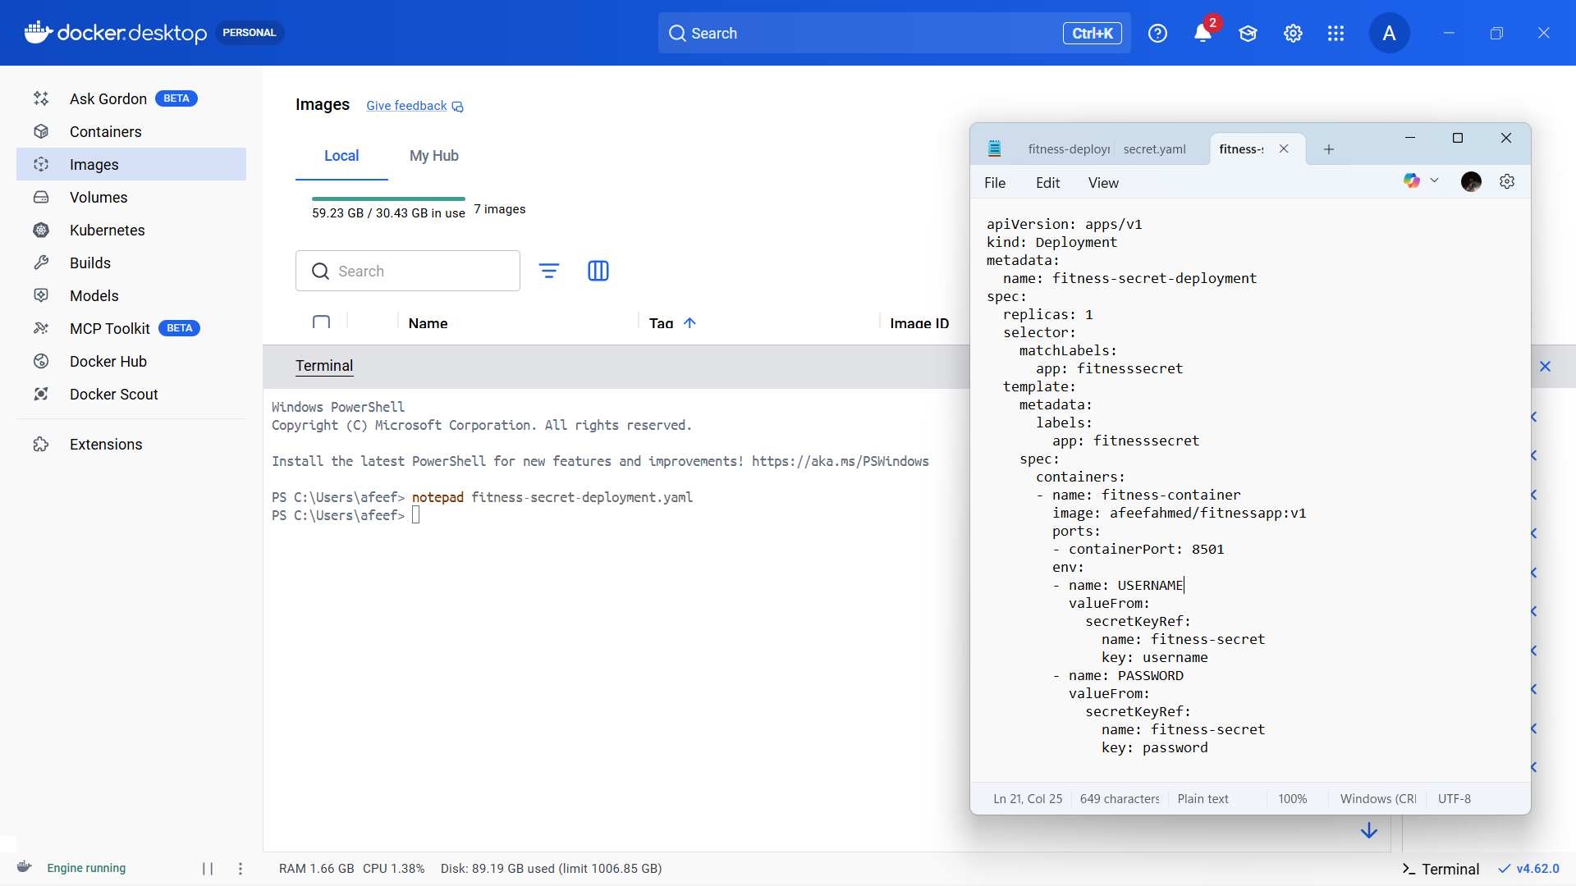
Figure 26: New Deployment Defining Kind Secret

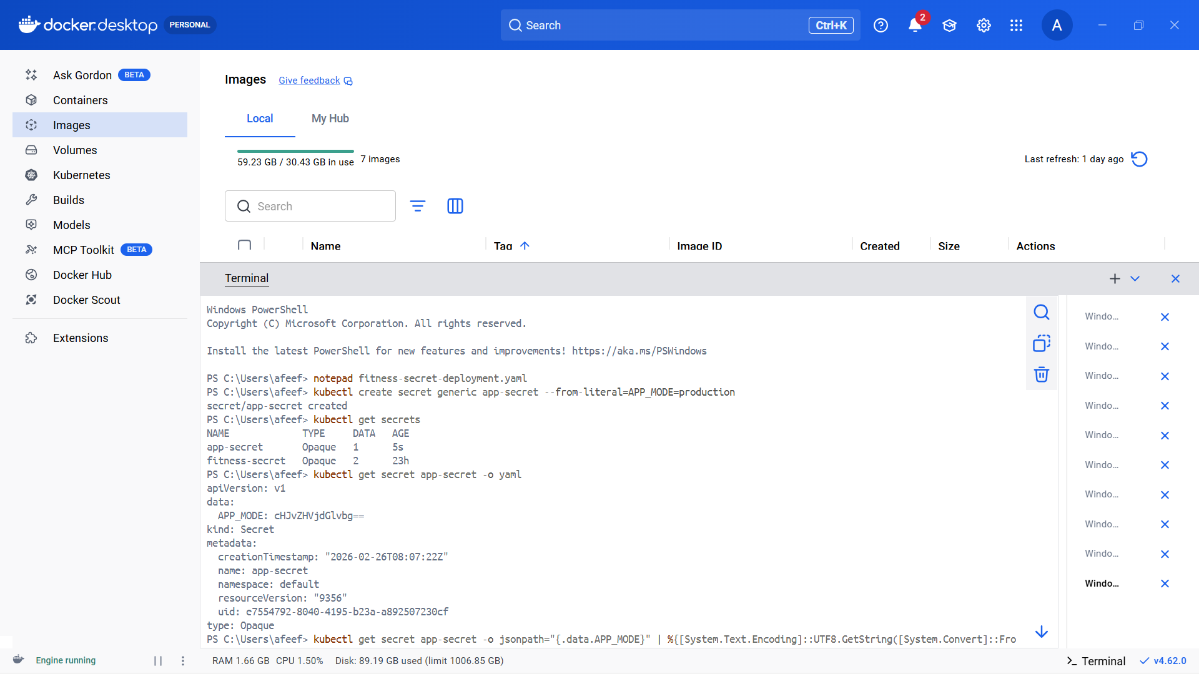
Figure 27: Getting Secret For Check

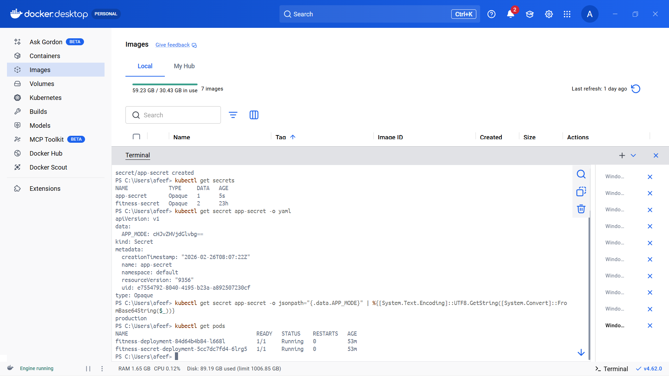
Figure 28: Secret Deployment

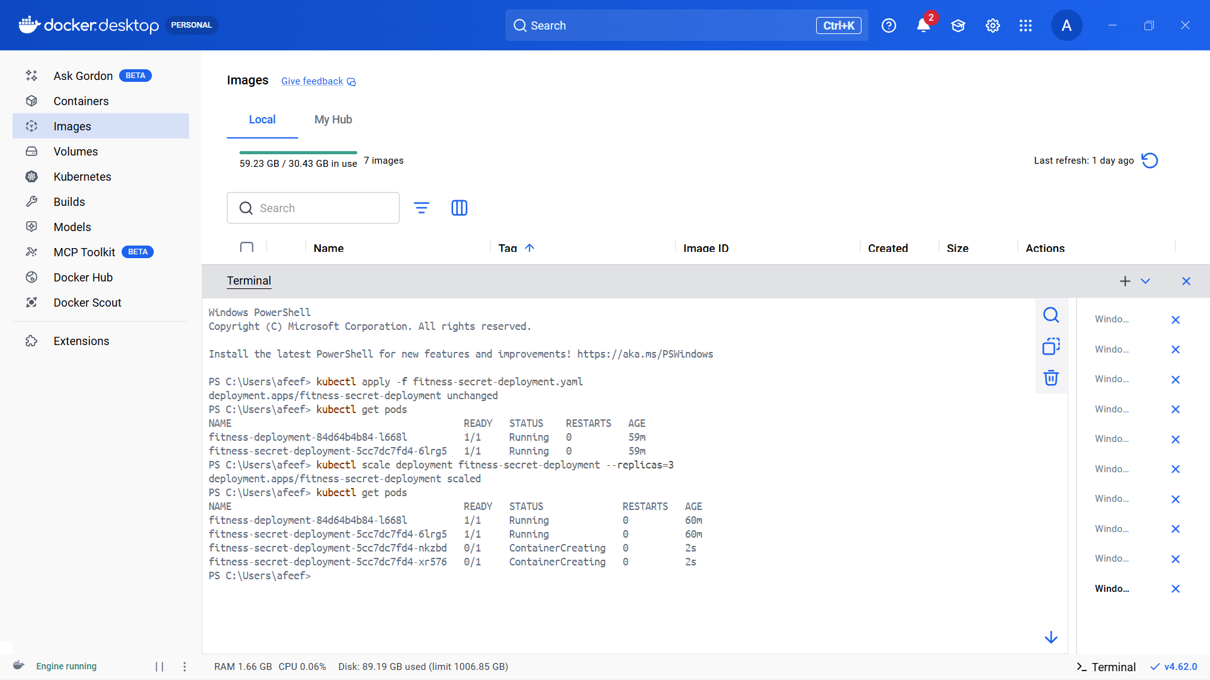
Figure 29: UPSCALE

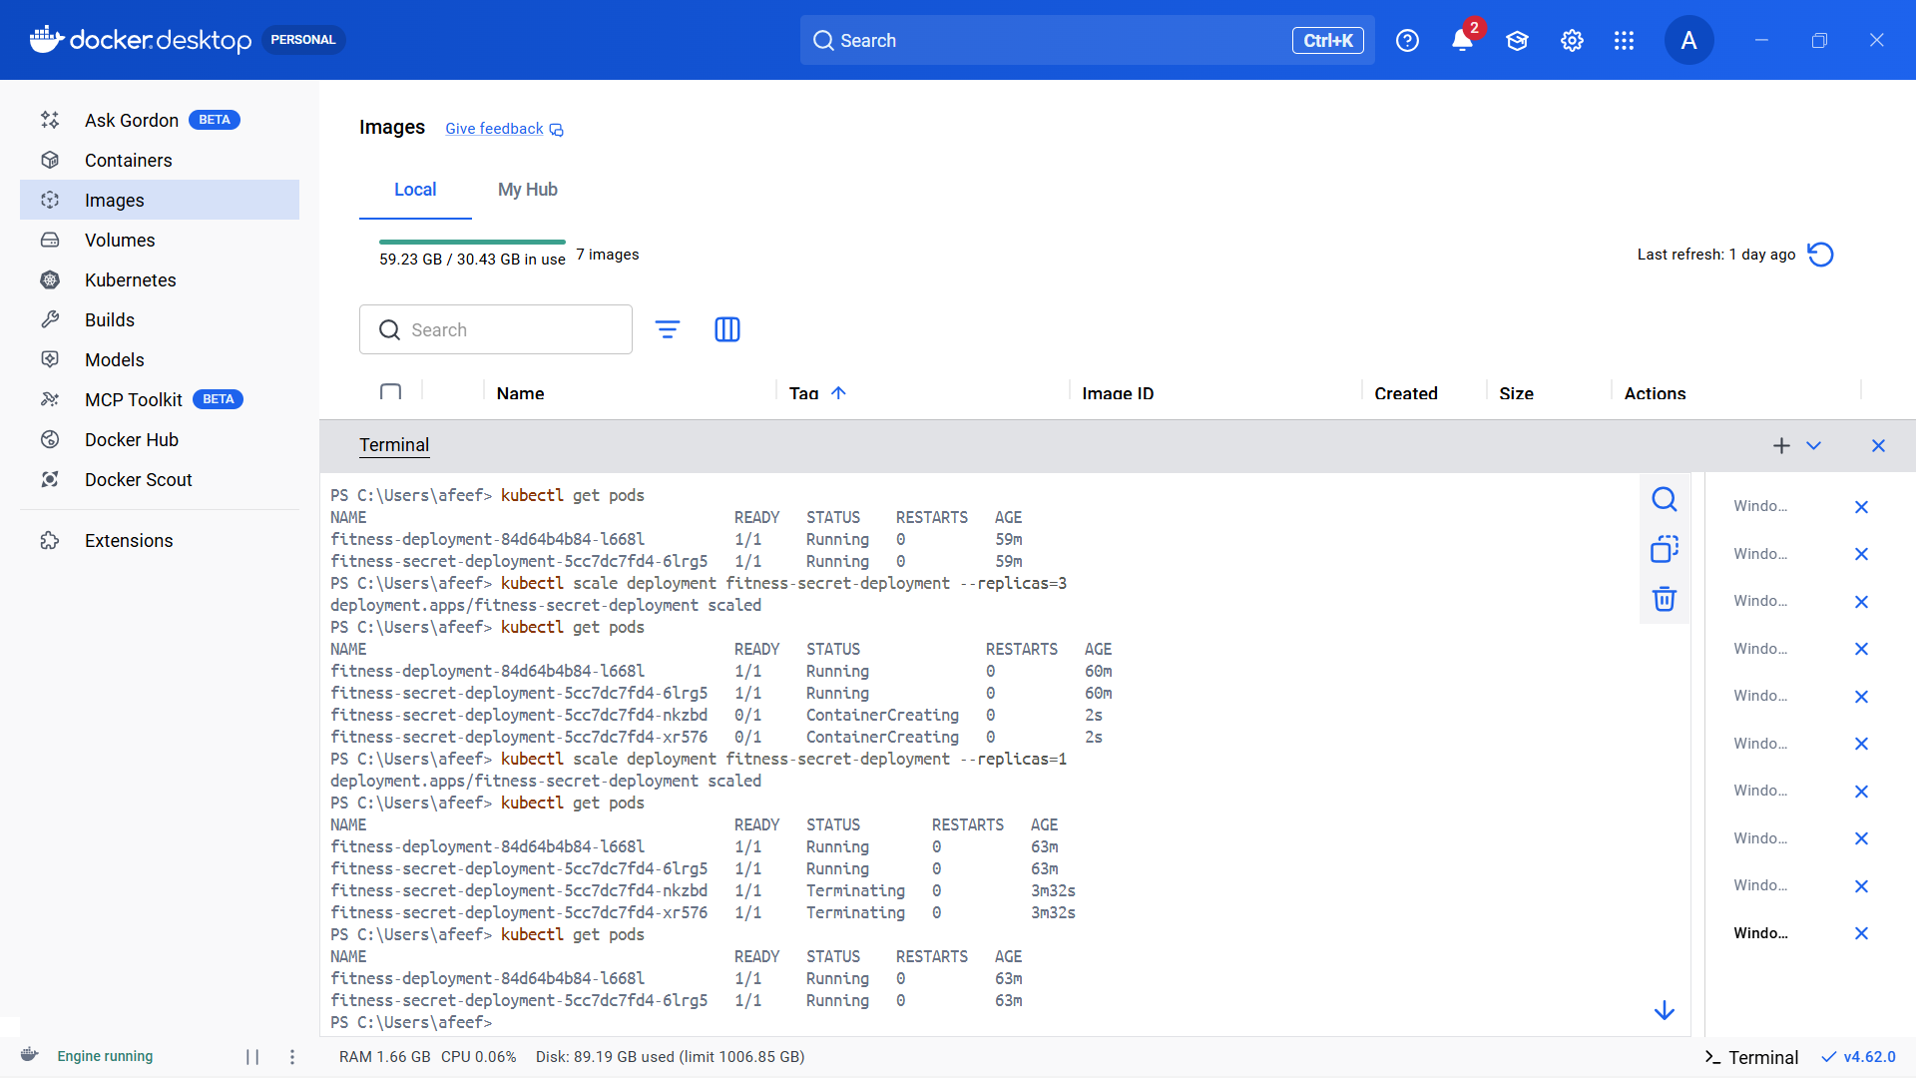
Figure 30: Downscaling

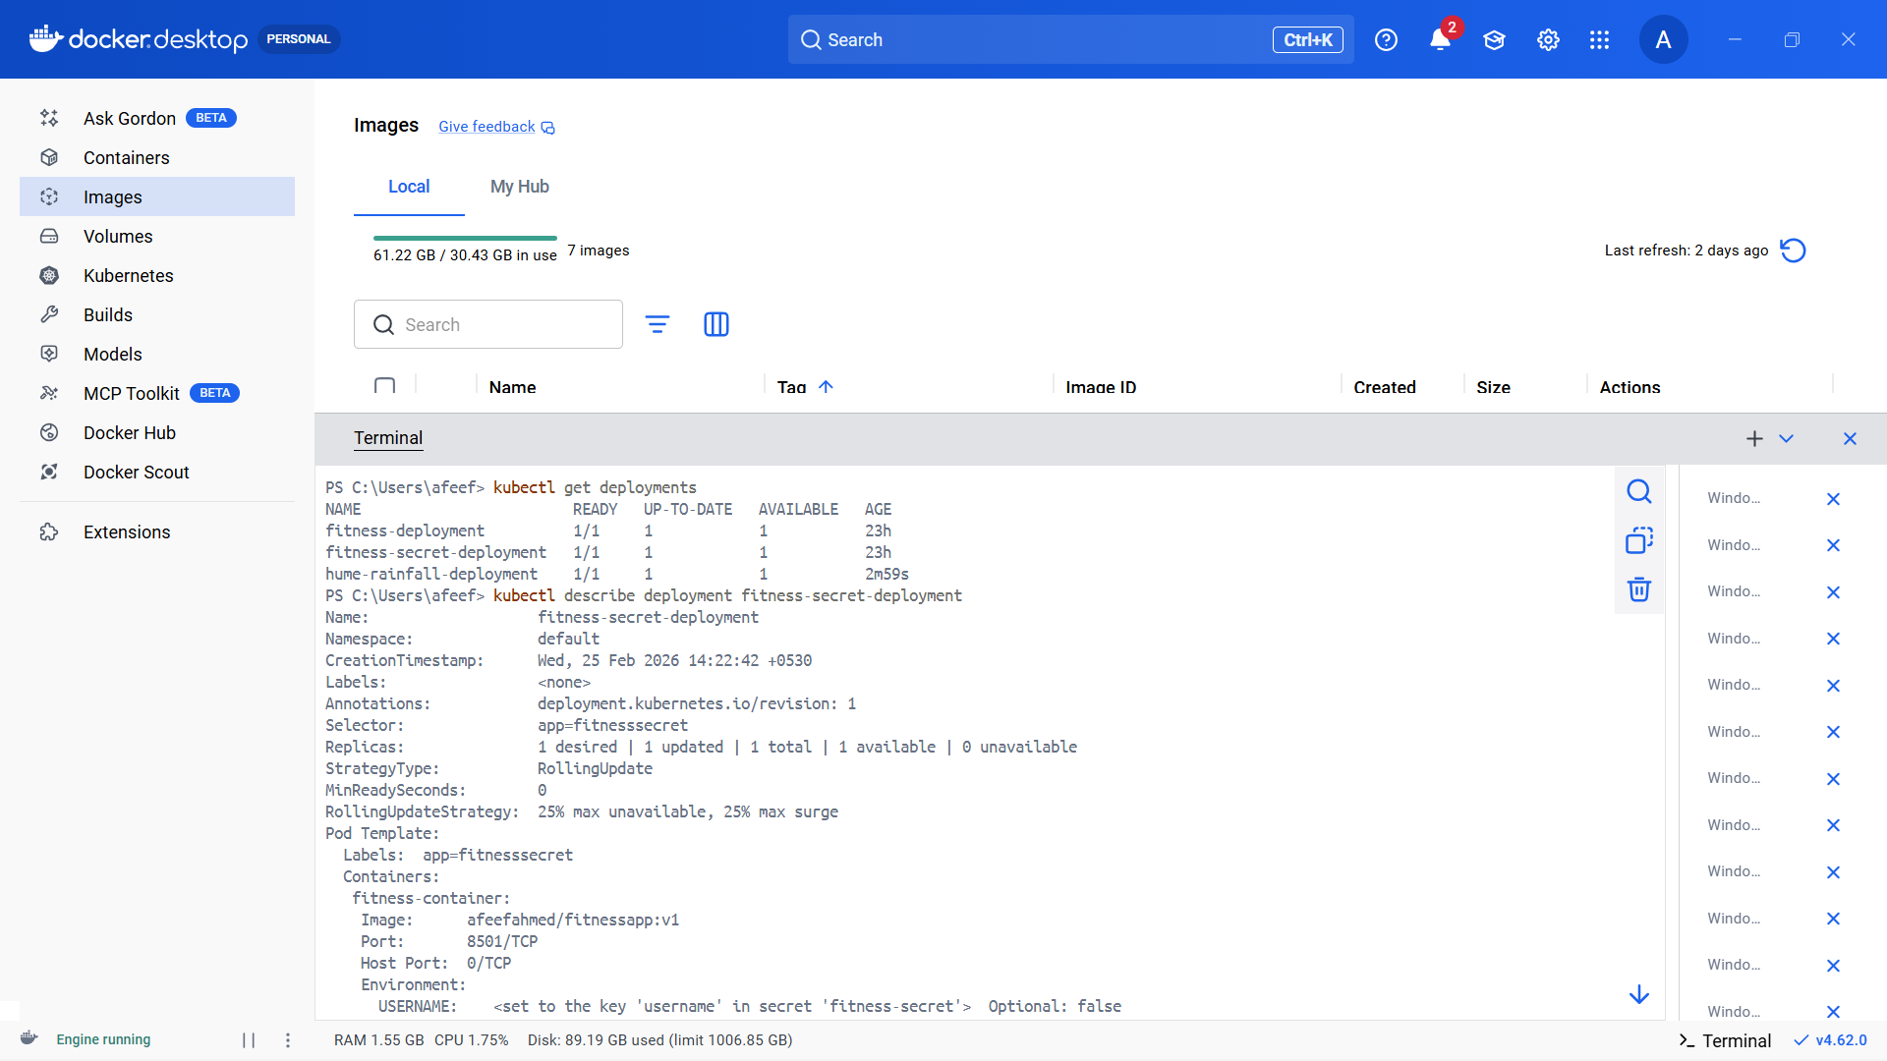
Figure 31: All Final Deployment

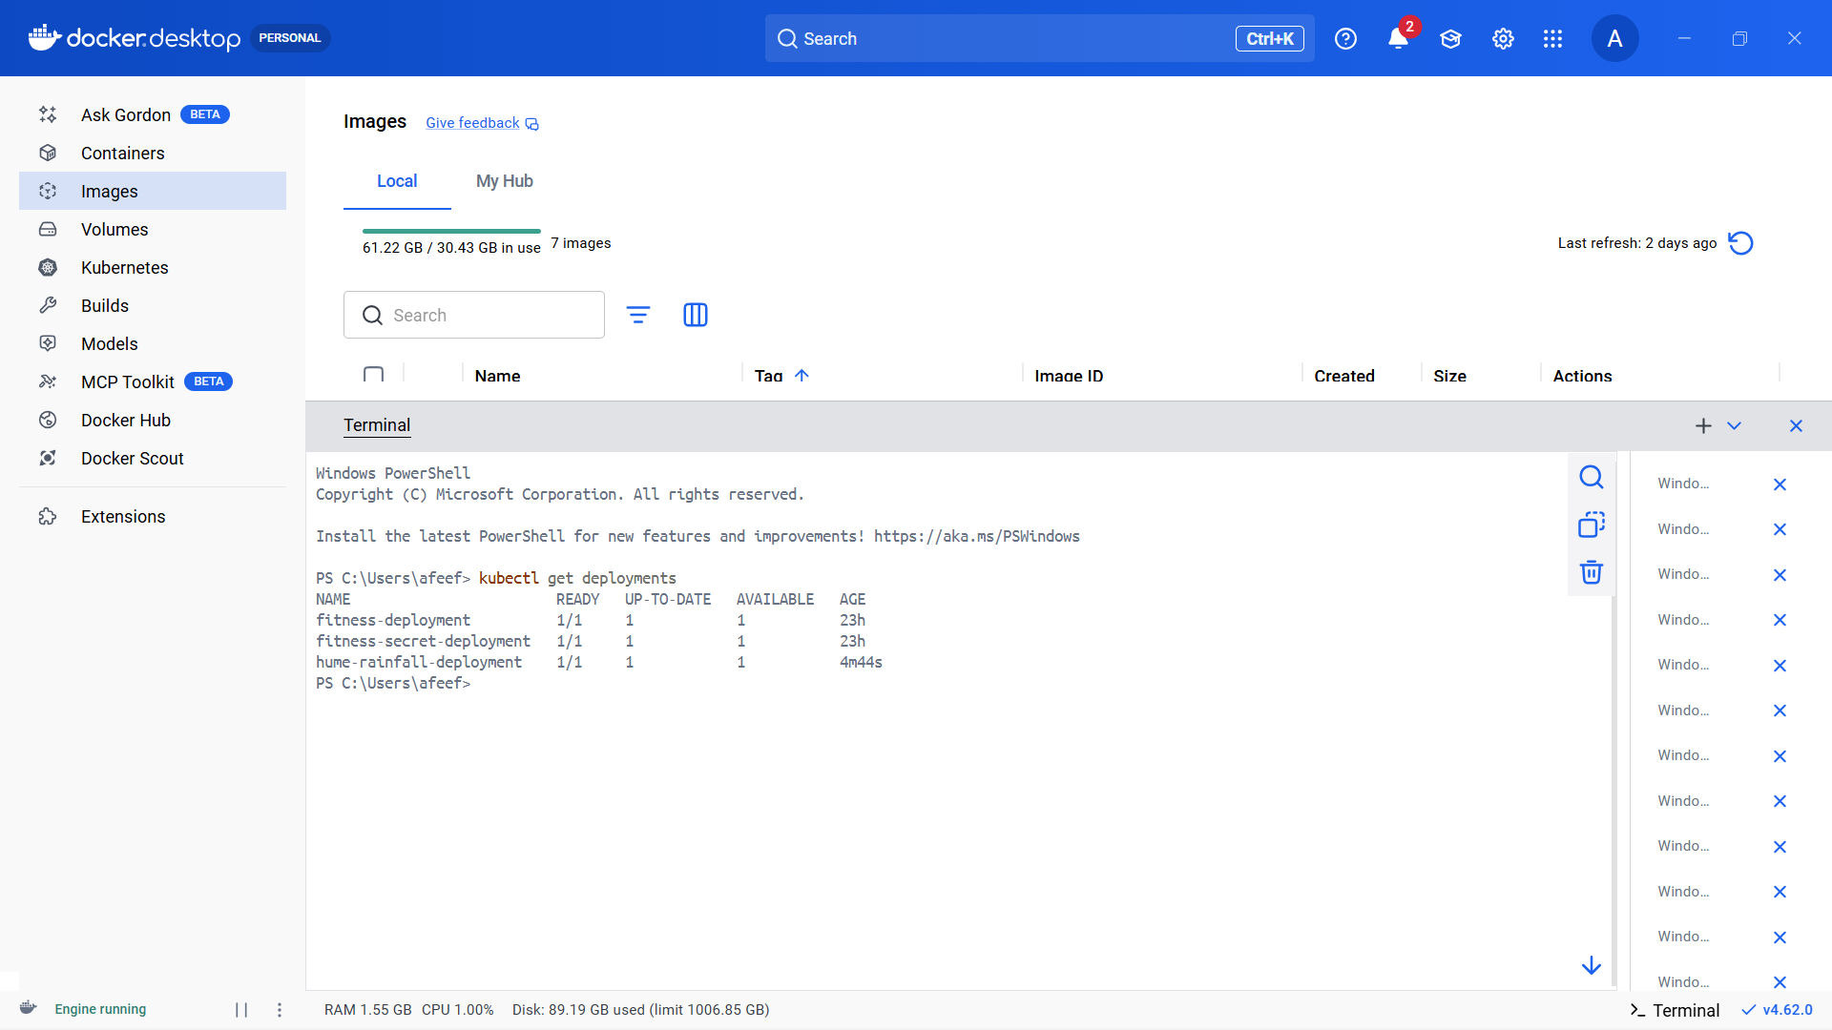
Figure 32: All Pods

