Review 1: Quality of the Module Developed

First of all, an essential aspect of the developed module is the presence of a structure in the system and the successful use of several advanced technologies within the model. It should be mentioned that the process of creating the model was performed on the basis of a rather rich COVID-19 Radiography Database, which includes many samples of chest radiograph images. The interaction with such a resource allowed considering important aspects, such as class distributions, data preparation, and training processes, contributing greatly to the creation of the proposed system.

Another crucial feature of the module is high computational efficiency due to the possibility to work with GPU. Training models in Google Colab using GPU resources allowed performing faster tests and avoiding problems related to the necessity to process big amounts of data and train complicated structures of deep learning models.
Moreover, it is important to note that another aspect of the quality of the module concerns its architecture. In the context of the described project, one can observe how the system successfully combines such important components as data preprocessing, model prediction, explaining AI, and report generation. Moreover, each component performs its function while improving the performance of the overall system.

In addition to the previous aspects, it is vital to note the presence of the feature of the generated explanations by the system. The ability to see visual explanations of results and use the information provided by AI about the disease increases the quality of the tool significantly.

Overall, it should be noted that the created project demonstrates the high quality of its modules since theoretical ideas are combined with the implementation of the solution..

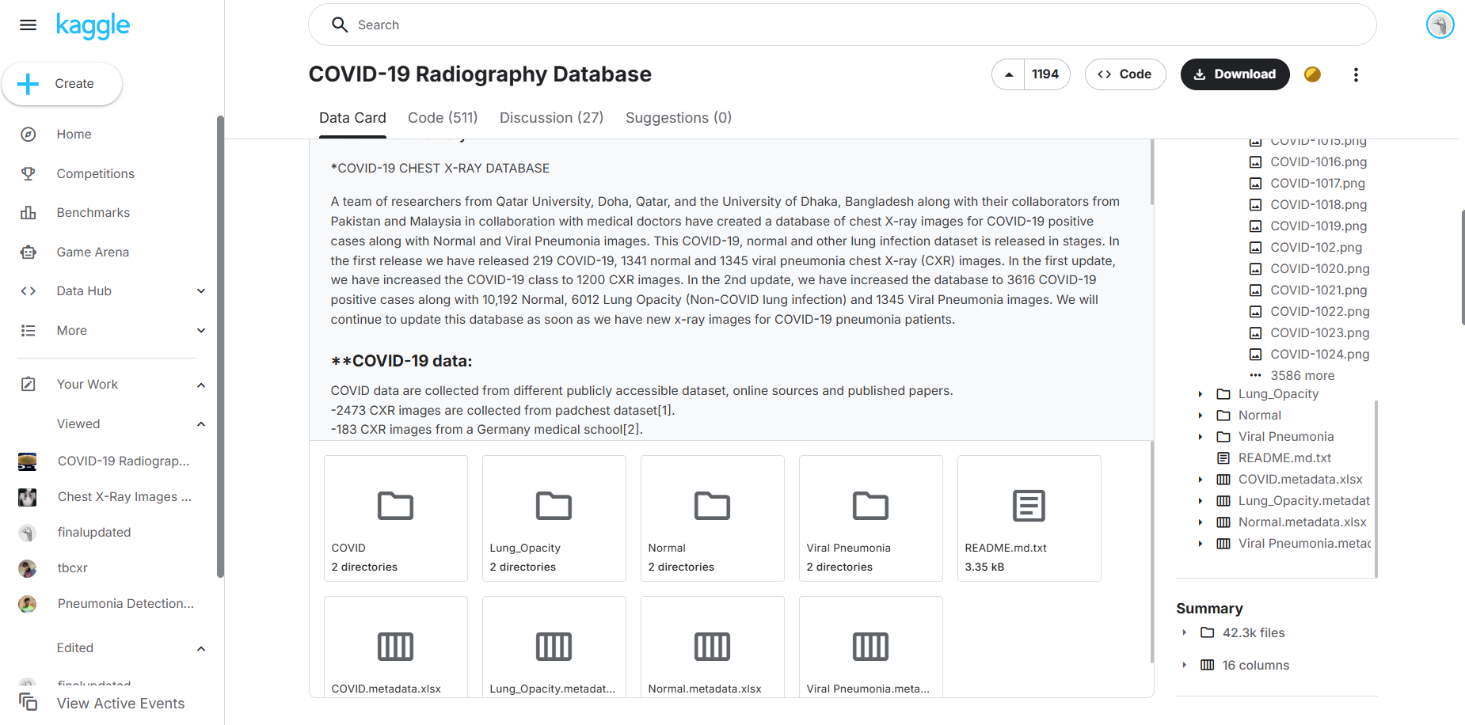
Figure 68: All the different dataset images

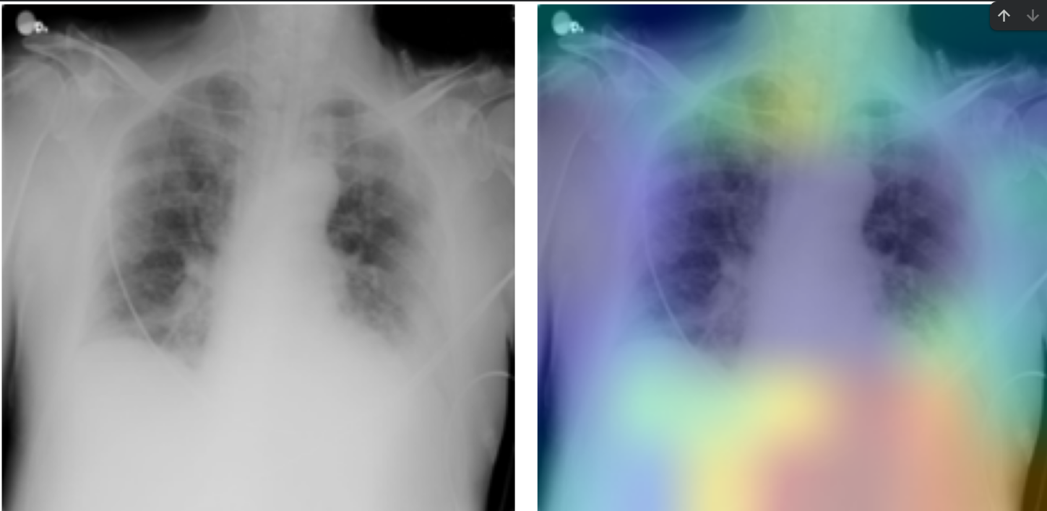
Figure 69: Untrained model false detection before fine tuning

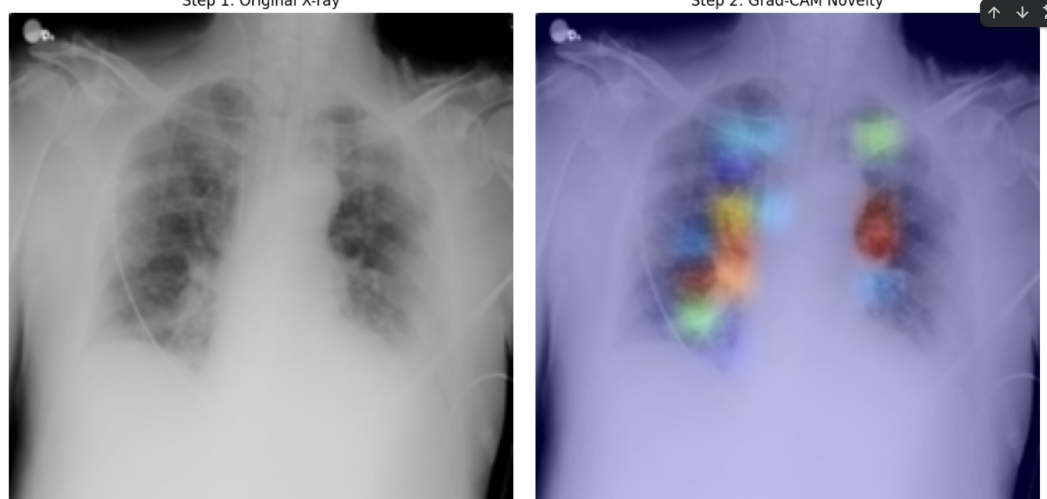
Figure 70:: Huge detection improvement after fine-tuning the model
Review 2: Containerization and Deployment

One of the most important features of the developed COVID-19 Detection System is the presence of clear mechanisms for containerization and deployment which make the system easily reproducible, portable and fit for productive use.

During the process of system creation, a special focus was put on following modern software architecture and deployment trends. Therefore, containerization was used in accordance with the modern principles based on Docker and Docker Compose technologies.

System Architecture:

The developed COVID-19 Detection System can be viewed as a multi-component architecture including the following parts:
- Frontend: React app that uses Vite for development and optimized building
- Backend: FastAPI server for images preprocessing, orchestration and API management
- Model Inference: NVIDIA Triton Inference Server for efficient, high-performance inference of models
- Local Model: As a fallback, Keras model can be used to ensure more reliable results

All of these components were packaged separately into containers by means of Docker technology. It guarantees that no external dependencies exist, and all necessary libraries are packed.

Docker Compose Orchestration

In order to facilitate the launch of multiple services, Docker Compose technology was used. The file docker-compose.yml describes services, their configuration, dependencies and networking. The system can be started with the following command:

docker compose up -d

This command does the following:
- Building and launching of Triton Inference Server with COVID classifier model loaded
- Starting a FastAPI server with correct health check setup and dependencies
- Launching React application
- Setting up inter-service communication and volumes for model loading

NVIDIA Triton Model Serving

When deploying a system, production-ready NVIDIA Triton Inference Server is used for efficient inference of pre-trained models. For setting up the service, the corresponding Docker image from NVIDIA repository is downloaded first:

docker pull nvcr.io/nvidia/tritonserver:23.10-py3

Service Endpoints

After deployment, all service endpoints can be accessed using the following URLs:
- Frontend: http://localhost:3000— React Vite application for uploading X-rays and visualizing results
- Backend API: http://localhost:8010/docs — FastAPI documentation with prediction endpoint
- Triton Server: http://localhost:8001— NVIDIA Triton Inference Server for models inference (HTTP), http://localhost:8002 (gRPC

Benefits of Deployment

The following are the key benefits of this deployment solution:

- Consistency: Standardized execution in development, testing, and production stages
- Mobility: All services can be executed on any device that supports Docker and Docker Compose
- Scaleability: Individual scaling of services based on demand (front-end, back-end, inference)
- Resilience: Health checks guarantee the availability of services; fault tolerance is provided by the mixed inference pipeline using Triton and local Keras
- Deployment Ready: Enterprise-level orchestration that is capable of being deployed to cloud-based systems or on-site infrastructure

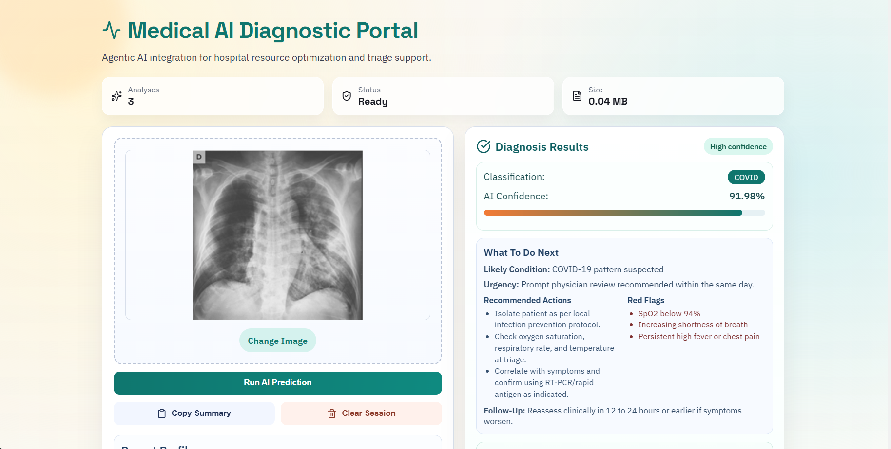
Figure 71: Main Dashboard

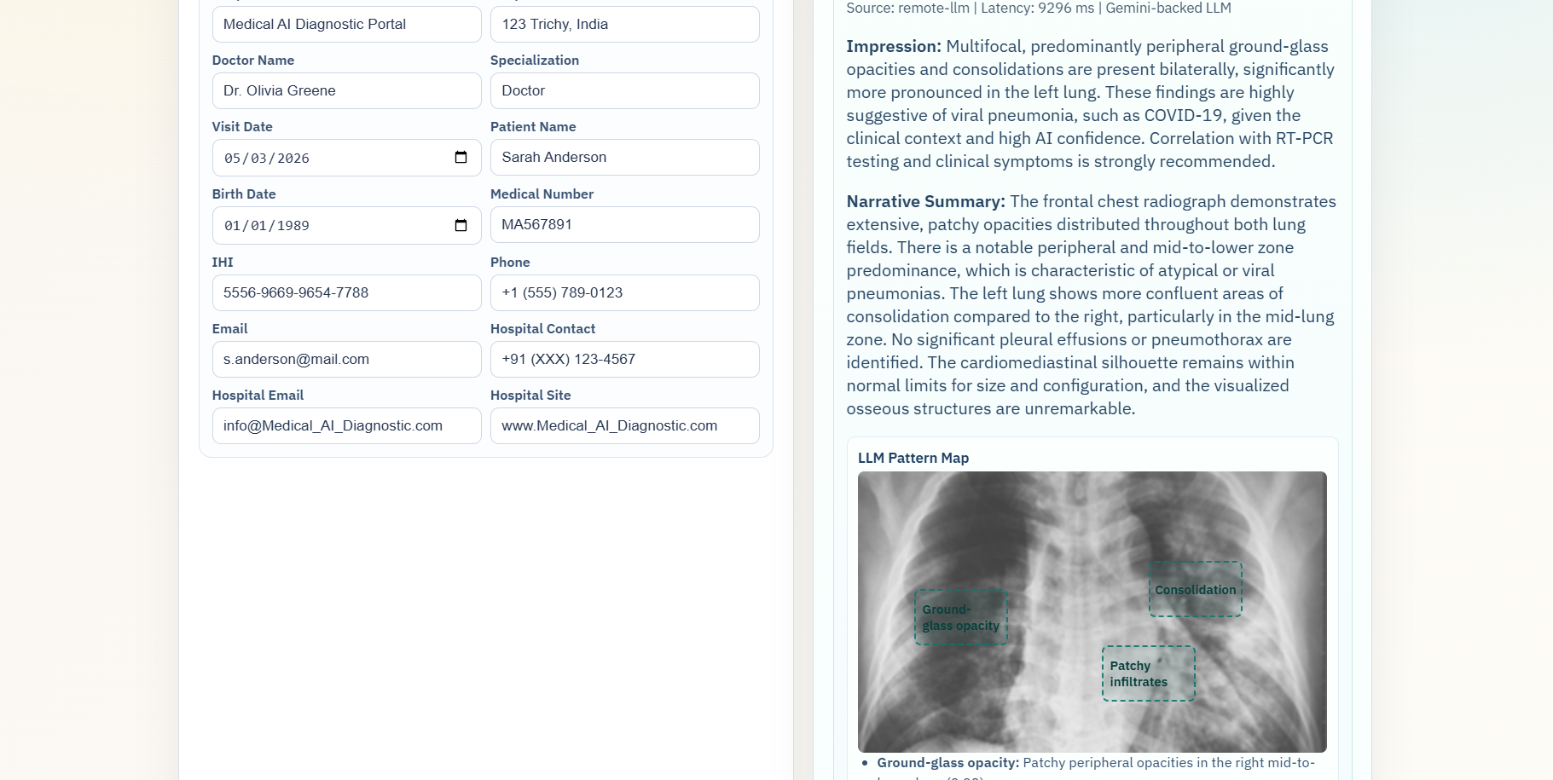
Figure 72: LLM model Insights
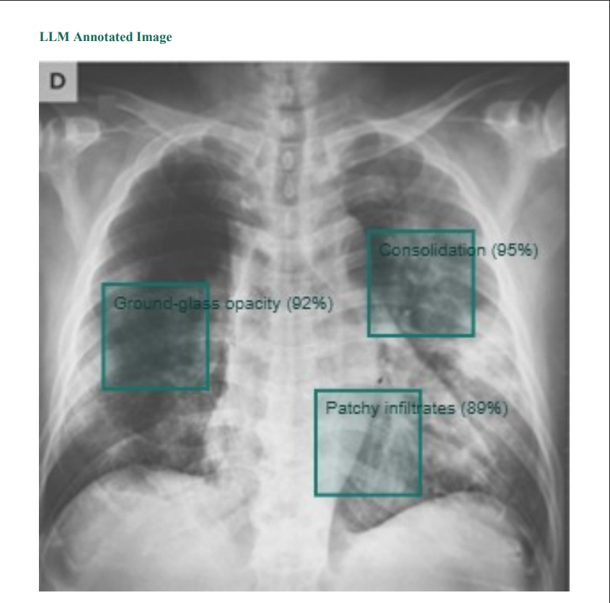
Figure 73: Model Overly of Detected virus
:
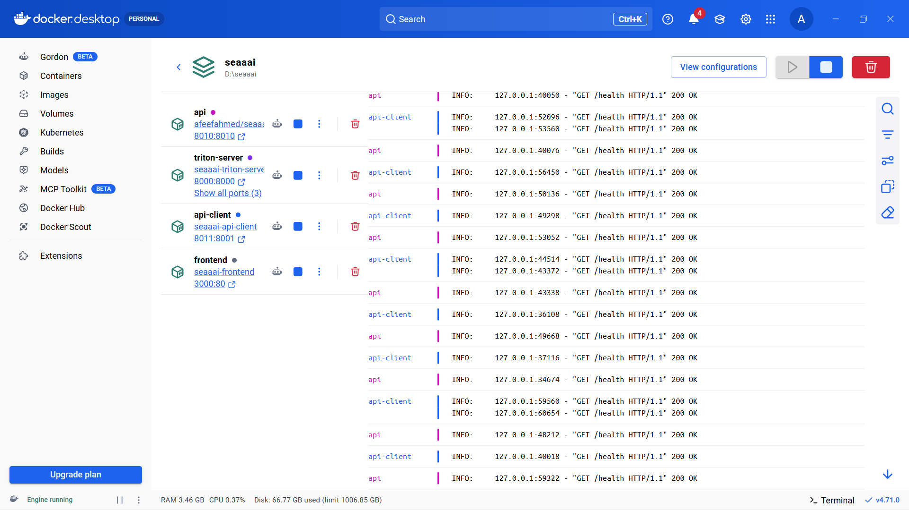
Figure 74: All containers running in docker

