PulmonaryAI: A Hybrid Deep Learning and LLM-Based System for Multi-Lung Disease Detection from Chest X-Ray Images

Afeef Ahmed Shaik
Department of Computer Science and Engineering
SRM INSTITUTE OF SCIENCE AND TECHNOLOGY
Tiruchirappalli, India
afeefahmed.shaik@gmail.com

Abstract
This project proposes PulmonaryAI which is an end-to-end AI-based clinical decision support system focused on classification of chest x-rays into four classes viz. COVID-19, Normal, Viral Pneumonia and Lung Opacity. For prediction, it uses hybrid inference pipeline which includes the use of NVIDIA Triton Inference Server for deploying the pre-trained Keras-based deep learning classifier model locally. Unlike classical inference models which follow single model architecture, PulmonaryAI follows ensemble model where confidence scores of predictions made by each of the branches of inference are combined in order to get the final prediction output. Grad-CAM based visualizations are used in order to identify regions in the image that play key role in determining the prediction output from the model. Besides this, it also incorporates the use of LLMs to generate clinical explanations for the prediction made by model in human readable form. The overall implementation of platform follows microservice based approach where backend is built using FastAPI and frontend is built using React (Vite).

Keywords
Multi-class Lung Disease Classification, Deep Learning, Chest X-ray Analysis, Explainable AI, Grad-CAM, Ensemble Models, Clinical Decision Support Systems

Metadata

Nr | Code metadata description | Metadata
C1 | Current code version | v1.0
C2 | Github link to code/repository | https://github.com/ssdafeef/PulmonaryAI
C3 | Legal code license | MIT
C4 | Code versioning system used | Git
C5 | Software code languages, tools and services used | Python 3.x, FastAPI, React (Vite), TensorFlow/Keras, NVIDIA Triton Inference Server, Docker, Gemini API
C6 | Compilation requirements, operating environments and dependencies | Docker Desktop (12GB+ RAM recommended), Python 3.x, Node.js 18+
C7 | Developer documentation/manual | https://github.com/ssdafeef/PulmonaryAI/  blob/main/README.md
C8 | Support email for questions | afeefahmed.shaik@gmail.com

1. Motivation and Significance

Despite advancements, respiratory diseases, including COVID-19, pneumonia, and lung opacity, remain significant global health concerns, especially in locations where expert radiologists are not available. Chest X-rays are commonly used for diagnosis. However, the process is often lengthy, subjective, and requires clinical expertise.

PulmonaryAI proposes an automated and explainable diagnostic solution that will aid clinicians in decision-making. While existing solutions rely solely on deep learning models for inference, PulmonaryAI proposes a novel hybrid approach using a multi-branch inference strategy that uses Triton served models and locally hosted Keras inference models. The approach will improve the robustness of the inference process and reduce the need to rely solely on a single inference model’s results.

The main novelty of the system is the confidence-aware ensemble approach that checks the agreement among all inference sources. If there is a high level of agreement among the predictions, the prediction is marked as having a high level of confidence. Otherwise, if the outputs are different, the prediction is marked as low confidence. The second motivation behind the development is interpretability. Most medical AI models have a black-box nature, limiting the ability of clinicians to validate their reasoning. In addition to providing visual interpretability through Grad-CAM visualization, the model will also integrate the use of a large language model that can automatically generate clinical reasoning.

2. Software Description

2.1 Software Architecture
The software architecture for PulmonaryAI is based on a modular design, with a three-layer approach that includes:
- Frontend Layer (React + Vite)
Offers a user-friendly interface for uploading chest X-ray images, displaying the predictions, interpreting Grad-CAM maps, and downloading the reports.

- Backend Layer (FastAPI)
Serves as the coordination system for handling:
  - Image preprocessing (resizing to 224×224 and normalizing)
  - Scheduling model inference
  - Ensembling of predictions
  - Generation of Grad-CAM heat maps
  - LLM-driven report generation
- Inference Layer (Hybrid Model Serving)
  - Triton Inference Server: Runs the main deep learning model for inference operations
  - local Keras Model: Serves as the secondary model for inference reliability
The process starts with users uploading the images, followed by image processing and parallel inference using Triton and Local Models.

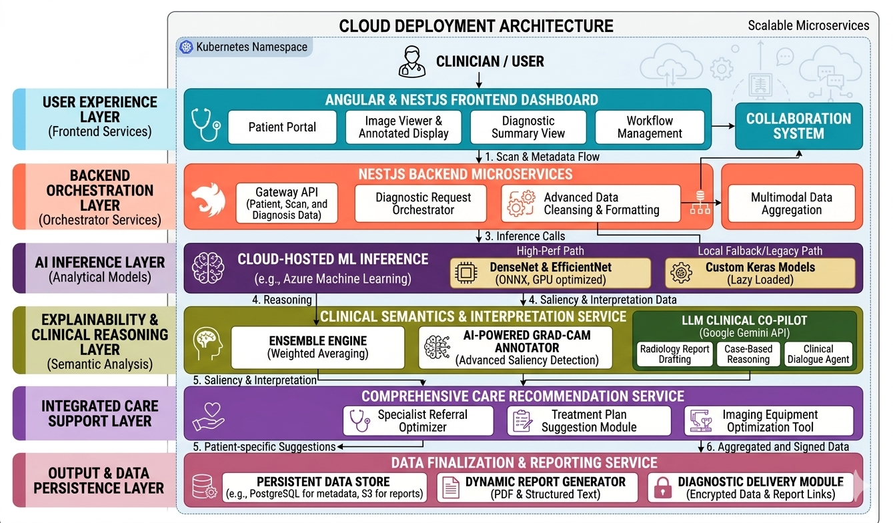
Figure 1: PulmonaryAI system architecture depicting the end-to-end pipeline from image input to diagnosis, explanation, and clinical report generation.

2.2 Software Functionalities

Some of the advanced features offered by PulmonaryAI are:
- “Multi-Class Disease Classification”
Classification of chest x-rays into:
- COVID-19
- Normal
- Viral Pneumonia
- Lung Opacity
- “Hybrid Ensemble Prediction”
Prediction of classification by combining the results of Triton and local prediction models with confidence and agreement.
- “Explainability via Grad-CAM”
Heatmap generation to identify regions affecting model decisions.
- “Explainability via Grad-CAM”
Conversion of numerical results into medical conclusions such as:
- Diagnosis summary
- Evidence points
- Differential diagnosis
- Actionable suggestions
- “Image Quality and Severity Estimation”
Analysis of input image quality and severity estimation through areas of attention.
- “Interactive Visualization”
Displays predictions, heatmaps, and ai-generated insights in real time.

2.3 Implementation Details

n the PulmonaryAI system, deep learning is coupled with the web framework and cloud deployment capabilities for the creation of the production-grade application. The backend implementation involves FastAPI with asynchronous support to allow processing of multiple users' input at once. Preprocessing of the chest X-rays images includes resizing to 224 × 224 pixels, normalization of pixel values, and conversion into the format suitable for the neural network. The classification model implemented uses the architecture of ResNet and includes dense layers with four output classes. Hybrid inference strategy has been adopted in PulmonaryAI, with the first being hosted within NVIDIA Triton Inference Server and the second being the local Keras model. HTTP requests are used to transmit data between the backend and Triton server; specifically, requests sent from the backend include tensors of preprocessed images, whereas the responses received from the inference contain probabilities of four predictions that will be further processed to determine a class label with a certain level of confidence.

The confidence-aware ensemble method is employed in the system to make a final diagnosis based on the agreement of two inference sources and assigning predictions to high confidence and further verification categories. Explainability of AI-based predictions is ensured through the integration of Grad-CAM, which provides heatmap visualization of predictions by computing gradients in the final convolutional layer and mapping them onto the original image. Severity estimation and anomaly identification can be done by analyzing such heatmaps. To provide structured reports of AI-assisted diagnosis, PulmonaryAI implements LLM through an external API. Frontend of the app is created using React and Vite and is capable of interacting with the backend via REST API. The entire application is containerized using Docker and deployed using Docker Compose tool.

3. Illustrative Example

In order to showcase the functioning of PulmonaryAI, an image taken through a chest X-Ray scan is uploaded through the web-based interface. Then, the backend process processes the image and sends it simultaneously to the Triton server and the locally installed Keras model. Both models come up with the respective predictions as well as their respective confidence scores. Ensemble methods are applied on both the predictions and accordingly the final result is determined.

For instance, in case of similar predictions by both the models of presence of COVID-19 with high level of confidence, the final result comes up as 'COVID-19 (High Confidence)' and Grad-CAM visualization is used to generate heat maps indicating the severity of condition.

Lastly, the LLM creates a clinical report including:
- Diagnosis report
- evidence
- Differential diagnosis
- Recommendations for Clinical Action

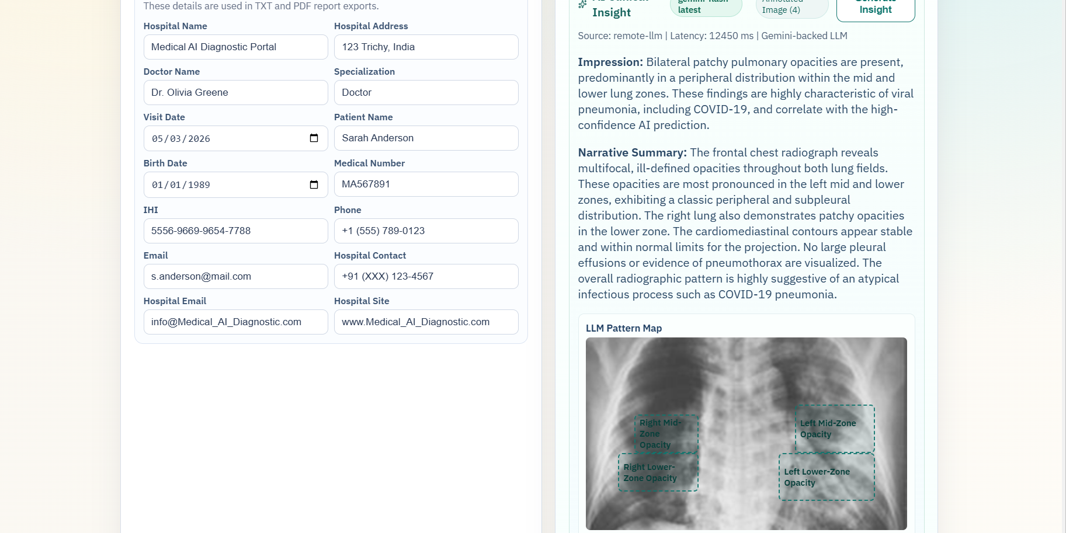
Figure 2: PulmonaryAI output detecting COVID and showcasing Virus being detected using LLM model

4. Impact

There are several promising directions of research associated with the implementation of PulmonaryAI in the domain of medical imaging and artificial intelligence-based decision support systems. The first important novelty of this approach involves the implementation of hybrid inference architecture based on the combination of a centralized inference framework, like NVIDIA Triton, and local models for ensuring redundant and reliable operation. This hybrid inference design allows the use of a number of tradeoffs between latency, scalability, and interpretability, thus allowing application in real clinical environment. At the same time, the utilization of Grad-CAM visualization in the context of multi-models ensemble raises important questions about the consistency of generated explanations, their validity and credibility. Another important innovation relates to the integration of the large language model allowing for automatic generation of structured patient-friendly explanations of findings made by the algorithm.

This project is significantly better than existing algorithms, as it is designed to operate under confidence-aware ensemble and provide for greater generalization of results and enhanced robustness. It addresses one of the main challenges that academic AI projects face – lack of practical implementations due to scalability issues. This system is designed to allow for fast preliminary assessment of the chest x-rays with the help of the generated heatmap and automatic clinical report, assisting clinicians in making better-informed decisions, particularly in under-resourced areas. The design of a modular and containerized system ensures easy deployment and usage across organizations. Moreover, there are multiple opportunities for developing commercial products using this solution in the future, including telemedicine services and other AI-based diagnostic tools.

5. Conclusions

The PulmonaryAI solution provides a scalable and explainable artificial intelligence-based tool for multi-class pulmonary disease classification based on chest X-ray images using an inference approach that includes hybrid inference. Using the NVIDIA Triton Inference Server to serve a locally trained deep learning model, the solution offers better stability and robustness via ensemble-based predictions. The combination of Grad-CAM helps provide visual interpretability, whereas the introduction of a large language model contributes towards improved explanation generation.

The use of Docker container technology for the construction of PulmonaryAI allows for easy deployment of the system and its portability across different environments. Thus, PulmonaryAI shows how recent advances in areas such as deep learning, inference, and explainable artificial intelligence can be effectively integrated to create a practical tool contributing to the development of computer-aided diagnosis.

6. Acknowledgements

The author gratefully acknowledges the valuable inputs and constant guidance received from the faculty and mentors in developing the current study. The author wishes to thank the Department of Computer Science for the facilities provided to carry out the research. The author also wishes to acknowledge the role of the open source community in helping develop this study through the use of various resources.

7. References

[1] COVID-19 Radiography Database, Kaggle Dataset. Available: https://www.kaggle.com/datasets/tawsifurrahman/covid19-radiography-database
[2] K. He, X. Zhang, S. Ren, J. Sun, “Deep Residual Learning for Image Recognition,” in Proc. IEEE CVPR, 2016.
[3] R. R. Selvaraju et al., “Grad-CAM: Visual Explanations from Deep Networks via Gradient-based Localization,” in Proc. IEEE ICCV, 2017.
[4] NVIDIA Corporation, “Triton Inference Server,” 2023. Available: https://developer.nvidia.com/triton-inference-server
[5] TensorFlow Developers, “TensorFlow: Large-Scale Machine Learning on Heterogeneous Systems,” 2015. Available: https://www.tensorflow.org/
[6] FastAPI Contributors, “FastAPI Framework,” 2023. Available: https://fastapi.tiangolo.com/
[7] Google, “Gemini API Documentation,” 2024. Available: https://ai.google.dev/
[8] Docker Inc., “Docker Documentation,” 2023. Available: https://docs.docker.com/

