Product Innovation

Title: COVID-19 Detection System: AI-Powered Clinical Diagnostic Platform for COVID-19 Detection using Deep Learning and Explainable AI

- Introduction

This project presents an advanced AI-driven system designed for the automated detection of COVID-19 and related pulmonary conditions using chest X-ray images. Unlike conventional machine learning systems that depend on a single predictive model, this platform integrates multiple deep learning models, explainable AI techniques, and scalable deployment strategies to create a comprehensive and reliable diagnostic tool. The primary objective of the system is not only to achieve high prediction accuracy but also to ensure interpretability, usability, and adaptability in real-world healthcare environments.

The system is trained using a large-scale publicly available dataset containing thousands of labeled chest X-ray images. By leveraging this dataset, the model learns to distinguish between multiple categories such as COVID-19, normal lungs, viral pneumonia, and lung opacity. However, what differentiates this system from traditional approaches is its use of a multi-model ensemble mechanism, where multiple models independently analyze the same input and contribute to a final decision. This approach significantly improves robustness and reduces the risk of incorrect predictions.

In addition to prediction accuracy, the system emphasizes transparency through explainable AI techniques. Medical professionals often require justification for diagnostic decisions, and this system addresses that need by highlighting critical regions in the X-ray images that influenced the prediction. Furthermore, the integration of AI-generated clinical explanations ensures that the output is not only accurate but also understandable. By combining deep learning, interpretability, and deployment readiness, this project represents a significant step toward bridging the gap between research-based AI models and practical healthcare applications.

The developed version of this project is available at:
https://github.com/ssdafeef/PulmonaryAI

Problem Statement
Existing AI-based diagnostic systems in healthcare face several critical limitations that restrict their effectiveness and adoption. One of the major issues is their dependence on a single deep learning model, which can lead to biased predictions and reduced reliability. In high-stakes medical scenarios, even small inaccuracies can have serious consequences, making it essential to design systems that are robust and dependable. Unfortunately, many current solutions fail to address this requirement adequately.

Another significant challenge is the lack of interpretability. Most AI systems operate as “black boxes,” producing outputs without explaining how the decision was made. This lack of transparency creates hesitation among healthcare professionals, as they cannot fully trust a system whose reasoning is unclear. In clinical practice, understanding why a diagnosis is made is just as important as the diagnosis itself. Without this clarity, AI systems struggle to gain acceptance in real-world environments.

Additionally, many existing solutions are developed primarily for research purposes and are not optimized for deployment in real healthcare settings. They often lack scalability, integration capabilities, and user-friendly interfaces. Real-world clinical workflows involve multiple stages, including data validation, collaborative decision-making, and structured reporting. However, traditional AI models do not replicate this process and typically provide isolated predictions without context or supporting information.

Furthermore, these systems rarely incorporate uncertainty handling or confidence measures, leading to overconfident predictions that may misguide decision-making. They also do not provide features such as automated report generation, severity classification, or multilingual support, which are essential for practical usability. This project addresses all these limitations by proposing a system that is not only accurate but also transparent, scalable, and aligned with real-world clinical practices.

Proposed Solution
The proposed solution introduces a hybrid AI framework that combines advanced deep learning techniques, explainable AI, and modern deployment technologies to create a complete clinical decision support system. At its core, the system utilizes a modified convolutional neural network architecture based on ResNet50, enhanced with an attention mechanism. This allows the model to focus on the most relevant regions of the chest X-ray, improving classification performance across multiple disease categories.

To further enhance reliability, the system employs a multi-model ensemble strategy. Instead of relying on a single model, multiple models independently process the input image and generate predictions. These predictions are then aggregated using a confidence-based voting mechanism. When all models agree with high confidence, the system produces a strong and reliable diagnosis. In cases of disagreement, the system flags the result for further review, thereby reducing the risk of incorrect conclusions. This approach closely mimics the collaborative nature of real-world medical diagnosis, where multiple experts contribute to decision-making.

Explainability is a key component of the proposed solution. The system integrates Grad-CAM techniques to generate visual heatmaps that highlight the regions of the X-ray image responsible for the prediction. This provides valuable insights to medical professionals and helps build trust in the system. Additionally, a language model is incorporated to generate detailed and human-readable explanations of the diagnosis. These explanations include reasoning, potential implications, and suggested next steps, making the system more accessible and user-friendly.

The solution also includes automated report generation, where all results are compiled into a structured PDF document. This report contains predictions, confidence levels, severity classification, and explanatory insights. Additional features such as multilingual support and severity analysis further enhance the system’s usability. Overall, the proposed solution transforms a basic AI model into a comprehensive, interpretable, and deployable healthcare platform.

System Workflow
The system operates through a well-defined pipeline that simulates a real-world diagnostic workflow. The process begins with the user uploading a chest X-ray image through a web-based interface. This interface is designed to be intuitive and user-friendly, ensuring that even non-technical users can easily interact with the system.

Once the image is uploaded, it is sent to the backend server, where preprocessing steps are performed. These steps include resizing the image to a standard resolution, normalizing pixel values, and converting the image into a format suitable for model input. Proper preprocessing is essential to ensure consistent and accurate predictions.

After preprocessing, the image is passed through multiple inference models. Each model independently analyzes the image and produces probability scores for different classes. These outputs are then combined using an ensemble mechanism. If the models produce consistent results, the system assigns a high-confidence prediction. If there is disagreement, the system highlights the uncertainty and suggests further evaluation. Following prediction, the system applies explainable AI techniques to generate visual heatmaps. These heatmaps indicate which regions of the image were most influential in the decision-making process. The system then uses a language model to generate a detailed explanation of the results, making the output more understandable and informative.

Additional processing steps include severity classification, which categorizes the condition into levels such as mild, moderate, or severe. Finally, all results are compiled into a structured format and presented on the user interface. A downloadable PDF report is also generated, providing a comprehensive summary of the diagnosis.

Key Innovations
- AttentionResNet50 with custom attention mechanism for COVID-19 classification
- Hybrid inference using NVIDIA Triton Inference Server + local Keras model
- Explainable AI using Grad-CAM visualization for every prediction
- Confidence-based ensemble voting across multiple inference branches
- AI-powered clinical explanation using LLM (Google Gemini)
- Automated PDF report generation with multi-language support
- Four-class classification: COVID-19, Normal, Viral Pneumonia, Opacity
- ~94% accuracy with ~0.97 AUC-ROC on 21,165 chest X-ray images
- Severity classification of COVID-19 severity (mild, moderate, severe)
- Full-stack deployment using Docker Compose
- Production-grade model serving using NVIDIA Triton Inference Server
- End-to-end integrated AI pipeline from upload to PDF report

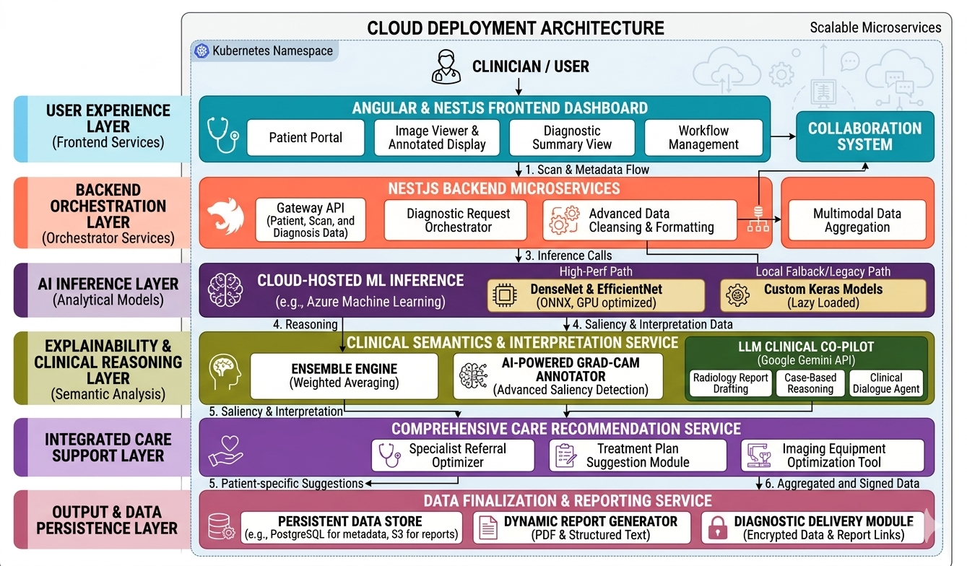
Figure 1: Architecture Diagram of model

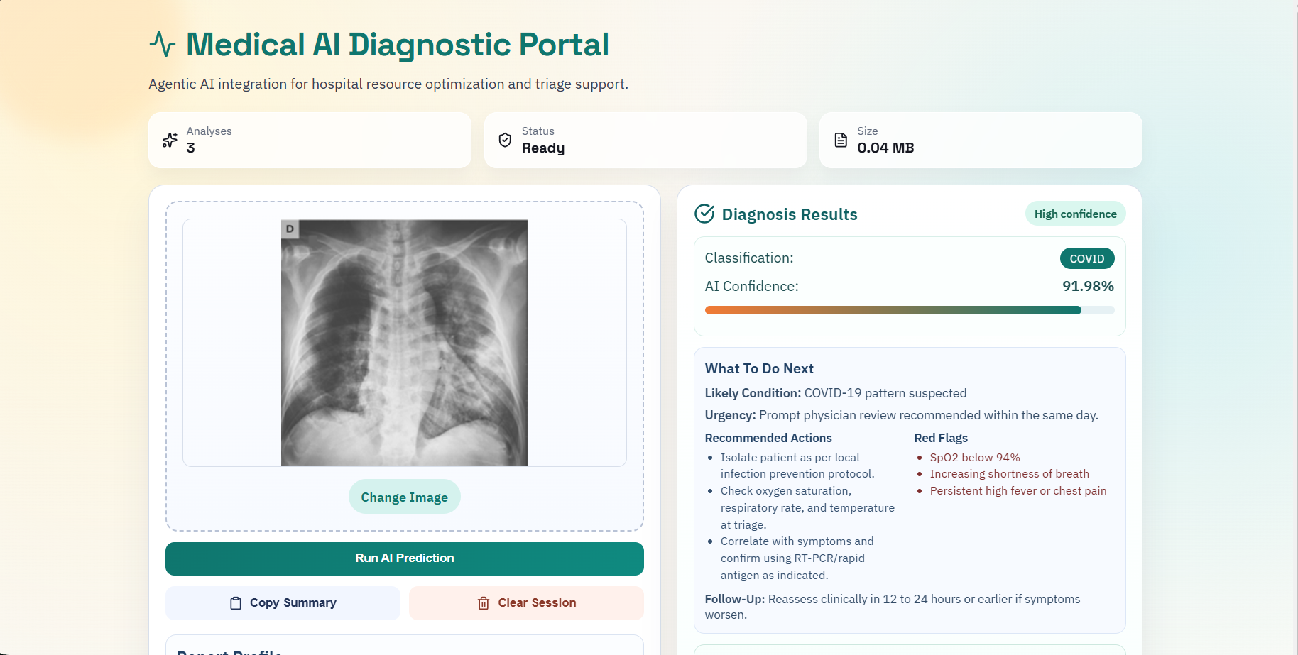
Figure 2: X-ray prediction output showcasing result

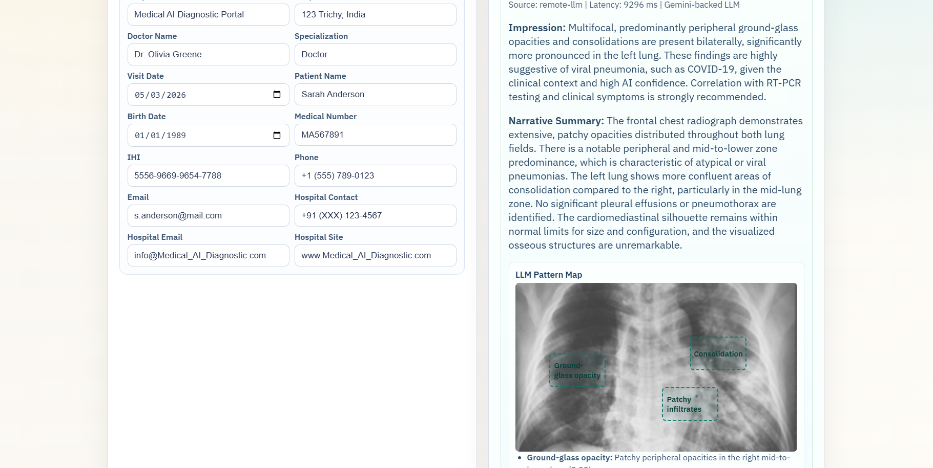
Figure 3: The LLM model showcasing overlay of detected area

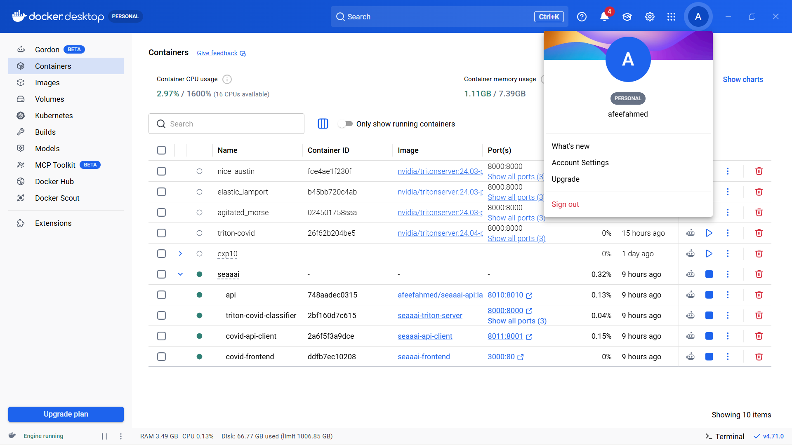
Figure 4: The Whole Project running on docker

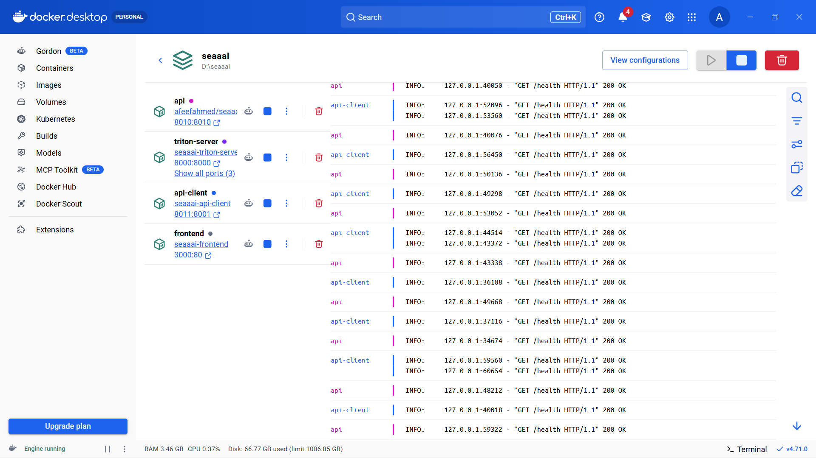
Figure 5: All the container inside docker container

Dataset and Training Details
The development and evaluation of the COVID-19 Detection System are based on the COVID-19 Radiography Database, a widely used dataset for medical image classification. It contains a large collection of chest X-ray images categorized into classes such as COVID-19, Normal, Viral Pneumonia, and Lung Opacity. With over 21,000 images, the dataset provides sufficient diversity for training robust deep learning models.

The dataset is divided into training, validation, and testing subsets to ensure reliable evaluation. The training set is used for learning patterns, while the validation set helps monitor performance during training and prevent overfitting. The test set is reserved for final evaluation on unseen data, ensuring unbiased performance assessment.

Several preprocessing techniques are applied to improve model performance. Images are resized to a standard input size (224 × 224 pixels), and pixel values are normalized. Data augmentation methods such as rotation, flipping, and zooming are also used to increase variability and improve generalization. Since the dataset is imbalanced, class weighting is applied during training to ensure fair learning across all categories.

The models are trained using TensorFlow on Google Colab with GPU support, enabling faster computation. Transfer learning is employed using pretrained architectures like ResNet50 and DenseNet121, which are fine-tuned on the dataset to improve accuracy.
Standard training practices are followed, including the use of appropriate loss functions and optimizers. Model performance is evaluated using metrics such as accuracy, precision, recall, and F1-score. Among the tested approaches, the system achieves high accuracy (around 94%) with strong overall performance.

Overall, the combination of a large dataset, effective preprocessing, transfer learning, and GPU-based training ensures that the system is accurate, efficient, and suitable for real-world medical applications.

Deployment and Scalability
The system is designed with scalability and portability in mind, utilizing containerization technologies to ensure seamless deployment across different environments. Each component of the system, including the frontend, backend, and inference services, is packaged into separate containers. This modular approach simplifies development, testing, and maintenance.

The use of a high-performance inference server enables efficient handling of multiple requests, making the system suitable for real-time applications. Additionally, the hybrid architecture allows the system to operate on both GPU-enabled and CPU-only environments, ensuring accessibility in resource-constrained settings.

By leveraging container orchestration tools, the system can be easily scaled to handle increased workloads. This makes it suitable for deployment in hospitals, research institutions, and remote healthcare centers. Overall, the deployment strategy ensures that the system is not only powerful but also practical and adaptable.

Real-World Impact
The system has the potential to significantly improve healthcare delivery by enabling early and accurate detection of COVID-19 and related conditions. By providing automated diagnosis along with clear explanations, it supports healthcare professionals in making informed decisions. This is particularly beneficial in regions where access to experienced radiologists is limited.

The system also enhances efficiency by reducing the time required for diagnosis and minimizing human error. Its ability to generate structured reports and provide severity assessments further contributes to better patient management. By making advanced diagnostic tools more accessible, the system plays a crucial role in improving overall healthcare outcomes.

Conclusion
In conclusion, this project presents a comprehensive AI-powered diagnostic platform that goes beyond traditional machine learning models. By integrating multiple advanced technologies, including deep learning, explainable AI, and scalable deployment frameworks, it delivers a reliable and interpretable solution for medical diagnosis.

The system demonstrates how AI can be effectively applied to solve real-world healthcare challenges. Its combination of accuracy, transparency, and usability makes it a valuable contribution to the field of medical artificial intelligence. By bridging the gap between research and practical implementation, this project highlights the transformative potential of AI in healthcare.

Review 1: Quality of the Module Developed

A major strength of the developed module lies in its structured design and the effective integration of multiple advanced technologies into a unified system. The model development process was carried out using the COVID-19 Radiography Database, which contains a large and diverse collection of chest X-ray images. Working with this dataset required careful analysis of class distributions, preprocessing requirements, and training strategies, ensuring that the model could learn meaningful patterns across different categories. This contributed significantly to the robustness and reliability of the final system.

The module demonstrates high computational efficiency through the use of GPU-accelerated training on Google Colab. Leveraging GPU resources enabled faster experimentation, efficient handling of large datasets, and the ability to train complex deep learning architectures without performance bottlenecks. This made it feasible to implement and compare multiple models, including attention-based architectures and ensemble techniques, within a reasonable time frame.
Another important aspect of quality is the modular and well-organized system design. The project successfully integrates various components such as data preprocessing, model inference, explainable AI, and report generation into a seamless pipeline. Each component is designed to perform a specific function while contributing to the overall system performance. This modular approach not only improves maintainability but also allows future enhancements without disrupting existing functionality.

The incorporation of explainable AI techniques further enhances the quality of the module by improving transparency. By generating visual explanations for predictions, the system ensures that users can understand the reasoning behind the results. Additionally, the integration of AI-generated clinical explanations adds another layer of interpretability, making the system more user-friendly and practical for healthcare applications.

Overall, the module reflects a strong balance between theoretical concepts and real-world implementation. The use of a high-quality dataset, efficient training strategies, and advanced features such as ensemble learning and explainability demonstrates that the system is both technically sound and practically valuable.

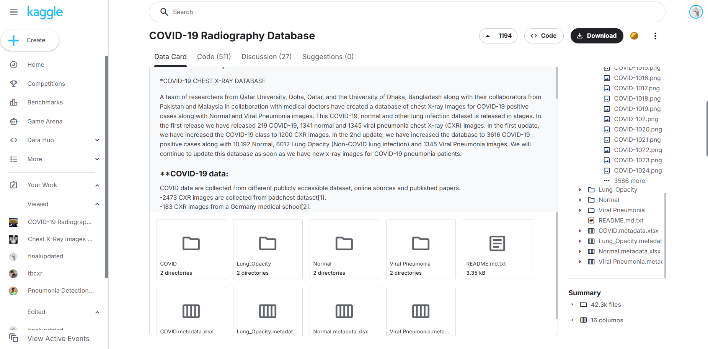
Figure 6: All the different dataset images

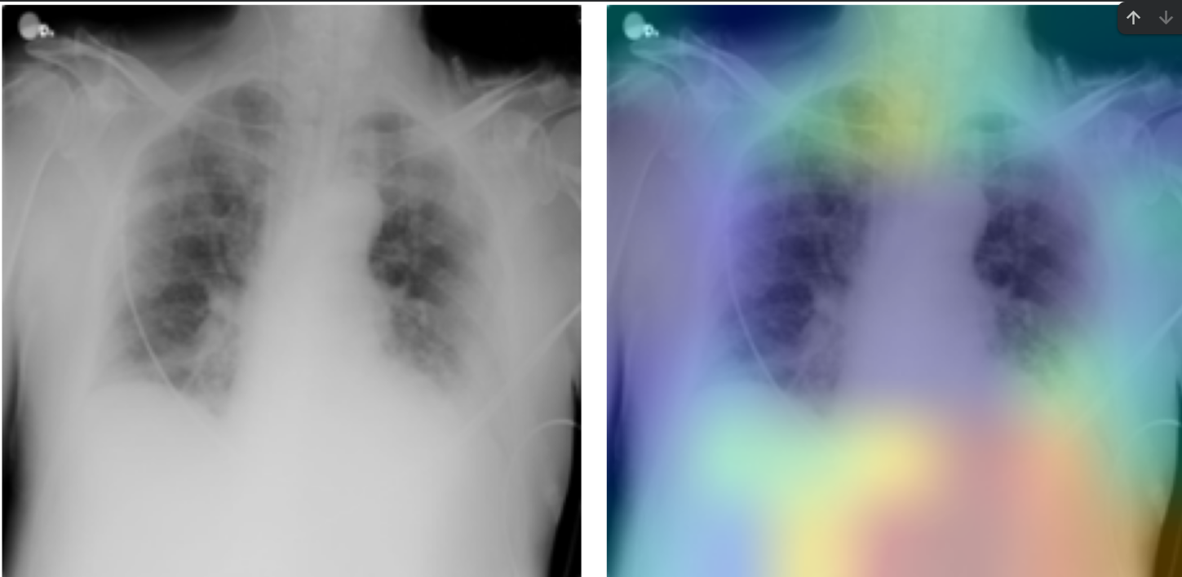
Figure 7: Untrained model false detection before fine tuning

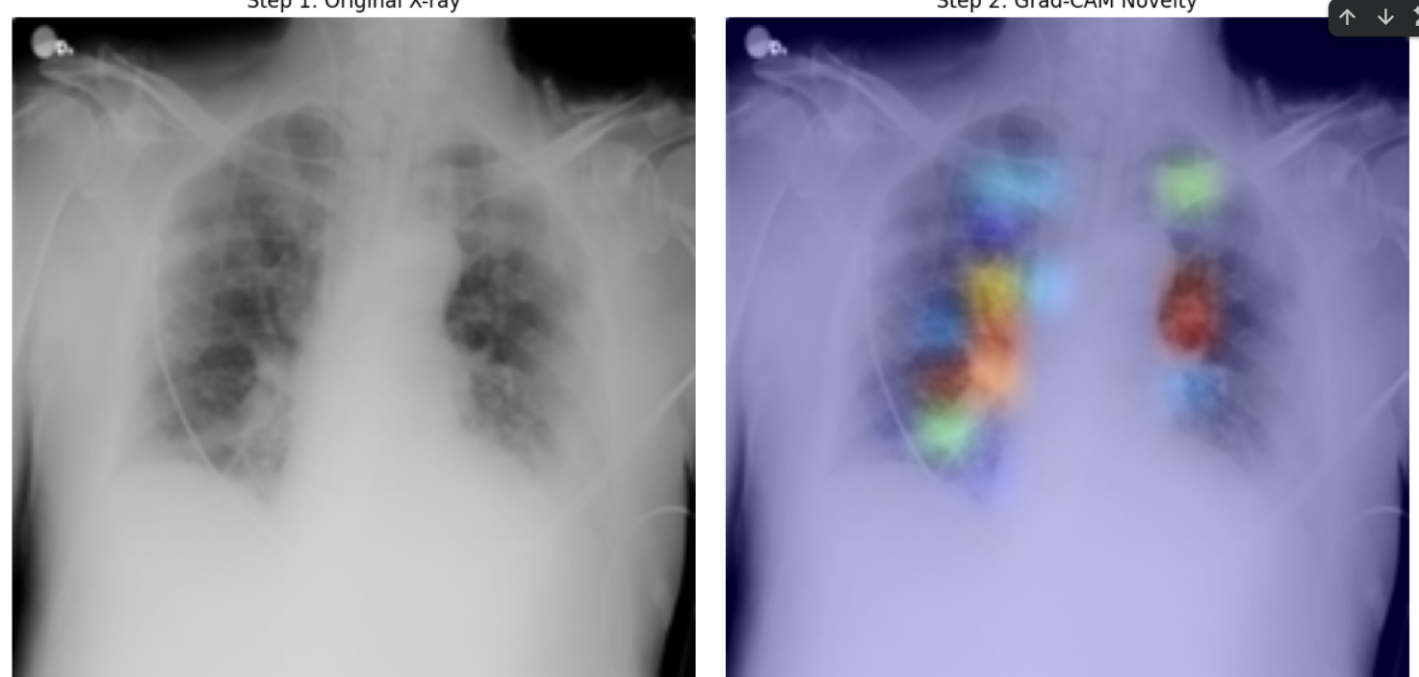
Figure 8: Huge detection improvement after fine-tuning the model
Review 2: Containerization and Deployment

A key quality of the developed COVID-19 Detection System is its clearly defined containerization and deployment processes, making the system reproducible, portable, and ready for production use.

Development was performed with attention to best practices in modern software architecture and deployment methodologies. The system was built and deployed using contemporary containerization practices based on Docker and Docker Compose.

System Architecture:

The COVID-19 Detection System is organized as a multi-component architecture:
- Frontend: React application with Vite for rapid development and optimized builds
- Backend: FastAPI server for image preprocessing, orchestration, and API management
- Model Inference: NVIDIA Triton Inference Server for scalable, production-grade model serving
- Local Model: Fallback Keras model for enhanced inference reliability

Each of these components was containerized using Docker. All dependencies, libraries, configurations, and model artifacts are packaged into dedicated containers. This eliminates the "works on my machine" problem and ensures consistent behavior across all environments.

Docker Compose Orchestration

To manage multiple services efficiently, Docker Compose was used to define and orchestrate all system components. The docker-compose.yml file defines all services, networks, and configurations, allowing the entire system to be launched with a single command:

docker compose up -d

This command automatically:
- Builds and starts the Triton Inference Server with the COVID classifier model
- Launches the FastAPI backend with proper health checks and dependencies
- Starts the React frontend application
- Establishes inter-service networking and volume mounts for model access

NVIDIA Triton Model Serving

For production model inference, the system leverages the NVIDIA Triton Inference Server deployed via Docker. The Triton image is pulled from NVIDIA's container registry:

docker pull nvcr.io/nvidia/tritonserver:23.10-py3

Service Endpoints

Once deployed, system components are accessible through the following endpoints:
- Frontend: http://localhost:3000— React Vite application for X-ray upload and result visualization
- Backend API: http://localhost:8010/docs — FastAPI documentation and prediction endpoint
- Triton Server: http://localhost:8001— Model inference server (HTTP) and http://localhost:8002 (gRPC)

Deployment Benefits

This containerized, multi-component architecture provides several critical advantages:

- Reproducibility: Consistent execution across development, testing, and production environments
- Portability: The entire system runs on any machine with Docker and Docker Compose installed
- Scalability: Independent scaling of components (frontend, backend, inference services) based on workload demands
- Reliability: Health checks ensure services remain operational; the hybrid inference pipeline (Triton + local Keras) provides fault tolerance
- Production Readiness: Professional-grade orchestration suitable for deployment to cloud platforms or on-premises infrastructure


Figure 9: Main Dashboard


Figure 10: LLM model Insights
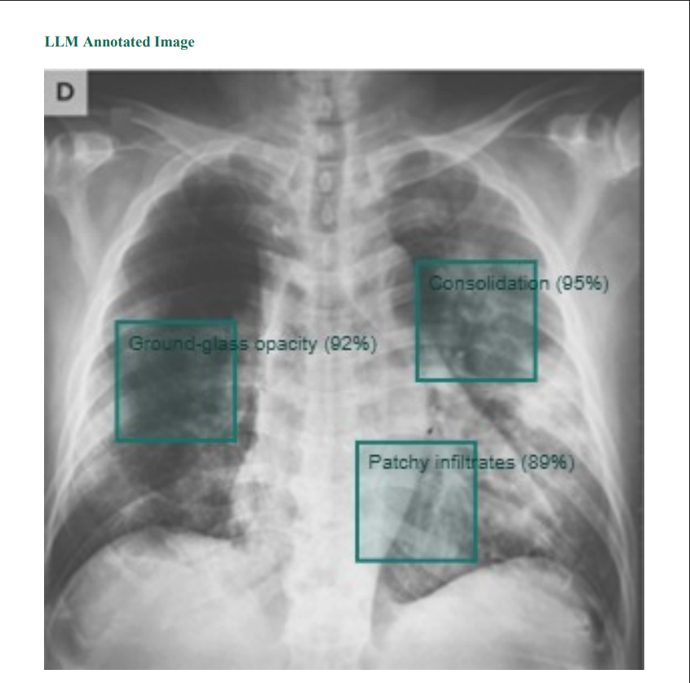
Figure 11: Model Overly of Detected virus
:

Figure 12: All containers running in docker

