PulmonaryAI: A Hybrid Deep Learning and LLM-Based System for Multi-Lung Disease Detection from Chest X-Ray Images

Afeef Ahmed Shaik
Department of Computer Science and Engineering
SRM INSTITUTE OF SCIENCE AND TECHNOLOGY
Tiruchirappalli, India
afeefahmed.shaik@gmail.com

Abstract
PulmonaryAI is a full-stack AI-powered clinical decision support system designed for multi-class lung disease detection from chest X-ray images. The system classifies images into COVID-19, Normal, Viral Pneumonia, and Lung Opacity using a hybrid inference pipeline that integrates NVIDIA Triton Inference Server and a locally deployed Keras-based deep learning model. Unlike traditional single-model approaches, PulmonaryAI employs a confidence-aware ensemble mechanism that combines predictions from multiple inference branches to improve reliability and robustness. To enhance interpretability, the system incorporates Grad-CAM-based visualization to highlight critical regions influencing model predictions. Additionally, PulmonaryAI integrates a large language model (LLM) to generate structured clinical explanations and human-readable diagnostic reports, bridging the gap between AI outputs and clinical understanding. The platform is implemented using FastAPI for backend orchestration and React (Vite) for frontend interaction, with Docker-based deployment ensuring scalability and portability. PulmonaryAI aims to provide an explainable, accessible, and efficient diagnostic aid for healthcare environments, particularly in resource-constrained settings.

Keywords
Multi-class Lung Disease Detection, Deep Learning, Chest X-ray Analysis, Explainable AI, Grad-CAM, Ensemble Learning, Clinical Decision Support, LLM Integration

Metadata

Nr | Code metadata description | Metadata
C1 | Current code version | v1.0
C2 | Github link to code/repository | https://github.com/ssdafeef/PulmonaryAI
C3 | Legal code license | MIT
C4 | Code versioning system used | Git
C5 | Software code languages, tools and services used | Python 3.x, FastAPI, React (Vite), TensorFlow/Keras, NVIDIA Triton Inference Server, Docker, Gemini API
C6 | Compilation requirements, operating environments and dependencies | Docker Desktop (12GB+ RAM recommended), Python 3.x, Node.js 18+
C7 | Developer documentation/manual | https://github.com/ssdafeef/PulmonaryAI/  blob/main/README.md
C8 | Support email for questions | afeefahmed.shaik@gmail.com

1. Motivation and Significance

Respiratory diseases such as COVID-19, pneumonia, and lung opacity conditions remain major global health challenges, particularly in regions with limited access to expert radiologists. Chest X-rays serve as a primary diagnostic tool; however, manual interpretation is time-consuming, subjective, and dependent on clinical expertise.

PulmonaryAI addresses these challenges by introducing an automated and explainable diagnostic system capable of assisting clinicians in rapid and reliable decision-making. Unlike conventional approaches that rely on a single deep learning model, PulmonaryAI implements a hybrid multi-branch inference strategy combining Triton-served models and local Keras inference. This design improves system robustness and reduces dependency on a single model’s prediction.
A key innovation of the system is its confidence-aware ensemble mechanism, which evaluates agreement between inference sources. Predictions with strong agreement are marked as high confidence, while conflicting outputs trigger a lower confidence classification, encouraging further clinical review. Another critical motivation is interpretability. Medical AI systems often suffer from a lack of transparency. PulmonaryAI integrates Grad-CAM visualizations to highlight image regions influencing predictions, enabling clinicians to validate model reasoning. Additionally, the integration of a large language model enables automated generation of structured clinical explanations, making AI outputs more accessible to both healthcare professionals and patients.

Overall, PulmonaryAI aims to combine accuracy, interpretability, and usability into a unified platform that supports real-world clinical workflows.

2. Software Description

2.1 Software Architecture
PulmonaryAI follows a modular, three-tier architecture consisting of:
- Frontend Layer (React + Vite)
Provides an intuitive interface for uploading chest X-ray images, viewing predictions, visualizing Grad-CAM heatmaps, and downloading reports.

- Backend Layer (FastAPI)
Acts as the orchestration engine handling:
  - Image preprocessing (resize to 224×224, normalization)
  - Model inference coordination
  - Ensemble prediction logic
  - Grad-CAM generation
  - LLM-based report generation
- Inference Layer (Hybrid Model Serving)
  - Triton Inference Server: Hosts the primary deep learning model for scalable inference
  - Local Keras Model: Provides a redundant inference pathway to improve reliability
The workflow begins with user image upload, followed by preprocessing and parallel inference through Triton and local models. Predictions are aggregated, interpretability outputs are generated, and results are returned as structured JSON to the frontend.

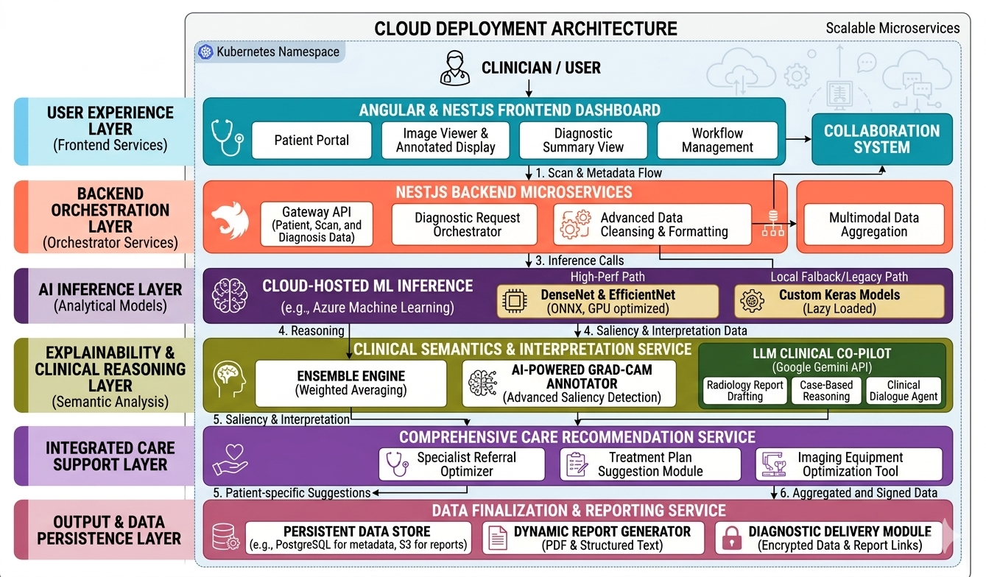
Figure 1: PulmonaryAI system architecture depicting the end-to-end pipeline from image input to diagnosis, explanation, and clinical report generation.

2.2 Software Functionalities

PulmonaryAI provides several advanced functionalities:
- Multi-Class Disease Classification
Classifies chest X-rays into:
- COVID-19
- Normal
- Viral Pneumonia
- Lung Opacity
- Hybrid Ensemble Prediction
Combines predictions from Triton and local models using confidence-based voting and agreement analysis.
- Explainability via Grad-CAM
Generates heatmaps highlighting regions influencing model decisions.
- Explainability via Grad-CAM
Converts numerical outputs into structured medical explanations including:
- Diagnosis summary
- Evidence points
- Differential diagnoses
- Recommended actions
- Image Quality and Severity Estimation
Evaluates input image quality and estimates severity based on model attention regions.
- Interactive Visualization
Displays predictions, heatmaps, and AI-generated insights in real time.

2.3 Implementation Details

The PulmonaryAI system integrates deep learning, web technologies, and scalable deployment frameworks to deliver a robust and production-ready solution. The backend is developed using FastAPI, leveraging asynchronous request handling to efficiently process multiple user inputs simultaneously. Image preprocessing is performed by resizing chest X-ray images to 224 × 224 pixels, normalizing pixel values, and converting them into a format compatible with deep learning models. The core classification model is based on a ResNet architecture with additional dense layers for four-class prediction. The system employs a hybrid inference approach where the primary model is served via NVIDIA Triton Inference Server for scalable and optimized performance, while a local Keras model acts as a redundant inference branch to ensure reliability. The backend communicates with Triton through HTTP-based requests, sending preprocessed image tensors and receiving prediction probabilities, which are then converted into class labels and confidence scores.

The final diagnosis is determined using a confidence-aware ensemble mechanism that combines predictions from both inference sources, evaluating agreement levels to classify outputs as high confidence or requiring further review. Explainability is achieved through the integration of Grad-CAM, which generates heatmaps by computing gradients from the final convolutional layer and overlaying them on the original image to highlight important regions. These heatmaps are further analyzed to estimate severity and identify abnormal areas. Additionally, the system integrates a large language model (LLM) through an external API to generate structured clinical explanations, including diagnostic summaries, evidence points, and recommended actions. The frontend, built with React and Vite, communicates with the backend via REST APIs to dynamically display predictions, visualizations, and reports. The entire application is containerized using Docker and orchestrated with Docker Compose, ensuring portability, scalability, and ease of deployment across different environments.

3. Illustrative Example

To demonstrate PulmonaryAI, a chest X-ray image is uploaded via the web interface. The backend preprocesses the image and forwards it simultaneously to the Triton server and the local Keras model. Each model generates a prediction along with a confidence score. These predictions are combined using ensemble logic. For example, if both models predict COVID-19 with high confidence, the final output is labeled as COVID-19 (High Confidence).
Grad-CAM heatmaps are generated to highlight affected lung regions, and severity estimation is derived from activation intensity.

Finally, the LLM generates a structured clinical report that includes:
- Diagnosis summary
- Supporting evidence
- Differential diagnoses
- Recommended clinical actions
The results are displayed in the frontend and can be exported as a PDF report for clinical use.

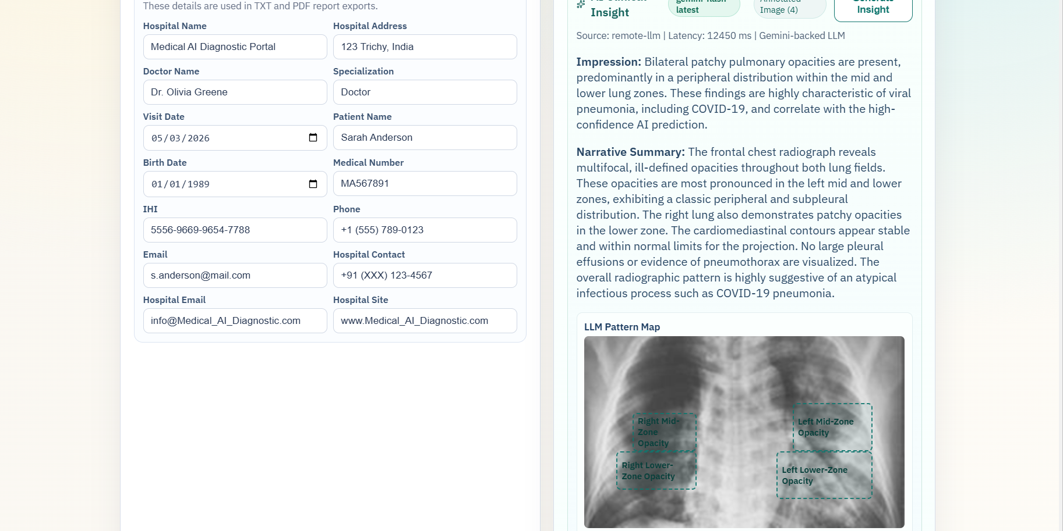
Figure 2: PulmonaryAI output detecting COVID and showcasing Virus being detected using LLM model
4. Impact

The development of PulmonaryAI opens up several new research directions in AI-assisted medical imaging and clinical decision support systems. A key contribution lies in the adoption of a hybrid inference architecture that combines a centralized model serving framework such as NVIDIA Triton with locally deployed models for redundancy and reliability. This hybrid design enables operation across different trade-offs involving latency, scalability, and interpretability, making it suitable for real-world clinical environments. Furthermore, the integration of Grad-CAM within a multi-model ensemble framework introduces important considerations regarding the consistency and trustworthiness of visual explanations across different inference sources. The incorporation of large language models also represents a significant advancement, as it enables the generation of structured, patient-friendly clinical explanations, effectively bridging the gap between raw AI predictions and human understanding.

PulmonaryAI represents a substantial improvement over traditional single-model diagnostic systems, which often suffer from limited generalization and reduced robustness. By employing a confidence-aware ensemble mechanism, the system enhances prediction reliability while reducing the likelihood of misclassification. The use of Triton Inference Server enables scalable and production-ready deployment, addressing a major limitation of many academic AI prototypes that fail to transition into practical healthcare applications. The system facilitates rapid preliminary screening of chest X-ray images, supported by interpretable heatmaps and automated clinical reports, thereby assisting healthcare practitioners in making informed decisions, especially in resource-constrained settings. Additionally, its containerized architecture ensures ease of deployment and adoption across institutions, while also presenting opportunities for future commercialization as a telemedicine solution or AI-driven diagnostic support platform, although it is currently intended for research and educational purposes.

5. Conclusions

PulmonaryAI presents a scalable and interpretable AI-driven system for multi-class lung disease detection from chest X-ray images using a hybrid inference architecture. By combining NVIDIA Triton Inference Server for efficient model serving with a locally deployed deep learning model, the system achieves improved reliability and robustness through ensemble-based predictions. The integration of Grad-CAM enables visual interpretability, while the incorporation of large language models enhances the system’s ability to generate clinically meaningful explanations and structured reports.

The containerized design of PulmonaryAI ensures reproducibility and ease of deployment across diverse environments, including local and cloud-based systems. Overall, the system demonstrates how modern advancements in deep learning, model serving, and explainable AI can be unified into a practical and production-ready framework, contributing to the advancement of computer-aided diagnosis and AI-assisted healthcare.

6. Acknowledgements

The author sincerely thanks the faculty and mentors for their valuable guidance and continuous support throughout the development of this project. Special appreciation is extended to the Department of Computer Science for providing the necessary resources and a conducive environment for research and innovation. The author also acknowledges the contributions of the open-source community for the tools, frameworks, and datasets that made this work possible.

7. References

[1] COVID-19 Radiography Database, Kaggle Dataset. Available: https://www.kaggle.com/datasets/tawsifurrahman/covid19-radiography-database
[2] K. He, X. Zhang, S. Ren, J. Sun, “Deep Residual Learning for Image Recognition,” in Proc. IEEE CVPR, 2016.
[3] R. R. Selvaraju et al., “Grad-CAM: Visual Explanations from Deep Networks via Gradient-based Localization,” in Proc. IEEE ICCV, 2017.
[4] NVIDIA Corporation, “Triton Inference Server,” 2023. Available: https://developer.nvidia.com/triton-inference-server
[5] TensorFlow Developers, “TensorFlow: Large-Scale Machine Learning on Heterogeneous Systems,” 2015. Available: https://www.tensorflow.org/
[6] FastAPI Contributors, “FastAPI Framework,” 2023. Available: https://fastapi.tiangolo.com/
[7] Google, “Gemini API Documentation,” 2024. Available: https://ai.google.dev/
[8] Docker Inc., “Docker Documentation,” 2023. Available: https://docs.docker.com/

