Kenya, Key Actors:

There’s a few links below to get a flavor of what’s out there. It seems to me that the following is true:

1. There’s a lot of variety to the particular institutional actors / social media use / etc. in each different country.
2. It’s relatively easy to figure this all out and scrape by hand. It doesn’t seem worthwhile to try and develop an autonomous algorithm to do it. For Kenya, getting all the current journalists and political actors = super easy. Getting top facebook users would be easy if we had access. And, anything else that matters we’d get from event data.
3. Getting data on *historical* actors seems very hard.
4. Government, opposition parties:

Easy to get a list (<https://en.wikipedia.org/wiki/List_of_political_parties_in_Kenya>) but no sense of which ones matter. For that, one can get the last election: <https://en.wikipedia.org/wiki/Kenyan_general_election,_2017>

Which gives weights by party. And, unsurprisingly, the main opposition leader Odinga is leader of the Orange Democratic Movement (the 2nd place party): <https://www.npr.org/sections/thetwo-way/2018/01/30/581783571/thousands-of-kenyans-risk-arrest-to-attend-symbolic-swearing-in-of-opposition-le>

Court is also online: <https://en.wikipedia.org/wiki/Supreme_Court_of_Kenya>

1. Journalists

<http://www.mediacouncil.or.ke/en/mck/index.php/mck-accreditation/2015-list-of-accredited-journalists>

There’s also a ton of stories about journalists worth tracking. E.g.,

<https://www.bbc.com/news/world-africa-43558216>

1. Social media leaders = harder. First, and most disturbing, Dorsey is RIGHT – facebook is where it’s at (<http://gs.statcounter.com/social-media-stats/all/kenya>):

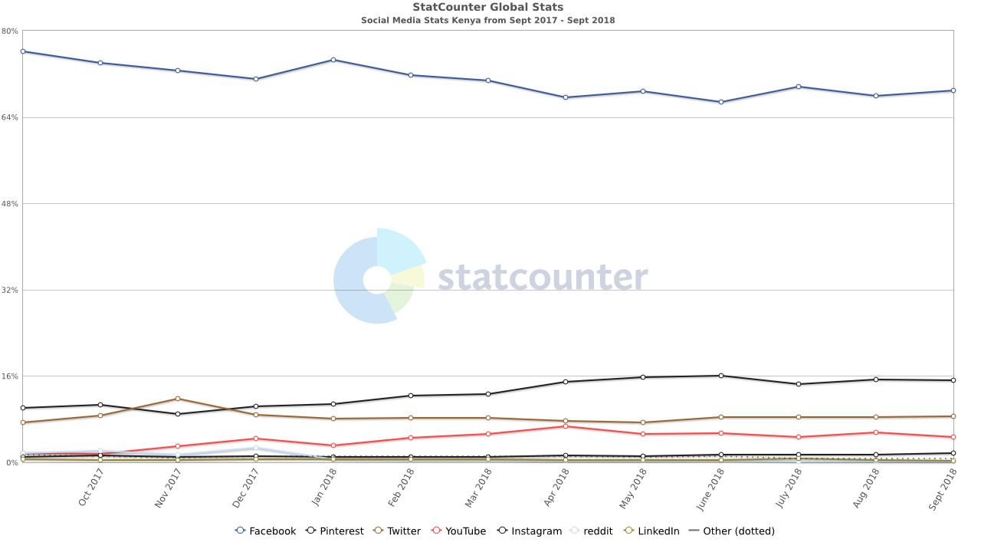

We really need to be able to do this: <https://www.facebook.com/notes/kampala-express/kenyas-100-most-popular-facebook-pages-may-11-2016/797211350409180/>