Persona 1: "Tom, the Small Business Owner"

Age: 38

Job: Owns a small retail store

Goal: Wants to fix his point-of-sale laptop urgently

Tech skills: Basic — uses email and Excel but avoids DIY tech fixes

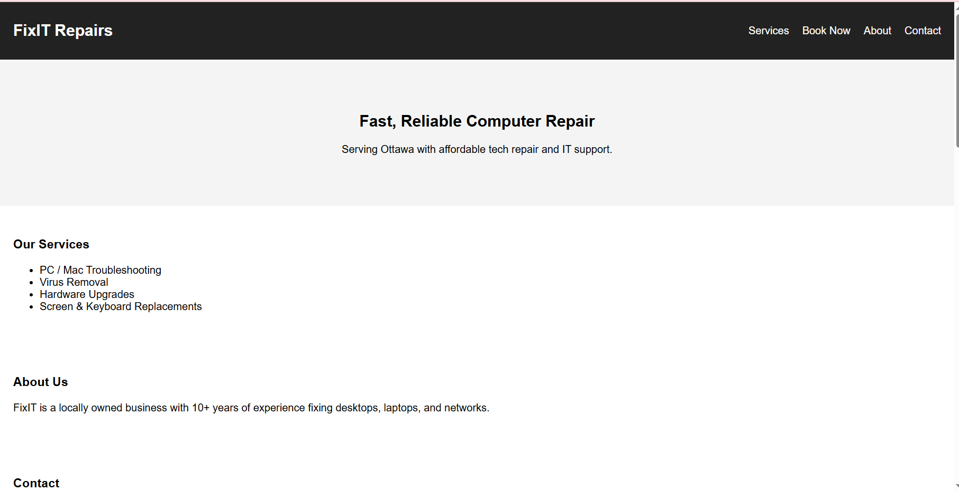

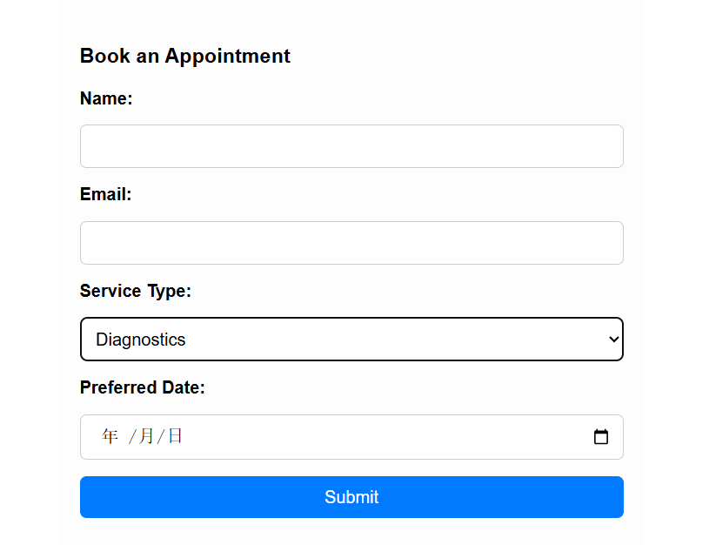

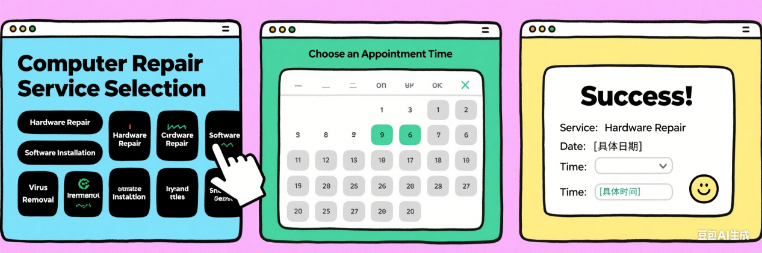

Step 1: Select a Service

Tom visits the homepage and is presented with a selection of repair services, such as:

Hardware Repair

Software Installation

Virus Removal

He clicks on “Hardware Repair” to continue.

Step 2: Choose an Appointment Time

After selecting the service, Tom sees a calendar interface. He selects a date and an available time slot that fits his schedule.

Step 3: Confirmation Screen

Tom sees a confirmation message that says “Success!”, along with: The service she selected the appointment date and the chosen time slot. A friendly visual icon to reinforce a positive experience