Persona 2: "Emma, the College Student"

Age: 20

Job: Full-time university student

Goal: Needs her laptop fixed before final project submission

Tech skills: Intermediate — uses design software, familiar with web tools

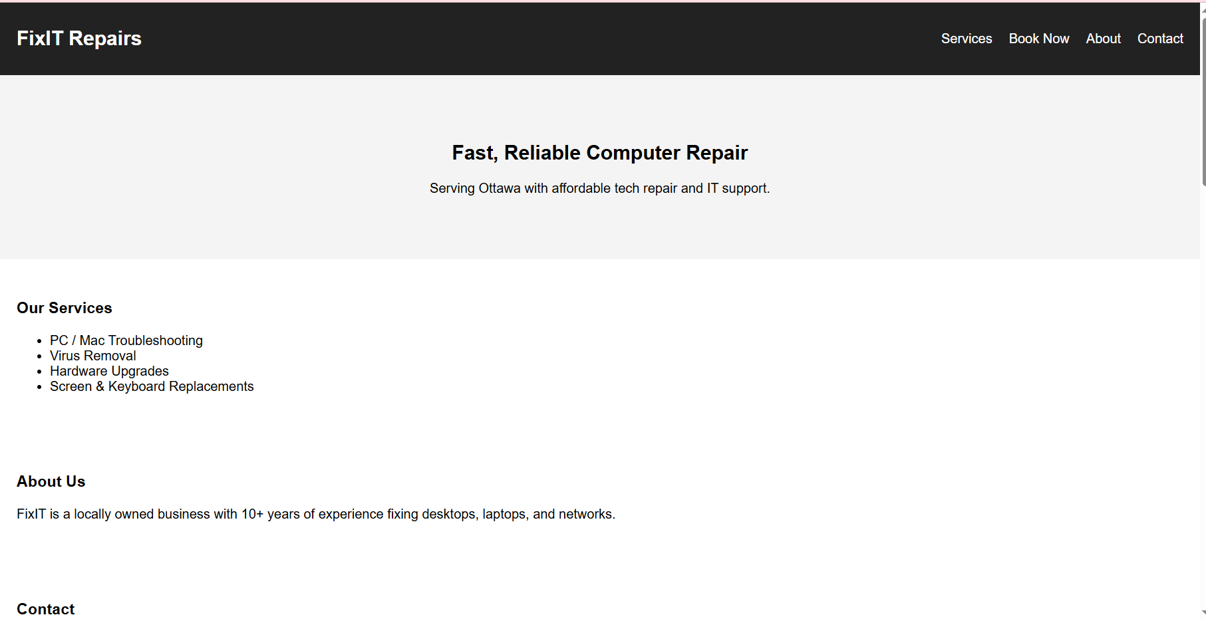

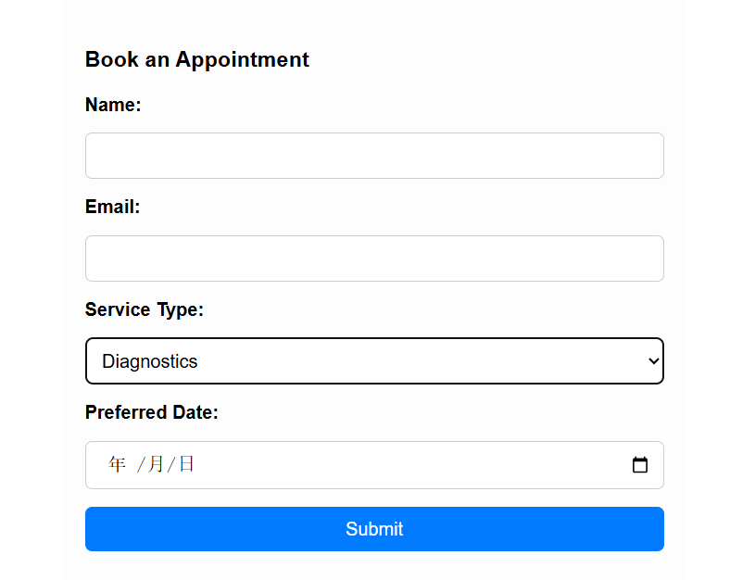

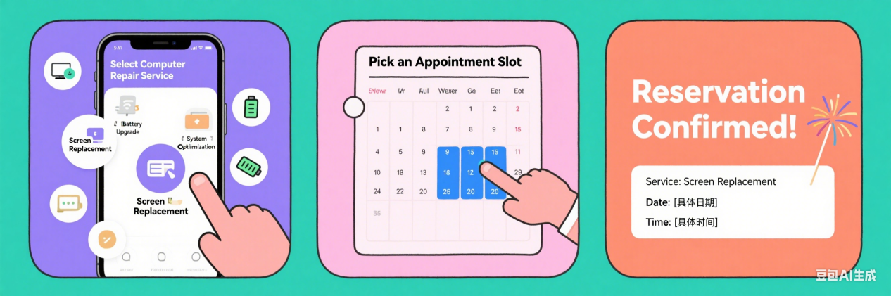

Step 1: Select a Service (Mobile View)

Emma opens the repair website on her phone and sees a selection of service options:

Battery Upgrade

System Optimization

Screen Replacement

She taps “Screen Replacement” to continue to the booking step.

Step 2: Pick an Appointment Slot

Emma is shown a calendar where she selects an available time slot. She chooses a date that fits her school schedule, ensuring her laptop can be fixed in time for her class project.

Step 3: Reservation Confirmation

Emma receives a confirmation screen with:

A cheerful message: “Reservation Confirmed!”

The selected service: Screen Replacement

The chosen date and time

A celebratory visual to reinforce her success and give her peace of mind