**Introduction**

**System Diagram**

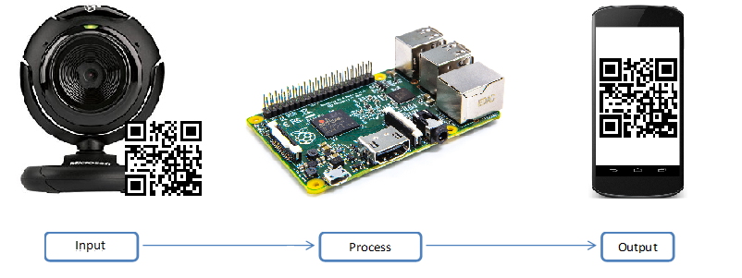

**Build Budget**  
Before we start building something, we need to plan a budget. A budget will be especially helpful in managing the financial costs related to our build.

Let's start with the core of the project, the Raspberry pi. The raspberry pi alone costs around $60-70 online if you're lucky enough find one. I highly recommend opting for the raspberry pi starter kit instead as it comes with all the necessary items like a microSD card, an AC adapter and a case (as well as other stuff like a microSD reader). It's available for about $20-30 extra.

A case is highly recommended as the raspberry pi is relatively fragile microcomputer. A microSD card is required to run the Raspian OS on the the pi. And of course the AC adapter can be substituted with any microUSB phone/tablet charger. I bought the Starter kit

Moving on, a webcam will be required to scan QR codes. Any USB webcam will do  fine. So no need a spend the extra bucks for a high definition webcam. An average webcam will cost between $20 and $35. Or even cheaper if you find a used/refurbished one.

Finally, there is cost associated with the printing of a PCB (Printed Circuit board). The prototype lab at Humber College charges about $40 to print a PCB. As a Humber student,  that's included as part of my tuition fees.

Altogether I spent about $100 on the Raspberry pi starter kit from Amazon. I used my old webcam which I bought for about $30-$35 about 7 years ago. And I didn't have to pay extra for the PCB since I'm a Humber student.

If I include the $40 for the PCB, then my final build cost totals to about approximately $200 (That's including taxes and other expenses like shipping and handling).

**Time Commitment**   
Time is a resource arguably as valuable as money. And this project demands plenty of it.