ER Diagram

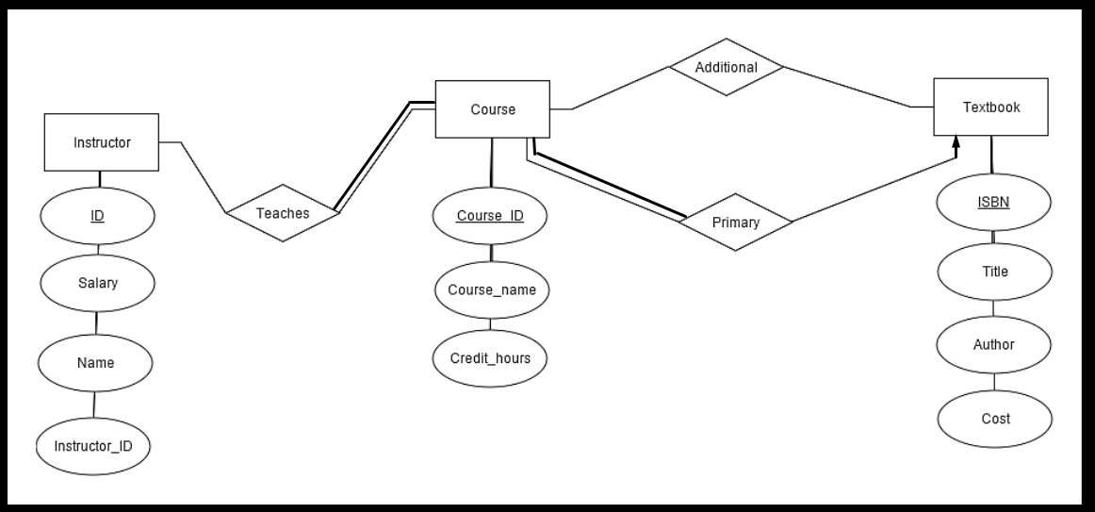

Schema

Instructor (id, name, salary)

course (course_id, course_name, credit_hours)

textbook (isbn, title, author, cost)

teaches (id, course_id)

additional (course_id, isbn)