# CMSC 345

### Software Design and Development

UMBC-CMSC 447 Section 2 Team 4

Team Awesome

# Planes for Hire

# **System Design Document Template**

**Client:**

John Winder

**Member:**

Sundar Sekar <[ssekar1@umbc.edu](mailto:ssekar1@umbc.edu)>

Tam Tran <[tamtran1@umbc.edu](mailto:tamtran1@umbc.edu)>

William Cahill <[wcahill1@umbc.edu](mailto:wcahill1@umbc.edu)>

Roberto Melgar <[rmelgar1@umbc.edu](mailto:rmelgar1@umbc.edu)>

Du Nguyen <[du2@umbc.edu](mailto:du2@umbc.edu)>

2/18/2015

Planes for Hire

System Design Document

#### **Table of Contents**

1. Introduction

1.1 Purpose of This Document

1.2 References

2. System Architecture

2.1 Architectural Design

2.2 Decomposition Description

3. Persistent Data Design

3.1 Database Descriptions

3.2 File Descriptions

4. Requirements Matrix

Appendix A – Agreement Between Customer and Contractor

Appendix B – Peer Review Sign-off

Appendix C – Document Contributions

# 1. **Introduction**

## 1.1 Purpose of This Document

The purpose of this document is to describe the design of the Planes for Hire application. Key topics covered in this document include descriptions of high level user interface design layouts, lower level design, and description of persistence data implementation. More information will be added for Spiral 2.

## 1.2 References

1. Refsnes Data (1999-2015). w3schools.com. Retrieved from “<http://www.w3schools.com/googleapi/>”
2. The PH Group (2001-2015). PHP. Retrieved from “<http://php.net/>”
3. QuinStreet Inc (2015). SQLCourse.com. Retrieved from “http://www.sqlcourse.com/”

# 2. **System Architecture**

## 2.1 Architectural Design

Draw a diagram that represents the logical architecture of your system. Describe what you are trying to communicate to the reader with the diagram.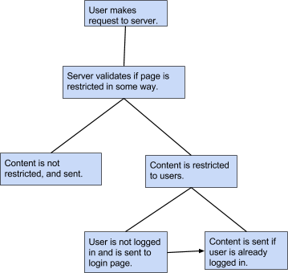

Web application will be stored on UMBC’s gl server. The server is a linux-based server. Our developers and customer can easily communicate with it by using an application such as secure shell or putty. This simplifies the process of adding, deleting, modifying, dragging and dropping files to and from the server. GL server uses Apache as the application that simplifies file access, we will use PHP, html, javascript, and ajax as the backend code, and PHPMyAdmin as the SQL database.

We know that the front end code will be written in html and javascript, which will be the the code that is executed in the user’s browser. Server-side instructions will not be included. We know that our PHP documents are used to execute the majority of the backend server code, and send generated html documents to the user while stripping server-side instructions. We know that our PHP code will communicate with the MySQL database, and that the database stores a collection of tables We know that the Javascript wil used extensively in order to add interactivity to a webpage’s gui elements.

## 2.2 Decomposition Description

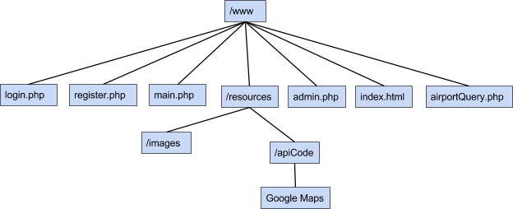

Each page behaves as a module that is imported to the main page. This allows each of us to work on separate files, and have it be plugged into the main one with ease. Our coding style will lean towards functional and procedural, meaning that there will be no try-catch statements, inheritance, etc. Errors instead will be checked using if-statements after an operation has been performed. There will be php files specifically designed as modules that will contain utility functions such as functions for creating, removing, and maintaining accounts.

# 3. **Persistent Data Design**

## 3.1 Database Descriptions

List of field :

1. Customer table:will keep customer record when they log in and out on the website

* 1st name , last name, address,

1. Airport Location table will keep the record of the airport on each state.

* Rockville, San jose, …...

1. airplane table is table will show what kind of airplane from the

* AirVenture 2010, Lycoming IO-390 ….

1. records table show how far they can fly and their record

* id, distance , fee

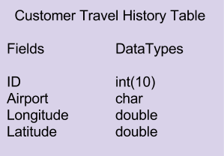

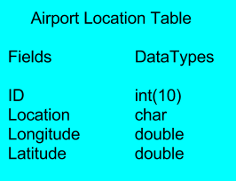

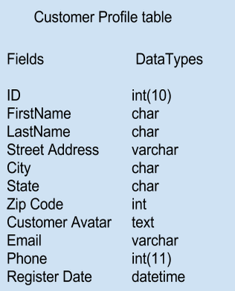

## 3.2 File Descriptions



Root directory of website is the /www folder. Index.html is the bootstrap that will load main.php. Main.php contains majority of the application’s content, and loads images and api code from the resources directory. Login.php is a modular file that is called from main.php to retrieve a user’s profile from the database, which is directed back to main.php. This is also the same for airportQuery.php. Register.php is a separate page that allows a users to create an account, which will be pushed into the database, and then the user will be redirected back to main.php. The user is only directed to register.php from main.php. Every database access is directed back to the main, and the result is shown in main. Search queries will invoked from main which calls airportQuery.php to access the database which will return a list airport candidates into main. Admin.php is a page that is only accessible to administrative users, which is able to display all users in the database, and all planes they have checked in and checked out currently, and in the past. Admin page is also capable of adding planes and airports to the database, which will make them available to users.

# 4. **Requirements Matrix**

Please refer to the System Requirements Specification for details regarding the corresponding use cases.

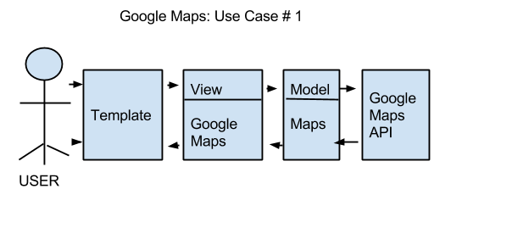

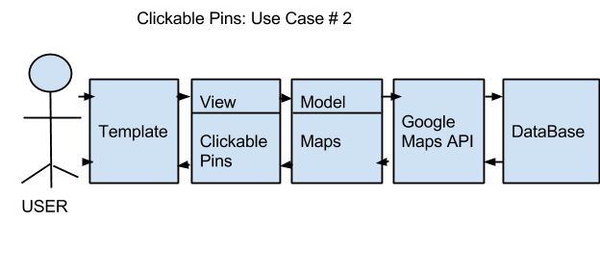

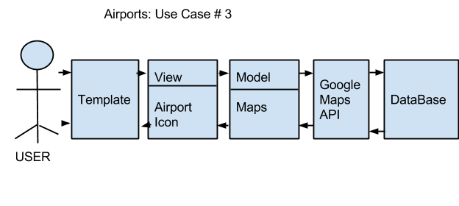

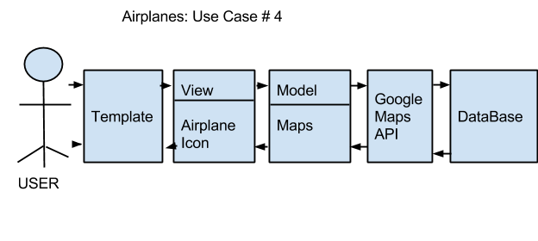

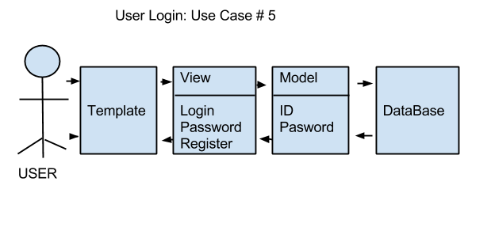

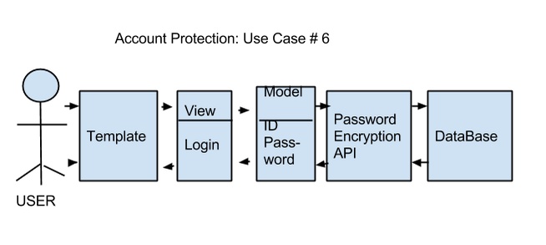

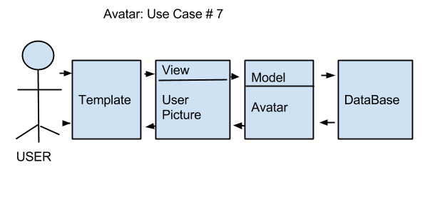

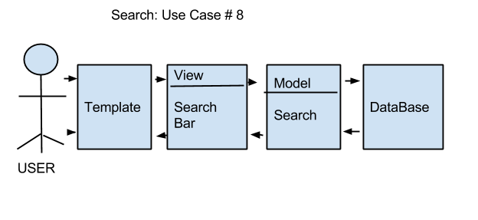

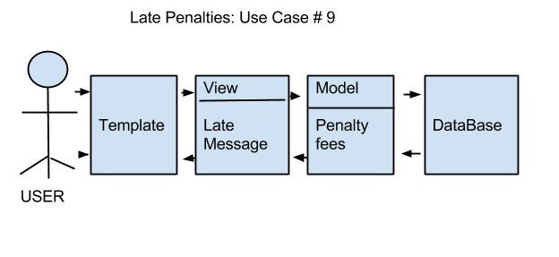

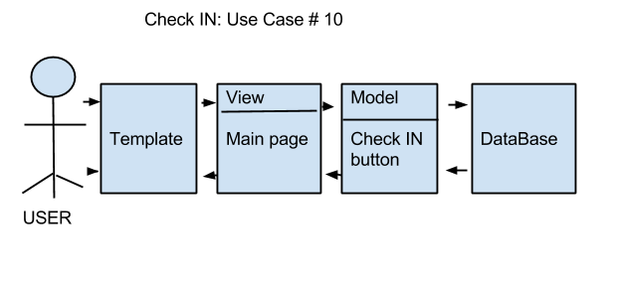

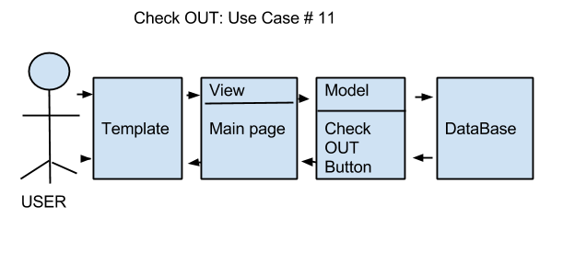

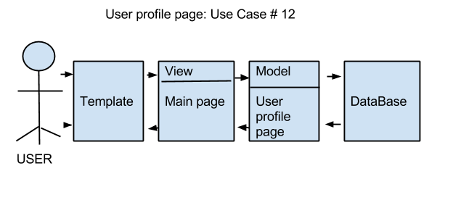

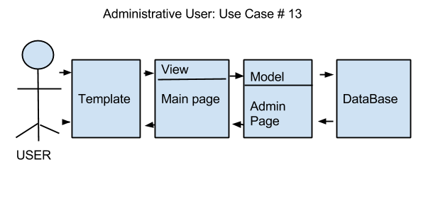

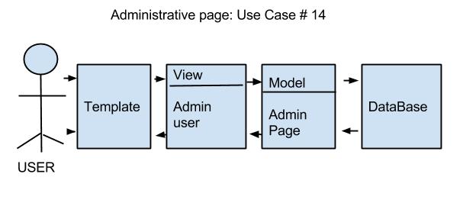

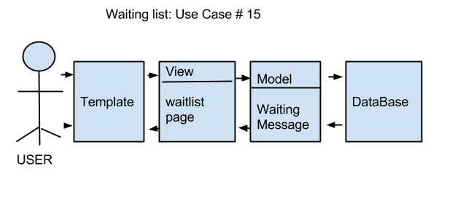

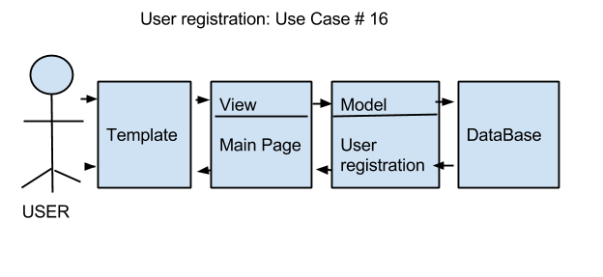

# Appendix A – Agreement Between Customer and Contractor

The customer agrees to a Planes For Hire web application with searching, google maps, and user accounts with security encryption capabilities. See System Requirements Specification for more information. Additional features will be provided in further development spirals.

When and if future changes to this document occur a drafted new document will be created. Both a hard and electronic copy of both versions will be presented to the client for review. Upon approval, the draft will be finalized and signed off by both parties.

**Client**

**Name ___________________________________________________**

**Date ____________________________________________________**

**Sign _____________________________________________________**

**Team**

**Name ___________________________________________________**

**Date ____________________________________________________**

**Sign _____________________________________________________**

**Name ___________________________________________________**

**Date ____________________________________________________**

**Sign _____________________________________________________**

**Name ___________________________________________________**

**Date ____________________________________________________**

**Sign _____________________________________________________**

**Name ___________________________________________________**

**Date ____________________________________________________**

**Sign _____________________________________________________**

**Name ___________________________________________________**

**Date ____________________________________________________**

**Sign _____________________________________________________**

# Appendix B – Team Review Sign-off

This document has been collaboratively written by all members the team. Additionally, all team members have reviewed this document and agree on both the content and the format. Any disagreements or concerns are addressed in team comments below.

**Team**

**Name ___________________________________________________**

**Date ____________________________________________________**

**Sign _____________________________________________________**

**Comments _________________________________________________________________**

**_________________________________________________________________**

**_________________________________________________________________**

**Name ___________________________________________________**

**Date ____________________________________________________**

**Sign _____________________________________________________**

**Comments _________________________________________________________________**

**_________________________________________________________________**

**_________________________________________________________________**

**Name ___________________________________________________**

**Date ____________________________________________________**

**Sign _____________________________________________________**

**Comments _________________________________________________________________**

**_________________________________________________________________**

**_________________________________________________________________**

**Name ___________________________________________________**

**Date ____________________________________________________**

**Sign _____________________________________________________**

**Comments _________________________________________________________________**

**_________________________________________________________________**

**_________________________________________________________________**

**Name ___________________________________________________**

**Date ____________________________________________________**

**Sign _____________________________________________________**

**Comments _________________________________________________________________**

**_________________________________________________________________**

**_________________________________________________________________**

# Appendix C – Document Contributions

Tam and Andrew took the lead on this document. Andrew drew the architectural design and wrote two paragraphs for section 2.1. He also wrote the file description and drew the graph. Tam searched for the references. Tam drew most of the images for document description. Andrew, Sundar, and Tam worked together on the decomposition description. Tam and Sundar discussed how to design the tables for 3.1 while Du wrote the description. Sundar an Tam also collaborated on the Requirement Matrices. Sundar Sekar created all the diagrams in requirement matrices, and also wrote description for purpose. He also assembled, reviewed and edited the document. Roberto worked on the purpose of the document and the creation of the Appendices. He also deleted some of the template examples.

|  |  |
| --- | --- |
|  |  |
|  |  |