# CMSC 345

### Software Design and Development

UMBC-CMSC 447 Section 2 Team 4

Team Awesome

# Planes for Hire

# 

# **User Interface Design Document Template**

Client: John Winder

Member: Sundar Sekar <[ssekar1@umbc.edu](mailto:ssekar1@umbc.edu)>, Tam Tran <[tamtran1@umbc.edu](mailto:tamtran1@umbc.edu)>,

William Cahill <[wcahill1@umbc.edu](mailto:wcahill1@umbc.edu)>, Roberto Melgar <[rmelgar1@umbc.edu](mailto:rmelgar1@umbc.edu)>,

Du Nguyen <[du2@umbc.edu](mailto:du2@umbc.edu)>

2/18/2015

[Planes for Hire]

User Interface Design Document

#### **Table of Contents**

## 

1. Introduction

1.1 Purpose of This Document

1.2 References

2. User Interface Standards

3. User Interface Walkthrough

4. Data Validation

Appendix A **-** Agreement Between Customer and Contractor

Appendix B – Peer Review Sign-off

Appendix C – Document Contributions

# 1. Introduction

## 1.1 Purpose of This Document

The purpose of this document is to show the user how to navigate and interact with the Planes for Hire web application. Images will show how the Planes for Hire is interconnected and will display the different pages within the application, highlighting important features that will make it easy to use for consumers. More will be added on the next Spiral.

## 1.2 References

Provide a list of all applicable and referenced documents and other media that were used in the creation of this document (e.g., user interface design textbooks or websites, class lecture notes). See the Writing Resources on Blackboard for the appropriate formats for references.

1. Refsnes Data (1999-2015). w3schools.com. Retrieved from “<http://www.w3schools.com/googleapi/>”
2. The PH Group (2001-2015). PHP. Retrieved from “<http://php.net/>”
3. QuinStreet Inc (2015). SQLCourse.com. Retrieved from “http://www.sqlcourse.com/”

# **2.** **User Interface Standards**

Give the reader an overview of the design standards that you will use to maintain consistency in the user interface throughout your system. Use illustrations as necessary. Discuss general screen layouts, common components (e.g., buttons, menus), general error handling, and navigation. You do not need to go into details such as colors and fonts. [Length will vary, but I would expect at least one overall screen layout illustration with explanations of the different screen areas, common components that will be used, and how the user will generally navigate through the system.]

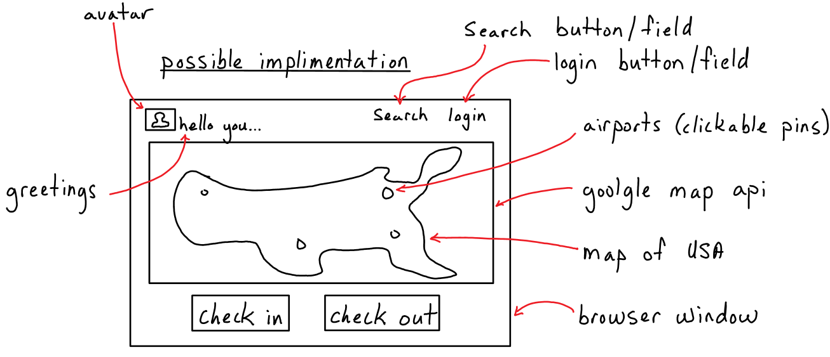

The general view for our API airport is a website which will display a possible of 3 boxes with different options such as Search Box, Login bar etc… . It also displays a US map base on google map api. There will be pins which display location of the airports.

* Login bar : It is a short text in 12 standard which will on the top right of the site. It will be linked to another site which will allow the customers log in
* Search bar: It will be right be behind the Login bar which will allow to customer do a random search such as name, address…
* US map: It is a whole US map
* Clickable pin: On the map, They will present the location of the airport for instant the name, address, hours of the airport. They are clickable.
* Greeting and Logo line: They are on the left on the website, will display company logo and a greetings.
* Check In and Check Out Button: Check in and check out airplanes.

# **3.** **User Interface Walkthrough**

Provide a diagram that illustrates how the user will navigate from one screen to another (I call this a “navigation diagram”). Label each symbol that represents a screen so that you can reference the screens, if necessary, later in the document. Give a brief description of what the diagram as a whole represents.

Next, guide the reader through a series of screen shots of all system screens. (You do not need to include error and confirmation messages/pop-ups.) Give the screen shots figure numbers and labels that match those in the navigation diagram. Refer to the figure numbers in the text of the walkthrough. Explain what the reader is seeing in each screen shot: the major screen areas, menus, what each button does, how to navigate to the next screen or return to the previous, etc. Note that if a feature has been standardized (e.g., how to return to the previous screen) and explained in Section 2, you do not need to repeat it here.

Screen shots should not be hand written, but may be drawn using any tool you wish (e.g., Visual Basic, PowerPoint, a drawing program, etc.). At this point in the process, they are a best approximation as to what the user interface will look like in both layout and annotation.

At the Planes for Hire Web application, the user can browse the maps and search for available planes and their airport locations.

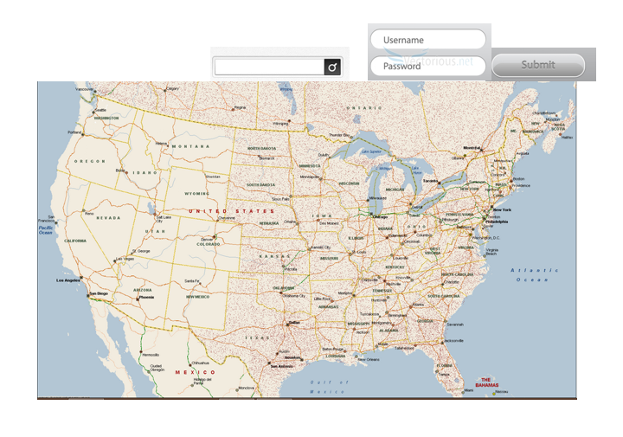

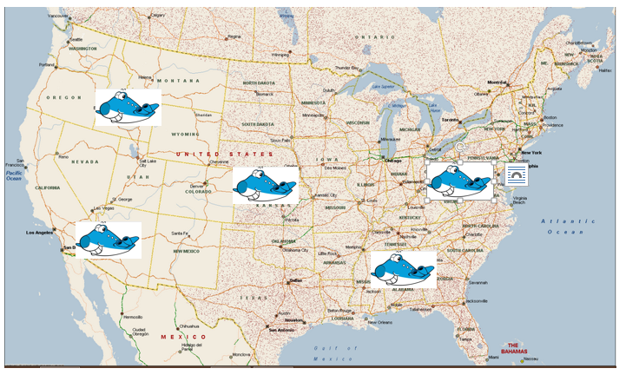

On the main page, the user can enter a string username and password. The above maps shows different airplanes location across the United States.

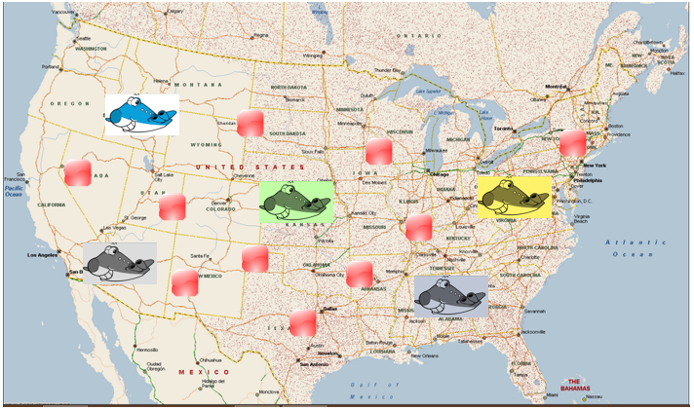

The above maps shows different airplanes and airports location across the United States.

# **4.** **Data Validation**

Include a full description of all data items that can be entered into the system by the user. The description should include the item’s basic data type (e.g., integer, string), its limits, and its allowable format(s). Be sure to uniquely identify each data item. For example, if you are using a GUI, a data item can be identified by screen name and data item label. A tabular format works well for the data validation information.

On the main page, the user can enter a string username and password. Upon entering this data, a php script will communicate with the database to verify if that username and password exists. If the username does not exist, or if the username exists but the password is invalid, the server will output an error message.

On the registration page, the user must put in a distinct username, and a password longer than 6 characters. Registration requires a valid email, and if all input fields are valid, the server will create a user account and generate a validation code, which will be emailed to the user. The user must navigate to his or her email and go the url with the validation code given. Url becomes invalid after 24 hours, and if the user has not validated their account, it will be deleted.

The main page will also have a search bar that will be used to query different airports. Also we will have check in and check out buttons that will allow users to rent airplanes. This will update the main with what nearby airports are available. If input cannot be interpreted by the google api, the user will be notified.

# Appendix A – Agreement Between Customer and Contractor

The customer agrees to a Planes For Hire web application with searching, google maps, and user accounts with security encryption capabilities. See System Requirements Specification for more information. Additional features will be provided in further development spirals.

When and if future changes to this document occur a drafted new document will be created. Both a hard and electronic copy of both versions will be presented to the client for review. Upon approval, the draft will be finalized and signed off by both parties.

**Client**

**Name ___________________________________________________**

**Date ____________________________________________________**

**Sign _____________________________________________________**

**Team**

**Name ___________________________________________________**

**Date ____________________________________________________**

**Sign _____________________________________________________**

**Name ___________________________________________________**

**Date ____________________________________________________**

**Sign _____________________________________________________**

**Name ___________________________________________________**

**Date ____________________________________________________**

**Sign _____________________________________________________**

**Name ___________________________________________________**

**Date ____________________________________________________**

**Sign _____________________________________________________**

**Name ___________________________________________________**

**Date ____________________________________________________**

**Sign _____________________________________________________**

# Appendix B – Team Review Sign-off

This document has been collaboratively written by all members the team. Additionally, all team members have reviewed this document and agree on both the content and the format. Any disagreements or concerns are addressed in team comments below.

**Team**

**Name ___________________________________________________**

**Date ____________________________________________________**

**Sign _____________________________________________________**

**Comments _________________________________________________________________**

**_________________________________________________________________**

**_________________________________________________________________**

**Name ___________________________________________________**

**Date ____________________________________________________**

**Sign _____________________________________________________**

**Comments _________________________________________________________________**

**_________________________________________________________________**

**_________________________________________________________________**

**Name ___________________________________________________**

**Date ____________________________________________________**

**Sign _____________________________________________________**

**Comments _________________________________________________________________**

**_________________________________________________________________**

**_________________________________________________________________**

**Name ___________________________________________________**

**Date ____________________________________________________**

**Sign _____________________________________________________**

**Comments _________________________________________________________________**

**_________________________________________________________________**

**_________________________________________________________________**

**Name ___________________________________________________**

**Date ____________________________________________________**

**Sign _____________________________________________________**

**Comments _________________________________________________________________**

**_________________________________________________________________**

**_________________________________________________________________**

# Appendix C – Document Contributions

Everyone worked on a part in this document. Roberto wrote the appendices and purpose of the document. Tam uploaded the picture for section 2. Du wrote the descriptions for said section. Andrew and sundar worked on data validation for section 4. Sundar wrote the references, User interface walkthrough and uploaded all the images for section 3. He played a role in editing and reviewing the document as well as creating and assembling the documents.