**Docker Toolbox Setup — Windows 10**

The guide below presents how to get the Docker Toolbox Setup on Windows and the general concepts behind Docker Machine.

Unlike Docker for Windows which runs natively on Windows, Docker Toolbox installs Docker inside a Virtual Box VM. Installing and configuring Docker Toolbox is somewhat less user-friendly than Docker for Windows.

1. <https://docs.docker.com/docker-for-windows/>
2. Docker for Windows now requires Microsoft’s Hyper-V. Once enabled, VirtualBox will no longer be able to run virtual machines (your VM images will still remain). You can still use docker-machine to manage remote hosts.
3. You have the option to import the default VM after installing Docker for Windows from the Settings menu in the System Tray.
4. Docker for Windows enables Hyper-V if necessary; this requires a reboot.

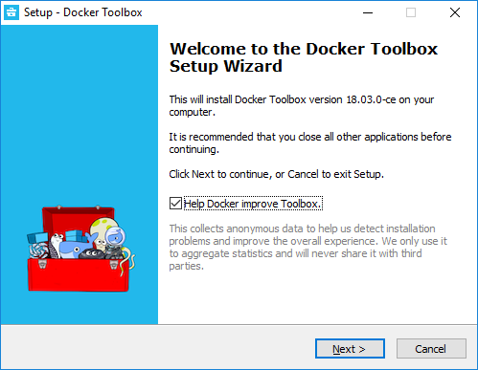

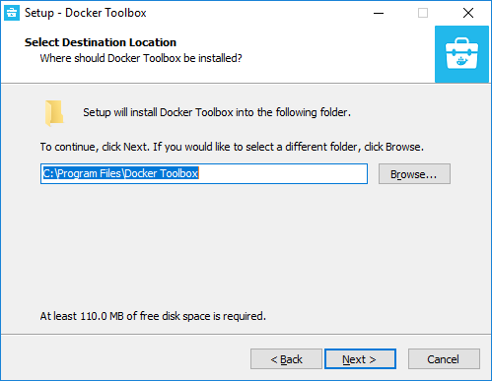

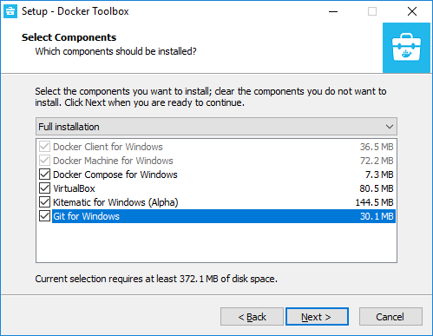

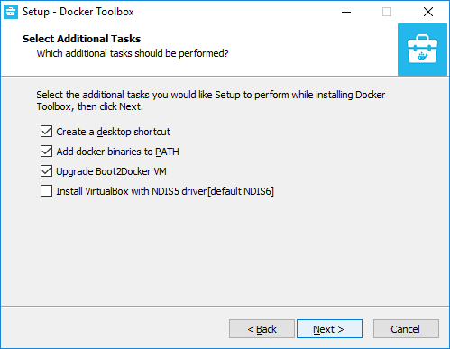

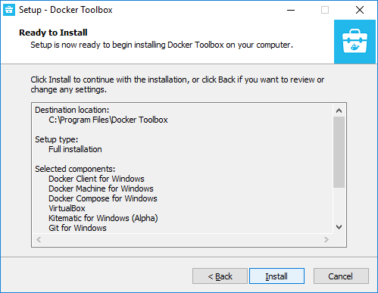

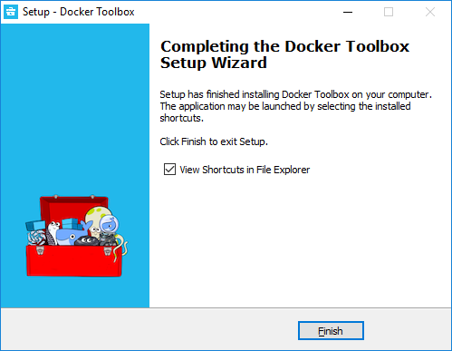

**Start Docker Quick Start Terminal**

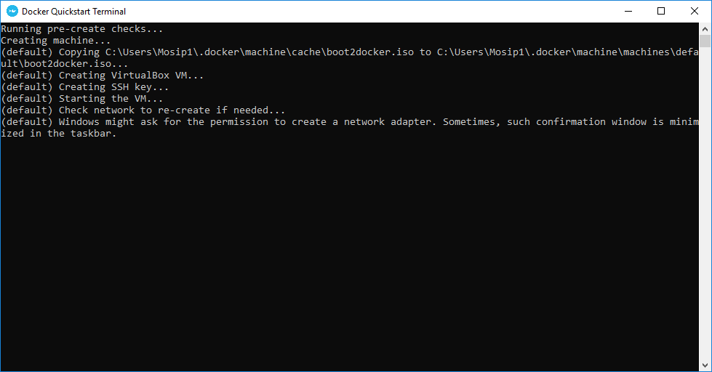

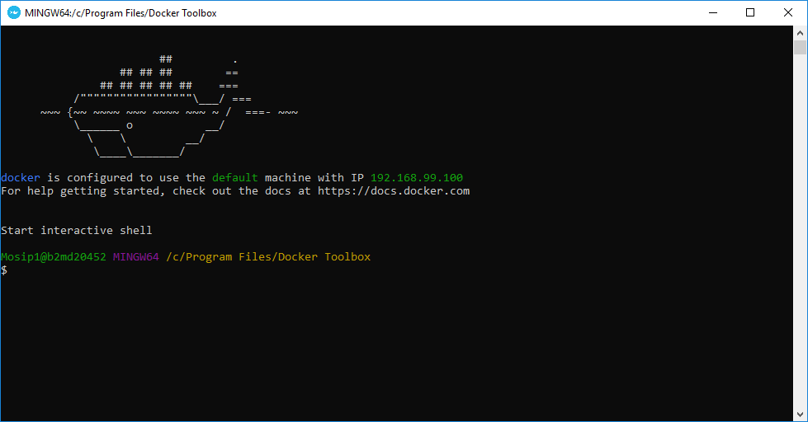

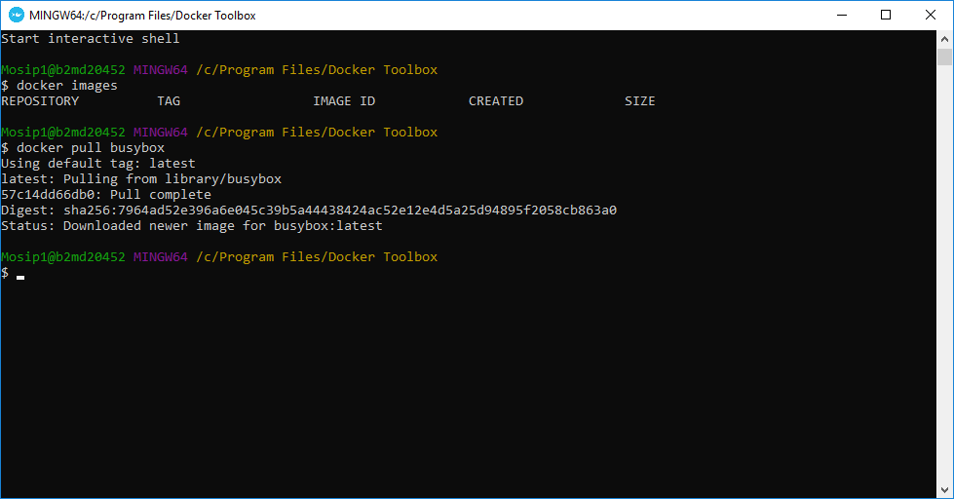

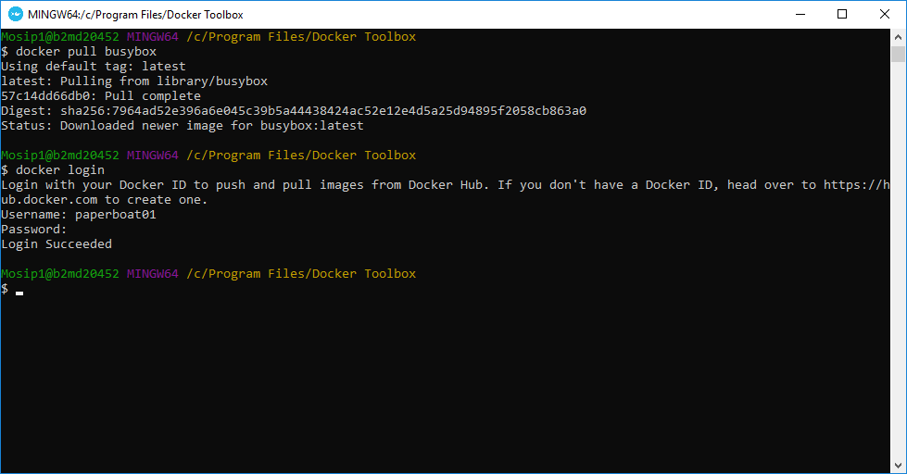

**Use Windows PowerShell for Docker Operations**

Windows PowerShell

Copyright (C) Microsoft Corporation. All rights reserved.

PS C:\Users\Mosip1> docker --version

Docker version 18.09.1, build 4c52b90

PS C:\Users\Mosip1> docker-compose --version

docker-compose version 1.23.2, build 1110ad01

PS C:\Users\Mosip1> docker-machine --version

docker-machine.exe version 0.16.1, build cce350d7

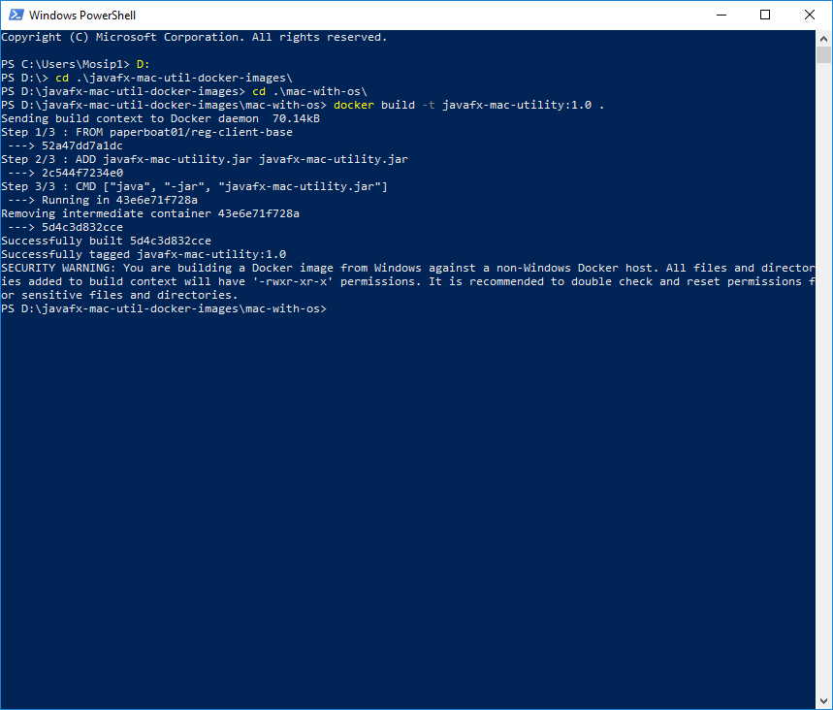

**Start Xming Server for GUI Component**

set-variable -name DISPLAY -value 10.82.5.11:0.0

vboxmanage usbfilter add 0 --target default --name 'Logitech Webcam C310' --vendorid 0x046d --productid 0x081b

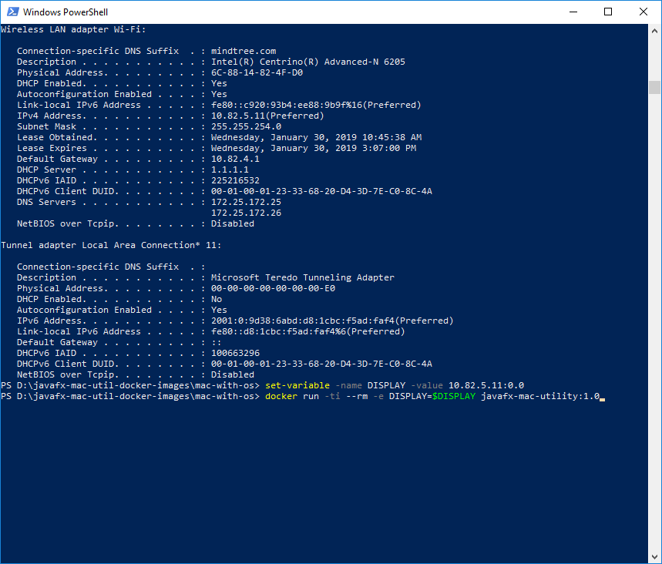

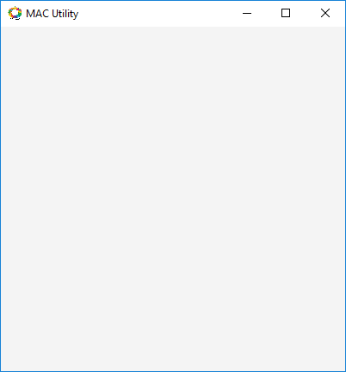

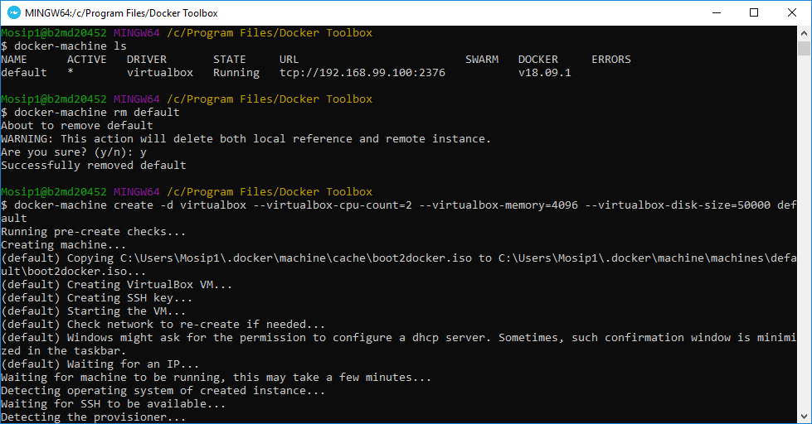

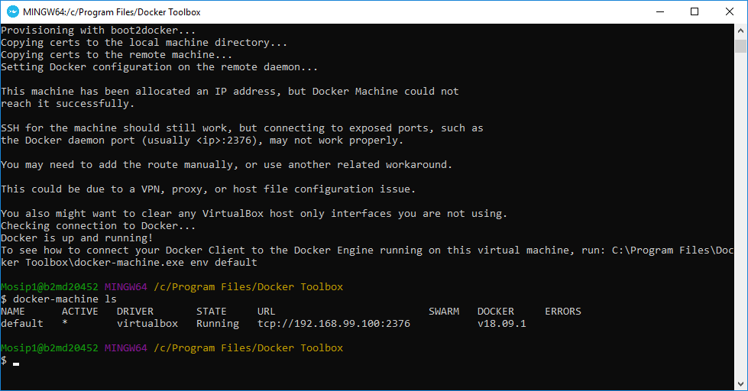

**Please set Environment Path "C:\Program Files\Oracle\VirtualBox"**

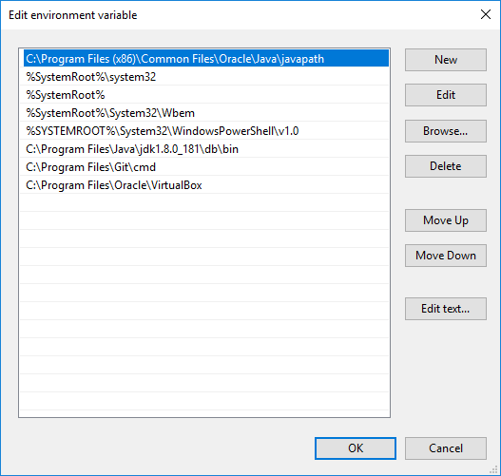

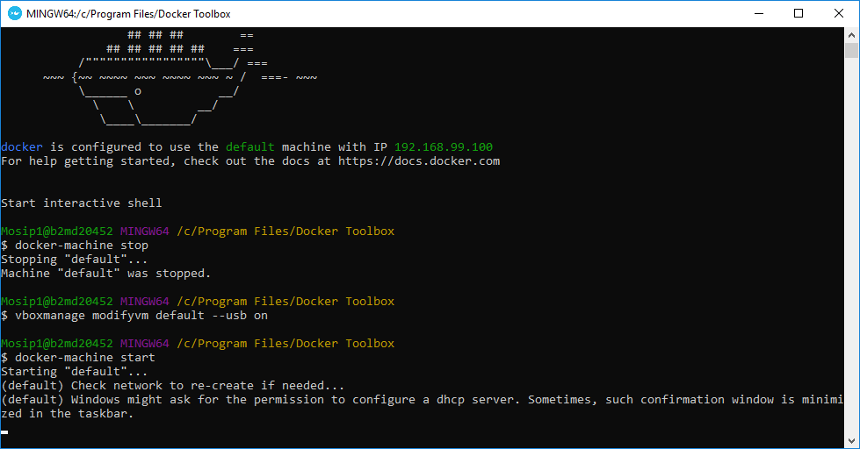

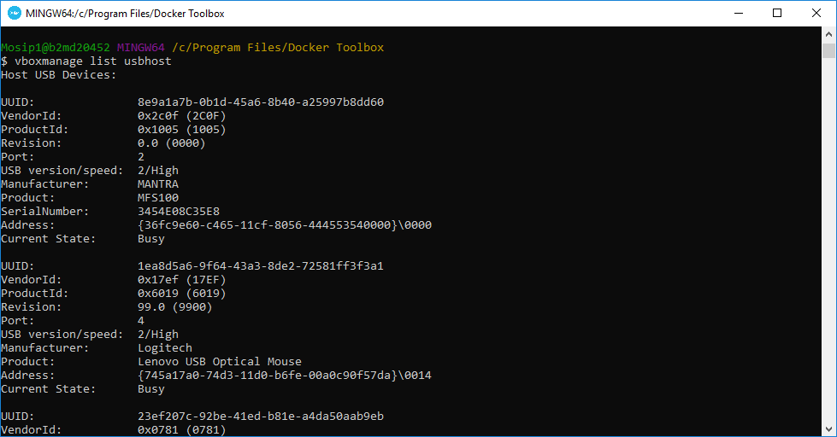

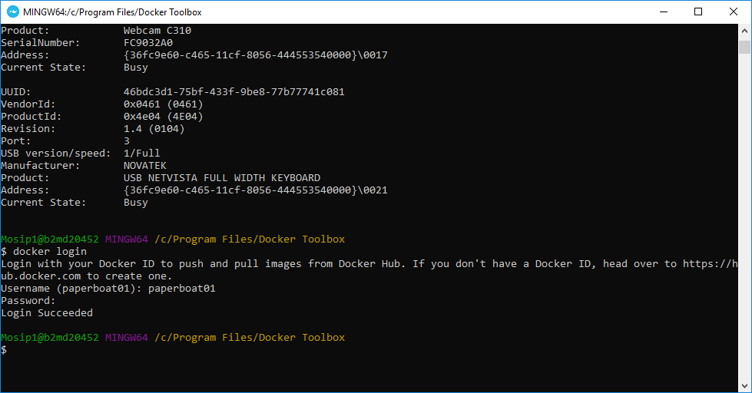

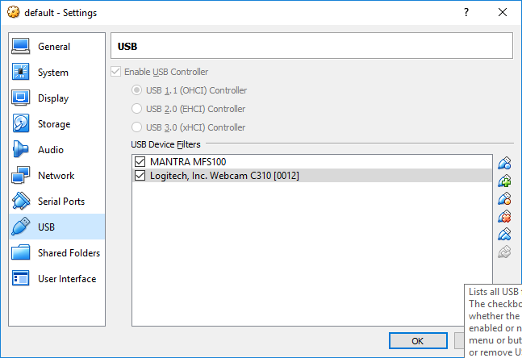

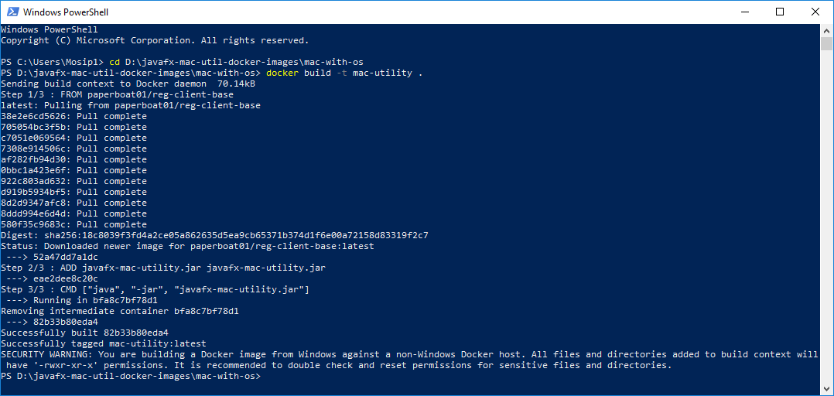

**Install Bash on Ubuntu on Windows 10**

docker build -t registration-client:1.0 .

set-variable -name DISPLAY -value 10.82.5.11:0.0

docker run -ti --rm -e DISPLAY=$DISPLAY registration-client:1.0

**UPDATE** REG.MACHINE_MASTER **SET** MAC_ADDRESS = 'D4-3D-7E-C0-8C-4A’;

d4:3d:7e:c0:8c:4a