UCL
Education & information support division
information systems



Advanced Excel

Statistical Functions and Formulae

Document No. IS-113 v1

Contents
Some key terminology and symbols 1
Data management 3
Calculating a new value 3
Recoding a variable 4
Missing values 4
Descriptive measures 5
Measures of central tendency 6
Calculating the Mean, Median or Mode using Excel functions 6
Using formulae in cells to calculate descriptive statistical measures 7
N 7
Mode 7
Median 7
Mean 7
Measures of Dispersion 7
Range 7
Variance 7
Standard Deviation 8
Frequencies 8
Measures of Association 10
Correlation Coefficient 10
Using an Excel function 10
Simple Linear Regression 10
Using an Excel function 10
More Regression: visualised. 11
Linear regression equations by hand. 12
Implicitly applying regression to the sample data. 12
Trends 14
Goal seeking 15
Goal Seek 15
Launching the goal seeker 15
Goal Seek with charts 16
Using Goal Seek with charts 16
Solver 17
Solver parameters 17
Setting up the Solver 17
Constraints 18
The Analysis ToolPak 19
Anova 20
Learning more 25
Open Learning Centre 26
Online learning 26
Getting help 26

Introduction
This workbook has been prepared to help you to:
- Manage and code data for analysis in Excel including recoding, computing new values and dealing with missing values;
- develop an understanding of Excel Statistical Functions;
- learn to write complex statistical formulae in Excel worksheets.
The course is aimed at those who have a good understanding of the basic use of Excel and sound statistical understanding.
It is assumed that you have attended the Introduction to Excel Formulae & Functions course or have a good working knowledge of all the topics covered on that course. In particular, you should be able to do the following:
- Edit and copy formulae
- Use built-in functions such as Sum, Count, Average, SumIf, CountIf and AutoSum
- Use absolute and relative cell referencing
- Name cells and ranges
You should also have some familiarity with basic statistical measures and tests. If you are uncertain about the statistical knowledge assumed by the course you may wish to use the list of key terminology and symbols to revise.
Excel has a number of useful statistical functions built in, but there are also some caveats about its statistical computations. For this reason and to facilitate more flexibility, in this course we demonstrate some handcrafted techniques as well First we look at some techniques to help you manage data, then descriptive statistics, and measures of association (covering correlation and regression). We move on to some special Excel functions using the goal seeking and solver techniques and then we introduce the Analsysis ToolPak, which we demonstrate by way of a single factor Anova.

Some key terminology and symbols
(…)
Used to group operations in formulae. Do everything inside the brackets before doing anything outside the brackets.
Mean
The weighted average of the scores: the sum of all the scores divided by the number of scores for a measure.
Median
The middle score in a sample. If there is an even number of scores the median falls midway between the two middle scores.
Mode
The most frequently occurring score for a measure.
Central tendency
The location of the middle of a distribution – roughly the average.
One Way Analysis of Variance (ANOVA)
The one way analysis of variance allows us to compare several groups of observations, all of which are independent but possibly with a different mean for each group. A very common test is whether or not all the means between sample groups or across variables are equal.
P-Value
The probability value (p-value) of a statistical hypothesis test is the probability of getting a value as or more extreme than that observed by chance alone, if the null hypothesis H0, is true. It is equal to the significance level of the test at which we would reject the null hypothesis. The p-value is compared with the significance level and, if it is smaller, the result is significant. That is, if the null hypothesis were to be rejected at = 0.05, this would be reported as 'p < 0.05'.
Range
The highest score for a measure minus the lowest score for a measure.
Regression Line
A regression line is a line drawn through the points on a scatter plot to summarise the relationship between the variables being studied. When it slopes down (from top left to bottom right), this indicates a negative or inverse relationship between the variables; when it slopes up (from bottom right to top left), a positive or direct relationship is indicated.
Score
The value recorded as the result of an observation or measurement.
Significance level ()
The significance level of a statistical hypothesis test is a fixed probability of wrongly rejecting the null hypothesis H0, if it is in fact true.
S
The variance – a measure of the dispersion or spread of scores around its average.
σ²
Standard deviation – another measure of the dispersion of scores.
∑
Sum of a series of values.
t-test
A test that compares for significant difference between means, either of paired samples in a repeated measure test or between groups in the independent samples test. The test assumes both a normal distribution and homogeneity of variance.
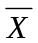
The mean for a variable X.
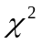(Chi Square)
A test of Association that allows the comparison of two values in a sample of data to determine if there is any relationship between them.

Data management
Although Excel doesn’t provide the sophisticated data coding techniques of a specialist statistical application, there are useful methods for accomplishing some common data management tasks.

Calculating a new value
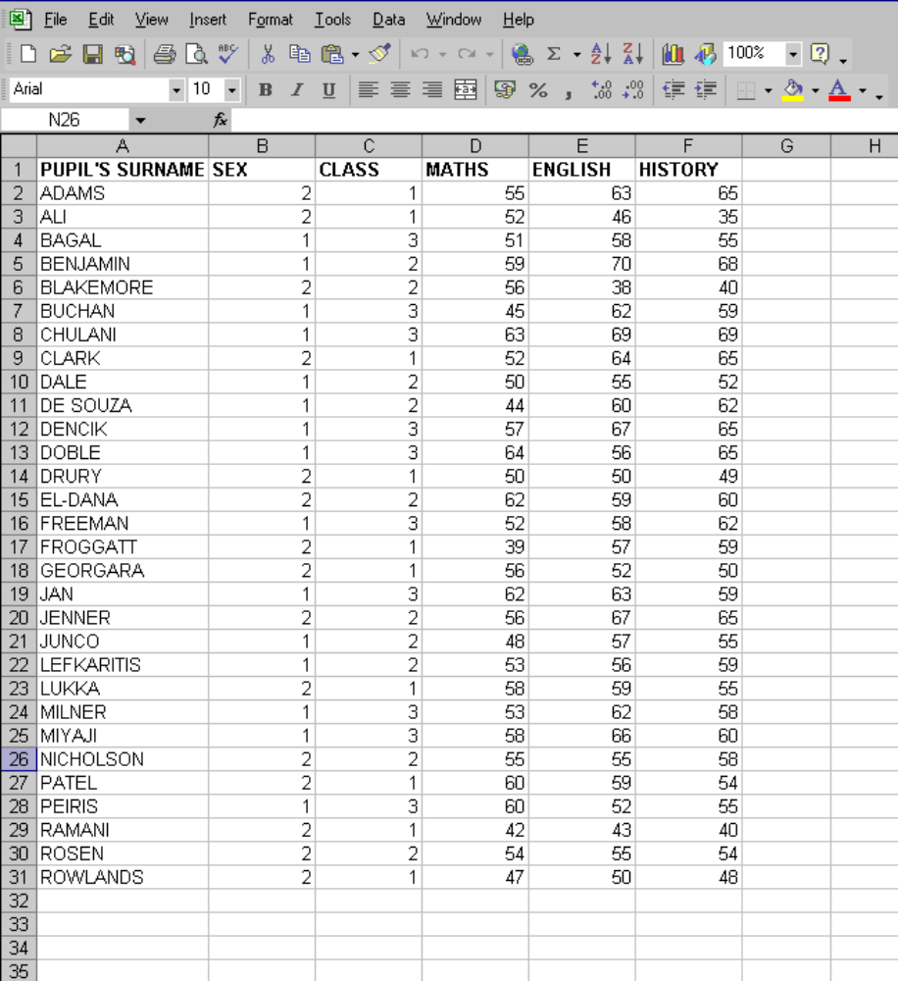
Open the file results.xls. You will see the following data in sheet 1:

We can label column G Mean Result and then enter the following formula in cell G2
=sum(D2,E2,F2)/3
and then copy the formula using the fill handle down to row 31. This will calculate the average exam score for each pupil.

Recoding a variable
Often analysis requires that we recode a variable. Sometimes this is straightforwardly because we wish, for example, to change the designation of gender as M or F to 1 or 2. On other occasions we wish to collapse a continuous value variable into a categorical variable. In the latter case we should usually recode into a new variable, ie non-destructively.
To recode a continuous into a categorical variable we will use the if function to compute a new variable Gender in the results.xls spreadsheet that assigns each pupil to the value M if the variable Sex has value 1 and the value F if Sex has the value 2.
The general format of an IF statement is
If(logical_test,value_if_true,value_if_false)
In our example the formula should be this:
=IF(G2=1,”M”,”F”)
Be aware that we could have a nested IF statement and that if we do, our catch all, default condition comes as the last argument of the nested IF.

Missing values
Sometimes you will not have a recorded observation or score for some case of a variable - that is there will be missing values. In this case, you have to decide how to manage these cases. Usual practise involves choosing a code to be input whenever a missing value is encountered for some case or to impute a value for the missing observations. Since Excel doesn’t have the sophisticated recoding methods available that specialist packages do, you will have to code missing values yourself in such a way that your analysis can be carried out accurately.
Choose the codes for your missing values carefully. If you have numeric variables, remember that there is no way to define a particular value as missing and thus exclude it from calculations. Therefore, while you might be tempted to code a missing age as 999 if you do this and then compute mean age, Excel will include all your 999 year olds. It may be wise to use a string as the missing value since strings will normally be excluded from Excel’s calculations.

Descriptive measures
Below is a list of common Excel functions used for descriptive statistical measures.
Function | What it does
SUM(range)  (SUMIF(range,criteria,sum_range) | Adds a range of cells  Adds cells from sum_range if the condition specified in criteria on range is met.
AVERAGE(range) | Calculates the mean (arithmetic average) of a range of cells
MEDIAN(range) | Calculates the median value for a data set; half the values in the data set are greater than the median and half are less than the median
MAX(range) | Returns the maximum value of a data set
MIN(range) | Returns the minimum value of a data set
SMALL(range,k)  LARGE(range,k) | Returns the kth smallest or kth largest value in a specified data range
COUNT(range)  COUNTA(range)  COUNTBLANK(range)  COUNTIF(range,value) | Counts the number of cells containing numbers in a range  Counts the number of non-blank cells within a range  Counts the number of blank cells within a range  Counts the number of cells in range that are the same as value.
VAR(range) and  VARP(range) | Calculates the variance of a sample or an entire population (VARP); equivalent to the square of the standard deviation
STDEV(range) and STEVP(range) | Calculates the standard deviation of a sample or an entire population (STDEVP); the standard deviation is a measure of how much values vary from the mean.

Each of these can be accessed from the menu sequence Insert |Function or using the function wizard or by writing a formula in a cell.

Measures of central tendency
The most common measures of central tendency are the mean, median and mode.

Calculating the Mean, Median or Mode using Excel functions
- First, open a new spreadsheet.
- Click on a blank cell where you will paste a function to calculate the mean, median or mode.
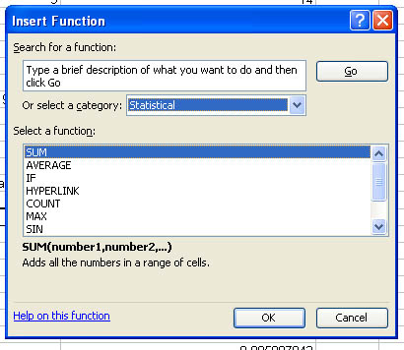
- Using the series fill function, enter the series of integer values 1 to 10 in cells A6 to A15.
- Next click on the function wizard button.
- From the drop down list Or select a category, select Statistical.
- Click on Average to highlight it, then on OK.

Using the mouse, I highlight the cells containing the data range just entered or you can select data by first clicking the collapse icons.
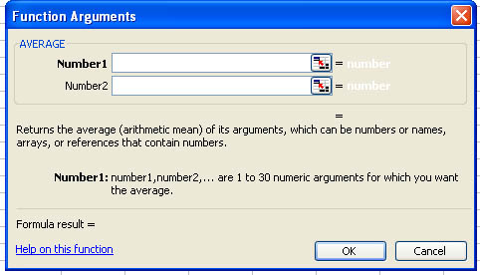 | These are the collapse icons and are used in selecting ranges in many Excel dialogues.  Excel previews the result of applying the function here.

Notice that as you fill in the ranges Excel previews the value that will result from applying the function.
Click OK.
The value of the mean will now appear in the blank cell you selected in step 2.
To calculate the median or mode, follow the same procedure but highlight MEDIAN or MODE in step 4. Alternately you can enter the formulae directly into spreadsheet cells as shown below. All the statistical functions are accessed in the same way and have a similar interface.

Using formulae in cells to calculate descriptive statistical measures

N
Before we calculate the measures of central tendency, we need to find out the value of N – the number of subjects or observations. The way to do this in excel is to use the Count() function over the range of values. In the results spreadsheet, use Count() to find out the number of pupils.

Mode
The syntax for this computation is
=Mode(Range)

Median
The syntax for this computation is
=Median(Range)

Mean
There is a built in Excel function that returns the mean as its value
=Average(Range)
It is often useful to put the result of this function into a suitably named cell in a spreadsheet.

Measures of Dispersion

Range
The range of a sample is the largest score minus the smallest score. This can be calculated using the Excel Formula
=(Max(A1:A10))-(Min(A1:A10))

Variance
The variance in a population is calculated as follows. We won’t build this equation ourselves in Excel during this session but I give it here so that you can try it in your own time.
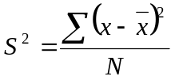
gives the population variance and
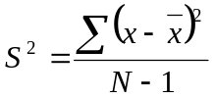
gives the sample variance.
This formula depends upon first calculating and N which we have already seen above.
The Excel function to calculate the variance for a population is
varp(range)
And for a sample
var(range)
You can access both from the function wizard or use them by typing formulae in cells.

Standard Deviation
The Standard Deviation is the square root of the variance. You can calculate it with the formula
=sqrt(var(range)) or by using the appropriate function, either
stdev(range)or stdevp(range).
Because of problems associated with Excel’s method of computing the standard deviation, we will usually calculate it by hand. We first compute the variance (formula given above) and then take the square root. You can see this in the spreadsheet stdevbyhand.xls.

Frequencies
Another useful Excel function is FREQUENCY. Given a set a data and a set of intervals, FREQUENCY counts how many of the values in the data occur within each interval. The data is called a data array and the interval set is called a bins array.
The format for the FREQUENCY function is:
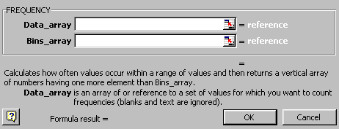FREQUENCY(DATA,BINS)
FREQUENCY is an array function. This means that the function returns a set of values rather than just one value. To enter an array function, the range that the array is to occupy must first be selected and the function must be entered by pressing Shift+Ctrl+Enter instead of just Enter or using the mouse.

The following worksheet contains the examination results for 14 students. The numbers in the column headed Score Below is the bins array.
Before keying in the function, you must select the range of the array for the result. In this case it will be F8:F17.
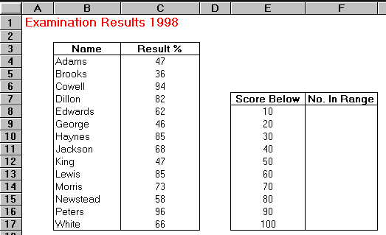
With this range selected, the following function is keyed into the Formula bar:
=FREQUENCY(C4:C17,E8:E17)
Press Shift+Ctrl+Enter.
The array is now filled with data. This data shows that no student scored below 30, 1 student scored between 30 and 39, 3 between 40 and 49, 1 between 50 and 59, 3 between 60 and 69, 1 between 70 and 79, 3 between 80 and 89, and 2 scored between 90 and 100.
If any of the results are changed, the data in the No. In Range column will be updated automatically.

Measures of Association

Correlation Coefficient
The Correlation Coefficient is calculated according to the following formula:
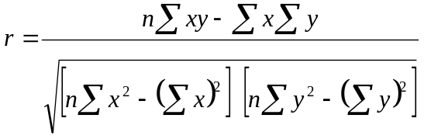
We would build a complicated formula like this in steps – incrementally - having broken it down to its component parts, each of which could be written simply using standard Excel features. If we have time, we will construct this formula in the training session.

Using an Excel function
=CORREL(A1:A15,B1:B15)
We will build this and see that the result from the hand built formula is more than tolerably close to Excel’s result. When you have built it, you can compare your result with that in the spreadsheet pearson.xls.

Simple Linear Regression
If the correlation coefficient indicates a sufficiently strong relation ship (direct or inverse) between variables, you may wish to explore that relationship using regression techniques.

Using an Excel function
Excel has three built in functions that give information about the line of best fit: Slope(X_values, Y_values) and Linest(X_values, Y_values,Constant)
The Constant is TRUE or FALSE. If False then the Y intercept of the line is set to 0. You must enter the formula as an array formula because it will return more than one value. To create an array formula you select the cells in which you want the results (ie the slope and intercept) to appear, enter the formula and press control-shift-enter and Excel will enclose the formula in curly braces to signify that the result is an array of values.
The syntax to calculate each of the terms in the regression is as follows:
- Slope, m: =SLOPE(known_y's, known_x's)
- y-intercept, b: =INTERCEPT(known_y's, known_x's)
- Correlation Coefficient, r: =CORREL(known_y's, known_x's)
- R-squared, r2: =RSQ(known_y's, known_x's)
As an example, let's examine the equation of motion, 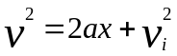, for a car coming to a stop. If we measure the car's position and velocity we can determine its acceleration and its initial velocity with the use of the SLOPE( ) and INTERCEPT( ) functions. The equation of motion has the form of 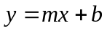, so if the square of the car's velocity is plotted along the y-axis and its position along the x-axis, then the slope is 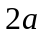, and the y-intercept is simply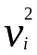.
Note that in order to find the acceleration, we must divide the slope by 2 and to find the initial velocity, we must take the square root of the y-intercept.
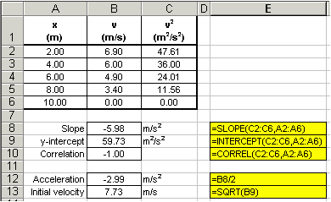
Note that the CORREL( ) function was used to ensure that the data did display a linear trend -- otherwise, the slope and y-intercept values are meaningless! It is always a good idea to plot the data as well as use these statistics functions because sometimes trends are not obvious. Additionally, a plot of the data allows us to visualize the data and gross blunders and errant data points are easily detected. The graph below tells us immediately that our data appears reasonable.
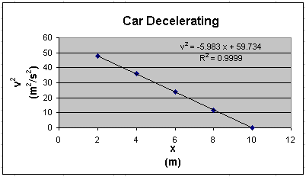

More Regression: visualised.
Say we have a set of data, x_{i}, y_{i} shown below. If we believe that there is a linear relationship between the variables x and y, we can plot the data and draw a "best-fit" straight line through it. Of course, this relationship is governed by the familiar equation y=mx+b. We can then find the slope, m, and y-intercept, b, for the data, which are shown in the figure below.
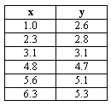
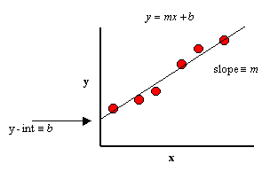
Enter the above data into an Excel spread sheet, plot the data, create a trendline and display its slope, y-intercept and R-squared value. Recall that the R-squared value is the square of the correlation coefficient. (Most statistical texts show the correlation coefficient as "r", but Excel shows the coefficient as "R". Whether you write is as r or R, the correlation coefficient gives us a measure of the reliability of the linear relationship between the x and y values. (Values close to 1 indicate excellent linear reliability.))
Enter your data as we did in columns B and C. The reason for this is strictly cosmetic as you will soon see.
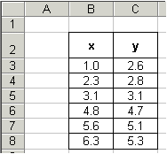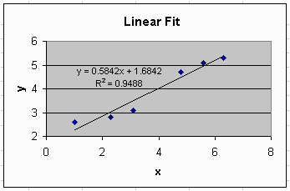

Linear regression equations by hand.
If we expect a set of data to have a linear correlation, it is not necessary for us to plot the data in order to determine the constants m (slope) and b (y-intercept) of the equation . Instead, we can apply use linear regression determine these constants.
Given a set of data x_{i}, y_{i} with n data points, the slope and y-intercept, can be determined as follows and r as discussed above.
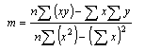
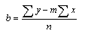

Implicitly applying regression to the sample data.
It may appear that the above equations are quite complicated, however upon inspection, we see that their components are nothing more than simple algebraic manipulations of the raw data. We can expand our spread sheet to include these components.
- First, we add three columns that will be used to determine the quantities xy, x² and y², for each data point.
- Now use Excel to count the number of data points, n. (To do this, use the Excel COUNT() function. The syntax for COUNT() in this example is: =COUNT(B3:B8) and is shown in the formula bar in the screen shot below.
- Finally, use the above components and the linear regression equations given in the previous section to calculate the slope (m), y-intercept (b) and correlation coefficient (r) of the data. The spread sheet will look like that below. Note that our equations for the slope, y-intercept and correlation coefficient are highlighted in yellow.
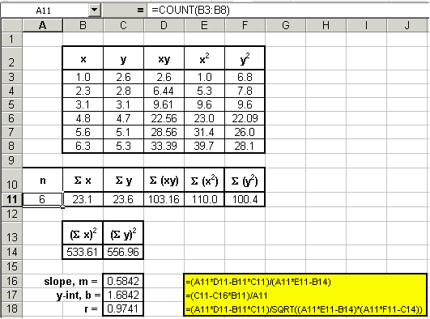

Trends
The TREND function is particularly useful. Using TREND, it is possible to analyse a pattern of numbers, and predict accurately the next number, using corresponding data. The function uses the known information and finds a trend to predict the new information.
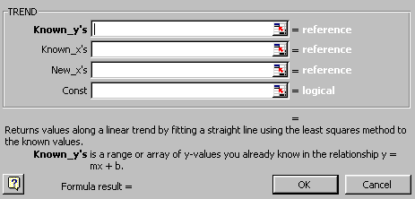The format of the TREND function is:
=TREND(known y’s, known x’s, new x’s)

This worksheet contains data relating to the number of people visiting given destinations. The Advanced Booking, Hours of Sunshine, and Mean Temperature were recorded for each of the destinations (these are the known x’s,. The number of Visitors for each destination is recorded (the known y’s). The Advanced Booking, Hours of Sunshine, and Mean Temperature were recorded for Mexico (the new x’s). We want to predict the number of people who will visit Mexico using all the available data.

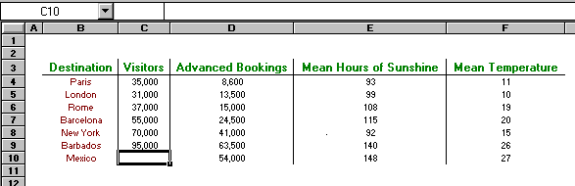

Cell C10 will hold the following formula: =TREND(C4:C9,D4:F9,D10:F10)
This function looks at the range D4:F9 and its relationship with the number of visitors (C4:C9). It then applies that relationship to the new information for Mexico (D10:F10) to predict the attendance for Mexico, 83,426.
If you change any of the data in the table, the figure for the number of visitors to Mexico will change accordingly.

1Goal seeking
Excel has a number of ways of altering conditions on the spreadsheet and making formulae produce whatever result is required. Excel can also forecast what conditions on the spreadsheet would be needed to optimise the result of a formula. For instance, there may be a profits figure that needs to be kept as high as possible, a costs figure that needs to be kept to a minimum, or a budget constraint that has to equal a certain figure exactly. Usually, these figures are formulae that depend on a great many other variables on the spreadsheet. Therefore, you would have to do an awful lot of trial-and-error analysis to obtain the desired result. Excel can, however, perform this analysis very quickly to obtain optimum results. The Goal Seek command can be used to make a formula achieve a certain value by altering just one variable. The Solver can be used for more painstaking analysis where many variables could be adjusted to reach a desired result. The Solver can be used not only to obtain a specific value, but to maximise or minimise the result of a formula (e.g. maximise profits or minimise costs).

Goal Seek
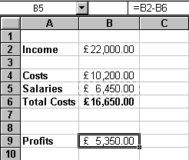The Goal Seek command is used to bring one formula to a specific value. It does this by changing one of the cells that is referenced by the formula. Goal Seek asks for a cell reference that contains a formula (the Set cell). It also asks for a value, which is the figure you want the cell to equal. Finally, Goal Seek asks for a cell to alter in order to take the Set cell to the required value.
In this example, cell B6 contains a formula that sums Costs and Salaries. Cell B9 contains a Profits formula based on the Income figure, minus the Total Costs.
A user may want to see how a profit of £6,000.00 can be achieved by altering Salaries.

Launching the goal seeker
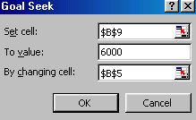Click on the cell whose value you wish to set. In this case, cell B9. (The Set cell must contain a formula.)
From the Tools menu select Goal Seek, the following dialog box appears:
The Goal Seek command automatically suggests the active cell as the Set cell. This can be overtyped with a new cell reference or you may click on the appropriate cell on the spreadsheet.
Enter the value you would like this formula to reach by clicking inside the To value box and typing in the value you want your selected formula to equal, i.e. 6000.
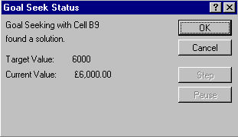Finally, click inside the By changing cell box and either type or click on the cell whose value can be changed to achieve the desired result (in this example, cell B5).
Click the OK button and the spreadsheet will alter the cell to a value sufficient for the formula to reach your goal. Goal Seek also informs you that the goal was achieved.
You now have the choice of accepting the revised spreadsheet, or returning to the previous values. Click OK to keep the changes, or Cancel to restore previous values.
Goal Seek can be used repeatedly in this way to see how revenue or other costs could be used to influence the final profits. Simply repeat the above process and alter the changing cell reference.
The changing cell must contain a value, not a formula. For example, if you tried to alter profits by changing total costs, this cell contains a formula and Goal Seek will not accept it as a changing cell. Only the advertising costs or the payroll cells can be used as changing cells.
Goal Seek will only accept one cell reference as the changing cell, but names are acceptable. For instance, if a user had named either cells B4 or B5 as "Costs" or "Salaries" respectively, these names could be typed in the By changing cell box.
For Goal Seek with more than one changing cell, use the Solver.

Goal Seek with charts
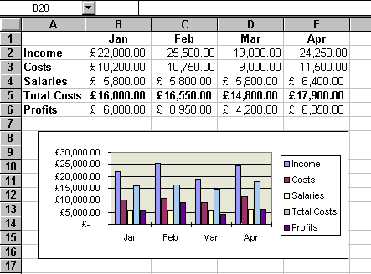Goal Seek can be used in conjunction with Excel's charting facility. Usually, when Ctrl is used with the mouse to select chart data, handles appear which permit dragging of the data up or down to a particular value. This then updates the corresponding figure on the spreadsheet. However, if the data that are dragged are the result of a formula, Goal Seek asks which cell to change in order to make the formula equal the required value. The following example shows a spreadsheet with an embedded chart:

Using Goal Seek with charts
Click to edit the chart, and then click twice on the series item you want to change – this could be a column or a plot point, depending on the type of graph you have. For this example, click on the March Profits series.
Use the black handle markers to drag up or down, altering the value of the plot point. If the plot point value you are changing is the result of a formula, when the mouse is released, you are returned to the spreadsheet and the Goal Seek dialog box appears. For this example, drag the March Profit series up to approximately £10,000.00.
The box informs you that you are changing the value of a cell, which is a formula. Therefore, it asks which cell to change in order to make the formula cell attain the value to which it was dragged.
Choose the appropriate cell, (i.e. D4, March Salaries) and click OK. You are returned to the chart window. (I guess no-one will get paid in March.)

Solver
For more complex trial-and-error analysis the Excel Solver should be used. Unlike Goal Seek, the Solver can alter a formula not just to produce a set value, but to maximise or minimise the result. More than one changing cell can be specified in order to increase the number of possibilities, and constraints can be built in to restrict the analysis to operate only under specific conditions.
The basis for using the Solver is usually to alter many figures to produce the optimum result for a single formula. This could mean, for example, altering price figures to maximise profits. It could mean adjusting expenditure to minimise costs etc. Whatever the case, the variable figures to be adjusted must have an influence, either directly or indirectly, on the overall result, that is to say, the changing cells must affect the formula to be optimised. Up to 200 changing cells can be included in the solving process, and up to 100 constraints can be built in to limit the Solver's results.

Solver parameters
The Solver needs quite a lot of information in order for it to be able to come up with a realistic solution. These are the Solver parameters.

Setting up the Solver
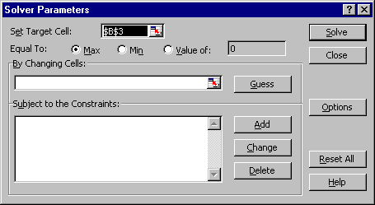
From the Tools menu, select Solver. A dialog box appears as follows:
Like Goal Seek, the Set cell is the cell containing the formula whose value is to be optimised. Unlike Goal Seek, however, the formula can be maximised or minimised as well as set to a specific value.
Decide which cells the Solver should alter in order to produce the Set cell result. You can either type or click on the appropriate cells, and Ctrl-click (hold down Ctrl and click with the left mouse button) if non-adjacent cell references are required.
When using a complex spreadsheet, or one that was created by someone else, there is an option to let the Solver guess the changing cells. Usually it will select the cells containing values that have an immediate effect on the Set cell, so it may be necessary to amend this.

Constraints
Constraints prevent the Solver from coming up with unrealistic solutions.

Building constraints into your Solver parameters
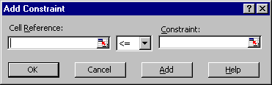
In the Solver dialog box, choose Add.

This dialog box asks you to choose a cell whose value will be kept within certain limits. It can be any cell or cells on the spreadsheet (simply type the reference or select the range).
This cell can be subjected to an upper or lower limit, made to equal a specific value or forced to be a whole number. Use the drop-down arrow in the centre of the Constraint box to see the list of choices: to set an upper limit, click on the <= symbol; for a lower limit, >=; the = sign for a specific value and the int option for an integer (whole number).
Once the OK button is chosen, the Solver Parameter dialog box displays again and the constraint appears in the window at the bottom. This constraint can be amended using the Change button, or removed using the Delete button.
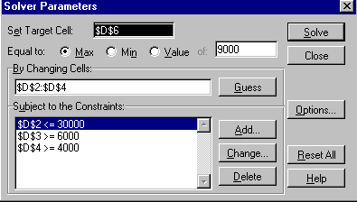
IMPORTANT
When maximising or minimising a formula value, it is important to include constraints, which set upper or lower limits on the changing values. For instance, when maximising Profits by changing Income figures, the Solver could conceivably increase these figures to infinity. If the Income figures are not limited by an upper constraint, the Solver will return an error message stating that the cell values do not converge. Similarly, minimising total costs could be achieved by making one of the contributing costs, i.e. Salaries and Costs, infinitely less than zero. A constraint should be included, therefore, to set a minimum level on these values.
When Solve is chosen, the Solver carries out its analysis and finds a solution. This may be unsatisfactory. Further constraints could now be added to force the Solver to increase salaries or costs etc.

The Analysis ToolPak
Microsoft Excel provides a set of data analysis tools - called the Analysis ToolPak - that you can use to save time when you perform complex statistical analyses.
You input the data and parameters for each analysis and Excel computes the appropriate statistical measures or test results and displays the results in an output table. Some tools generate charts in addition to output tables.
Before using an analysis tool, you must arrange the data you want to analyze in columns or rows on your worksheet. This is your input range.
If the Data Analysis command is not on the Excel Tools menu, you need to install the Analysis ToolPak:
1. On the Tools menu, click Add-Ins.
2. Select the Analysis ToolPak check box.
3. Install.
To use the Analysis ToolPak:
1. On the Tools menu, click Data Analysis.
2. In the Analysis Tools box, click the tool you want to use.
3. Enter the input range and the output range, and then select the options you want:
The Analysis ToolPak also contains the following tools:
- Anova
- Correlation analysis tool
- Covariance analysis tool
- Descriptive Statistics analysis tool
- Exponential Smoothing analysis tool
- Fourier Analysis tool
- F-Test: Two-Sample for Variances analysis tool
- Histogram analysis tool
- Moving Average analysis tool
- Perform a t-Test analysis
- Random Number Generation analysis tool
- Rank and Percentile analysis tool
- Regression analysis tool
- Sampling analysis tool
- z-Test: Two Sample for Means analysis tool
In this section we will perform an single factor analysis of variance to demonstrate the use of the Analysis ToolPak.

Anova
An ANOVA is a guide for determining whether or not an event was most likely due to the random chance of natural variation. Or, conversely, the same method provides guidance in saying with a 95% level of confidence that a certain factor (X) or factors (X, Y, and/or Z) were the more likely reason for the event.
Once you are sure you have the Analysis ToolPak installed, open the file results.xls. We would like to know if there is any significant difference between the mean scores in the three subjects, English, History and Maths. We can’t use a student t-test because that test will only compare two groups of scores.
The F ratio is the probability information produced by an ANOVA. It was named for Fisher. The orthogonal array and the Results Project, DMAIC designed experiment's cube were also his inventions.
An ANOVA can be, and ought to be, used to evaluate differences between data sets. It can be used with any number of data sets, recorded from any process. The data sets need not be equal in size. Data sets suitable for an ANOVA can be as small as three or four numbers, to infinitely large sets of numbers.
Here is how you could use an Excel ANOVA to determine who is a better bowler. You could and can use an ANOVA to compare any scores. Lengths of stay, days in AR, the number of phone calls, readmission rates, stock prices and any other measure are all fair game for an ANOVA. Below are six game scores for three bowlers. Which bowler is best? If there is a best bowler, is the difference between bowlers statistically significant?
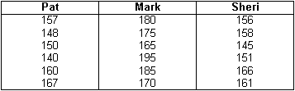
Step 1. Recreate the columns using Excel. Each bowler's name is the field title.
Step 2. Go to Tools and select Data Analysis as shown. If Data Analysis does not appear as the last choice on the list in your computer, you must click Add-Ins and click the Analysis ToolPak options.
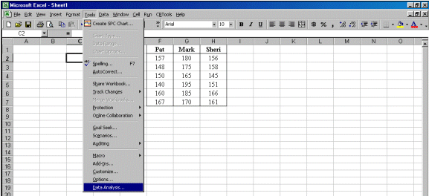
Step 3. Click OK to the first choice, ANOVA: Single Factor.
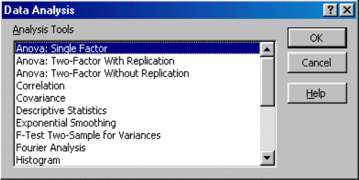
Step 4. Click and drag your mouse from Pat's name to the last score in Sheri's column. This automatically completes the Input Range for you:$F$1:$H$7. Click the box labeled "Labels in First Row." Click Output Range. Then either type in an empty cell location, or mouse click an empty cell, $I$8, as illustrated by the dotted cell below. Click OK.
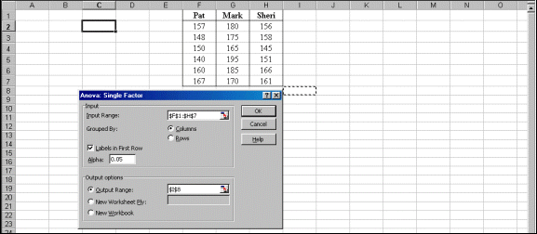
Step 5. Interpret the probability results by evaluating the F ratio. If the F ratio is larger than the F critical value, F crit, there is a statistically significant difference. If it is smaller than the F crit value, the score differences are best explained by chance.
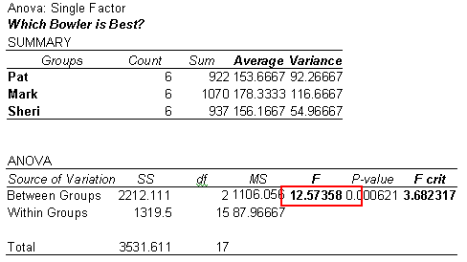
The F ratio 12.57 is larger than the F crit value 3.68. Mark is a better bowler. The difference between him and the other two bowlers is statistically significant. Excel automatically calculated the average, the variance - which is the standard deviation, s, squared - and the essential probability information instantly. You can use this technique to compare physicians, nurses, hospital lengths of stay, revenue, expense, supply cost, days in accounts receivable, or any other factor of interest.
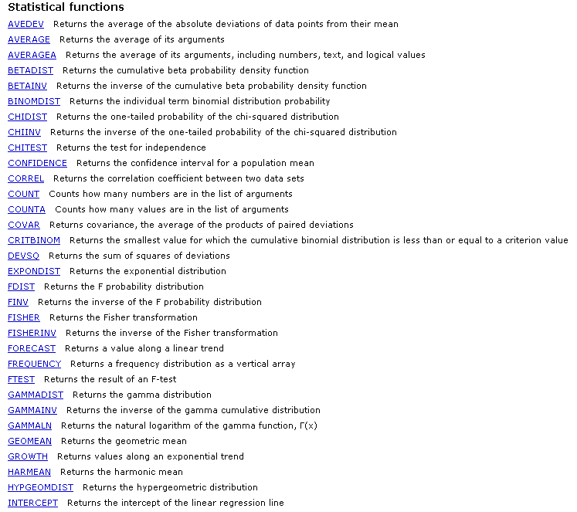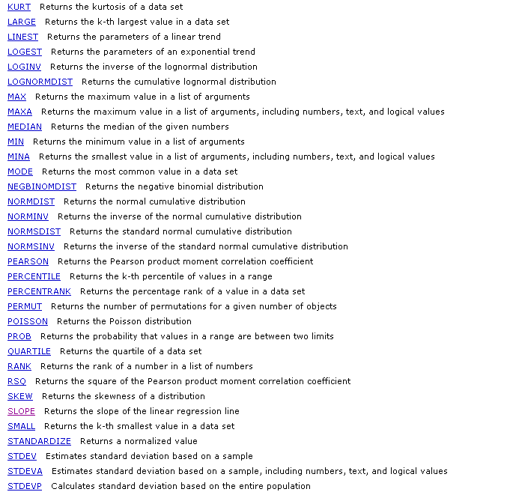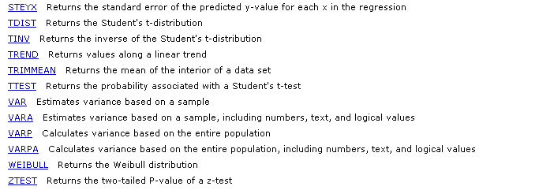

Learning more
Central IT training
Information Systems runs courses for UCL staff, and publishes documents for staff and students to accompany this workbook as detailed below:
Getting started with Excel | This 3hr course is for those who are new to spreadsheets or to Excel, and wish to explore the basic features of spreadsheet design. Note that it does not cover formulae and functions.
Getting more from Excel (no formulae or functions) | This 3hr course is for users of Excel who wish to learn more about the non-mathematical features of Excel and to work more efficiently.
Using Excel to manage lists | This 3hr course is for those already familiar with Excel and would like to use some of its basic data-handling functions.
Excel formulae & functions | This 3hr course is aimed at introducing users, who are already familiar with the Excel environment, to formulae and functions.
More Excel formulae & functions | This 3.5hr course is aimed at competent Excel users who are already familiar with basic functions and would like to know what else Excel can do and try some more complex IF statements.
Advanced formulae & functions | This 3.5hr course is aimed at competent Excel users who are already familiar with basic functions. It aims to introduce you to functions from several different categories so that you are equipped to try out other functions on your own.
Excel statistical functions | This course aims to introduce you to built-in Excel statistical functions and those in the analysis tool pack. The course covers major descriptive, parametric and non-parametric measures and tests.
Excel statistical formulae | This course covers best practise in constructing complex statistical formulae in spreadsheets using common statistical measures as example material.
Excel tricks and tips | This is a 2hr interactive demonstration of popular Excel shortcuts. It aims to help you find quicker ways of doing everyday tasks. This fast-paced course is also a good all-round revision course for experienced Excel users.
Pivot tables | Pivot tables allow you to organise and summarise large amounts of data by filtering and rotating headings around your data. This 2 hr course also shows you how to create pivot charts.
Advanced Excel – Data analysis tools | This course aims to help you learn to use some less common Excel features to analyse your data.
Advanced Excel – Setting up & automating Excel | Would you like to customise and automate Excel to perform tasks you do regularly? If you are an experienced user of Excel, then this course is for you.
Advanced Excel – Importing data and sharing workbooks | Do you share workbooks with others? Would you like to see who has updated what? Do you know how to import data from text files or databases? This course aims to show you how.

These workbooks are available for students at the Help Desk.

Open Learning Centre
- The Open Learning Centre is open every afternoon for those who wish to obtain training on specific features in Excel on an individual or small group basis. For general help or advice, call in any afternoon between 12:30pm – 5:30pm Monday – Thursday, or 12:30pm – 4:00pm Friday.
- If you want help with specific advanced features of Excel you will need to book a session in advance at: www.ucl.ac.uk/is/olc/bookspecial.htm
- Sessions will last for up to an hour, or possibly longer, depending on availability. Please let us know your previous levels of experience, and what areas you would like to cover, when arranging to attend.
- See the OLC Web pages for more details at: www.ucl.ac.uk/is/olc

Online learning
There is also a comprehensive range of online training available via TheLearningZone at: www.ucl.ac.uk/elearning

Getting help
The following faculties have a dedicated Faculty Information Support Officer (FISO) who works with faculty staff on one-to-one help as well as group training, and general advice tailored to your subject discipline:
- Arts and Humanities
- The Bartlett
- Engineering
- Maths and Physical Sciences
- Life Sciences
- Social & Historical Sciences
See the faculty-based support section of the www.ucl.ac.uk/is/fiso Web page for more details.
A Web search using a search engine such as Google (www.google.co.uk) can also retrieve helpful Web pages. For example, a search for "Excel tutorial” would return a useful selection of tutorials.

