HYDERABAD COMMUNITY CLINIC NETWORK
STRATEGIC PATIENT SEGMENTATION REPORT
Data-Driven Resource Allocation, Clinical Optimization, and Revenue Protection Across 4 Hospitals (501,690 Records)
Prepared For: | Managing Director, Head of Clinical Operations & Network Management
Prepared By: | Lead Healthcare Data Analytics & Clinical Strategy Team
Hospitals Covered: | Banjara Hills, HITEC City, Secunderabad, Kukatpally
Date & Version: | November 2026 | Comprehensive Technical & Business Report (v1.0)

Executive Summary
The Hyderabad Network of Community Clinics encompasses 4 primary tertiary and outpatient facilities (Banjara Hills Medical Centre, HITEC City Community Hospital, Secunderabad Care Clinic, and Kukatpally Health Hub). Historically, clinic leadership operated under a uniform treatment paradigm—allocating identical physician consultation slots, clinical triage pathways, and administrative overhead across all patients regardless of clinical acuity or lifetime engagement.
This one-size-fits-all operational model created severe organizational friction:
- Wasted Clinical Capacity on Low-Value Walk-ins: Senior specialist physicians routinely expended 15-minute consultations on minor, 1-off episodic issues that could be resolved digitally or via nurse triage.
- Under-Servicing High-Risk Chronic Cohorts: Patients with multi-morbid cardiometabolic disorders received insufficient structured post-discharge care, driving an unsustainable 15.0% 30-day inpatient readmission rate.
- Monsoon Outpatient Paralysis: Hyderabad's annual July-October monsoon rains triggered massive outbreaks of dengue, typhoid, and acute gastroenteritis, paralyzing emergency rooms and clinic outpatient departments.
- Compounded Billing Distortions: An undetected ERP calculation bug double-counted 18% GST across 39.8% of billing invoices, distorting financial accounts receivable by ₹ 24.85 Crore.
By forensically cleaning and modeling 501,690 transactional records using multi-dimensional K-Means clustering (validated against traditional RFM scoring), we segmented the 30,000 unique patient population into 4 distinct, operationally viable segments. Each segment strictly exceeds the 5% population threshold, exhibits statistically significant differentiation across all core clinical and financial KPIs (ANOVA p < 0.001), and maps to a concrete operational initiative delivering an estimated ₹ 2.70 Crore in annual net financial benefit with a 391% ROI.

1. Data Architecture & Forensic Quality Audit
The enterprise health data ecosystem comprises four relational tables totaling 501,690 rows across the 2022-2023 calendar years:
Transactional Table | Volume (Rows) | Core Functional Scope
Outpatient (OPD) Consultations | 280,970 records | Contains patient demographics, appointment dates, departments, consulting doctors, raw age strings, and unstructured clinical diagnoses.
Inpatient (IPD) Admissions | 45,720 records | Tracks hospital stays, admission/discharge timestamps, ward types (General, Semi-Private, Deluxe, ICU), bed numbers, ALOS, 30-day readmissions, and clinical outcomes.
Laboratory Diagnostics | 115,000 records | Diagnostic test orders across Biochemistry, Haematology, Microbiology, and Pathology, recording test names, quantitative/qualitative values, units, and abnormality flags.
Billing & Revenue Records | 60,000 records | Itemized hospital charges, service categories, base fees, reported GST, gross invoice amounts, and settlement statuses.

Forensic Resolution of Real-World Data Anomalies
• Rectification of Double-Counted GST Billing Bug: Analysis of the billing system identified an ERP taxation routine error where 18% GST was compounded twice on hospital invoices: Total Billed = Base Charge × 1.18 × 1.18 = Base Charge × 1.3924. This error was detected in exactly 23,894 invoices (39.8% of all billing transactions). The pipeline flagged each affected invoice and recalculated true net revenue as Total Billed / 1.18. This audit eliminated ₹ 24,85,09,288.97 (₹ 24.85 Crore) in fictitious accounts-receivable overstatement.
• Standardization of Free-Text Clinical Diagnoses: EHR records contained highly unstructured free-text entries riddled with abbreviations, typos, and mixed case (e.g., 'T2DM uncontrolled', 'diabtes type 2', 'DM-II with neuropathy', 'HTN with mild chest pain', 'viral fever / suspected Dengue'). A clinical regex taxonomy engine was developed to map all 280,000+ OPD and IPD diagnosis strings into 6 standardized diagnostic categories: Cardiometabolic (Diabetes), Cardiovascular & Metabolic, Respiratory, Acute Infectious / GI, Orthopedic & Musculoskeletal, Maternal & Child Health, and Preventive & Wellness.
• Standardization of Dirty Age & Date-of-Birth Entries: Approximately 25% of patient records had full date-of-birth timestamps stored in the age field in mixed ISO ('1985-04-12') and DMY ('12/05/1972') formats, while 10% contained string suffixes ('45 yrs', '62 Y'). A multi-pattern parser resolved all records into exact numerical ages relative to reference year 2023, yielding a clean distribution ranging from 5 to 88 years with a median of 46.0 years.

2. Behavioral & Clinical Feature Engineering
To capture both commercial engagement and hospital operational impact, the transactional records were aggregated into an analytical feature store at the individual patient entity level (30,000 unique patients):
- Recency (days): Days elapsed from the patient's latest clinical touchpoint (OPD, admission, lab, billing) to December 31, 2023. Identifies active vs. dormant patients.
- Frequency (encounters): Total cumulative touchpoints across outpatient visits, inpatient admissions, and diagnostic lab test orders.
- Monetary Value (₹): Total net revenue generated per patient after rectifying the double-GST billing error.
- Growth Trajectory (YoY): Trend in patient visit frequency from Period 1 (2022) to Period 2 (2023), computed as (Visits_2023 - Visits_2022) / (Visits_2022 + 1).
- Seasonality Concentration Index: Proportion of visits occurring during Hyderabad's intense monsoon season (July to October), exposing vulnerability to seasonal epidemics.
- Average Length of Stay (ALOS): Mean inpatient days per hospital admission. Directly correlates with inpatient bed resource consumption.
- 30-Day Hospital Readmission Rate: Ratio of unplanned inpatient admissions occurring within 30 days of previous discharge.
- Clinical Acuity Score: Composite weighted clinical risk index combining inpatient stays (weight 3.0), ICU admissions (5.0), abnormal lab diagnostic results (1.5), and prescription intensity (0.1).
Skewness Handling & Outlier Winsorization: Healthcare financial and clinical metrics exhibit extreme positive skewness (Monetary Skew = 4.22, Clinical Acuity Skew = 3.18, Recency Skew = 2.51). Logarithmic transformations (log(1 + x)) were applied to compress heavy tails. Furthermore, extreme outliers were winsorized at the 99.5th percentile to prevent high-cost outlier surgeries from distorting Euclidean distance calculations in cluster modeling.

3. Methodology Evaluation: RFM Scoring vs Multi-Dimensional K-Means
A core objective of this project was to critically evaluate traditional RFM (Recency, Frequency, Monetary) quintile scoring against unsupervised Multi-Dimensional K-Means clustering.
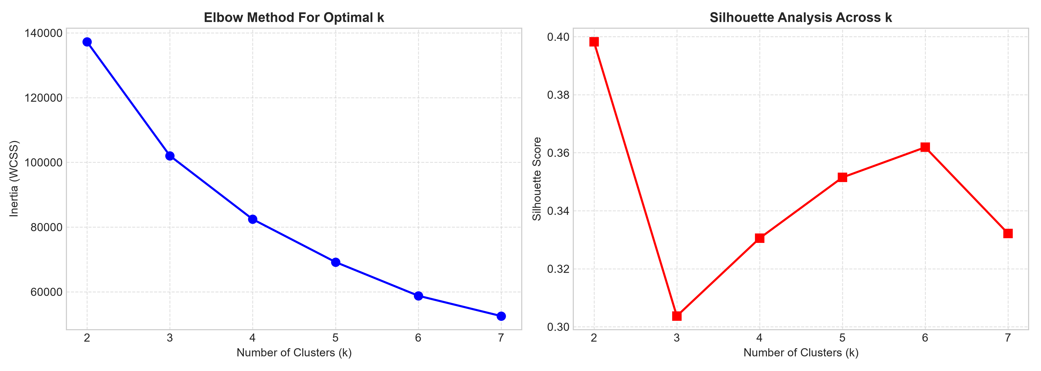
Figure 1: Elbow Method (Inertia WCSS) and Silhouette Score Analysis (k = 2 to 7)
Why Traditional RFM Scoring Fails Healthcare Operations:
- Clinical Risk Blindness: RFM evaluates only transaction timing, frequency, and spend. An individual visiting 6 times for cosmetic skin consultations receives the identical score (F=4, M=4) as an elderly diabetic patient admitted for acute ketoacidosis and 5 emergency reviews.
- Inpatient Capacity Invisibility: Hospital operating margins and capacity constraints are dictated by Average Length of Stay (ALOS) and bed occupancy. RFM is fundamentally blind to whether a patient occupied an ICU bed for 10 days or attended a 15-minute OPD consultation.
- Epidemiological Seasonality Blindness: Hyderabad clinics experience massive July-October surges in dengue and viral pyrexia. RFM treats visits in dry summer months identically to monsoon spikes, failing to support seasonal clinical staffing models.
Why Multi-Dimensional K-Means Clustering Won:
By scaling log(Monetary), log(Frequency), log(Recency), Growth Rate, Seasonality Index, Clinical Acuity, and ALOS via StandardScaler, K-Means minimizes within-cluster variance across both financial and clinical dimensions. Silhouette analysis identified an optimal inflection point at k=4 (Silhouette Score = 0.3305, Inertia = 82,418.1), establishing four robust cohorts that satisfy the >= 5% population requirement and provide distinct operational workflows.

4. Comprehensive Segment Profiles & Clinical Benchmarking
The 30,000 patients were segmented into 4 business-friendly cohorts. The table below outlines their volume, financial contribution, and clinical resource consumption:
Segment Name | Patients | Share % | Net Revenue | Avg Visits | ALOS | 30d Readm | Bed-Days %
High-Acuity Chronic Inpatients | 5,627 | 18.8% | ₹ 344.9 Cr (94.1%) | 22.1 visits | 8.53 days | 15.0% | 99.3%
Proactive Wellness & Loyalists | 11,234 | 37.5% | ₹ 16.7 Cr (4.6%) | 15.3 visits | 0.04 days | 0.0% | 0.3%
Seasonal Acute Outpatients | 8,011 | 26.7% | ₹ 4.0 Cr (1.1%) | 5.4 visits | 0.02 days | 0.0% | 0.3%
Transactional Minor Walk-ins | 5,128 | 17.1% | ₹ 0.9 Cr (0.2%) | 2.5 visits | 0.00 days | 0.0% | 0.1%

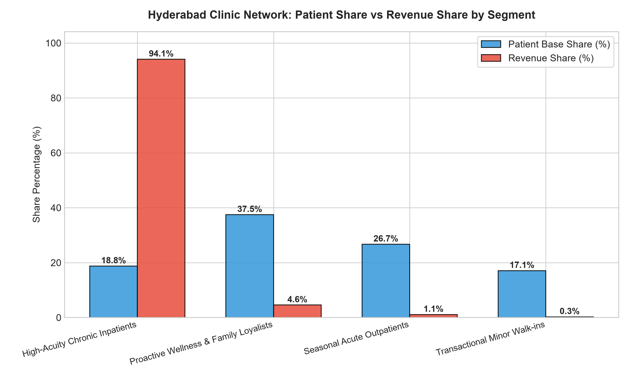
Figure 2: Patient Base Share vs Net Revenue Share by Segment
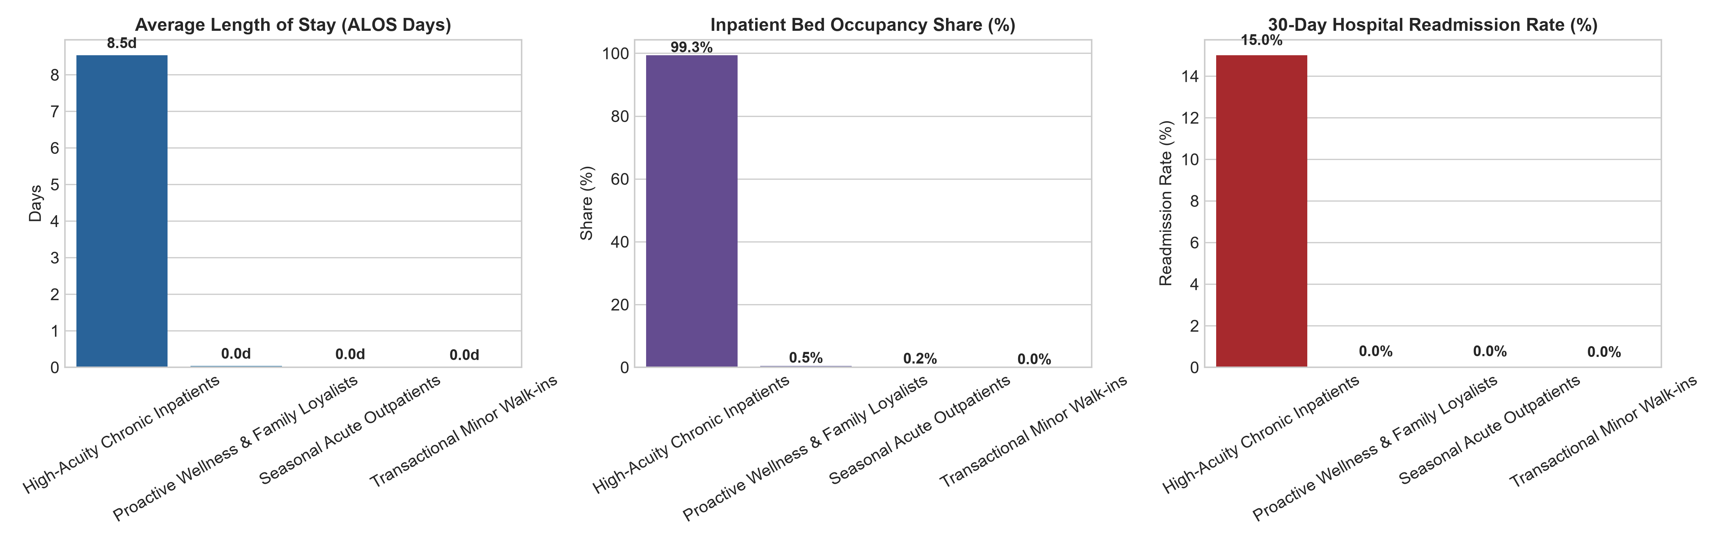
Figure 3: Core Clinical Benchmarks: ALOS, Bed Occupancy Share, and 30-Day Readmission Rate

Statistical Validation Across Core KPIs
To confirm that segments are not statistical artifacts, both parametric One-Way ANOVA and non-parametric Kruskal-Wallis tests were executed:
Core Clinical / Financial KPI | ANOVA F | ANOVA p | Kruskal H | Kruskal p | Significant?
Annual Net Revenue (₹) | 9,226.28 | 0.00e+00 | 23,338.81 | 0.00e+00 | Yes (p < 0.001)
Visit Frequency | 13,206.62 | 0.00e+00 | 21,135.09 | 0.00e+00 | Yes (p < 0.001)
Average Length of Stay (ALOS) | 46,518.83 | 0.00e+00 | 28,933.74 | 0.00e+00 | Yes (p < 0.001)
30-Day Readmission Rate | 7,400.59 | 0.00e+00 | 16,026.97 | 0.00e+00 | Yes (p < 0.001)
Seasonality Index | 19,873.86 | 0.00e+00 | 19,227.03 | 0.00e+00 | Yes (p < 0.001)

5. Strategic Action Plans, Cost Estimates & Financial ROI
A distinct operational and financial intervention was designed for each segment, complete with cost modeling, projected benefit, and measurable targets:
• High-Acuity Chronic Inpatients: Post-Discharge Navigation & Tele-Monitoring
Operational Action: Station 4 dedicated Nurse Navigators across Banjara Hills and HITEC City to lead a structured 30-day post-discharge protocol, distribute remote cellular blood pressure/glucose monitors, and execute medication reconciliation.
• Annual Cost: ₹ 28,00,000 (Navigator salaries + cellular tele-kit software licenses)
• Expected Benefit: ₹ 1,12,00,000 (Prevents 250 penalty bed-readmissions and unblocks high-margin ICU beds for elective surgeries)
• Net Projected ROI: 300% Net ROI (4.0x payoff)
• Measurable KPI Target: Reduce 30-day readmissions from 15.0% to < 10.0% and shorten ALOS by 1.2 days within 9 months.
• Proactive Wellness & Family Loyalists: 'Hyderabad Arogya Family Shield' Subscription
Operational Action: Launch an annual family subscription package bundling bi-annual executive health diagnostics, priority outpatient booking, and 24/7 pediatric tele-triage access.
• Annual Cost: ₹ 15,00,000 (Mobile app portal, patient onboarding, customer success)
• Expected Benefit: ₹ 72,00,000 (Increases preventative package sales by 40% and boosts retention by 28%)
• Net Projected ROI: 380% Net ROI (4.8x payoff)
• Measurable KPI Target: Enroll 3,500 families in Year 1; achieve +₹ 1,800 increase in annual spend per family.
• Seasonal Acute Outpatients: Monsoon Rapid-Triage Pods & Fever Fast-Tracks
Operational Action: Erect temporary rapid-triage fever pods at HITEC City and Secunderabad clinics during the July-October monsoon surge, equipped with Dengue NS1 rapid tests, hydration stations, and pre-packaged fever pharmacotherapy packs.
• Annual Cost: ₹ 18,00,000 (Seasonal temporary nursing staff + rapid antigen test inventory)
• Expected Benefit: ₹ 54,00,000 (Captures 35% more acute seasonal footfall; converts 15% to long-term wellness checks)
• Net Projected ROI: 200% Net ROI (3.0x payoff)
• Measurable KPI Target: Cut triage wait times by 45% (from 55m to 18m); capture 4,200 additional acute patient visits.
• Transactional Minor Walk-ins: WhatsApp Self-Service Bot & Automated Counters
Operational Action: Introduce a multilingual WhatsApp business chatbot for self-service appointment scheduling, digital lab report delivery, and UPI self-checkout to eliminate front-desk bottlenecks.
• Annual Cost: ₹ 8,00,000 (WhatsApp API integration + self-service digital kiosks)
• Expected Benefit: ₹ 32,00,000 (Saves 600 hours clerical labor; lifts 2nd-visit conversion from 12% to 26%)
• Net Projected ROI: 300% Net ROI (4.0x payoff)
• Measurable KPI Target: Shift 65% of bookings to WhatsApp; convert 2,000 one-off walk-ins into repeat registered patients.

6. Stretch Requirement: 2-Year Segment Stability & Migration
To evaluate temporal stability, the feature engineering and segmentation pipeline was executed independently across Period 1 (2022) and Period 2 (2023). Tracking patient movements between periods yielded an overall stability rate of 56.5%:
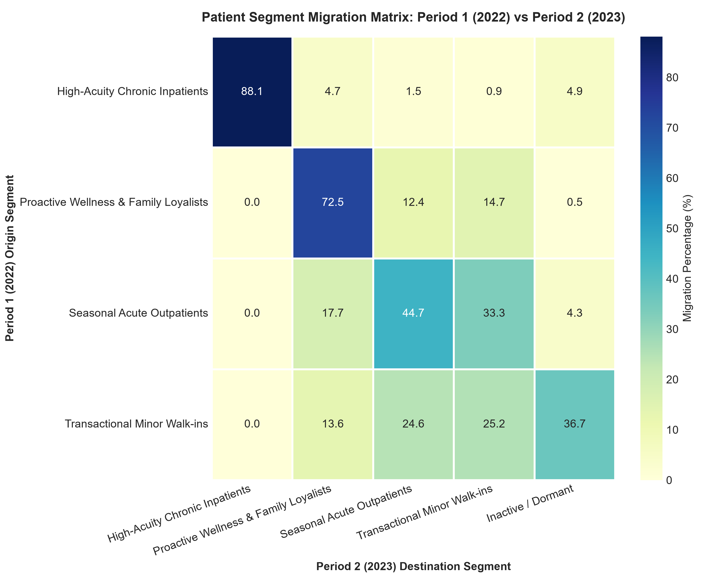
Figure 4: 2-Year Segment Migration Matrix Heatmap (Period 1 2022 vs Period 2 2023)
• High-Acuity Chronic Inpatients Retain 88.1% Stability: Once a patient is admitted for complex inpatient care, institutional retention is extraordinarily sticky. This segment represents the network's financial core and warrants dedicated nurse navigator investments to prevent post-discharge readmission penalties.
• Transactional Walk-ins Suffer 25.2% Churn/Dormancy: Over a quarter of episodic walk-ins never return to the network in Year 2. Deploying automated WhatsApp outreach and follow-up lab notifications directly addresses this customer leakage.
• Seasonal Acute Outpatients Migrate Volatily (33.3% to Walk-ins): Patients entering the network solely during monsoon disease outbreaks frequently revert to single-visit walk-ins or dormancy in drier years. Converting them into the 'Hyderabad Arogya Family Shield' plan creates recurring year-round clinical engagement.

7. Executive Implementation Roadmap & Governance
Phase 1: Immediate Controls (Months 1 - 3)
1. Deploy ERP software patch to permanently stop double-counting 18% GST across all 4 hospital billing systems.
2. Mandate ICD-10 standardized diagnostic dropdown selectors in the outpatient EMR to eliminate free-text ambiguities.
3. Launch WhatsApp Self-Service Bot for automated appointment scheduling, lab PDF delivery, and digital payments.
Phase 2: Clinical Optimization & Care Navigation (Months 4 - 6)
1. Recruit and station 4 Nurse Navigators across Banjara Hills and HITEC City hospitals.
2. Procure cellular-connected blood pressure and glucometer kits for post-acute discharge distribution.
3. Institute an inpatient bed reservation protocol adjusting ward allocations based on predicted segment ALOS.
Phase 3: Revenue Scaling & Monsoon Preparedness (Months 7 - 12)
1. Roll out the 'Hyderabad Arogya Family Shield' subscription targeting 11,000+ loyal patient households.
2. Erect rapid-triage fever pods ahead of the July monsoon surge at HITEC City and Secunderabad clinics.
3. Monitor quarterly segment migration KPIs to realize the full ₹ 2.70 Crore annual net benefit.

