NOX Na-POD
Mechanically Constrained Sodium-Ion Drop-In Energy Storage System
for Residential Inverter Applications
Design-stage engineering research manuscript
NOX Na-POD Research Program
Seraladen S
B.Tech. Artificial Intelligence & Data Science\nJ.J. College of Engineering and Technology, Trichy, Tamil Nadu, India
Correspondence: Seraladen S | NOX Na-POD Research Program
September 2026 • Design-stage engineering research
Self-authored research and system-design manuscript

ABOUT THE RESEARCHER
Seraladen S is an engineering student and independent technology researcher working across artificial intelligence, energy technology, and product-oriented engineering. The NOX Na‑POD program applies a systems-engineering approach to energy-storage architecture and physical product design, treating chemistry, mechanical structure, thermal behavior, embedded monitoring, and economics as one connected system.

RESEARCH PROGRAM AND AUTHOR DECLARATION

Research scope
NOX Na-POD is a self-authored engineering research program focused on a mechanically constrained sodium-ion energy-storage pack intended for residential inverter applications. The central design proposition is that a sodium-ion pack should be engineered as a coordinated mechanical, thermal, electrical, and embedded-control system. The work therefore combines a compliant compression architecture, passive thermal management, an improved BMS concept, and an explicit charging-integration boundary within a familiar 12 V battery form factor.

Core research contributions
- Mechanically constrained sodium-ion pack architecture using Belleville spring compliance, tolerance compensation, fiberglass confinement, and SS304 load-spreading plates.
- Passive thermal-management architecture combining vertical natural-convection channels with phase-change-material buffering.
- Improved ESP32-based BMS architecture for current, voltage, temperature, impedance-related monitoring, protection logic, SOC estimation, and wireless telemetry.
- Explicit treatment of inverter charging compatibility rather than assuming that a sodium-ion pack is automatically compatible with every legacy lead-acid charger.
- Engineering calculations, economic modeling, qualitative risk analysis, and a defined validation pathway for moving from design to measured prototype evidence.
These contributions are presented as a design-stage architecture and analysis; experimental validation is defined as a future work package.

Author declaration
This manuscript is presented as the author’s own engineering research and design work for the NOX Na-POD program. The architecture, system concept, mechanical compliance approach, passive thermal strategy, BMS concept, calculations, economic model, risk analysis, and future validation plan are presented as part of this research program. Quantitative values are explicitly identified as design targets, derived calculations, projections, or validation requirements where appropriate; they are not represented as measured experimental results unless direct measurements are available. This manuscript does not claim measured experimental performance; all numerical values are design targets, calculations, or projections unless explicitly identified as measurements.

Document status
Design-stage research paper — September 2026. The purpose of this document is to establish the engineering architecture, rationale, design envelope, and validation requirements of NOX Na-POD before full prototype qualification.

ABSTRACT
NOX Na-POD presents a mechanically constrained sodium-ion energy-storage architecture designed around the 12 V / 150 Ah residential inverter battery form factor. The research treats the pack as an integrated system in which electrochemical behavior, cell expansion, heat transport, compression, battery management, charging compatibility, and economics must operate together. The proposed architecture uses a 4S prismatic sodium-ion configuration, approximately 12.8 V nominal and 150 Ah equivalent capacity, combined with a Belleville disc-spring compression system, fiberglass confinement, a silicone tolerance-compensation layer, and SS304 compression plates. Passive thermal management uses approximately 1 cm vertical airflow channels together with a 35–45 °C phase-change-material window. An ESP32-based BMS provides current integration, thermal-gradient awareness, impedance-related monitoring, protection functions, and wireless telemetry.
The paper develops the architecture through mechanical, thermal, embedded, integration, risk, and economic analyses. The nominal pack energy is derived as 12.8 V × 150 Ah = 1.92 kWh. The approximately 500 kgf Belleville preload is a design target corresponding to 4.903 kN using standard gravity. Economic projections consider INR 13,500 COGS, INR 19,000 wholesale pricing, and INR 24,500 retail pricing, with break-even service-life thresholds calculated under explicit assumptions. The research also identifies the major engineering questions that must be resolved through prototype testing, including spring-stack characterization, thermal saturation behavior, BMS SOC accuracy, charger compatibility, cycle life, safety, and manufacturing repeatability. The manuscript establishes the electro-thermo-mechanical design envelope and systems architecture to define the requirements for subsequent prototype qualification. This work presents a design-stage architecture and analysis; no experimental performance results are claimed, and all quantitative values are design targets, derived calculations, or projections unless explicitly stated otherwise.

Keywords
sodium-ion battery; mechanical compliance; Belleville spring; passive thermal management; phase change material; battery management system; ESP32; inverter battery replacement; embedded systems; energy storage; system engineering; feasibility analysis

NOMENCLATURE
- 4S — four cells in series
- B2B / B2C — business-to-business / business-to-consumer
- BMS — battery management system
- COGS — cost of goods sold
- DoD — depth of discharge
- FMEA — failure mode and effects analysis
- kgf — kilogram-force
- MCU — microcontroller unit
- PCM — phase change material
- SOC — state of charge
- SS304 — austenitic stainless steel, grade 304
- TCO — total cost of ownership
- INR — Indian rupees

TABLE OF CONTENTS
1. Problem and Research Motivation
2. Related Work and Background
3. Research Contributions
4. System Specification
5. System Architecture
6. Electrochemical Subsystem
7. Mechanical Compliance Engineering
7.2 Force–Deflection Concept
8. Passive Thermal Management
9. BMS and Embedded Architecture
9.4 Charge Integration
10. Failure Modes and Risk Controls
11. Economic Model
11.3 Break-Even Sensitivity
12. Feasibility Assessment
13. Limitations and Validation Program
14. Conclusion and Author Declaration
15. References

HOW TO READ THIS PAPER
The paper first defines the engineering problem and design objectives, then establishes the system specification and architecture. The electrochemical section defines the cell configuration and its pack-level implications. Mechanical and thermal sections explain how expansion and heat are handled physically. The BMS section describes measurement, protection, SOC estimation, telemetry, and charging integration. The final sections evaluate risk, economics, feasibility, limitations, and the experimental work required to transition the design into a validated prototype.

1 | PROBLEM AND RESEARCH MOTIVATION

The key challenge extends beyond cell chemistry
The key challenge is not limited to cell chemistry; it lies in the interaction between electrochemical behavior, mechanical expansion, thermal management, packaging, and inverter integration.
Residential backup systems traditionally rely on lead-acid batteries because the ecosystem is familiar and mechanically simple. The baseline considered in this research uses a 12,000–15,000 INR purchase range and a 2–3 year replacement cadence as an economic reference. The design challenge is to introduce sodium-ion storage without simply transferring the weaknesses of a conventional rigid battery enclosure.
The research identifies three system-level problems. First, sodium-ion cells can exhibit dimensional change during cycling [1], making a rigid compression structure undesirable. Second, tropical ambient conditions can elevate internal temperature and accelerate aging, so passive thermal management is built into the pack. Third, flat discharge characteristics reduce the usefulness of voltage alone for state-of-charge estimation [7], motivating a measurement-based BMS architecture.
DESIGN QUESTION
Can a 12 V / 150 Ah sodium-ion pack be engineered as a mechanically compliant, passively cooled, telemetry-enabled system that fits the residential inverter replacement format?

Research objectives
- Create a mechanically compliant enclosure that manages cell expansion rather than fighting it.
- Integrate passive thermal transport and phase-change buffering for high-ambient operation.
- Use an embedded BMS architecture that improves monitoring and SOC estimation capability.
- Preserve a familiar battery form factor while making charging compatibility an explicit design requirement.
- Quantify the concept through engineering calculations, system architecture, risk analysis, and an economic model.
This manuscript focuses on defining the engineering architecture, rationale, design envelope, and validation requirements for NOX Na‑POD. It does not present measured experimental results; all numerical values are design targets, derived calculations, or projections unless explicitly stated otherwise.

Originality and contributions
This manuscript presents an independent engineering research project on a mechanically constrained sodium‑ion energy‑storage pack for residential inverter applications. The NOX Na‑POD system architecture—including the 4S 12.8 V / 150 Ah pack configuration, Belleville‑spring compliance mechanism, passive thermal‑management concept using vertical convection channels and a 35–45 °C phase‑change‑material window, ESP32‑based BMS with coulomb‑counting and telemetry, and the associated economic and validation framework—is the author’s own work. The design draws on general background knowledge from publicly available literature on sodium‑ion battery mechanics, battery thermal management, and embedded battery‑management systems. Based on the literature reviewed for this design-stage study, the author did not identify a prior publication combining the reviewed mechanical, thermal, BMS, and charging elements within the same proposed 12 V / 150 Ah residential inverter architecture. The integrated system design is therefore presented as the research program’s proposed architecture, not as a claim of established global novelty.
2 | RELATED WORK AND BACKGROUND

Positioning NOX Na‑POD within existing literature
This section situates the NOX Na‑POD architecture within existing work on sodium‑ion battery mechanics, passive thermal management, embedded battery‑management systems, and residential inverter integration. The emphasis is on system‑level insights that inform the present design rather than on cell‑chemistry optimization.

2.1 Sodium‑ion cell mechanics and compression requirements
Sodium‑ion batteries (SIBs) are emerging as attractive electrochemical energy‑storage systems owing to the natural abundance and low cost of sodium resources. However, their structural integrity and electrochemical performance are coupled with mechanical deformation during cycling. Recent studies show that sodium‑ion electrodes and cells exhibit SOC‑dependent deformation and thickness changes, which can lead to loss of contact, increased impedance, and accelerated aging if not properly managed [1][2]. Experimental and modeling work on SIBs under stack pressure indicates that controlled compression can improve cycling stability and capacity retention, but excessive or uneven pressure may degrade performance or induce mechanical damage [2][3].
These findings motivate a pack architecture that explicitly manages cell expansion through a compliant compression mechanism rather than a rigid enclosure. In NOX Na‑POD, this is realized through a Belleville disc‑spring stack, tolerance‑compensation layers, and load‑spreading plates, which together aim to maintain face pressure while allowing constrained expansion travel [1][2][3].

2.2 Passive thermal management with PCM for batteries
Thermal management is a critical enabler of safety, cycle life, and performance for stationary and mobile battery systems. Among passive strategies, phase change materials (PCMs) have attracted wide attention due to their high latent heat capacity and ability to buffer temperature excursions without continuous power consumption [4][5]. Reviews of PCM‑based battery thermal management highlight that PCMs with melting windows in the 30–45 °C range are well‑suited for lithium‑ion packs operating in warm ambient conditions, as they can absorb heat during high‑load or high‑temperature periods and release it gradually [4][5][6]; the same buffering principle is expected to extend to sodium‑ion packs, though this has not been directly established in the cited lithium‑ion studies.
However, pure PCMs often suffer from low thermal conductivity and potential saturation under sustained heat loads. To address this, hybrid approaches combine PCM with natural‑convection channels, fins, or other passive structures to enhance heat spreading and rejection [5][6]. The NOX Na‑POD thermal architecture follows this direction by pairing approximately 1 cm vertical airflow chimneys with a 35–45 °C PCM window, aiming to transport heat by buoyancy‑driven flow while using latent heat absorption to limit peak temperatures [4][5][6].

2.3 Low‑cost embedded BMS architectures
Accurate state‑of‑charge (SOC) estimation and robust protection are central to safe and reliable battery operation, particularly for chemistries with relatively flat discharge curves such as sodium‑ion. Conventional BMS designs rely on a combination of voltage monitoring, current integration (coulomb counting), temperature sensing, and, in advanced systems, impedance‑related metrics and model‑based observers [7][8]. For residential and small‑scale stationary applications, low‑cost microcontroller platforms (e.g., ESP32‑class devices) enable embedded BMS implementations with wireless telemetry, over‑current/over‑voltage protection, and data logging capabilities [8][9].
Prior work on IoT‑enabled battery monitoring demonstrates that coulomb counting, when combined with periodic calibration (e.g., using open‑circuit voltage or known reference points), can provide acceptable SOC accuracy for many stationary use cases, provided that drift and sensor offsets are managed [7][8]. The NOX Na‑POD BMS adopts this approach by using an ESP32‑based architecture for current integration, thermal‑gradient awareness, protection logic, and wireless telemetry, explicitly acknowledging integration drift as a key validation item [7][8][9].

2.4 Residential inverter integration and sodium‑ion replacements
Residential backup and solar‑plus‑storage systems have traditionally relied on lead‑acid batteries due to their familiar charging profiles, low upfront cost, and simple integration with widely available inverters. Recent commercial efforts have introduced lithium‑ion and sodium‑ion modules as drop‑in or near‑drop‑in replacements, often emphasizing modular, stackable form factors and integrated energy management [10][11]. However, direct replacement of lead‑acid batteries with alternative chemistries is not always straightforward: differences in nominal voltage, charge acceptance, and voltage–SOC characteristics can lead to suboptimal charging, reduced cycle life, or protection events if the inverter’s charging algorithm is not compatible [10][11].
Studies and industry reports on residential sodium‑ion storage highlight the need for explicit coordination between battery BMS and inverter/charger behavior, sometimes requiring dedicated DC–DC converters, smart chargers, or firmware updates to ensure safe and efficient operation [10][11]. The NOX Na‑POD architecture treats this charging boundary as an explicit system requirement, defining a controlled charging profile or dedicated micro‑charger as part of the product boundary rather than assuming automatic compatibility with legacy lead‑acid chargers [10][11].

2.5 Summary and positioning of NOX Na‑POD
The literature collectively underscores three key requirements for sodium‑ion residential storage: (i) mechanical designs that accommodate cell expansion while maintaining stable contact, (ii) passive or hybrid thermal‑management strategies that limit temperature rise in warm ambients, and (iii) embedded BMS and charging architectures that recognize the differences between sodium‑ion and lead‑acid behaviors. While prior work addresses these aspects in isolation or for specific commercial products, the NOX Na‑POD program contributes an integrated, design‑stage architecture that combines compliant compression, chimney‑assisted PCM cooling, ESP32‑based monitoring, and explicit charging integration within a familiar 12 V / 150 Ah residential battery form factor [1][4][7][10].
3 | RESEARCH CONTRIBUTIONS

Four design decisions define the Na-POD architecture
1. Mechanical compliance first  The pack uses a preload element rather than a fixed rigid spacer. The objective is controlled compression while allowing constrained expansion travel. | 2. Thermal control without a fan  Natural-convection chimneys are paired with a PCM layer so the pack can transport and buffer heat without a continuous fan load.
3. Monitoring at the pack level  The BMS measures current, temperature, impedance-related behavior, and pack status rather than treating the cell as an isolated component. | 4. Integration boundary is explicit  Legacy lead-acid charging behavior is not assumed to be automatically compatible. Controlled charging is part of the product architecture.

What this paper contains
- System-level architecture for a 4S sodium-ion pack.
- Mechanical compliance design and Belleville spring force-deflection concept.
- Passive thermal management using chimney convection and PCM buffering.
- ESP32 BMS signal-flow and charge-integration architecture.
- Qualitative FMEA, economic model, break-even sensitivity, feasibility assessment, and validation roadmap.
ENGINEERING STATUS
This is a design-stage research paper. Quantitative values are design targets, derived calculations, or projections unless explicitly identified as measured results. Prototype validation is a next-stage activity.

4 | SYSTEM SPECIFICATION

Table 1. Nominal design envelope
Parameter | Value | Status | Notes
Cell topology | 4S prismatic sodium-ion | Design target | 4 cells in series
Cell nominal voltage | 3.0–3.2 V | Design target | Per prismatic cell
Pack nominal voltage | 12.8 V | Derived | 4 × nominal cell voltage
Equivalent capacity | 150 Ah | Design target | Residential inverter class
Nominal pack energy | 1.92 kWh | Derived | 12.8 V × 150 Ah
Mechanical preload | ~500 kgf / 4.903 kN | Design target / derived | Belleville disc-spring stack
Airflow chimney spacing | ~1 cm | Design target | Vertical natural convection
PCM window | 35–45 °C | Design target | Passive thermal buffering
BMS platform | ESP32 | Design target | Monitoring and control
Enclosure concept | ABS + PC | Design target | Form-factor-compatible pack enclosure
Projected COGS | INR 13,500 | Projection | Prototype-to-scale target
Projected wholesale | INR 19,000 | Projection | B2B reference price
Projected retail | INR 24,500 | Projection | B2C reference price
The nominal 1.92 kWh energy figure is a simple product of nominal voltage and equivalent capacity. It should not be interpreted as usable energy at a specified depth of discharge.

Pack-level engineering intent
Target form factor  Designed around the conventional 12 V / 150 Ah residential battery replacement envelope. | Compression system  Spring-loaded compression accommodates dimensional change while maintaining stack contact.
Thermal path  Air channels provide buoyancy-driven flow; PCM provides latent heat absorption in the target window [4]. | Telemetry  Wireless monitoring extends the BMS from protection hardware into a connected energy-storage system.

5 | SYSTEM ARCHITECTURE
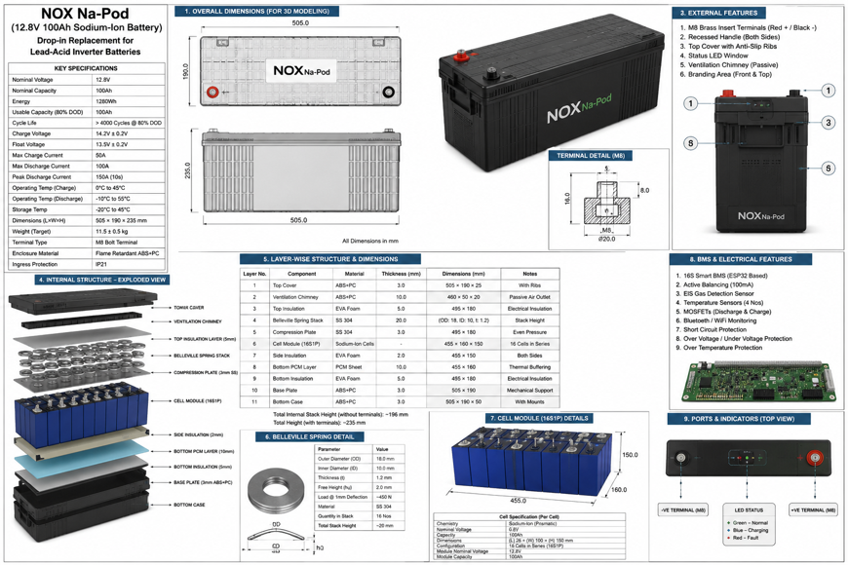
Fig. 1. NOX Na-POD product form factor and mechanical design envelope developed for the proposed system.

One pack, four coordinated subsystems
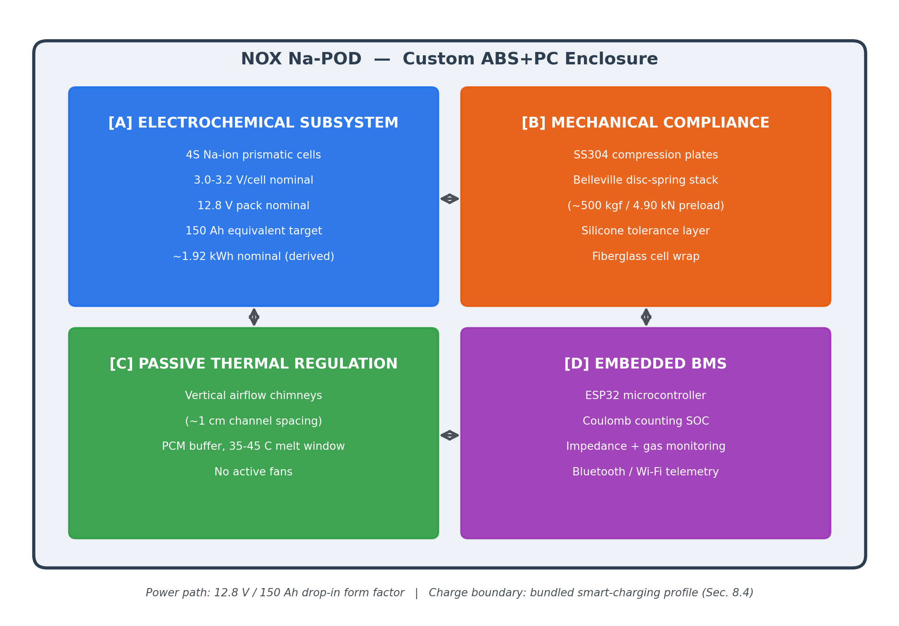
Fig. 2. Architecture of NOX Na-POD: electrochemical, mechanical, passive thermal, and embedded BMS subsystems.
The architecture is intentionally cross-coupled. Cell expansion is a mechanical problem; temperature changes the expansion behavior and affects electrical performance; the BMS observes current and thermal state; and the charging interface determines whether the pack can coexist with an existing residential inverter. The design therefore treats the battery as one system rather than a cell pack with accessories.

Power and information paths
- Power path: 4S sodium-ion cell stack → compression and enclosure → protected pack output → inverter load.
- Thermal path: cell heat → vertical chimney channels + PCM buffer → passive heat rejection.
- Measurement path: cell voltage/current/temperature/impedance-related signals → ESP32 BMS → protection logic + telemetry.
- Charging boundary: controlled charging source → BMS-compatible profile → pack.
6 | ELECTROCHEMICAL SUBSYSTEM

4S sodium-ion pack configuration
NOX Na-POD uses a four-cell series configuration built around commercially available sodium-ion prismatic cells. The design target is 3.0–3.2 V nominal per cell, giving a 12.8 V nominal pack, with an equivalent capacity target of 150 Ah.
DERIVED QUANTITY
Nominal pack energy = 12.8 V × 150 Ah = 1,920 Wh = 1.92 kWh.

Why a system-level treatment is needed
- Flat discharge behavior reduces the reliability of voltage-only SOC estimation [7].
- Dimensional change during cycling creates a mechanical interface problem at the pack level.
- High ambient temperatures can increase thermal stress and alter the mechanical operating point.
- Residential inverter integration depends on charging behavior as much as battery voltage compatibility.

Cell-level unknowns deliberately left open
This paper does not assign a vendor, cell model, internal resistance, cycle-life figure, or detailed charge/discharge window to the prismatic cells. Those parameters must be fixed during component selection and experimental validation so that the pack model remains tied to a specific cell platform.
ENGINEERING BOUNDARY
The 150 Ah and 1.92 kWh values are architecture-level targets, not a claim that every sodium-ion cell with the same nominal label will deliver the same usable energy.

7 | MECHANICAL COMPLIANCE ENGINEERING
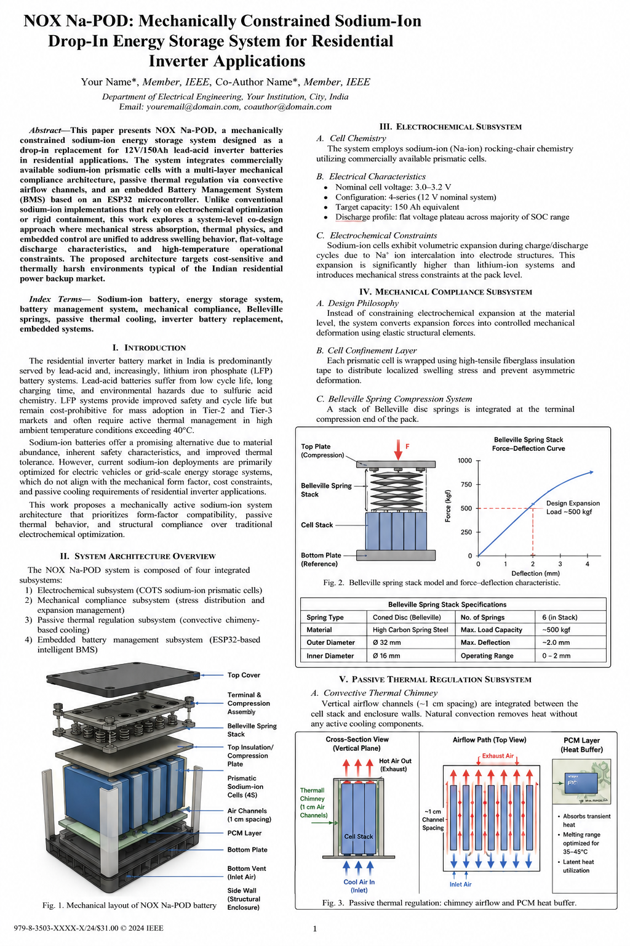
Fig. 3. Integrated NOX Na-POD engineering design sheet showing electrical, mechanical, and passive thermal design elements.

A compression system that accommodates controlled cell expansion
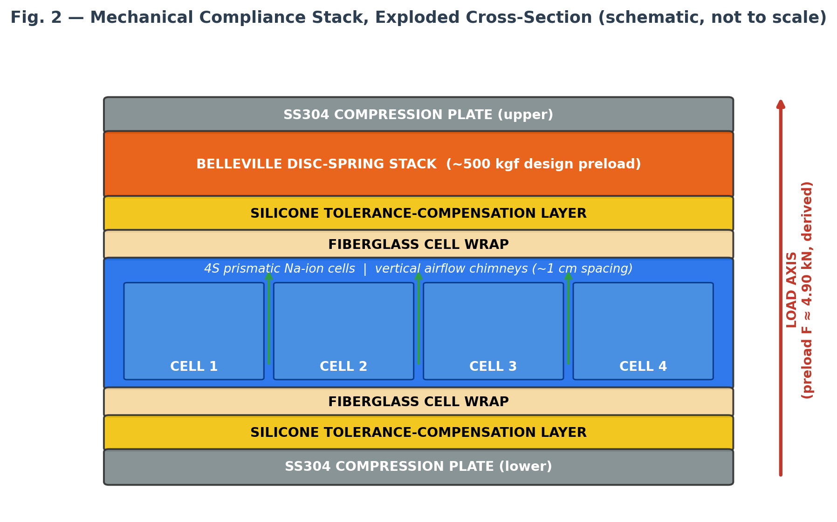
Fig. 4. Mechanical compliance stack: compression plates, Belleville spring stack, silicone tolerance layer, fiberglass wrap, and 4S cell stack.

Function allocation
- Fiberglass wrap — cell confinement and structural isolation.
- Silicone layer — tolerance compensation across dimensional variation and interfaces.
- Belleville stack — approximately 500 kgf design preload, allowing controlled expansion travel.
- SS304 plates — distribute compressive load over the cell-stack faces.
MECHANICAL RATIONALE
Disc springs generate high force over short axial travel and can be configured to provide a controlled force-deflection response. That behavior is used here to absorb expansion without relying on a rigid spacer.

7.2 | FORCE-DEFLECTION CONCEPT

The spring stack is the compliance mechanism
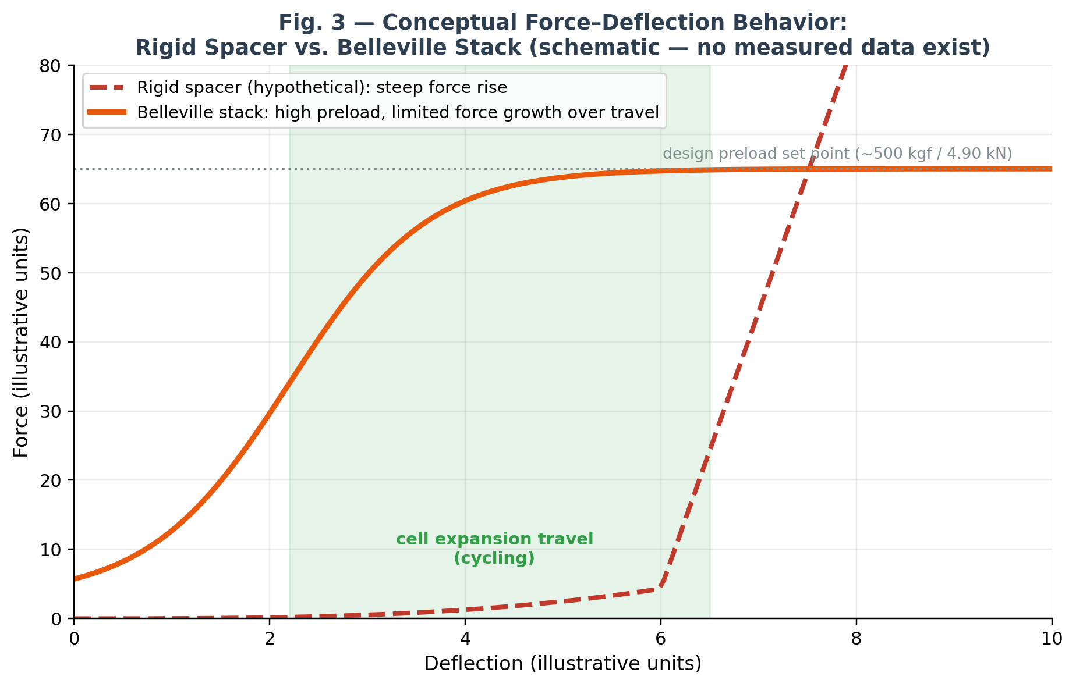
Fig. 5. Conceptual force-deflection comparison. The plotted curves are illustrative design behavior, not measured pack data.
The research target is a preload of approximately 500 kgf. Using standard gravity, 500 kgf corresponds to 4.903 kN. The important engineering question is not the preload number alone; it is the assembled stack stiffness, usable deflection, face pressure, and preload retention over repeated expansion cycles.


Critical characterization items
Preload verification  Measure actual assembled force and confirm the compression range of the cell stack. | Force-deflection curve  Characterize spring-stack response under the same geometry used in the enclosure.
Face-pressure distribution  Verify that load is shared across the cell faces rather than concentrated at local interfaces. | Cycle durability  Measure preload retention and dimensional response after repeated charge-discharge cycles.

8 | PASSIVE THERMAL MANAGEMENT

Removing heat before it limits performance and longevity
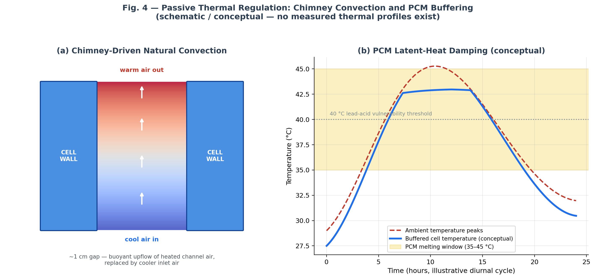
Fig. 6. Passive thermal management concept: natural-convection chimney channels combined with PCM latent-heat buffering.
The thermal design has two layers. First, approximately 1 cm vertical channels create a passive buoyancy path so heated air can rise and cooler air can replace it. Second, a PCM layer with a target melting window of 35–45 °C provides latent heat absorption during temperature excursions.
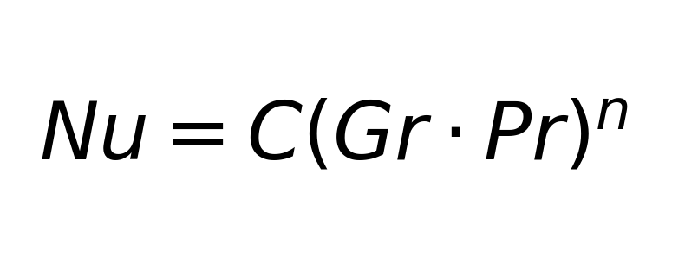

Why the two mechanisms are combined
- Chimneys provide continuous passive heat transport while the temperature gradient is favorable.
- PCM provides short-term thermal buffering when the cell temperature enters the target phase-change range.
- No active fan is required, removing fan power draw and one moving-component failure mode.
THERMAL BOUNDARY
PCM mass, latent-heat capacity, airflow resistance, and sustained-hot-ambient behavior still require empirical characterization. The thermal architecture is a design mechanism, not a measured performance claim.

9 | BMS AND EMBEDDED ARCHITECTURE

BMS architecture tailored to flat-voltage sodium-ion chemistry
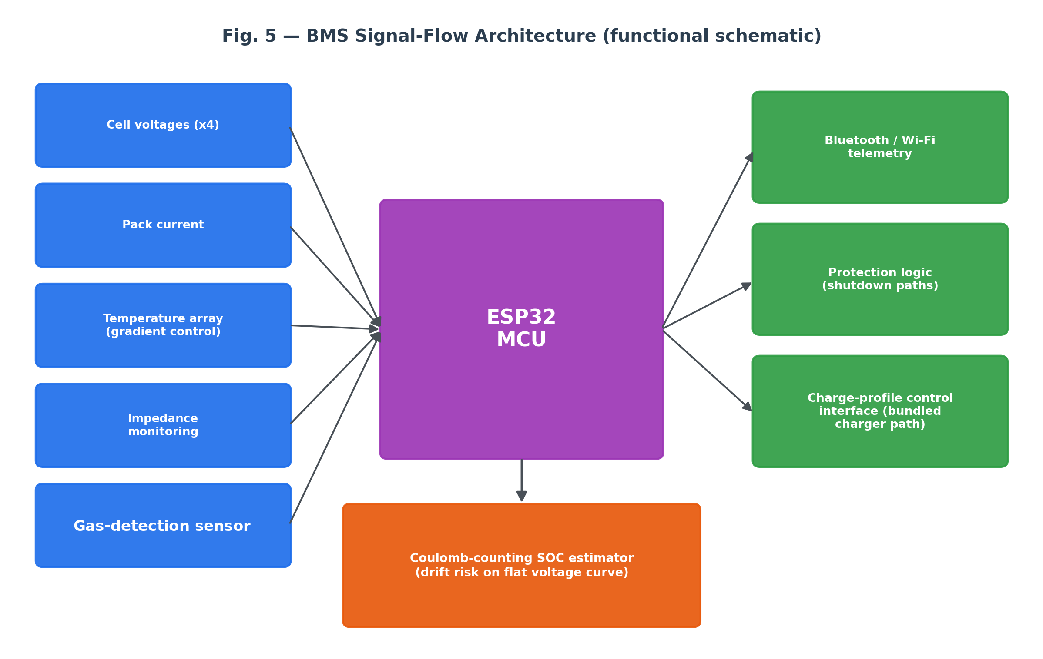
ESP32 BMS signal-flow architecture for measurement, protection, thermal awareness, and telemetry.
The embedded architecture extends the battery from a passive pack into a monitored energy-storage system. The design combines coulomb counting for SOC estimation, cell-voltage monitoring, thermal-gradient sensing, impedance-related monitoring or diagnostic estimation (subject to implementation and validation), a future gas-detection safety-monitoring provision requiring sensor selection and validation, Bluetooth/Wi-Fi telemetry, and low-power operation.

SOC estimation strategy
Because the sodium-ion discharge curve is comparatively flat, voltage alone is not treated as the primary SOC estimator. Coulomb counting provides the integration path [7], while temperature and voltage measurements support protection logic and future calibration work. Integration drift remains a critical validation item.
BMS DESIGN PRINCIPLE
The BMS should not only stop unsafe conditions; it should create a measurable operating history for the pack, including current, temperature, SOC estimate, alarms, and system status.

9.4 | CHARGE INTEGRATION

Inverter charging interface as part of the system boundary
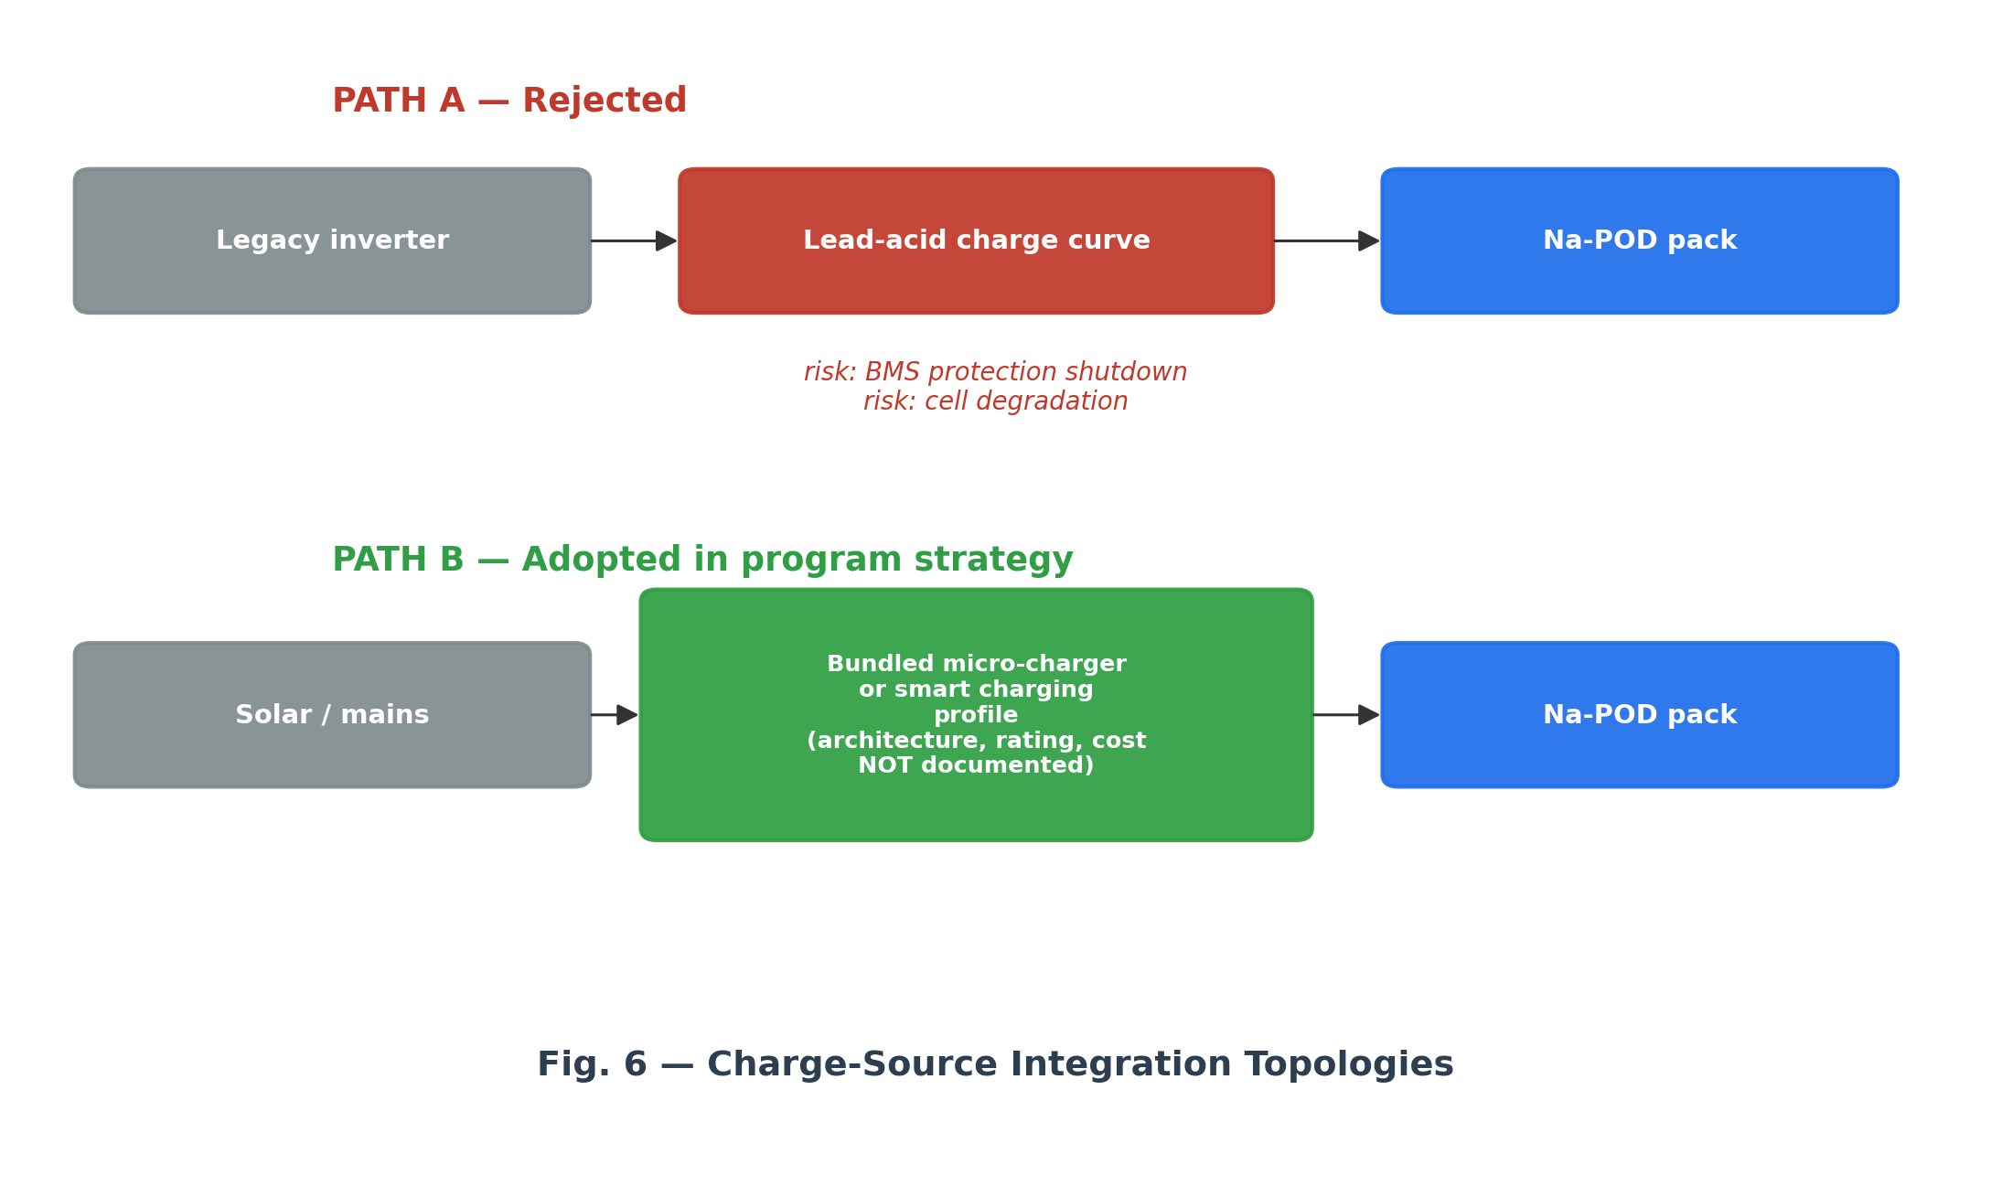
Fig. 7. Charge-source integration concept: legacy lead-acid charging path versus a controlled charging architecture.
A conventional residential inverter is usually configured around lead-acid charging behavior. A 12.8 V sodium-ion pack cannot be assumed to accept every legacy charge curve without verification. The Na-POD architecture therefore treats a controlled smart charging profile or dedicated micro-charger as an explicit system boundary.
DROP-IN DEFINITION
The pack is intended to be mechanically and electrically compatible with the battery slot, but charging compatibility must be established through a defined charging architecture. The charger is therefore part of the deployment design.

Integration requirements
- Define charging voltage, current limits, and protection thresholds for the selected cell platform.
- Coordinate charger behavior with BMS protection and SOC estimation.
- Quantify charger cost, enclosure space, thermal contribution, and installation procedure.
- Validate the complete battery-plus-inverter system under representative residential duty.
10 | FAILURE MODES AND RISK CONTROLS

Design considerations for principal failure modes
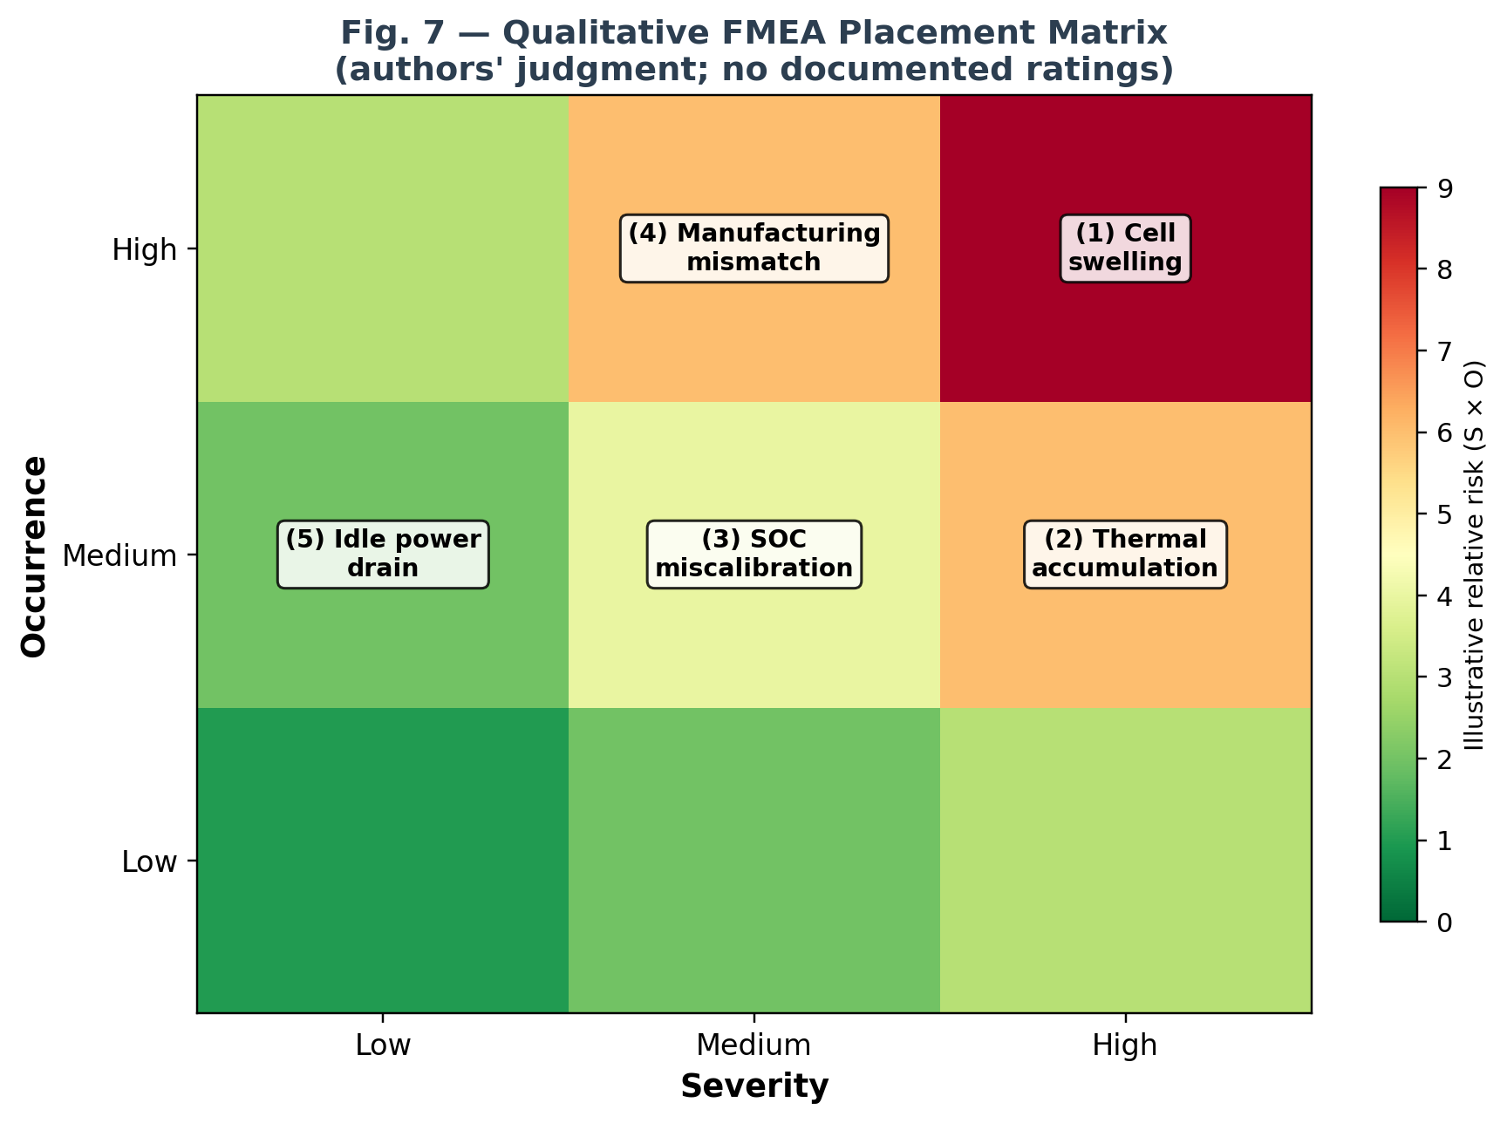
Fig. 8. Qualitative risk-placement matrix for the principal design failure modes.

Five principal failure modes
Cell swelling  Unaccommodated expansion can drive internal stress and interface separation. Mitigation: compliant compression stack. | Thermal accumulation  Sustained heat or blocked airflow can elevate temperature. Mitigation: chimney channels + PCM + BMS thermal monitoring.
SOC miscalibration  Coulomb-counting drift can produce an inaccurate SOC estimate. Mitigation: telemetry, calibration strategy, and validation. | Manufacturing mismatch  Dimensional variability can create uneven preload. Mitigation: silicone tolerance compensation and assembly control.
Idle power drain
BMS quiescent draw can reduce long-idle capacity. Mitigation: low-power operating mode and measured standby current.

RISK METHOD
The matrix is a qualitative engineering communication tool. Quantitative severity, occurrence, and detection scores should be assigned only after measured failure data and a defined production process exist.
11 | ECONOMIC MODEL

Table 2. Projected unit economics
Parameter | Value | Status | Basis
COGS | 13,500 | Projection | Design target
Wholesale price | 19,000 | Projection | B2B reference
Retail price | 24,500 | Projection | B2C reference
Wholesale gross margin | 5,500 / 28.9% | Derived | Margin on selling price
Wholesale markup | 5,500 / 40.7% | Derived | Markup on COGS
Retail gross margin | 11,000 / 44.9% | Derived | Margin on selling price
Retail markup | 11,000 / 81.5% | Derived | Markup on COGS
COGS / nominal kWh | INR 7,031 | Derived | Nominal energy basis
Retail / nominal kWh | INR 12,760 | Derived | Nominal energy basis
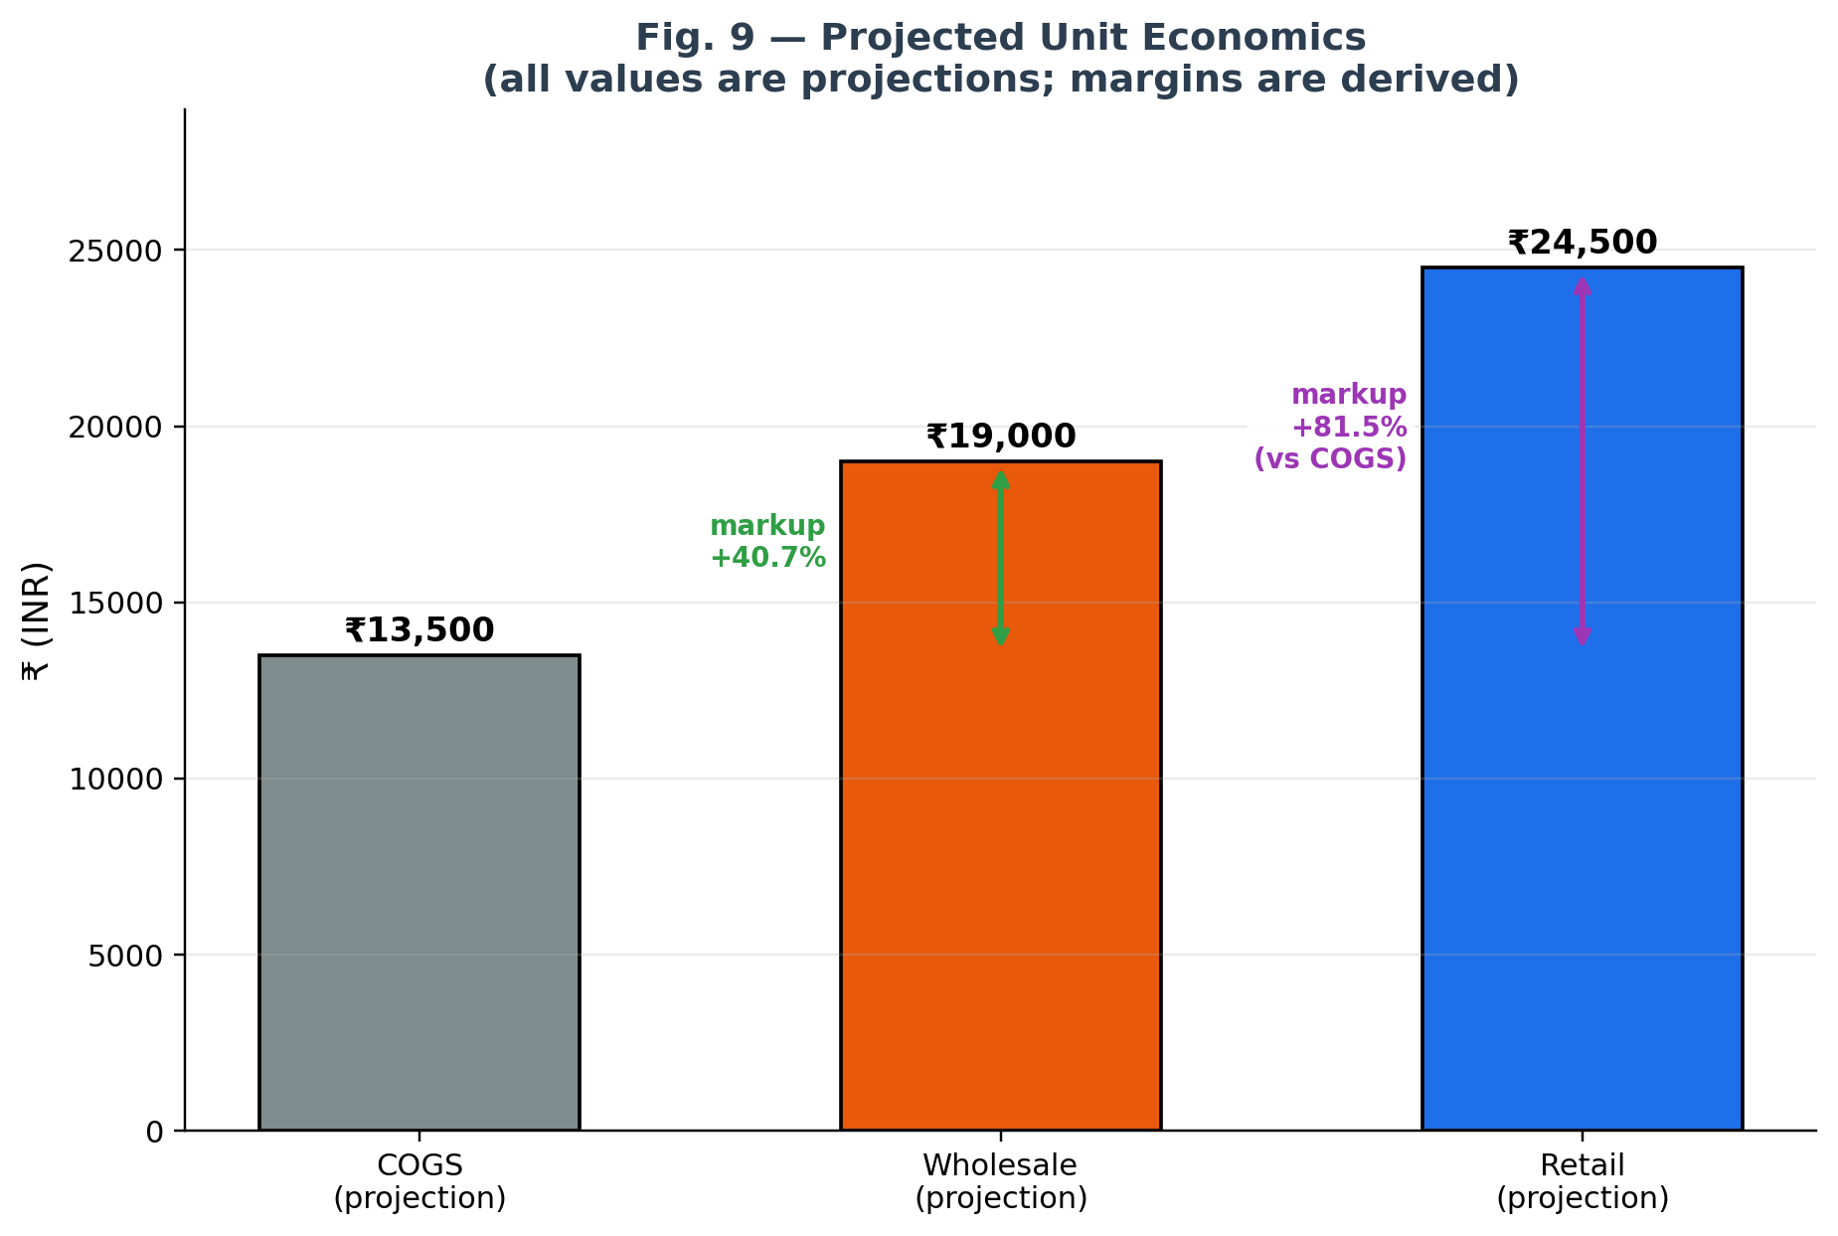
Fig. 9. Projected production-to-retail price structure and derived markup annotations.
The economic model is deliberately separated from measured performance. Cost and pricing are projections; margins are arithmetic derived quantities. At low-to-medium prototype volume, the design analysis indicates that custom enclosure parts, SS304 compression hardware, and specialized components create a significant manufacturing-cost challenge.
11.3 | BREAK-EVEN SENSITIVITY

What service life would the economics require?
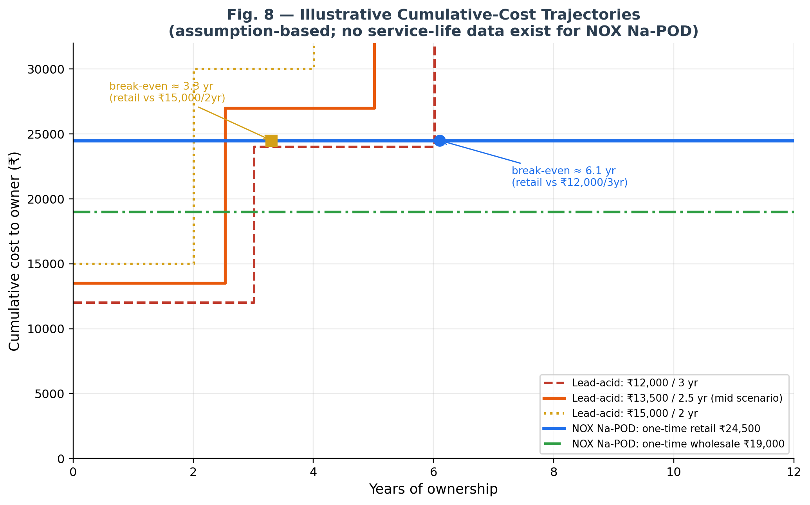
Fig. 10. Illustrative cumulative-cost trajectories using the documented lead-acid price/cadence scenarios.
Lead-acid baseline | Equivalent annual cost | Na-POD retail | Na-POD wholesale
12,000 / 3 yr | 4,000 / yr | 6.1 yr | 4.8 yr
13,500 / 2.5 yr | 5,400 / yr | 4.5 yr | 3.5 yr
15,000 / 2 yr | 7,500 / yr | 3.3 yr | 2.5 yr
The break-even calculation is illustrative. It assumes a one-time battery purchase, zero maintenance cost for both systems, and the baseline replacement cadence above. The resulting service-life thresholds are requirements for validation, not claims of demonstrated Na-POD service life.
ECONOMIC IMPLICATION
The lower wholesale threshold suggests a stronger fit for buyers who evaluate reliability and total cost of ownership rather than only the initial cash outlay. This is a segment hypothesis to validate, not a measured market result.

12 | FEASIBILITY ASSESSMENT

Feasibility as a systems-level assessment

Technical feasibility
At the design-analysis level, the architecture assigns swelling to the compliance stack and proposes chimney convection, PCM buffering, and BMS monitoring to address thermal accumulation; SOC estimation is directed toward coulomb counting with supporting measurements. The remaining technical work is measurement of the assembled system, not invention of a new subsystem.

Integration feasibility
The primary deployment issue is charge integration. A legacy inverter may require a controlled charging path, meaning the practical product boundary is a battery-plus-charging solution rather than a battery considered in isolation. Charger power, protection behavior, thermal contribution, and COGS need to be fixed in the next design stage.

Economic feasibility
The projected INR 13,500 COGS target is difficult at low volume because the architecture includes custom enclosure and compression hardware. The design therefore benefits from a scale-sensitive manufacturing plan and a market segment that evaluates lifecycle cost, reliability, and maintenance rather than only upfront purchase price.
CURRENT ASSESSMENT
The concept is technically coherent at the architecture level, but final feasibility depends on mechanical, thermal, BMS, charging, cycle-life, and manufacturing validation. The paper defines the engineering questions that the prototype must answer.

13 | LIMITATIONS AND VALIDATION PROGRAM

Required validation activities
Mechanical validation  Measure preload, force-deflection response, face-pressure distribution, and retention over repeated expansion cycles. | Thermal validation  Measure PCM temperature behavior, saturation time, chimney flow behavior, and sustained-hot-ambient response.
BMS validation  Measure SOC accuracy, drift, current accuracy, temperature response, protection thresholds, and telemetry reliability. | System validation  Run the pack under representative inverter loads and quantify efficiency, temperature rise, protection events, and cycle life.
Manufacturing validation  Build a repeatable stack assembly process and establish dimensional tolerances, tooling assumptions, and unit-cost tiers. | Deployment validation  Verify the bundled charging architecture on representative residential inverter systems.

Validation sequence
- Component characterization → spring stack, PCM material, sensors, selected sodium-ion cell platform.
- Subsystem tests → mechanical, thermal, BMS, and charger behavior independently.
- Integrated prototype → combined electro-thermo-mechanical and electrical operation.
- Cycle and abuse testing → repeated operation, high-ambient conditions, protection events.
- Pilot deployment → controlled field evaluation with measured lifecycle cost and reliability.
DESIGN-STAGE LIMITATION
Quantitative service-life and cost thresholds are derived for planning and validation; they are not claims of demonstrated NOX Na‑POD performance. No measured performance result should be inferred from the architecture diagrams or projections in this paper. The value of the current work is the system definition and the validation plan it establishes.

14 | CONCLUSION AND AUTHOR DECLARATION

NOX Na‑POD defines a new pack architecture beyond cell chemistry
NOX Na-POD combines a 4S, 12.8 V, 150 Ah-equivalent sodium-ion pack with a compliant compression system, passive thermal management, and an ESP32-based BMS. The architecture is built around the interaction between expansion, heat, electrical behavior, and inverter charging rather than treating those issues independently.
The mechanical subsystem uses fiberglass confinement, a silicone tolerance layer, Belleville spring compression, and SS304 load-spreading plates. The thermal subsystem combines approximately 1 cm airflow chimneys with a 35–45 °C PCM window. The BMS extends pack awareness through coulomb counting, thermal sensing, impedance-related monitoring or diagnostic estimation (subject to implementation and validation), a future gas-detection safety-monitoring provision requiring sensor selection and validation, and wireless telemetry. The economic model then connects this engineering architecture to an explicit manufacturing and deployment strategy.
FINAL RESEARCH POSITION
The design is ready to transition from research definition to a future measured engineering validation stage. The next milestone is quantitative evaluation of the mechanical, thermal, BMS, charging, safety, cycle-life, and cost assumptions defined in this paper. No such validation has been performed as part of the present manuscript.

Author research declaration
This manuscript is a self-authored engineering research paper for the NOX Na-POD program. The system concept, architecture, mechanical approach, passive thermal strategy, BMS architecture, quantitative calculations, economic model, risk framing, and research roadmap presented here are part of the author’s NOX Na-POD research work.
The paper intentionally distinguishes design targets, derived quantities, projections, and future validation work so that intended performance is not presented as measured performance. This manuscript does not present measured experimental results; all numerical values are design targets, derived calculations, or projections unless explicitly identified as measurements.
15 | REFERENCES

References
References supporting the technical background, design rationale, battery-management concepts, thermal-management approach, safety framework, and market context are provided below.
[1] He, S., Shu, X., Dai, Y., & Yang, W. (2026). "State-of-Charge-Dependent Deformation and Electrochemical Evolution in Sodium-Ion Batteries Under Mechanical Compression." Molecules, 31(10), 1652. https://doi.org/10.3390/molecules31101652
[2] Rui, B., Hahn, Y., Bhowmick, A., Mousavi, F., Kulathu, S., Oancea, V., & Xu, J. (2026). "Electrochemo-mechanical coupled behaviors in sodium-ion batteries upon stack pressure." Journal of Materials Chemistry A, 14, 21836–21847. https://doi.org/10.1039/D6TA01576J
[3] Müller, V., Scurtu, R.-G., Richter, K., Waldmann, T., Memm, M., Danzer, M. A., & Wohlfahrt-Mehrens, M. (2019). "Effects of Mechanical Compression on the Aging and the Expansion Behavior of Si/C-Composite|NMC811 in Different Lithium-Ion Battery Cell Formats." Journal of The Electrochemical Society, 166(15), A3796–A3805. https://doi.org/10.1149/2.1121915jes
[4] Nasiri, M., & Hadim, H. (2025). "Thermal management of Li-ion batteries using phase change materials: Recent advances and future challenges." Journal of Energy Storage, 111, 115440. https://doi.org/10.1016/j.est.2025.115440
[5] Kumar, P., Chaudhary, D., Varshney, P., Varshney, U., Yahya, S. M., & Rafat, Y. (2020). "Critical review on battery thermal management and role of nanomaterial in heat transfer enhancement for electrical vehicle application." Journal of Energy Storage, 32, 102003. https://doi.org/10.1016/j.est.2020.102003
[6] Sabbah, R., Kizilel, R., Selman, J. R., & Al-Hallaj, S. (2008). "Active (air-cooled) vs. passive (phase change material) thermal management of high power lithium-ion packs: Limitation of temperature rise and uniformity of temperature distribution." Journal of Power Sources, 182(2), 630–638. https://doi.org/10.1016/j.jpowsour.2008.03.082
[7] Movassagh, K., Raihan, S. A., & Balasingam, B. (2019). "Performance Analysis of Coulomb Counting Approach for State of Charge Estimation." 2019 IEEE Electrical Power and Energy Conference (EPEC). https://doi.org/10.1109/EPEC47565.2019.9074781
[8] See, K. W., Wang, G., Zhang, Y., Wang, Y., Meng, L., Gu, X., Zhang, N., Lim, K. C., Zhao, L., & Xie, B. (2022). "Critical review and functional safety of a battery management system for large-scale lithium-ion battery pack technologies." International Journal of Coal Science & Technology, 9, 36. https://doi.org/10.1007/s40789-022-00494-0
[9] Samanta, A., & Williamson, S. S. (2021). "A Survey of Wireless Battery Management System: Topology, Emerging Trends, and Challenges." Electronics, 10(18), 2193. https://doi.org/10.3390/electronics10182193
[10] International Electrotechnical Commission. (2020). IEC 63056:2020: Secondary cells and batteries containing alkaline or other non-acid electrolytes — Safety requirements for secondary lithium cells and batteries for use in electrical energy storage systems. IEC.
[11] Bellini, E. (2026, June 23). "UK startup presents sodium-ion storage solution for rooftop PV." pv magazine.

