**Student**

Implement the following class which has several setter and getter methods.

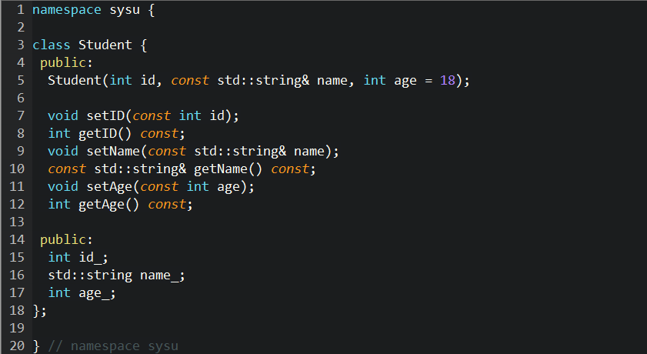

Hint: class, namespace. You should submit the definition and implementation of the class.