Implement the following class.

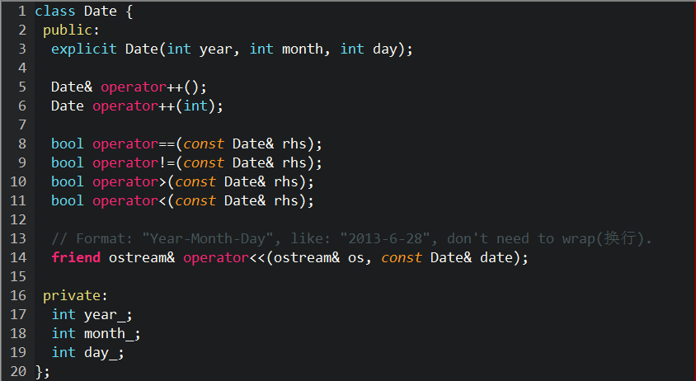

Some code for your reference:

// The number of days for every month when the year is not a leap one.

int daysInMonth[] = {31, 28, 31, 30, 31, 30, 31, 31, 30, 31, 30, 31};

// Return true when the |year| is a leap year.

bool isLeapYear(int year) {

if (year % 4)

return false;

if (!(year % 400))

return true;

if (!(year % 100))

return false;

return true;

}

Some use case:

Date d(2013, 5, 25);

cout << d++ << endl; // Should output in one line: 2013-5-25.

cout << ++d << endl; // Should output in one line: 2013-5-27.

Data d2(2012, 12, 22);

d > d2 // Should be true.

d < d2 // Should be false.

d == d2 // Should be false.

d != d2 // Should be true.

Hint: Operator overloading. You should submit the definition and implementation of the class Date. Do not forget to submit the reference code if you use it.