JSON, or JavaScript Object Notation, is a text-based open standard designed for human-readable data interchange. Now we have the flowing classes to simulate it.

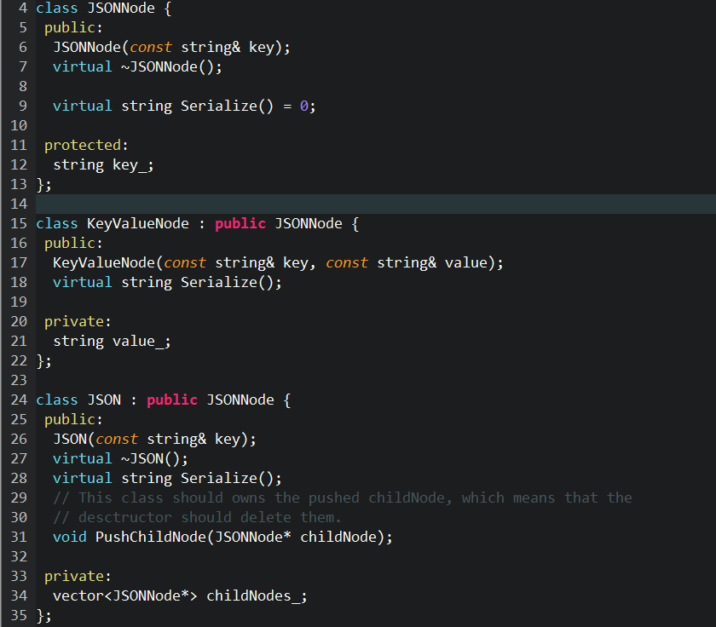Use case:

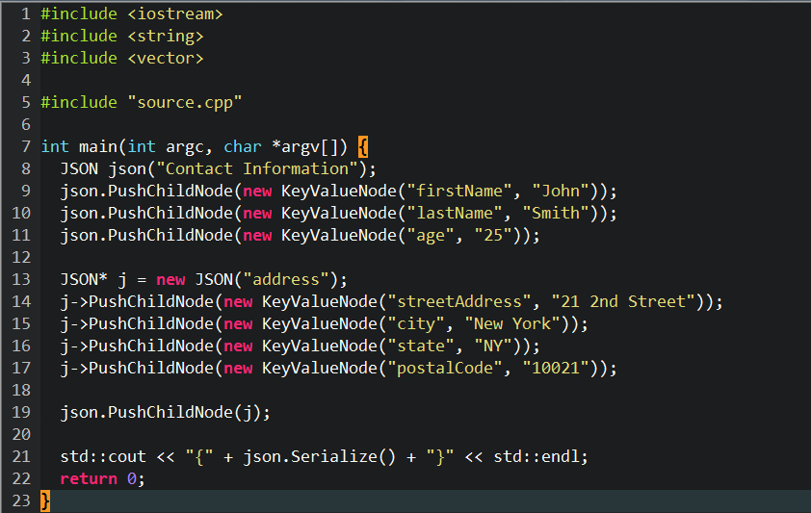

The output will be (Note that it is one-line).

|  |
| --- |
| {"Contact Information":{"firstName":"John","lastName":"Smith","age":"25","address":{"streetAddress":"21 2nd Street","city":"New York","state":"NY","postalCode":"10021"}}} |

To make problem clearer, the formatted one is

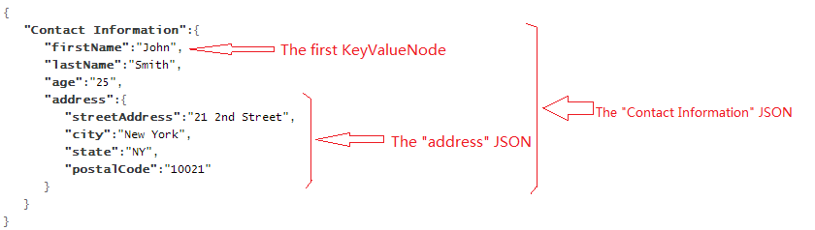

Sample

KeyValueNode* node = new KeyValueNode("key", "value");

std::cout << node->Serialize() << std::endl;

KeyValueNode* node2 = new KeyValueNode("key2", "value2");

JSON json("json");

json.PushChildNode(node);

json.PushChildNode(node2);

std::cout << json.Serialize() << std::endl;

Sample Output:

"key":"value"

"json":{"key":"value","key2":"value2"}

Hint: Abstract Class, Inheritance and polymorphism.