Student

Implement the following class which has several set and get methods.
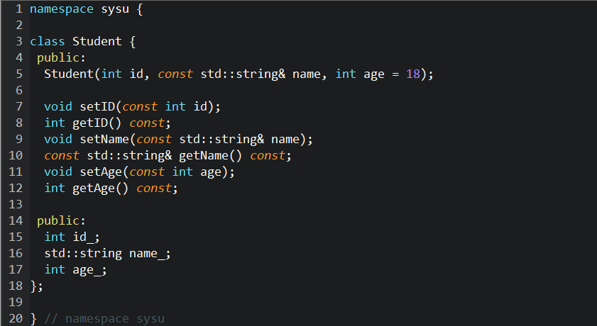

Hint: class, namespace. You should submit the definition and implementation of the class.

