Towards Transparent Predictive Maintenance: Applying XAI Techniques in Manufacturing Systems
Serkan Akin
University of Twente
P.O. Box 217, 7500 AE Enschede The Netherlands
s.akin@student.utwente.nl

Introduction
Predictive Maintenance (PdM) is an innovative, data-enabled approach to oversee equipment failures and optimize operational uptime. At the heart of PdM is the incorporation of Artificial Intelligence (AI), especially through methods that not only forecast future conditions but also clarify the logic behind these predictions—specifically, using Explainable Artificial Intelligence (XAI). This research focuses on the application of XAI on manufacturing systems, where the complexity and critical nature of the equipment underscore the need for transparent and understandable maintenance predictions.
During research we will develop and test predictive models that integrate XAI to enhance the clarity and usability of maintenance predictions. These models will be implemented to help understand why certain decisions were made, thereby improving trust. This research will utilize experimental setups provided by the Fraunhofer institute, equipped with advanced sensors and simulation capabilities to mimic real-world manufacturing conditions, providing a rich dataset for model development and testing.

Literature Review
We will now establish the foundation for the research project, which explores the integration of Explainable Artificial Intelligence (XAI) into predictive maintenance systems that contain time-series data. The review will explore the application of AI technologies, specifically deep learning and traditional machine learning, and incorporation of XAI techniques that make these AI models transparent and understandable. By providing an overview of these critical areas, in this section the aim will be to highlight the past advancements in the field and identify possible further developments. As this research progresses, I believe that further research will be necessary to incorporate more detailed analyses and address any gaps in my knowledge.

Handling Time-Series Data
Handling time-series data effectively is crucial and can be approached using both traditional machine learning (TML) and deep learning (DL) techniques, each having their own benefits.
Traditional Machine Learning (TML) techniques like regression models, decision trees, and SVMs require feature engineering to ensure accuracy in time-series data. TML can be proffered for its understandability, providing clear insights on how decisions are made. Furthermore, there are machine learning techniques like GBRT that have been and are still used for time-series forecasting. In a study t was revealed that a GBRT, which was efficiently feature-engineered, was able to outperform state-of-the-art Deep Neural Network models.[1]
Deep Learning (DL), on the other hand, have extensive capacity in capturing process nonlinearity and have flexibilities in modeling time-dependent data.[1], [2]
In a study where a time-series COVID-19 dataset was used to compare NN-based models, including RNN, LSTM, BiLSTM, GRU, and VAE, it is observable that VAE models capture most of the variability in data and provide better forecasting compared to other RNN-based models.[2]
Another approach for time-series was studied by Wibawa A. et al. with the use of data smoothing method known as Exponential Smoothing. Smoothed CNN (S-CNN) mostly outperformed CNN and other forecasting models like MLP and LSTM with the best MSE of 0.01214.[3]

XAI Techniques
Explainable Artificial Intelligence (XAI) techniques play an important role in making AI models used in predictive maintenance understandable and transparent. This section discusses traditional XAI techniques as well as advanced approaches designed for deep learning models with time-series data.
Traditional XAI techniques are better suited for simpler machine learning models. Methods such as feature importance highlight which features significantly impact a model’s predictions. This offers an understanding of an input’s effect on the output. Decision trees provide a clear visual representation of the decision-making process, making it easy to understand the logic that the model used for the output. Partial Dependence Plots (PDP) offer a graphical representation of the effects that the values of a single feature have on the predicted outcome.[4]
Deep learning models, with their complex architectures, often are preferred more in predictive maintenance as they can handle large datasets and identify complex patterns. However, their “black box” nature makes them less understandable, so researchers have come up with more advanced XAI approaches. Layer-wise Relevance Propagation (LRP) and SHapley Additive exPlanations (SHAP) are techniques that provide insights into the contribution of each input feature to the final prediction, offering local and global explanations. Whereas Local Interpretable Model-agnostic Explanations (LIME), instead of providing a global understanding of the model on the entire data, focuses on explaining the model’s prediction for individual instances.[4]
For time-series data-in our case from sensor readings from the experimental setup- might require specialized techniques. Implemented by Zhang et al. ShapTime extends SHAP values to time-series forecasting, allowing for deeper understanding of temporal influences on outcomes. Similarly, TS-MULE modifies LIME to incorporate time-series data, providing relevant explanations.[5], [6], [7]

Research Question
How can Explainable Artificial Intelligence (XAI) techniques be integrated into predictive maintenance models that are targeted at predicting health status of induction motors using sensor measurements that are time-series to make decisions given by the models transparent?
Sub-Question: What are the most effective XAI techniques for deep learning and traditional machine learning models in predictive maintenance, and what are the attributes that contribute to their effectiveness?
Purpose: This question aims to find out and evaluate the XAI methods most suitable for deep learning and machine learning models in the context of predictive maintenance.
Sub-Question: How do the explanations of XAI techniques differ when applied to deep learning versus traditional machine learning models in predictive maintenance?
Purpose: This question explores which model architecture (DL or TML) has the potential to offer more benefits in terms of transparency and understandability in the context of predictive maintenance.

Data
The data for this research project is provided by Fraunhofer. It was collected from an experimental setup available on site, which simulates a real-world induction motor. To collect the required data, it was possible to introduce possible misalignments that could occur in a real-world scenario. The setup consists of three sensors for data collection: temperature, voltage, and vibration.
The primary format of the data is time-series, which tracks changes in sensor readings over time. This data will be crucial for analyzing patterns that might introduce failures. During data collection, various scenarios were simulated to model potential failures, such as intentionally introducing misalignment in machinery. Additionally, data was captured at different frequencies to reflect diverse operations. The measured data is stored in a Python dictionary variable named “jsonData”. In the “jsonData” dictionary there are three key-value pairs:
- batteryVoltage: The voltage of the on-board backup battery
- timestamp: Unix timestamp
- sensors
The value of the sensors key-value pair, is another dictionary with three key-value pairs:
- raw: This is an array of raw values read from the analog inputs. The first element in this array is always 1.65, this is a reference value used to calculate the temperature of the PTC sensors. The last element in this array is the voltage of the on-board backup battery, after a 1:3 voltage divider.
- adc: This is an array of the converted values of the 15 analog inputs.
- modbus: This is a dictionary of key-value pairs, where the key is the Modbus address, and the value is the reading from that register.
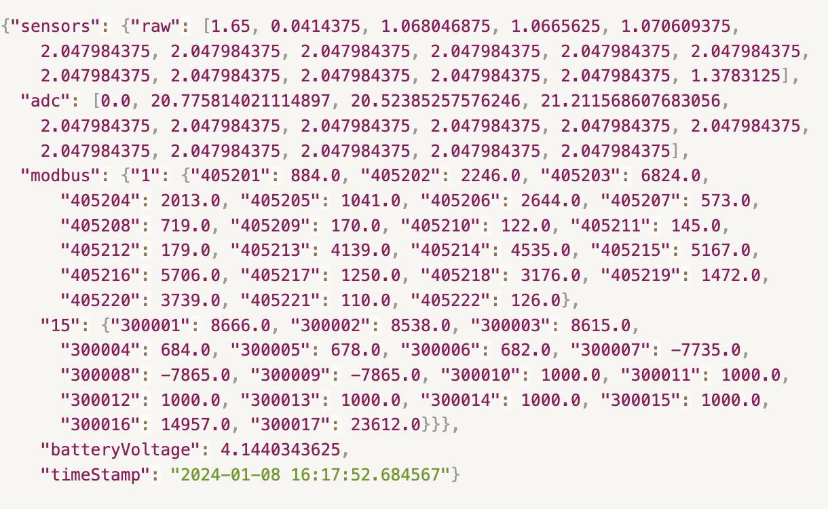
Figure 1: Example Data

Methodology
To successfully finish the research, a structured approach needs to be taken. Therefore, the CRISP-DM framework will be utilized during the progress of the project as described below.

Business Understanding
Objective: Integration of Explainable Artificial Intelligence into predictive maintenance models to make them understandable and transparent. Aiming to make models more reliable and easier for the experts to trust and interpret, supporting better maintenance decisions.

Data Understanding
Prepare Data: Check that the data provided by Fraunhofer’s experimental setup is comprehensive and ready for initial analysis.
Initial Analysis: Explore the characteristics, quality, and completeness of the data. Find out if there are any anomalies or patterns that might need special consideration during processing.

Data Preparation
Data Cleaning: Solve any issues identified during initial analysis. This could include missing values, noise and outliers.
Feature Engineering: Develop features that could enhance model performance, such as averages, frequency domain features, or statistics that capture trends over time.
Feature Selection: Select the most informative features that might enhance the model’s performance, using methods like Principal Component Analysis.

Modeling
Model Selection: Choose appropriate models based on the data characteristics and requirements. This includes choosing a model for deep learning (such as CNNs) and traditional machine learning models.
Building Models: Construct the models using the selected features and/or configuring them for optimal performance.
Applying XAI: Integrate XAI techniques chosen according to the goals and the model architectures.

Evaluation
Model Evaluation: Evaluate the predictive models using performance metrics like accuracy, precision, and recall.
XAI Explanation Evaluation: Assess the explanation provided by the XAI techniques applied. Methods that are developed to assess these XAI techniques can be used to assess quality.

Reporting/Documentation
Reporting: Regularly report progress to supervisors, showing findings and challenges that are observed during research and implementation.
Documentation: Thoroughly document all methodologies, code, and findings to support further research.
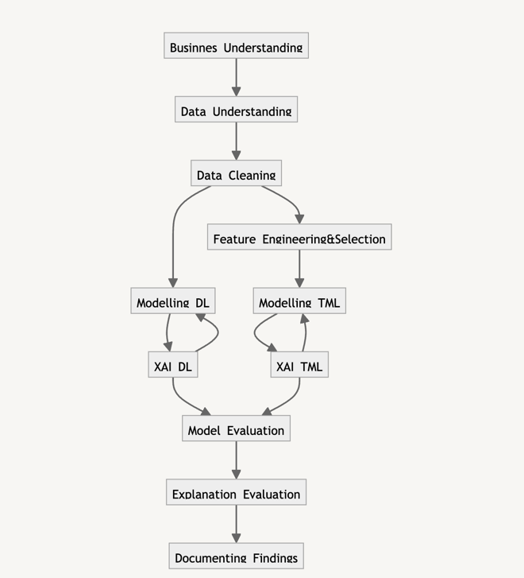
Figure 2: Overview of CRISP-DM Workflow

What Could Go Wrong?
Model Inaccuracy: Predictive models created, whether DL or TML, might not achieve the desired level of accuracy due to various factors, like wrong feature selection, poor model architecture, and or wrong configurations during training processes. I will be regularly reviewing and optimizing the features I have chosen, the model parameters, and the training algorithms I use to minimize the chances of coming across this issue.
Complexities in Implementing XAI: XAI techniques might not integrate easily with all model architectures, specifically neural networks. This might lead to explanations that are not quite understandable or that do not make sense. I plan to avoid this by using XAI techniques that are well documented and have been used in similar scenarios.

Workflow
The research process will consist of three main phases. These phases do not contain any deadlines or deliverables. Parallel to this workflow, literature research will continue needed and findings will be shared with the supervisors for further discussions.
Phase 1: Data Preparation (6 May - 17 May)
- Explore the data and features provided from the experimental setup.
- Conduct initial cleaning if needed.
- Identify any issues with the data that might need further attention.
- Conduct feature engineering and selection.
Phase 2: Modeling (18 May - 1 June)
- Decide on the model architectures both for DL and TML according to the data available and future XAI integrations.
- Train the models.
- Iteratively refine the models to achieve desired performance.
Phase 3: XAI Integration (2 June - 14 June)
- Apply XAI to the models, techniques that have been decided after research.
- Conduct testing on XAI clarity.
- Adjust the models and explanation techniques.

References
[1] S. Elsayed, D. Thyssens, A. Rashed, H. S. Jomaa, and L. Schmidt-Thieme, “Do We Really Need Deep Learning Models for Time Series Forecasting?,” Jan. 2021, [Online]. Available: http://arxiv.org/abs/2101.02118
[2] A. Zeroual, F. Harrou, A. Dairi, and Y. Sun, “Deep learning methods for forecasting COVID-19 time-Series data: A Comparative study,” Chaos Solitons Fractals, vol. 140, Nov. 2020, doi: 10.1016/j.chaos.2020.110121.
[3] A. P. Wibawa, A. B. P. Utama, H. Elmunsyah, U. Pujianto, F. A. Dwiyanto, and L. Hernandez, “Time-series analysis with smoothed Convolutional Neural Network,” J Big Data, vol. 9, no. 1, Dec. 2022, doi: 10.1186/s40537-022-00599-y.
[4] R. Dwivedi et al., “Explainable AI (XAI): Core Ideas, Techniques, and Solutions,” ACM Comput Surv, vol. 55, no. 9, Jan. 2023, doi: 10.1145/3561048.
[5] U. Schlegel, D. L. Vo, D. A. Keim, and D. Seebacher, “TS-MULE: Local Interpretable Model-Agnostic Explanations for Time Series Forecast Models,” in Communications in Computer and Information Science, Springer Science and Business Media Deutschland GmbH, 2021, pp. 5–14. doi: 10.1007/978-3-030-93736-2_1.
[6] Y. Zhang, Q. Sun, D. Qi, J. Liu, R. Ma, and O. Petrosian, “ShapTime: A General XAI Approach for Explainable Time Series Forecasting,” in Lecture Notes in Networks and Systems, Springer Science and Business Media Deutschland GmbH, 2024, pp. 659–673. doi: 10.1007/978-3-031-47721-8_45.
[7] U. Schlegel and D. A. Keim, “A Deep Dive into Perturbations as Evaluation Technique for Time Series XAI,” Jul. 2023, [Online]. Available: http://arxiv.org/abs/2307.05104

