Assignment – 1

S.Seshathiri

Power BI

1. Report view

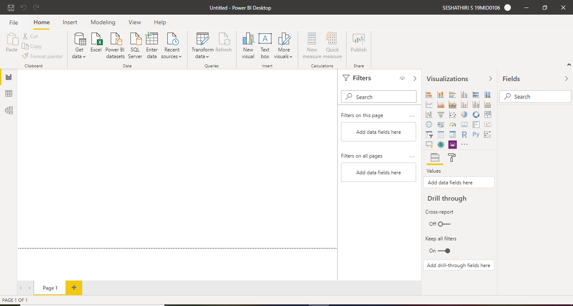

2. Data view

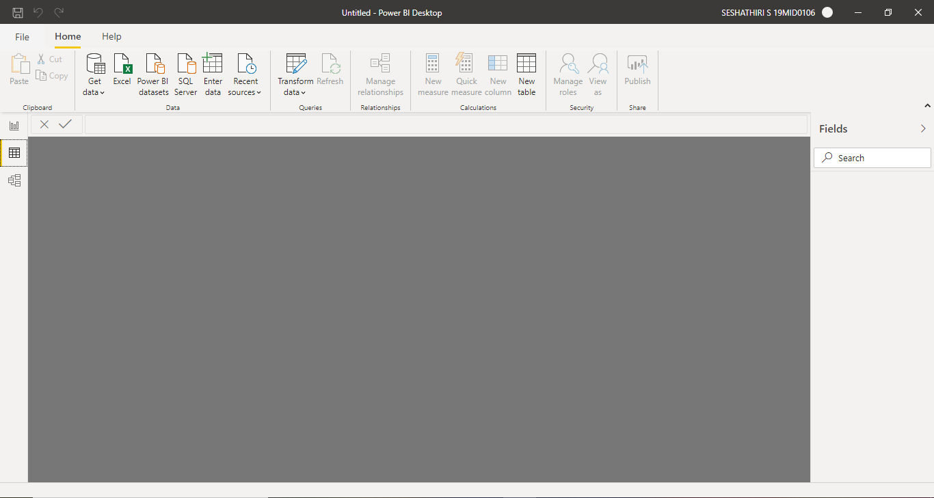

3. Model view.

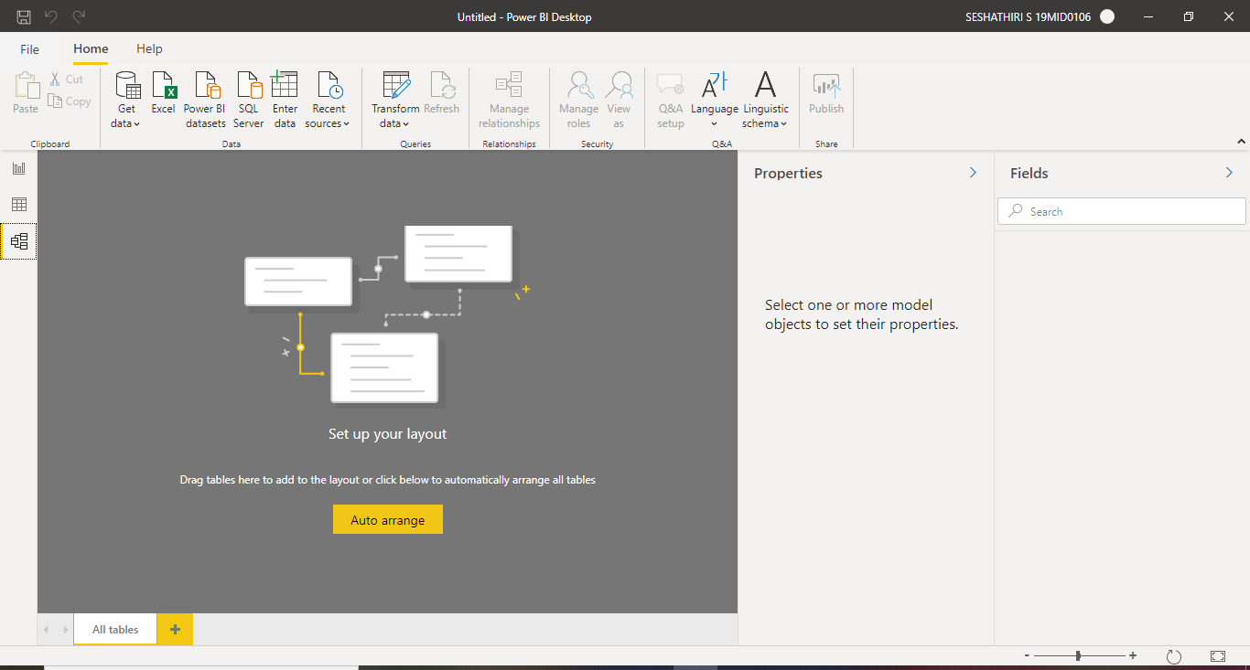

4. Power query editor

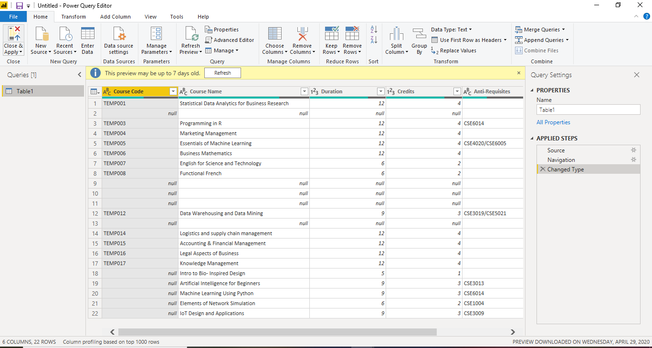

5. Advanced editor

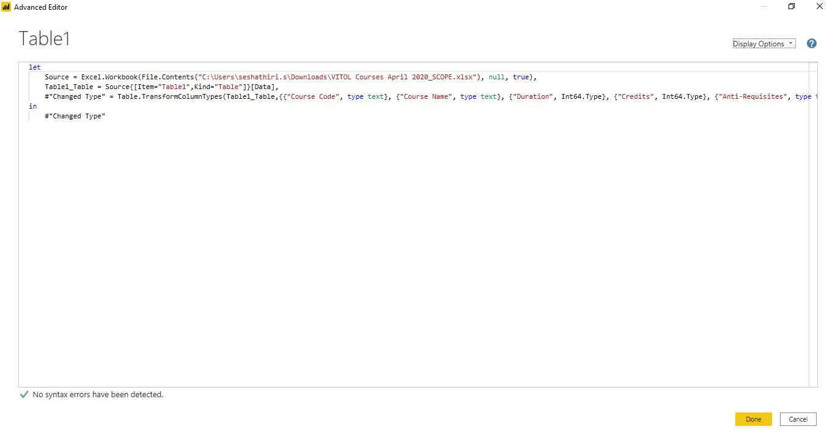

Details along with their prices.

**Power BI desktop**

The Desktop level is free for individual users

Connect to data

Transform and clean that data, to create a data model

Create visuals, such as charts or graphs that provide visual representations of the data

Create reports that are collections of visuals, on one or more report pages

Share reports with others by using the Power BI service

**Power BI Pro**

Self-service and modern BI in the cloud

Collaboration, publishing, sharing, and ad-hoc analysis

Fully managed by Microsoft

**Add Power BI Premium**

Enterprise BI, big data analytics, cloud and on-premises reporting

Advanced administration and deployment controls

Dedicated cloud compute and storage resources

Allows any user to consume Power BI content

