**Regression Model:**

It is found out that 75.6% of the variation in the body mass is brought about by the changes in the bill_length, bill_depth and flipper_length.

The fitted model is highly significant since the F-statistic is high, and the overall p-value is less than the 5% critical level.

Any amount of increase in the independent variables cause a positive chance in the body mass of the species since all their coefficients are positive but its only that of the flipper length that is positive.

**Classification Model:**

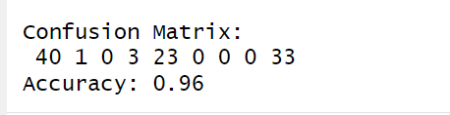

The developed model accurately predicts the outcome by 96%, therefore it can be relied on to make the predictions.

The model further shows that there are 40 species that are in class 1 and also predicted as class 1 by the model, 1 species that is actually in class 1 but predicted as class 2. 23 species that are in class 2 are predicted as class 2 and finally 33 species that are in class 3 are predicted as class 3.