“See beyond the numbers”







Who We Are

SM Accounting & Management Consultants is a seasoned and reputable firm of Professional Accountants (S.A). We offer a range of services within the assurance, accounting, taxation, advisory as well as a wide range of other financial and general management services. SM Accounting & Management Consultants has an impeccable record in the provision of services to various industries and sectors within South Africa.



Our values encompass Independent, Objective, Professional care and Competence, forging partnerships, and provision of customized/personalized services for our clients.

Focus on SMMEs

SM Accounting & Management Consultants has identified public and private sector as a primary market for its operations. For this reason, we have gone to great lengths to ensure that we strive towards becoming market leaders in the provision of Financial Management, Accounting, taxation, and Advisory Services. We have found that maintaining this special focus has allowed us to master our delivery capability for the market and to fully identify with the client climate in the process of rendering services

Multidisciplinary/Complimentary Services

SM Accounting & Management Consultants understands the complex nature of SMMEs and government, financial environments and fully appreciates the reliance of Financial Operations on sound Information Technology

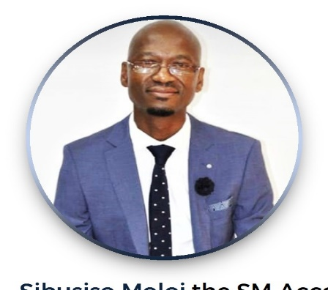





SIBUSISO MOLOI – EXECUTIVE DIRECTOR

Sibusiso Moloi is the Founder and Executive Director for SM Accounting & Management Consultants. He is a qualified Professional Accountant (S.A) and a registered member of the South African Institute of Professional Accountants (SAIPA).

He has over 10 years of experience in audit, advisory & tax. His extensive experience includes private sector which is the SME’s and public sector.

During his time at NgwenyaXimun Chartered Accountants he worked on various projects such technical support for a clean audit, external audits, due diligence review, asset management projects, revenue enhancement strategy, compilation of annual financial statements and internal audits assignments on clients such North West Gambling Board, Rural Development, North West Tourism Board, Bushbuckridge Local Municipality, Emfuleni Local Municipality, Auditoand Department of Education Eastern Cape and Gauteng.





THABO NTIMBA – ASSOCIATE DIRECTOR – CA (SA)

Thabo Ntimba is an Associate Director at SM Accounting & Management Consultants. He completed his assessment of professional competence (APC) and qualified as Chartered Accountant in 2018 from the South African Institute of Chartered Accountants (SAICA).

He is experienced and competent professional with over 12 years’ experience managing strategic business units, teams, departments, and companies in challenging and diverse environments. His working experience spans over various industries including construction, events management, ICT, and auditing.

He has strong entrepreneurial flair and prior to this, he worked as a Financial Manager at Basil Read, Principal Advisor at CXO Advisor, Financial Accountant for the 2010 Local Organizing Committee and as Trainee Accountant at KPMG and SizweNtsalubaGobodo.



Assurance **Services**

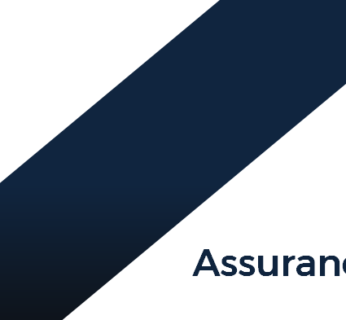

* Independent Review
* Compilation Engagement
* Agreed upon procedures
* System reviews, accounting, and internal controls
* Specialized Investigation
* Due Diligence Review

**Advisory Services**

* Preparation and review of policies and standard operating procedure
* Financial management workshops & trainings
* Business valuations
* Business Plans
* Secondment of Key financial staff
* Business turnaround strategy
* Business mentorship and coaching

**Accounting and Related Services**

Bookkeeping, Accounting and Management accounting solutions provides you with the option to outsource some or all aspects of your accounting requirements. We would be pleased to contact you to explain the services in detail. You remain in control of your business and choose which of the following services you require Range of accounting services to choose from:

* Processing of financial information to produce a credible Trial Balance
* Preparation of annual financial statements
* Preparation of monthly management accounts
* Full payroll services
* Budgeting and cash flow management
* Monthly reconciliations – bank, debtors, creditors, revenue

**Taxation Services**

* Completion and submissions of tax returns
* Calculations of tax liability
* VAT
* Tax planning
* PAYE Reviews
* Tax Clearance Certificate for good standing and tenders
* Salary Structuring
* Income tax registration
* Application for exemption for employee tax
* Checking income tax assessments
* Arranging deferred payments and
* Objections



**Public Sector Services**

* Preparation of annual financial statements which are GRAP compliant
* Technical financial support for clean audit and assist in clearing of audit findings
* Audit management and support
* VAT reviews and VAT audit support
* Procurement Management

We assist the public sector in the provision of a complete comprehensive procurement service. This includes the compilation of terms of reference, sourcing of technical expertise, evaluation of proposals and negotiation of contracts.

**Asset Management**

We provide a complete and reliable service in the management of assets. This service includes the compilation of an asset register, physical verification, and review of useful life of assets, assist in identifying assets that needs to be scraped and barcoding of new assets or replacement of barcodes.

Company Secretarial Services

* Registration of companies
* Appointment of auditors, accounting officers
* Appointment of new members, directors
* Transfer of shares, allotment of shares and issuing of share certificate
* Change in the year end of a company or close



Frequently Asked Questions



e interest of yo

Why Management Accounting service may b

A director will review your financial information and provide relevant reports that will cover among others the liquidity, profitability, and others about the business to help you make management decision. This information may be provided by our bookkeeping service or from you to maintain by yourself. The cost of this expertise would be small fraction of the true cost of employing somebody of equal experience.

Why Bookkeeping services may be of your interest?

We offer computerized bookkeeping system maintained by our qualified staff and we also assist clients to move from manual bookkeeping to computerized bookkeeping system. This service could be performed by our bookkeeping service at your office or our facility. Outsourcing allows you to allocate more management time to run your business and increase profits rather than on this mundane albeit skilled necessary function.

Audit Partner

SM Accounting & Management Consultants has an active Memorandum of Understanding with NgwenyaXimun Chartered Accountants (SA) as our audit Partner.

KEY PERSONNEL DETAILING



1. Noluthando Tshabalala – Auditor: Assurance & Audit

TEAM MEMBER NAME

Post Grad. Internal Auditing

1. Prudence Mnguni – Auditor: Assurance & Audit

Btech. Internal Auditing

1. Michelle Mokoena – HR & Office Manager

Dip. Business Management

1. Patience Nemulodi – Accountant

Adv. dip Cost and Management Accounting

YEAR EXP EXPERIENCE

1.5 ▪ AFS preparation specialist

* Taxation
* Bookkeeping
* Financial Management
* Internal Audits
* Due Diligence Review
* External Audits
* Business Advisor

2 ▪ Bookkeeping

* Financial Management
* Compilation and Analysis of Annual Financial Statements
* Internal Controls
* Financial Statements
* Policies and Procedure
* Special Audits

3 ▪ Bookkeeping

* Reconciliations – Creditors & Debtors
* Office Management
* Income Tax returns & Company Registration
* Financial Management
* Processing of financial information into the accounting system
* Reconciliations – Bank, Creditor, Revenue and Balance Sheet
* Management Accounting
* Financial Management
* AFS Preparations

▪ Web & Graphic Design

* Copywriting
* Computer Networking
* SEO + UI/UX

    

education

GAUTENG PROVINCE

SERITI 



**SOUTH AFRICAN POLICE SERVICE**

**FOOTBALL ASSOCIATION**

**

Head office