**Task**

Implement a sample test automation project:

• Decide what features can be automated on www.ubs.com

• Write 3-5 scenarios in feature files preferably using Specflow (other BDD tools such as Cucumber are also acceptable)

• Implement above in steps preferably using C# (Java or other alternatives are also acceptable)

• Make project configurable, so it is possible to run test suite for particular language/instance/user…

**Important Points to be considered:**

I create 7 automated tests.

I used the last selenium version with C#.

I applied Page Object concepts.

I also create 1 automated test using BDD (Specflow).

The tests can be run filtering by suit (I tried share the tests in their Testsclass).

Make sure you have the ChromeDriver in the path: (@"C:\Selenium\ChromeDriver"), because I decided to do the tests using Chrome browser.

**The tests were created for the following features**

1.ConctatForm (3 tests)

* Submit a contact form successfully
* Submitting a contact form successfully using SpecFlow (feature file)
* Trying to submit a form with an invalid email

2.Search (2 tests)

* Executing a search and returning result
* Trying to execute a search but don’t return result

3. Language (1 tests)

* Changing localization and validating if the language will be change

4. Looking for Legal Information filtering by Localization (1 tests)

* Doing a filter by localization to find Legal Information

After run all my tests:

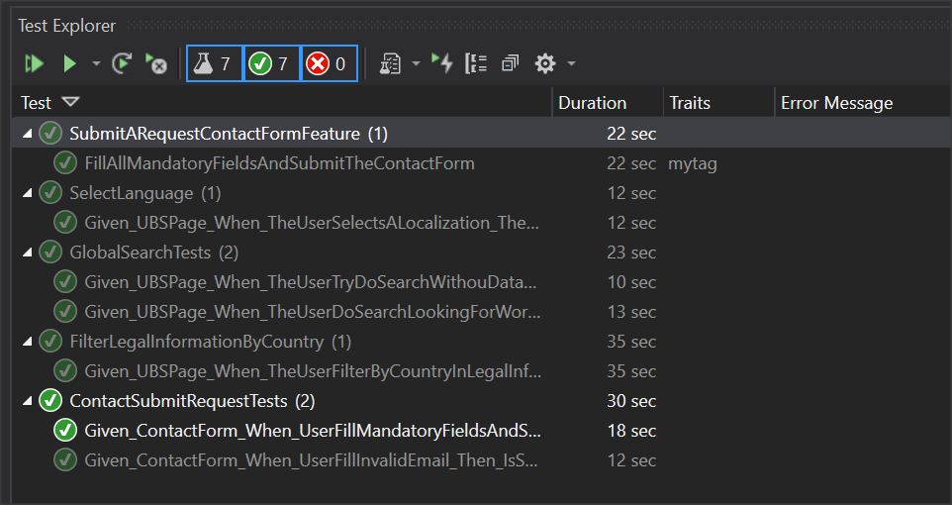

Implemente um projeto de automação de teste de amostra:

• Decida quais recursos podem ser automatizados em www.ubs.com

• Escreva de 3 a 5 cenários em arquivos de recursos, de preferência usando o Specflow (outras ferramentas BDD, como Cucumber, também são aceitáveis)

• Implementar acima nas etapas preferencialmente usando C # (Java ou outras alternativas também são aceitáveis)

• Tornar o projeto configurável, para que seja possível executar o conjunto de testes para determinado idioma / instância / usuário…