Ex 1

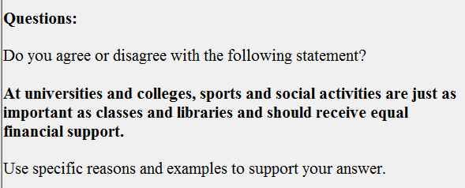

Should sports and social activities receive equal financial support as classes and libraries? From my frame of reference, I fundamentally go along with the speaker/frown on the viewpoint, for the following reasons.

In the first place, the course of history has informed us vividly that because …., the education ought to be designed to suit every single student, which is especially true in the realm of science. Take the celebrated A for example. …. As we can see from the above, it is … that…

In the second place, a recent authoritative survey has unveiled that.… In the light of a 20-year study of 3000 reputable scientists conducted by the Chinese Academy of Social Science, as many as seven out of ten of the respondents reveal that… Among them, George Johnson, an illustrious professor in Social Department of Fudan Universities, even harbors the standpoint that …. From the result, we can confidently draw the conclusion that nothing can be compared with A in ….

Ex 2

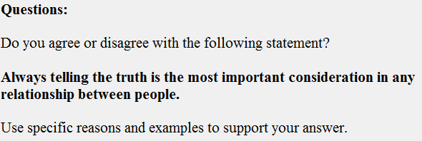

Ex 3

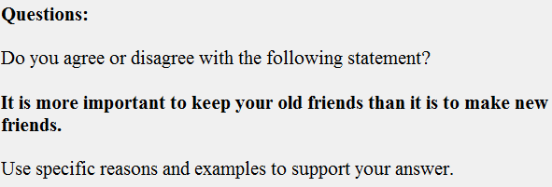

Ex 4

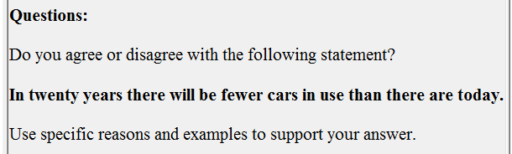

Ex 5

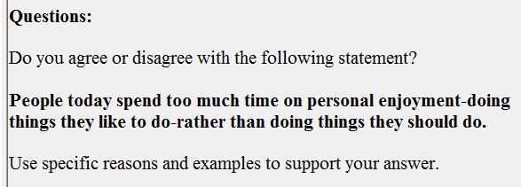

Ex 6

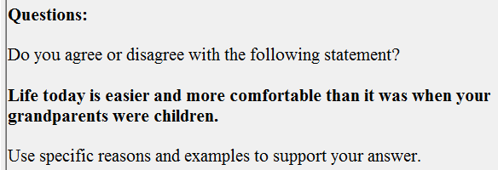

Ex 7

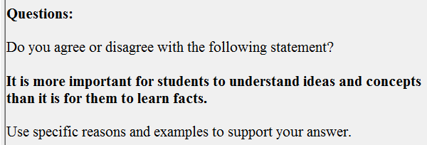

Ex 8

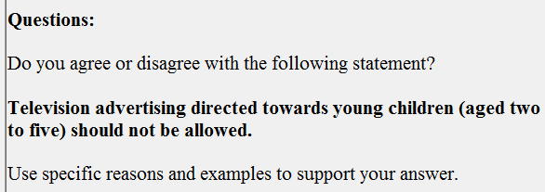

Ex 9

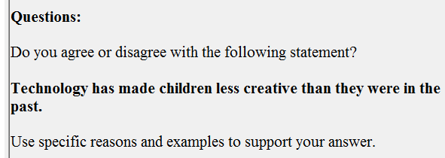

Ex 10

