- Exp, 表达式;
- Stmt, 一条语句;
- ->: 可以具有某种形式;
- “I” means selection/OR;
- Joint of strings satisfy LAW of associative;

- Important: Chinese version, page 336,
- 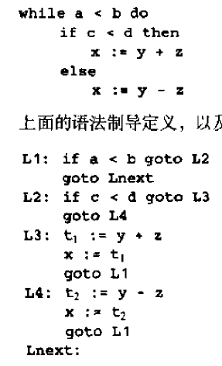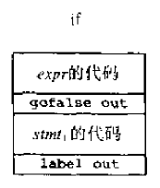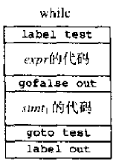

- Source code is a long string, done; (2017-11-11)
- Do we need to write our own compiler? Yes, but we should expand operator to all symbols, done; (2017-11-11)
- Our compiler stops at intermediate code, done; (2017-11-11)
- Parser is to report syntax errors. (2017-11-15)
- Syntax tree is different from parse tree, done; (2017-11-18)

- The reason why I learn compilder principle is that I should always remember the process of doing job;
- Stack machine is very important, it shows basic of computer,
- Unlike AI has many courses, compiler is not that much, done; (2017-11-11)
- (0, 1, 2, 3) is state, (a, b) is input, done; (2017-11-13)

- 我算是草草看过《圣经》和《四书》，其实两者共通之处还是挺多的。
- 比如答主提到的“世界的痛苦”“世界的诱惑”，《孟子》中有“富贵不能淫，贫贱不能移，威武不能屈”。
- 答主提到的“对真理负责，对信仰献身，不拜偶像”，《孟子》中有“天下有道，以道殉身；天下无道，以身殉道”，“尽信书不如无书”，《论语》中有“当仁，不让于师”。
- 《圣经》中有很大的篇幅在讴歌人性， 《礼记》中也有“故人者,其天地之德,阴阳之交,鬼神之会,五行之秀气也”。
- 所以，我个人认为没有必要细分东方西方，因为先进和美好的东西具有普世价值。

- -

