### **NEO-6M GPS Module Pinout**

The NEO-6M GPS module has four pins: GND, TxD, RxD, and VCC. The TxD and RxD pins are used to communicate with the microcontroller.

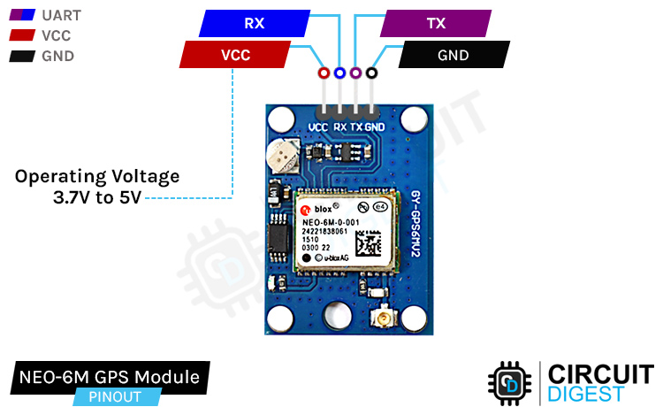

GND is the ground pin of the GPS Module and it should be connected to the ground pin of the ESP32.

TXD is the transmit pin of the GPS module that needs to connect to the RX pin of the ESP32.

RXD is the receive pin of the GPS module that needs to connect to the TX pin of the ESP32.

VCC is the power pin of the GPS module and needs to connect to the 3.3V pin of the ESP32.

### **NEO-6M GPS Module – Parts**

The NEO-6M module is a ready-to-use GSM module that can be used in many different applications. The parts on the NEO-6M GPS module are shown below-

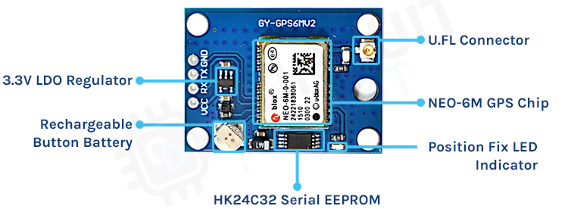

The NEO-6M GPS module has five major parts on the board, the first major part is the NEO-6M GPS chip in the heart of the PCB. Next, we have a rechargeable battery and a serial EEPROM module. An EEPROM together with a battery helps retain the clock data, latest position data(GNSS orbit data), and module configuration but it’s not meant for permanent data storage. Without the battery, the GPS always cold-starts so the initial GPS lock takes more time. The battery is automatically charged when power is applied and maintains data for up to two weeks without power. Next, we have our LDO, because of the onboard LDO, the module can be powered from a 5V supply. Finally, we have our UFL connector where we need to connect an external antenna for the GPS to properly work.

### ****SEFFES****

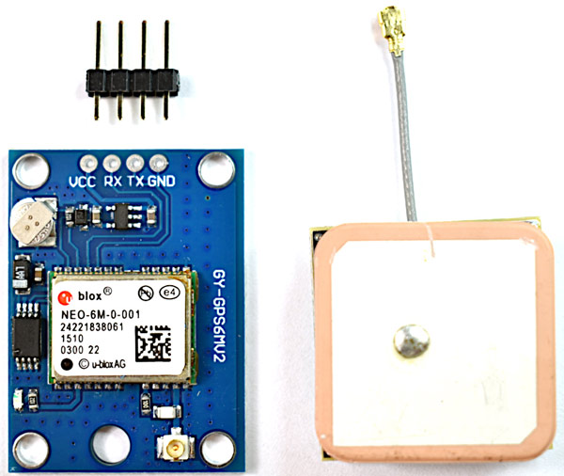

The Global Positioning System (GPS) is a system consisting of 31 satellites orbiting earth. We can know their exact location because they are constantly transmitting position information with time through radio signals. At the heart of the breakout board, there is the NEO-6M GPS module that is designed and developed by u-blox. This is very small but it packs a lot of features. It can track up to 22 satellites over 50 channels while consuming only 45mA of current and has an operating voltage of 2.7V ~ 3.6V. One of the most interesting features of this module is its power-saving mode. This allows a reduction in system power consumption. With power-saving mode on, the current consumption of the module reduces to 11MA only. For more details about the NEO-6M GPS Module, you can check out the [NEO-6M Module datasheet](https://components101.com/sites/default/files/component_datasheet/NEO6MV2%20GPS%20Module%20Datasheet.pdf).

#### **Position Fix LED Indicator:**

If you take a close look at the NEO-6M GPS module board, you can find a small LED that is used to indicate that the GPS module is able to communicate with the satellites.

* No blinking – it is searching for satellites.

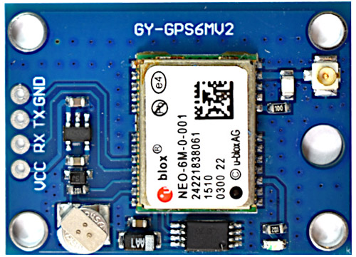

* Blink every 1s – Position Fix is found (the module can see enough satellites).

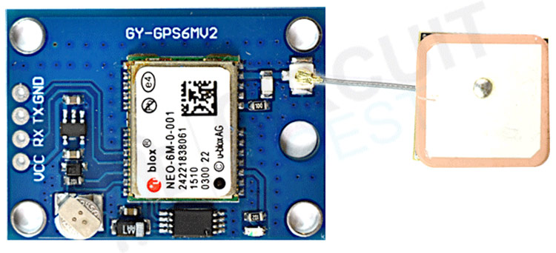

#### **Antenna:**

The module comes with a -161 dBm sensitive patch antenna that can receive radio signals from GPS satellites. You can connect the antenna to a small UFL connector which we have mentioned in the parts marking section of this article.

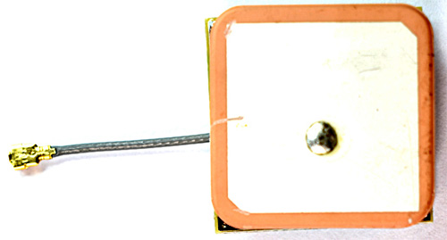

For most outdoor applications, the patch antenna will work just fine but for more demanding or indoor applications it is advised to use a 3V active GPS antenna.