**HC-05 Bluetooth Module Interfacing with Arduino UNO**

Overview of Bluetooth

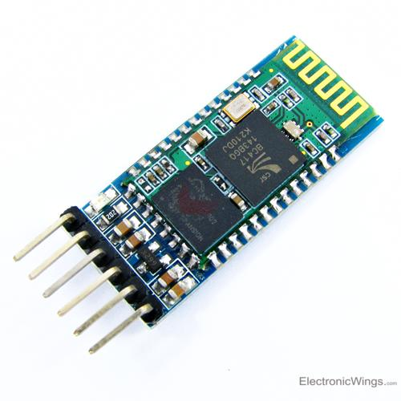

HC-05 is a Bluetooth device used for wireless communication with Bluetooth enabled devices (like smartphone). It communicates with microcontrollers using serial communication (USART).

Default settings of HC-05 Bluetooth module can be changed using certain AT commands.

As HC-05 Bluetooth module has 3.3 V level for RX/TX and microcontroller can detect 3.3 V level, so, there is no need to shift TX voltage level of HC-05 module. But we need to shift the transmit voltage level from microcontroller to RX of HC-05 module.

For more information about HC-05 Bluetooth module and how to use it, refer the topic [**HC-05 Bluetooth**](http://www.electronicwings.com/sensors-modules/bluetooth-module-hc-05-) module in the sensors and modules section.

**Note :**Default Bluetooth name of the device is “HC-05” and default PIN (password) for connection is either “0000” or “1234”.

# Send Message using Bluetooth HC-05 With Arduino

Here, we will transmit data from Smartphone via Bluetooth to the Arduino Uno and display it on Serial Monitor of PC.

Download and install a **Bluetooth terminal** application on your phone and use it to connect to the HC-05 Bluetooth module.

Data is sent from the Smartphone using the **Bluetooth terminal** application.

https://www.electronicwings.com/arduino/hc-05-bluetooth-module-interfacing-with-arduino-uno