1. **What is a Pedometer?**

Pedometer is a device which can calculate the steps walked by the person. Motion of the hands is detected by the pedometer which in turn calculates the number of steps walked by the person. Leoanrdo da Vinci first envisioned mechanical pedometer. First pedometer was developed by Abraham Louis Perrelet in 1780. Many pedometers have been developed by big tech companies such as Apple, Nike and many more. Initially all mechanical pedometers were developed.

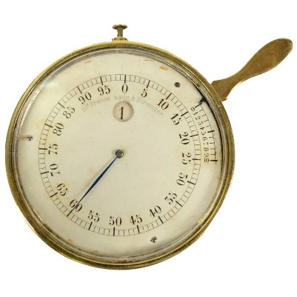

[https://a.1stdibscdn.com/archivesE/upload/3663232/f_49466231466454301652/4759_org_l.jpg]

With the advancement of technology all electronic pedometers have come. Electronic pedometers are equipped with accelerometers. Step count is detected by the spike obtained in accelerometer data. Newly released smart phones (such as Nexus P) are equipped with pedometer sensors. [MEMS](https://en.wikipedia.org/wiki/Microelectromechanical_systems) inertial sensors and sophisticated software’s are used to detect steps. 1-, 2- or 3-axis detection of acceleration is present in the sensors.

1. **Problems with Pedometers**

Pedometers have been developed in different forms by the tech giants. Fit bit is widely used now a days. People have become more health conscious. Everyone wants to live a healthy life. Nike has also launched “Nike+Ipod”([http://www.kohls.com/product/prd-452483/nike-ipod-sport kit.jsp?ci_mcc=ci&utm_campaign=ELECTRONICS&utm_medium=CSE&utm_source=google&utm_product=90062180&CID=shopping15&gclid=CjwKEAiAjvrBBRDxm_nRusW3q1QSJAAzRI1t6ksIEzt5XcVHEuaPox7EXRasenj7NIQ_8mQHvRrp4BoCUr_w_wcB&gclsrc=aw.ds&dclid=CLz7nZOY0NACFU-PaQodZKgBIg](http://www.kohls.com/product/prd-452483/nike-ipod-sport%20kit.jsp?ci_mcc=ci&utm_campaign=ELECTRONICS&utm_medium=CSE&utm_source=google&utm_product=90062180&CID=shopping15&gclid=CjwKEAiAjvrBBRDxm_nRusW3q1QSJAAzRI1t6ksIEzt5XcVHEuaPox7EXRasenj7NIQ_8mQHvRrp4BoCUr_w_wcB&gclsrc=aw.ds&dclid=CLz7nZOY0NACFU-PaQodZKgBIg)).

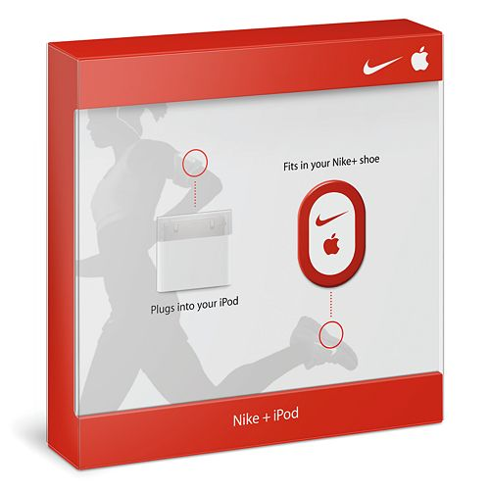

The main problem is that the sensor must be put in the shoe. Also, there is additional hardware which must be carried. So, the hardware cost is also increased.

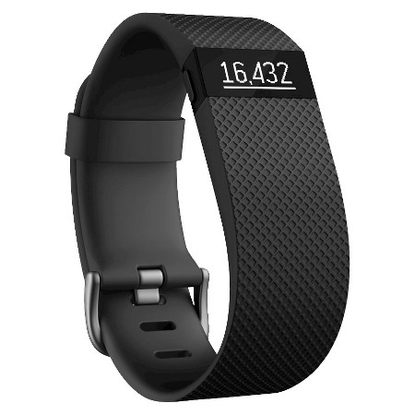

Fit bit seems to be a viable option. The main problem is that Fit bit must be interfaced with computer/laptop or mobile. The best part is that it can be worn as a watch and can be carried anywhere. On the other side, Fit bit needs to be charged at regular intervals. If it gets switched off there are chances that the user might not get proper step count. Also, Pedometer tries to fetch Bluetooth signals of mobile or laptop to sync the data. The energy of both the devices is wasted. Integrating pedometer sensor in a smart phone seems to be a viable option. The user need not carry or purchase any additional hardware along with him/her. Also, the user need not spend extra money in purchasing additional device with a pedometer sensor. All people carry the cell phones along with them. If the application is opened in the cell phone the steps taken can be counted automatically. Mobile phones are recharged daily by the users. So, there is no separate requirement of re-charging the device.

1. **Technical Drawing**



Pedometer Sensor

Steps Count, calories burnt, distance traversed is displayed

 

* **Stage 1**
* Initially the values are written from the pedometer sensor by the android.
* **Stage 2**
* Android app calculates the steps taken, calories burnt as well as the distance traversed based on the weight and height given by the user.
* **Stage 3**
* Once the user clicks on the stop button, SMS will be triggered and sent to the given by the user on the application screen.
* The data is stored in the phone memory in a text file.

1. **Data Collected & Stored**

* Samsung Galaxy S4 has got in-built pedometer sensor.
* The application reads the values from the pedometer sensor. The sensor gives the total steps taken by the person.
* Once the STOP button has been pressed Steps taken, Calories burnt as well as distance traversed is calculated.
* The data is sent through SMS to the given mobile number by the user on the application screen.
* The data is also stored in the mobile phone memory.

1. **Flowchart**

Start

Initialize the sensor count by clicking on RESET Button

Start the journey by clicking on START button

The step count starts after few seconds. The user will be able to see the live step count, calories burnt as well as the distance covered.

Once the user finishes the journey stop button can be pressed.

Automatic SMS will be sent to the mobile number given by the user. Also the data displayed on the screen by clicking stop button will be updated to the phone memory.

End

1. **Working**
2. When the user will open the application, the initial screen will look like this. The user must fill Name, Mobile No, Weight and Height fields.

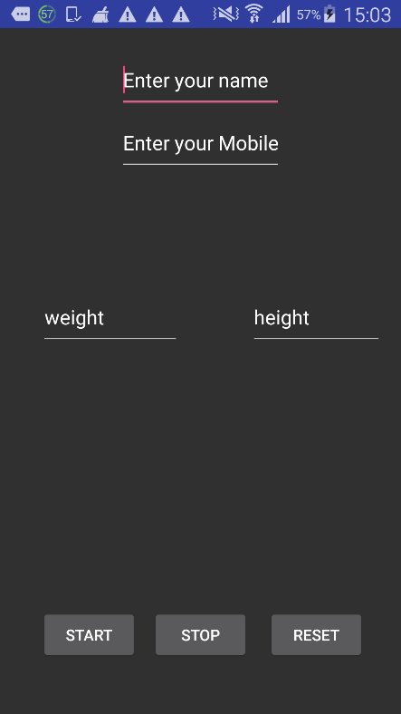

1. The user must give name, Mobile number, weight & height as input. Weight & height are required for the calculation of calories burnt. When the user will enter the required details the screen will look like the below screen.

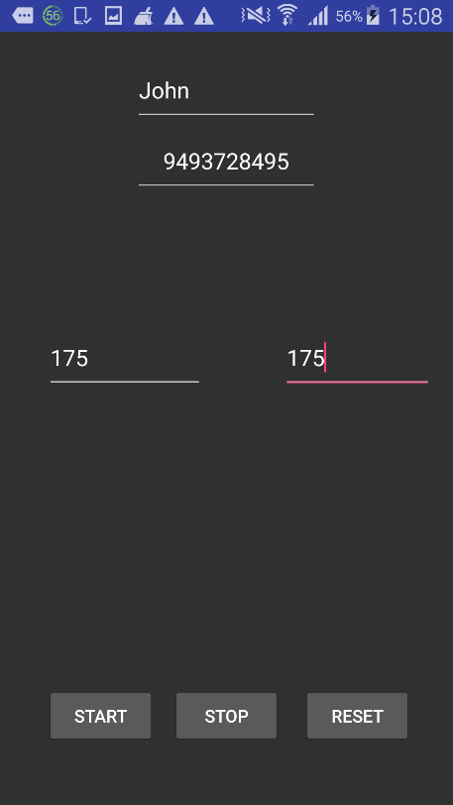

1. It’s better to reset the values before starting the app. The values can be reset by clicking the reset button. The following message will be displayed on clicking the reset button.

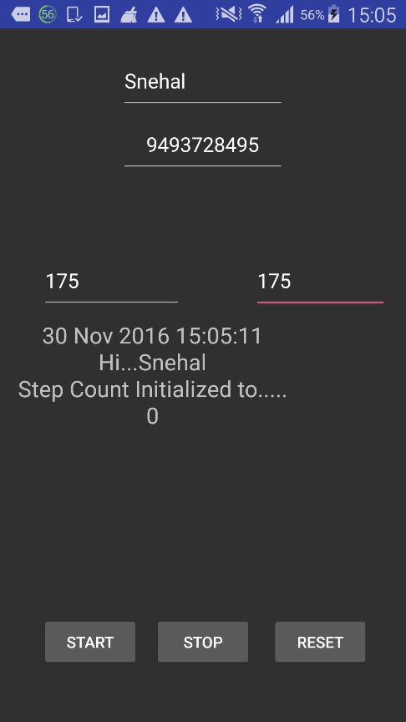

1. For counting the number of steps while walking “START” button must be clicked. The following message will be displayed on clicking the start button.

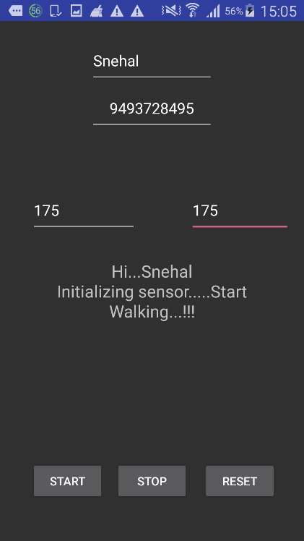

1. If the user clicks on STOP button instead of walking the following message will be displayed

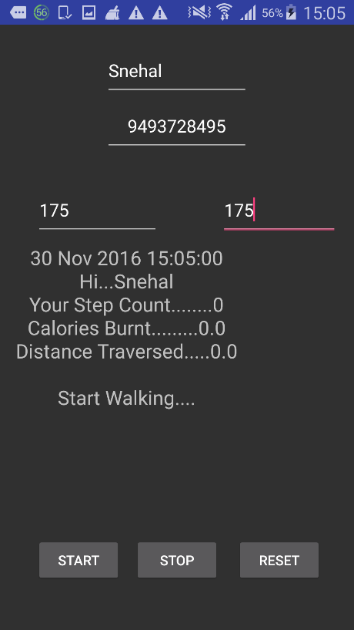

1. When the user clicks on STOP button, the following message will be displayed. The user will be able to see the calories burnt as well as the distance traversed. Automatic SMS will be sent on the number entered by the user.

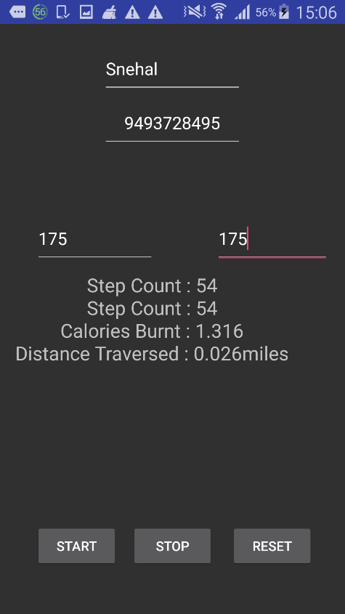

1. SMS is generated once the user clicks on STOP button

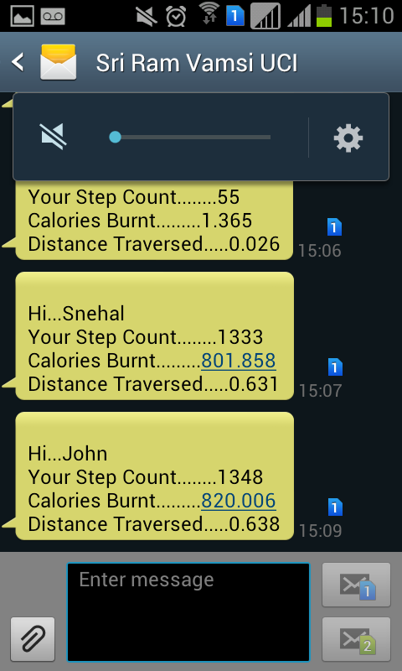

1. Calories burnt has been calculated based on formula obtained from the following link. (<http://fitness.stackexchange.com/questions/25472/how-to-calculate-calorie-from-pedometer>)
2. Calories burned per mile = 0.57 x 175 lbs. (your weight) = 99.75 calories per mile.
3. Your strip = height * 0,415.
4. steps_in_1_mile = 160934.4 (mile in cm) / strip.
5. Conversation Factor = Step Count (what the pedometer provides) / step_in_1_mile;
6. Calories Burned = Step Cunt * Conversion Factor;
7. **Uses**
8. The user can check the Steps taken, calories burnt as well as the distance traversed using this application.
9. User need not carry any additional hardware for the calculation of steps.
10. User need not purchase any additional hardware for the step detection.
11. The information is stored in the phone memory along with the time stamp. So, the user can check the steps taken on a particular day.
12. SMS is triggered with information related to step count, calories burnt as well as the distance traversed.
13. People usually recharge cell phones on regular basis. So, there is no problem of energy as well.