**SFM（Structure from Motion）**

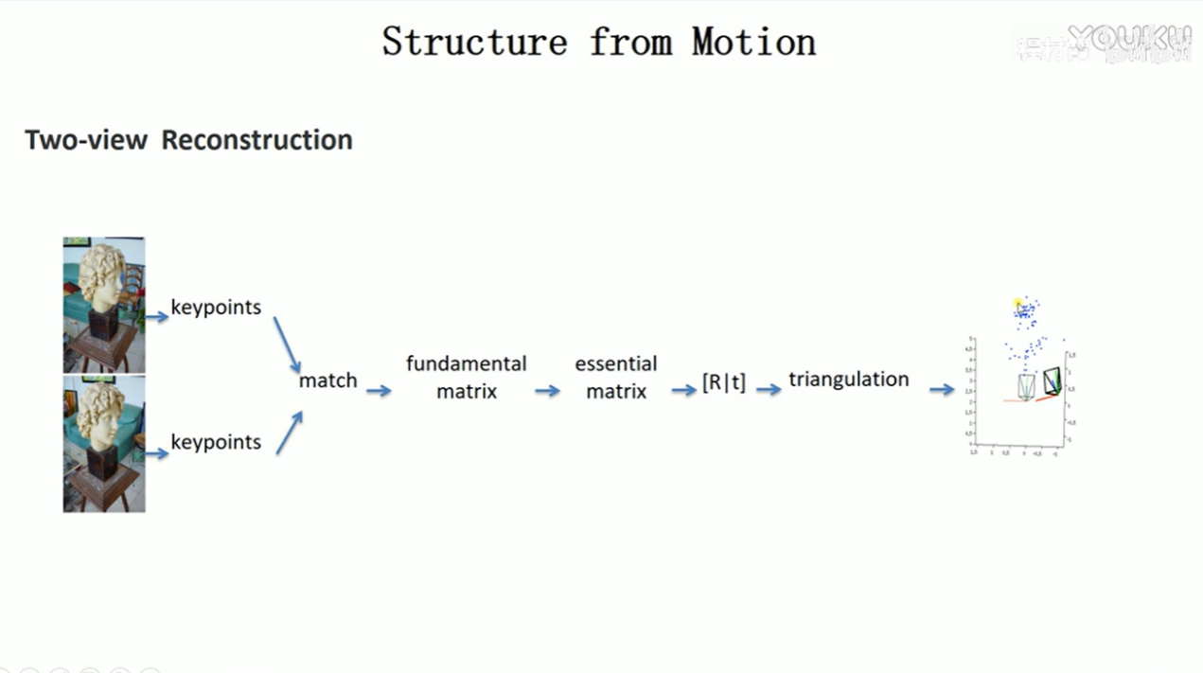

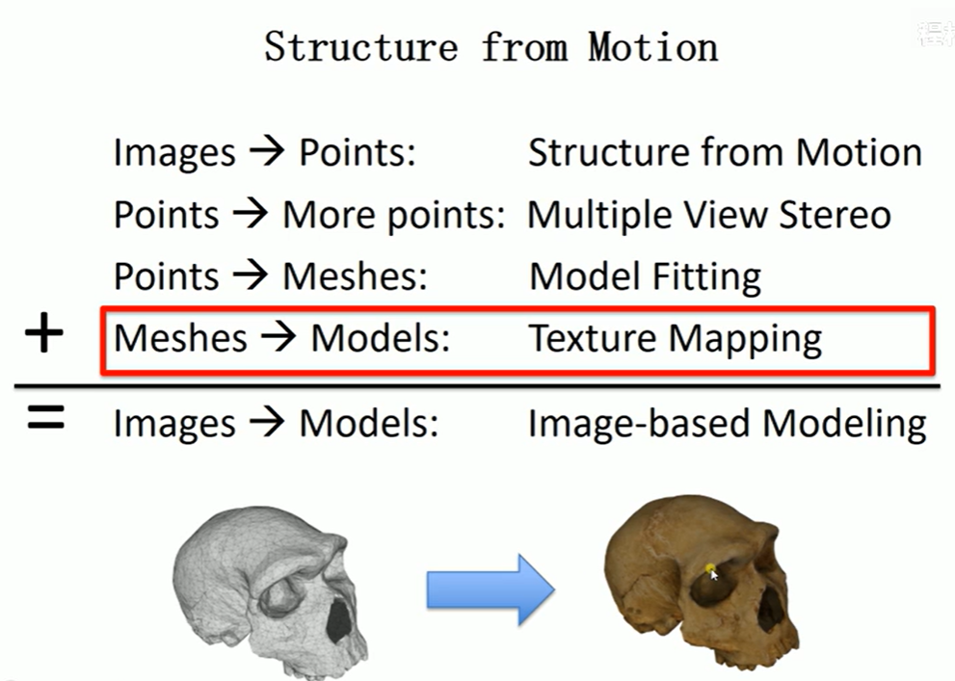

Currently, there is only one way to view NeRFs in 3D with your VR headset, Nvidia's Instant-NGP app for Windows.