AO

Ambient Occlusion的细分种类有：

* SSAO-Screen space ambient occlusion
* SSDO-Screen space directional occlusion
* HDAO-High Definition Ambient Occlusion
* HBAO+-Horizon Based Ambient Occlusion+
* AAO-Alchemy Ambient Occlusion
* ABAO-Angle Based Ambient Occlusion
* PBAO
* VXAO-Voxel Accelerated Ambient Occlusion

Hair

**Kajiya-Kay Model**

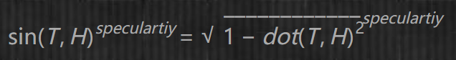

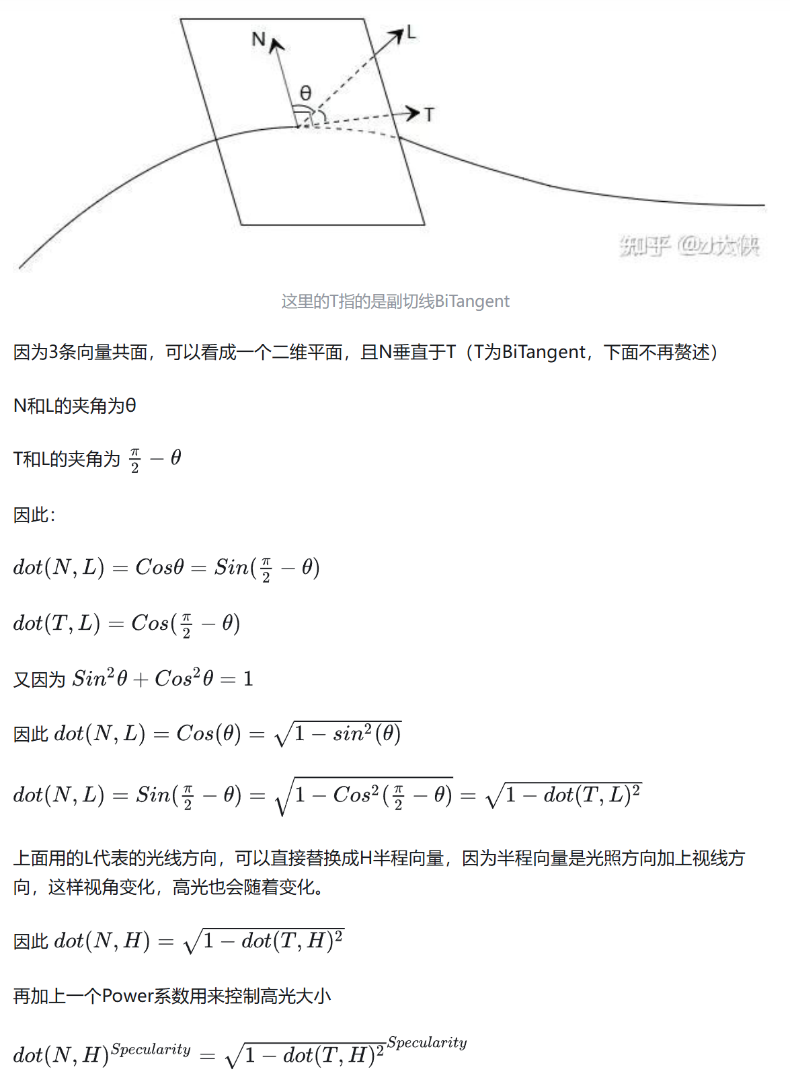

Why bitangent instead of normal？

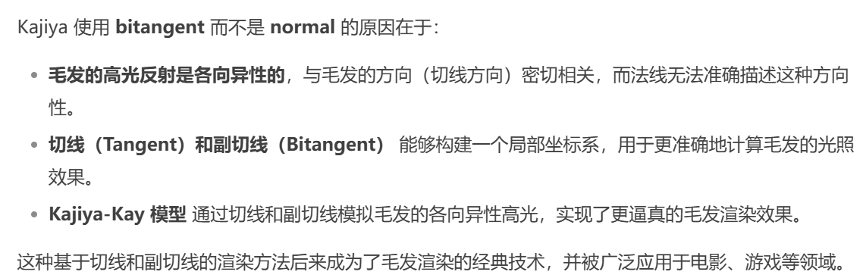

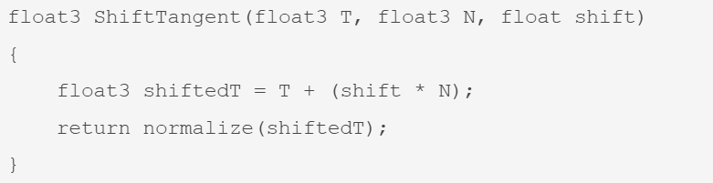

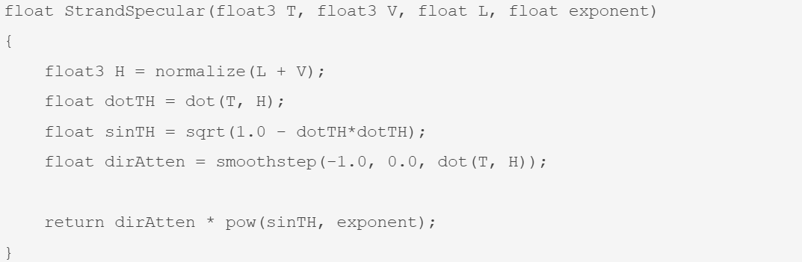

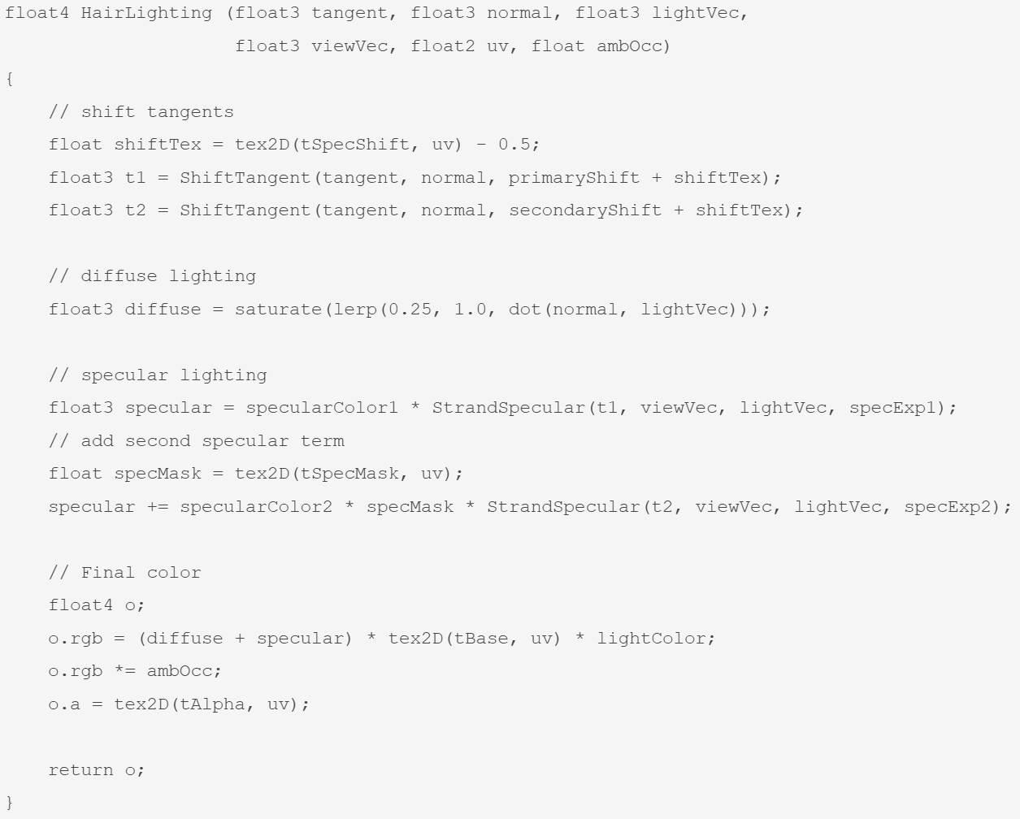

水体渲染

