Src\load_data.py

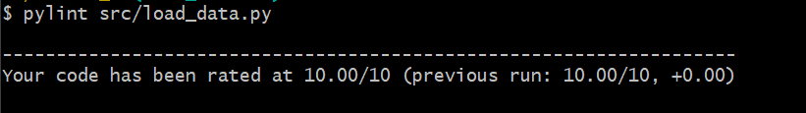

Src\app.py

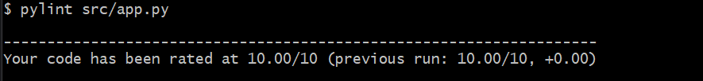

Src\query_data.py

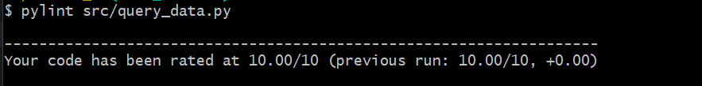

Tests\test_analysis_format.py

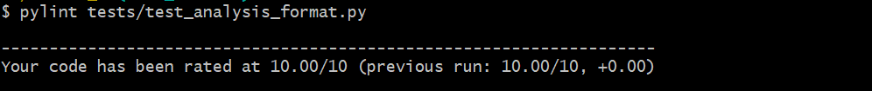

Tests\test_integration

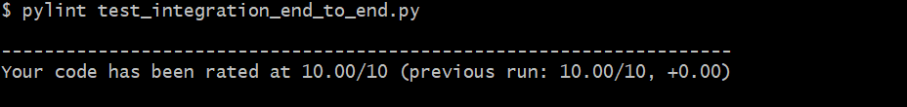

Tests\test_db_insert

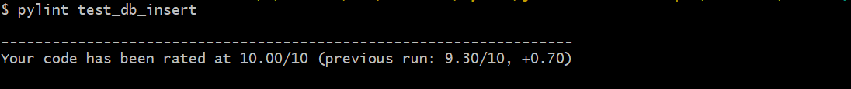

Tests\test_query_data

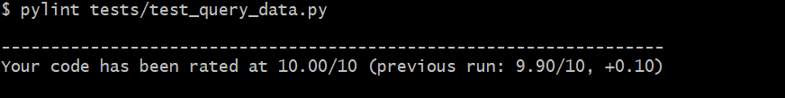

Tests\test_buttons

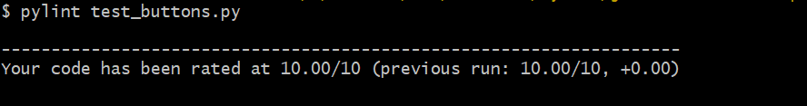

Tests\test_flask_page  
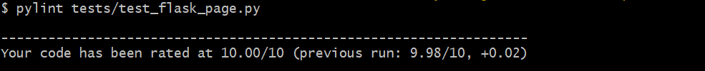

Tests\conftest.py

