**Nazava® water filters**

|  |
| --- |
| **Manual for the use of**  **Nazava Transparent Water Filter (13,5 Liter)** |

# We thank you for your purchase of a Nazava Water Filter. You can use the filter to purify you well, rain, tap or river water so it becomes 100 % safe to drink. The filter helps you in protecting your family against waterborne diseases like diarrhea, typhoid, cholera and dysentery. Please read this manual carefully and use your Nazava Water Filter properly. We hope you will enjoy our product.

**If you have any questions, problems or suggestions, please contact us at :**

Consumer Hotline **No. +62813-6086 2522**

 **Or send an email to : info@nazava.com**

**We are happy to hear from you!**

|  |
| --- |
| **Parts of your water filter** |

Please make sure that your package contains the following parts

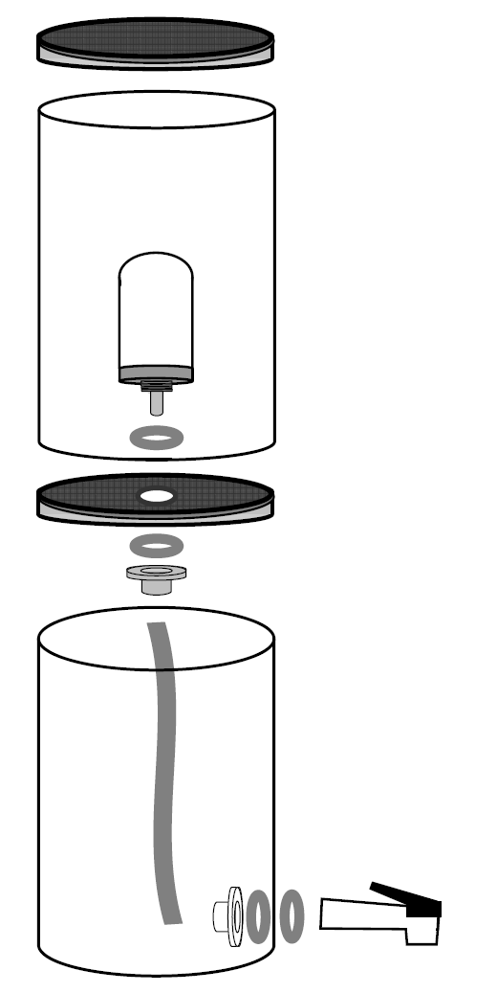

|  |  |  |  |  |  |  |  |  |  |  |  |  |  |  |  |  |  |  |  |  |  |  |  |  |  |  |  |  |  |  |  |
| --- | --- | --- | --- | --- | --- | --- | --- | --- | --- | --- | --- | --- | --- | --- | --- | --- | --- | --- | --- | --- | --- | --- | --- | --- | --- | --- | --- | --- | --- | --- | --- |
|  | |  |  | | --- | --- | | a | 1 Lit | | b | 1 Dirty water container | | c | 1 Filter | | d | 2 O-ring for the filter candle | | e | 1 Lit with a hole | | f | 1 Nut for the filter | | g | 1 Tube | | h | 1 Drinking water container | | i | 1 Tap | | j | 2 o-ring for the tap | | k | 1 Nut for the tap | | l | 1 Measuring ring | | m | 1 Manual | | n | 1 Warrantee card | | o | 1 Sponge | |
| **How to install your water filter** | |

**Picture 1**



**Picture 2**

**Picture 3**

**Picture 4**

**Installing the filter candle (Picture 1)**

1. Wash your hands with soap before you install the filter.
2. Check if the filter is complete before you start with the installation.
3. Insert the filter candle (d) with one rubber o-ring (d) in the hole in the dirty water container (b). Hold the plastic when installing the filter; avoid putting force on the ceramic.
4. Install the lit with the hole below the dirty water container. Put the second o-ring (d) around the outlet of the filter candle and screw the nut on the filter candle until it is tightened well. Make sure the screw is installed like in picture 2.

**Installation of the tap (Picture 3)**

Install the tap (i) with the rubber o-ring (j) in the hole of the drinking water container (h) and install the second rubber o-ring (j) and the nut (k) on the inside and screw until everything is well tightened.

**How to install the filter.(picture 4)**

1. Place the tube (g) at the end of the outlet of the filter candle.
2. Clean the drinking water container with a clean and dry cloth.
3. Install the dirty water container with the water filter and the tube that has already been installed, on top of the drinking water container.



**Please watch the moveie on the filter installation on** www.youtube.com/watch?v=lWATvEOCtww

|  |
| --- |
| **How to use your water filter** |

1. Fill the dirty water container with tap, well, river or rain water (picture 5)
2. The water will flow automatically to the lower water container.
3. If you use the filter for the first time, wait until the drinking water container is full. Throw this water away because it can have an odd taste (drinking it is not dangerous however).
4. Fill the dirty water container again.
5. The water that will flow to the drinking water container is ready to drink. (Picture 6)



**Picture 5**

**Picture 6**

|  |
| --- |
| **Maintenance** |

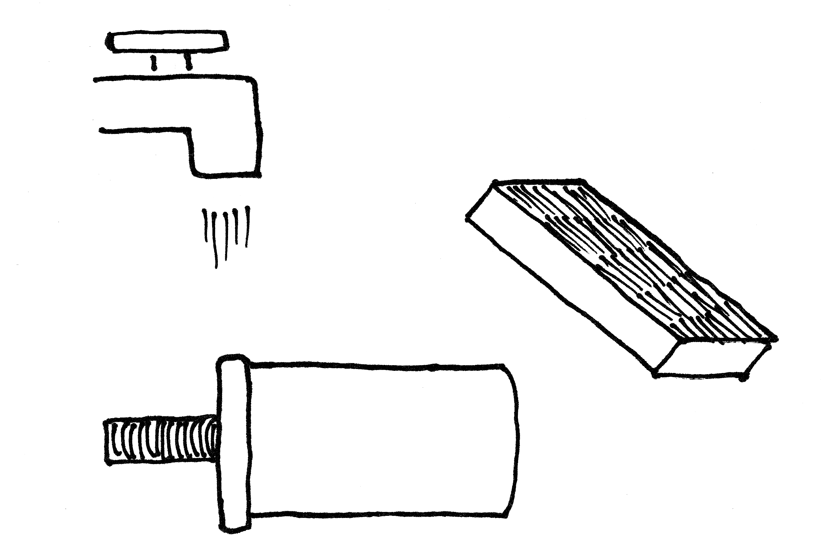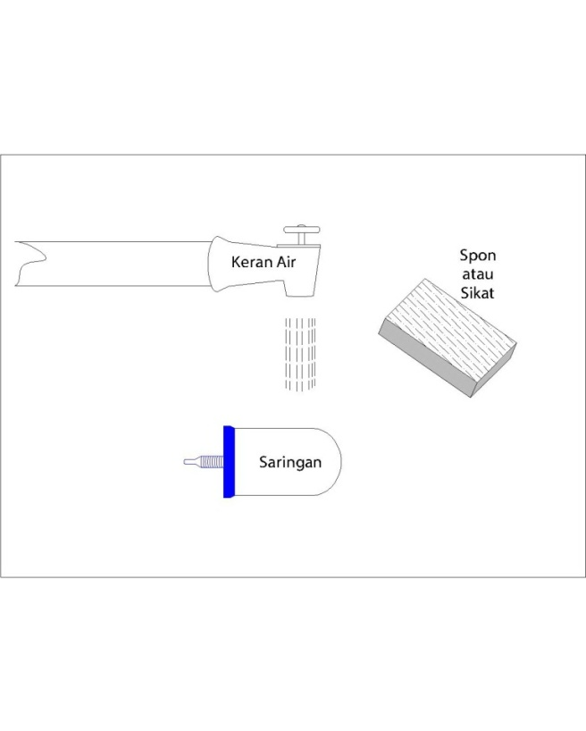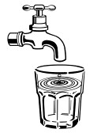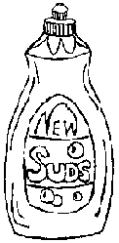

**Gambar 7**

1. The filter candle needs to be cleaned at least once every two weeks.
2. The filter candle can be cleaned with a sponge or a fine brush
3. In case the discharge is very slow even after cleaning, remove the water filter candle from the container and scrub the filter with a scrubbing sponge or a brush under running water. Do not use detergent, soap or any other chemicals. (Picture 7).
4. When removing the filter from the container, hold the filter candle at the plastic, to not place any force on the ceramic.
5. Each time the filter is cleaned and scrubbed the ceramic gets thinner. When the filter is less than 5 cm, the filter needs to be replaced (you can use the indicator ring for that see picture 8)

|  |
| --- |
| **Attention** |

1. Both clean and murky water can be used.
2. Salty water or water that is highly contaminated with chemical pollutants cannot be used.
3. Water from the water filter can be drunk without boiling it, because it is free of micro-organisms.
4. Change the filter candle when the diameter is smaller than 5 cm. When the indicator ring fits around the filter candle, the filter needs to be replaced. Picture 8.



1. After you installed a new filter candle, throw the first container of filtered water away. This water can have an odd taste.
2. To prevent leakage, always install the two o-rings of the filters and the candle at the right position (picture 1,2,3)
3. Never clean the filter candle with soap, detergent of any other chemicals except water.
4. When installing or removing the filter, hold the plastic not the ceramic.

|  |
| --- |
| **Warning** |

To avoid accidents or breakage, follow the steps provided in this manual. The manufacturer does not take responsibility for accidents and breakage caused by improper use or an improper installation of the device.

1. Please do not place the water filter in direct sunlight because it can damage the plastic.
2. Always place the water filter in a clean place that is free of dust
3. Clean both water containers at least two weekly.
4. Take care when holding the water filter candle.

|  |
| --- |
| **Specification** |

Nazava water filters come with a water filter candle that is made of silver impregnated ceramic and is filled with granular activated carbon. The ceramic and the silver kill all the bacteria, parasites and other micro-organisms. Activated carbon reduces smell, tastes and reduces levels of harmful chemicals.

**Ceramic**

**Carbon**

**Silver**

The ceramic has small pores (0.4 micron) so that bacteria, cysts, parasites, fungi and other micro-organisms are filtered out.

Activated carbon inside the filter removes smell and odour and reduces chemicals like chloride.

Silver inhibits the growth of micro-organisms and keeps the filter sterile.

|  |  |  |  |  |
| --- | --- | --- | --- | --- |
| Gambar tidak masak etc | Gambar tidak masak etc | Gambar tidak masak etc | Gambar tidak masak etc | Gambar tidak masak etc |
| **Without electricity** | **Free from bacteria** | **Economic & Cheap** | **No need to boil** | **Without chemicals** |

|  |  |  |  |  |  |
| --- | --- | --- | --- | --- | --- |
| **Product** | **Volume** | **Speed** | **Capacity** | **Material of container** | **Material of Filter** |
| Nazava Clear | Two containers of 13.5 liter | 2-3 liter per hour* | 7000 liter | Food grade plastic (PP) | Ceramic  Silver  Activated Carbon |
|  |  |  |  |  |  |

* Speed is achieved after 60 liter

|  |
| --- |
| **Warrantee** |

We guarantee that our water filter product is in line with our quality standards. We do not take responsibility for damage caused by improper use or an improper installation of the product. Please contact the consumer hotline or your reseller when you have any questions +62813-60862522

The water produced by our filters is tested in 15 laboratories all over the globe. All results indicate that the water is safe to drink. The results of the tests can be found at www.nazava.com

|  |
| --- |
| **Questions and answers** |

**Q = Question A= Answer**

|  |  |  |  |  |  |
| --- | --- | --- | --- | --- | --- |
| **1** | | **Q** | **What is the capacity of a Nazava Water Filter** | | |
|  | | **A** | Nazava Water Filter candles can filter 7000 liters of water before they need to be replaced | | |
| **2** | | **Q** | **What is the filtration speed** | | |
|  | | **A** | The clear small filter, filters around 2-3 liter per hour | | |
| **3** | | **Q** | **Where are Nazava Water Filters made from** | | |
|  | | **A** | Nazava water filters consist of silver impregnated ceramic with a core of activated carbon. | | |
| **4** | | **Q** | **How do you know when you have to change the filter** | | |
|  | | **J** | The filter candle can be used until the diameter is smaller than 5 cm. That can be measured with the simple indicator ring included in the package. | | |
| **5** | | **P** | **How use the filter.** | | |
|  | | **J** | The filter can be filled with river, well, rain and tap water. Drinking water can be tapped from the drinking water container. | | |
| **6** | | **P** | **Where is the water container made from** | | |
|  | | **J** | From PP, food grade plastic. | | |
| **7** | | **P** | **Is there any warrantee** | | |
|  | | **J** | Nazava water filters have a guarantee of one year on factory faults. | | |
| **8** | | **P** | **What is the difference with Reversed Osmosis** | | |
|  | | **J** | Reverse osmosis removes all minerals from water; it uses electricity and a lot of water. Nazava filters produce water that still have a natural mineral content and do not use electricity. | | |
| **9** | | **P** | **What is the difference with bottled or refilled water from water refill stations** | | |
|  | | **J** | This depends on the technology used. Always check whether your water provider has a proper license. | | |
| **10** | | **P** | **What is the difference with UV purification** | | |
|  | | **J** | UV lamps can kill bacteria. Before UV the water needs to be filtered as well. UV uses electricity. | | |
| **11** | | **P** | **What can be filtered out with Nazava Water Filters** | | |
|  | | **J** | All particles that are bigger than 0.4 micron are taken out. | | |
| **12** | | **P** | **Is calcium filtered out** | | |
|  | | **J** | Calcium in suspension is filtered out | | |
| **13** | | **P** | **Are parasites and bacteria removed?** | | |
|  | | **J** | Yes | | |
| **14** | | **P** | **Can I use salt water?** | | |
|  | | **J** | Salt is not removed by Nazava Water Filters | | |
| **15** | | **P** | **Can I filter brownish, yellowish or other high turbidity water?** | | |
|  | | **J** | Yes but the dirtier the water the more often you need to clean the candle. | | |
| **16** | | **P** | **Where can I buy Nazava Water Filter** | | |
|  | | **J** | All over Indonesia and we can ship everywhere! | | |
|  | |  |  | | |
| **Contact** | | | | | |
| **Head office**  Jalan R.A. Kartini No. 51  Peunayong  Banda Aceh, Aceh  Indonesia | | | | **www.nazava.com**  [**Info@nazava.com**](mailto:Info@nazava.com) |  |
| **Consumer Hotline +62813 6086 2522** | | | | | |